FinBlock Solutions
Real Numbers, Real Value, Real Estate

- Main Themes and purposes of your site

- The main theme and purpose of the site is to create a better experience for those buying, selling, or renting real estate. There are many things that go into a real estate decision which are down payment, mortgage, fees, taxes, household improvement costs, purchase price, rental income and many more things. Currently many individuals use programs like excel or just pencil and paper to help them budget their financial decisions in real estate. However, this website will help individuals budget their investments in a simple concise and helpful way.

- Another difficult aspect of real estate investing is deciding the rental price. Currently individuals rely on the judgment of professionals or simply estimating the price using their own guess. This method is not optimal and can lead to losses. In this website we will have an API that will fetch listing data according to specific attributes. User will be able to set the different characteristics of a house like the location, size, # of bedrooms, etc. Using this information, it will access market data from Realator.ca and try to match up as many houses that are like your description and calculate the estimated market rent for the property.

- The focus of this website is to better organize the numbers before buying, selling or renting real estate. It will have inputs where all cashflow within the property can be managed and calculated. Clients will be able to input their revenue appreciation, expenses, costs and many other things. Overall, this site will have a mortgage calculator, budget organizer, average Rent API, and an affordability calculator.

- Personas that will come to site
  - Person 1: Real Estate Agent
    - Name: Joe Berns
    - (1)
    - Demographics: Joe is a young 32-year-old male who works as a Real Estate Agent. He lives in Toronto where he sells condos as well as house in the GTA. He makes about 90k/year and has a business degree at the University of Waterloo. He is Christian so going to Church every Sunday is important. He is super outgoing and loves to try new restaurants in Toronto.
    - Knowledge and Skills: Joe has knowledge in business marketing and finance. He has skills in sales as well as he worked at Rogers as a sales representative throughout his university career. He then worked at an office in Toronto and now is a full time Real Estate Agent
    - Goals and Motives: Joe is young and wants to do his best in giving his customers the most accurate numbers as well as quality investment advice. He is motivated in finding the best deal for his clients. He is always learning and trying to find new methods and tools to better his work.
    - Approach to using the site: As a client comes in looking to buy or sell. He wants to provide the best service and analysis for his client. As an advisor he will use this site to help budget and judge whether a house is worth the money. Joe will be using this site daily since this information is crucial to all his clients.

  - Person 2: Investor
    - Name: Ron Mackenzie
    - (2)
    - Demographics: Ron is a 53yr old male who lives in Collingwood, Ontario. He already had 3 cottages in Collingwood near Blue Mountain. He enjoys camping and wilderness activities.
    - Knowledge and Skills: Ron is very knowledgeable in the real estate market. He has a degree in Finance from the University or Ottawa. He got into real estate in his early 30s and has loved it ever since. He is always up to date in the newest development in town. He was also one of the first pioneers to list his properties on AirBnb.
    - Goals and Motives: Ron is an opportunist and understands the importance of numbers. Ron is always looking at ways to make better decisions as well as exploring different business models. His motivation in life is to have steady reliable income and to be financially free. Investing can be very stressful however having the right math and projections gives Ron reassurance about his decisions.
    - Approach to using the site: Ron is a scavenger. He is always on the look out for new tools to help him with his investing. Ron really like this website because it helps him organize and calculate the numbers that matter. Rather than putting hours into research and on Excel, Ron has always wanted a tool that will stream line this and do it better than himself. Ron would be a reoccurring customer probably every few months when he needs insight on another property.

- Person 3: Home Buyer
  - Name: Simran Kaur
  - (3)
  - Demographics: Simran is a female that recently immigrated from India to Milton, Ontario 4 years ago. She is now 27 years old and has jus recently finished a diploma in Marketing from Sheridan Collage. She now works at a small trucking company helping them with their social media presence as well as cold calling potential clients. After saving lots of money over the past 4 years as well as her parents helping her financially from India, she is ready to purchase a new home. She lives a very minimal and simple life. She enjoys going on walks and feeding the ducks at the parks. Also, she does not like to take big risks.

  - Knowledge and Skills: Simran is very knowledgeable in marketing and human relations however she does not know too much about investing or how compounding works. However, she is aware of this is isn’t afraid of researching or getting help externally.

  - Goals and Motives: Simran wants to live a comfortable life and build a foundation for herself so she can eventually bring her parents from India to Canada. She is also looking to settle and get married but before she does that she wants to make sure she has a home.

  - Approach to using the site: Simran is more of a casual web surfer. She is in the market to look for a tool that will help her make a safe decision on what house she wants to buy. She also doesn’t know how to budget or know what her affordability range is.

- Scenario
  - Scenario 1: an individual wants to put their house on rent
    - Joe has a client that wants to make their basement into a rental income source. However their basement is not up to legal standards to be an apartment. Thus, there is costs involved in this. To do that they need to calculate if it is worth the cost. Joe needs to accurately consider the market value at which the basement can be rented for as well as the renovation costs (fixed costs) as well as the operating costs. There are a lot of variables that go in this in order to ensure money is made with this investment.
    - Joe makes calls to different contractors and gets an estimate on making the basement into a 2-bedroom apartment. Joe will then estimate the costs for marketing, his own fees, lawyer fees, and other miscellaneous costs. He also gathered all the attributes and features of the basement and inputed into the website. The website was able to compare the attributes and market rent price with hundreds of other basements in the area and outputted an accurate estimate of what the rental income should be. Right now Joe is using the website to organize the costs, interests, as well as the revenue coming in to judge if it is a viable option for the client.

  - Scenario 2: Ron wants an investment property
    - Ron is looking to buy his 3rd real estate property. He understands that you make money when you buy an asset not when you sell it. Therefore, he is in the market to finding the best deal, a property under market value. But how do we know what the market value is? This is when what Ron struggles with since its solely judgement based comparing with other properties in the area.
    - Ron looks at his top 3 options that he likes as well as his vision for any renovations that the properties need. He uses the website to firstly estimate the rental income he can generate as well as how much the renovations will cost him.
    - Ron then uses all these numbers and inputs it into the website. The site calculates his projected appreciation, profit, cashflow, interest charges and many other values.
    - Ron uses the website about twice a year however when he does use it its very thorough. He also tends to look back at his numbers to make sure everything is going according to plan and that his finances are in check.

  - Scenario 3: an individual wants to buy a house
    - Simran does’t know anything about investing or compounding however she wants to ensure that she doesn’t purchase a house that is too much for her budget. She is very precautious and needs something that is simple and informative.
    - She finds this website where she is able to input her yearly salary as well as other personal expenses to calculate what is an affordable range for her.
    - She can very simply understand how her mortgage payments, interest, and fees are set up so it is easy to follow. She really likes this site because it makes buying a home very transparent and ensures she is not getting herself into anything uncomfortable.

- Sketch of Website
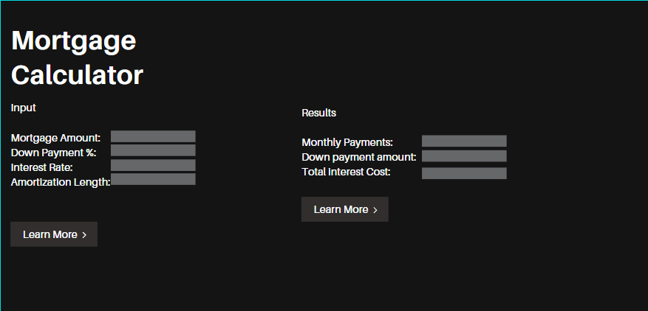
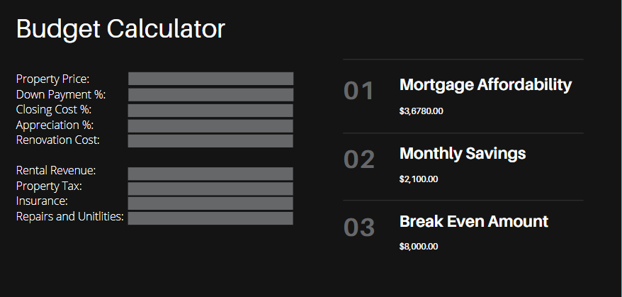
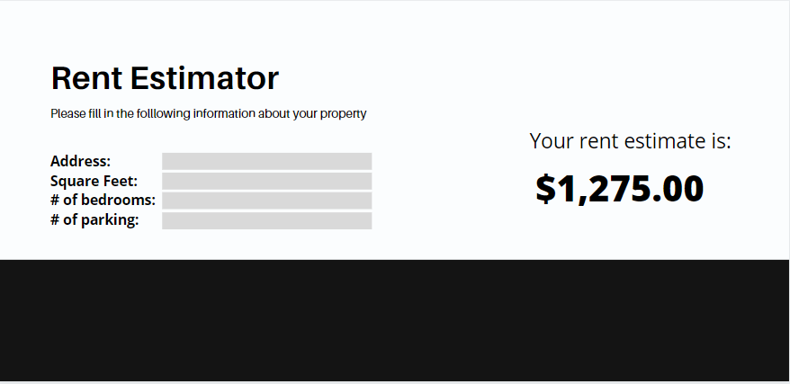

This is a rough estimate of how the website will look. Although it is a website I am aiming for a more app like look. To me it looks techier and cleaner.

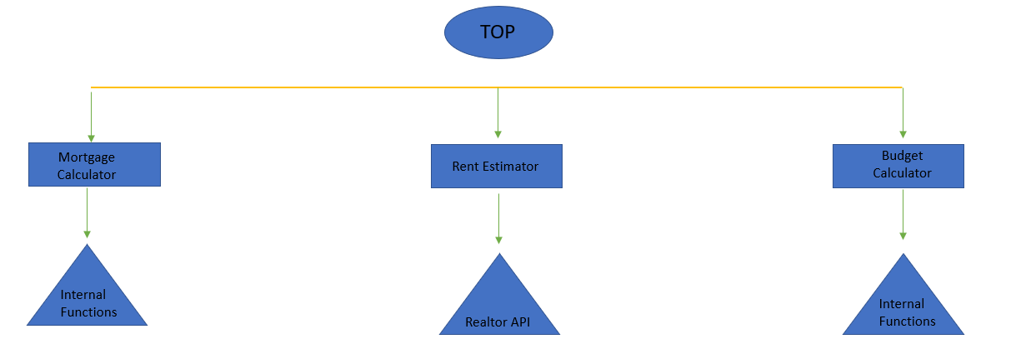

Citations:
1 Good person stock illustrations – 36,105 good person stock illustrations, Vectors & Clipart. Dreamstime. (n.d.). Retrieved October 15, 2021, from https://www.dreamstime.com/illustration/good-person.html.
2 HDClipartAll. (n.d.). Happy person clipart. HDClipartAll. Retrieved October 15, 2021, from
https://hdclipartall.com/img-4440.html.
3 Download woman standing clipart PNG - free PNG images. TopPNG. (n.d.). Retrieved October 15, 2021, from https://toppng.com/show_download/268178/woman-standing-clipart/large.

