PAUL-DANIEL PEDNEAULT
ppedneault1@athabasca.edu
Student id: 3510809

COMP 268 - Introduction to Computing Programming Java
PERSONAL NOTEBOOK
UNIT 0 TO 4

Athabasca University
Edmonton, 04/15/2022

COURSE MATERIAL FOR
UNIT 0 to 4 OF THE COURSE SYLLABUS

PRELIMINARY REMARKS - GAME PLAN
- I spent a fait amount of time thinking about how I will structure my work for the course.
- Starting this course, my only experience in "coding", at the exception of the basic work accomplished in the course COMPT 200 at Athabasca, dated back 1984 when my family got a TRS-1980 and I was coding (copying) program (games) codes in BASIC. All my professional life I has been a big user of computer as a "tool" in the sense of using efficiently computer to accomplish what I mean to accomplish using in an efficient way software with Graphic User Interface. I have no prior knowledge of "how" the computer, the program or the software works. I just called the helpdesk.
- I am starting by reading the whole course material for a superficial view of the content.
- Just finished reading the course manual.... Twice...
- I understand 20 percent of It.
- I started to watch on Youtube random short series of coding courses to get a sense of It before starting to work on the course content. I find the content of freeCodeCamp.org interesting and accessible to me at this point of time.
- Among many videos, I watched the complete course "Python for everybody" freely available on Youtube by "Dr Chuck" from Michigan State University. The course is about Python and was made available by freeCodeCamp.org on Youtube. The content is Python and can be seen irrelevant to a Java course, but I focused on the "steps" followed by the videos on how to learn coding, not the language. The debugging part was what gave me confidence of the process to learn coding... in any language.
- Before starting the course, I grabbed 5 randoms kid books about coding at the public library. I did the little coding projects in... Scratch... and minimal Python. That gave me confidence.
- Before starting, I decided to get another Java book as a companion for the course to get more examples and to get a paper copy. I got tired to read on the screen so many hours.
- I printed the whole course manual on paper. Easier for me to write on It. It is the way I am used to. I like the convenience provided by ebooks and editing capability of IT tools but somehow my brain likes traditional books.
- I checked online many recommendations for a companion book for the course to complement my readings. Up to now in my life the "Dummies" served me well every time I started to learn something new.
- I chose "Java - All-In-One for dummies" 6th Edition by Doug Lowe. It looks complete to me now and more "down to earth" that will help me complement the more CS approach of Professor Eck.
- I download many pdf books as well online about Java. Somehow, they appear to me to be pretty much all the same. My interest for those is to have as many examples as possible of codes when I got a part of the material that I have a hard time to understand. I know already after my superficial reading of the course material that I will have a hard time with OOP. The concepts don't come to me naturally for OOP.
- I am trying to put the course objectives in line with my personal objective of being Oracle Java Certified at the end of my two Java courses at Athabasca University.
- I want to get an appropriate toolkit to get start working as a Java coder thereafter.
- Reusability of the material I will produce is one of my concerns as well. Furthermore, I want somehow to document "how", from scratch, a mature learner can achieve what I am looking to accomplish. That can be useful over the road.
- I chose to go the "Chronological Notebook" way for my personal Notebook. That means, my Notebook will be "everything" I am doing for the course in chronological order. I will only segregate the parts related to the assignments as they cannot be put on the course landing and need to be submitted with my assignments. I will try to be consistent in the format and avoid reediting of my NOTEBOOK. However, I will review, updated content as I feel fit to do when needed. That imply that sometime the reader can see inconsistency in the time of verbs and editing in the text. Repetitions of content will happen as well. My NOTEBOOK being a "work in progress" not aiming to be published but "shared", weaknesses of that nature in the final version shared on the landing had to be expected.
- After reading the material for Unit 0, I started making skeletons of "wikipages" on the landing etc.
- My first idea was to make a bunch of wikipages that will be my personal "cheat cheats" after the course.
- I changed my mind and will publish on the landing my personal Notebook including everything on the landing after Unit 4 for the first part and after I completed the course material for the second part. Then I will have only the final assignment (project) and the final exam to think about.
- When I mention in general term the STANDARD in my NOTEBOOK, I means the Oracle Java specification document for Java which is available on the Oracle website. I guess that should be considered like the "Bible" of Java. I understand pretty much nothing of It starting this course. I will however read It daily until I got the whole document completely assimilated... some day.
- The structure of the course in my own view is in two parts. Unit 0 to 4 is one part, and the rest of the course is a second part (OOP).
- I will complete the course in the following sequence:
- Complete the course material covered in units 0 to 4.
- Assignment 1.
- Post my Notebook 0 - 4 on the landing.
- Complete the course material covered in Unit 5.
- Post my Notebook for Unit 5 and complete assignment 2.
- Complete the course material, Notebook and assignment 3.
- Final text-based game project.
- Final exam.
- For the first part, there are so many websites with examples It is easy to figure out examples. However, I will every time It will be suitable go to the Oracle website.
- Starting the course, I found Stackoverflow to be of low value for me. Updating my NOTEBOOK, I will say now that it is a good source, but somebody got know, with the right terms, what he is looking for. There are many misleading, incorrect content. Knowing little, it is hard to distinguish for a beginner. There are many "libraries" promotion etc... and class... etc... This apply to many other websites, GitHub being another example.
- My technic to learn is going from imperfect (general) knowledge to Deep knowledge. That will translate in me NOTEBOOK in a sequence like...
Draft - General Reading - Coding Exploration - Coding Rationalisation - Codes explanation.
- My interest in the course material is not only "coding" but "Computer Science" in general. It is why I will take time to define "concepts" and investigate "meanings" when I see fit.
- I will as much as possible go hands on and code the examples, or try self commissioned little codes. I will not finish them all every time.

PERSONAL REFERENCE SYSTEM IN MY NOTEBOOK
- I will TRY to be consistent with my concise reference system for future reusability of my NOTEBOOK.
- In general, I will use NameAuthor (page) for Eck and Lowe. For Other sources, I will TRY to give the complete reference. For website, I will just copy the link OR write, if It is for general ideas, "on such or suck website" if the reference is a "pointer" to further material. The objective here is to be able to "track" the source.
- I will takes liberality with the course manual when referring to it. For big chunk of text, I will TRY to do a complete reference. For small part, just the pages. I reserved myself the right to reedit chunk of the MANUAL text and put it in my textbook with only a pointer.
- I use some personal notation/abbreviations in my NOTEBOOK.
ex.: ATPIT: "At this point in time".
- I will TRY to put the meaning when it first shows up in the NOTEBOOK.
- I use latin words and locutions as well in their commonly accepted sense in scientific literature:
i.e.: id es
- A locution I use a lot is ceteris paribus meaning "All other things being equals". In the context of the course, it is a perfect expression in many situations.

CODING PRATICE
- I will try to make as much coding practice as possible as I am covering the course material. I will report and "snip" my codes and mistakes. Solutions found etc... Note that I don't mind looking "stupid" and won't reedit this content and my personal thoughts "at the moment" I have them. Future value of this NOTEBOOK is based in honesty on that matter. I don't mind looking stupid for a cause.

REMARKS ON TERMINOLOGY
- With respect with Dr Eck, there is a terminology inconsistency in the course material that made It harder to me to grasp some concepts.
- The most predominant Illustration of that fact is the use of "subroutine" method and Functions. In a context of Java, I will stick to method no matter what. When I quote the MANUAL, I will change systematically the other terms for method.
"As one final general note, you should be aware that subroutines in Java are often referred to as methods. Generally, the term “method” means a subroutine that is contained in a class or in an object. Since this is true of every subroutine in Java, every subroutine in Java is a method. The same is not true for other programming languages, and for the time being, I will prefer to use the more general term, “subroutine.” However, I should note that some people prefer to use the term “method” from the beginning." Eck (33)
- I choose the later view.

CODE EDITOR - JAVA VERSION - OS
- I reviewed different options for the code Editor I will use in the course and choose Notepad++ v8.2.1.
- I find it lean and simple (and I like the frog!).
- My OS is Windows 10 Home.
- I use version 15.0.1, Java (TM) SE Runtime Environment (build 15.0.1+9-18) and
Java HotSpot (TM) 64-Bit Server VM (build 15.0.1+9-18, mixed mode, sharing).

FIRST STEPS - TRYING THE SEQUENCE
- I will only use the Command Prompt to test my codes.
- For now, the Sequence is the following:
  - Write the codes in Notepad++
  - I save my work in the folder "My_Codes" which is on my desktop with the extension ".java"
- My work needs to be saved after each modification of codes. I need to be rigorous on that. Notebook++ shows a RED "save" icon when it is not saved... need to check that every time I test codes.
- In the Command Prompt, I make my way in the directories until the My_Codes is the active directory.
- I compile the saved .java file using the command javac NAME.java.
- A new file will appear within my active directory with the extension .class as in NAME.class
- To run my program there after the command is: java NAME.java.
- I figured out I can change the default folder for all the codes in Notepad++. Handy. The same is possible with the command prompt by adding a shortcut on my toolbar directly to my codes folder. Handy. Save a lot of time.

TEXTIO
- As per "Study Guide - Unit 2 - p.2" we won't use it in the course.
- When I gone be there in the course material, I will pause the material and work my way to understand Scanner class with my secondary personal learning material.
- As a practice, I will try to rewrite the codes of the MANUAL without TEXTIO when possible.

UNIT 1
- The whole content of this unit is a review of some COMP 200 material.
- Ma strategy for this unit is to add to my "CS Concepts et definitions" personal database.
- I will just complete the material I already have on the subject.
- Other reference to complement the topic I used in the part of the course:
Comptia A+ Certification - EXAM GUIDE - EXAMS 220-1001 & 220-1002 - TENTH EDITION, Mike Meyers, McGraw Hill Education, 2019. - (MEYERS)
Java All-In-One for dummies, Doug Lowe, 6th Edition, 2020
Wikipedia (Wiki) - Refers to the concept name page, if not otherwise stipulated.
- Some "redundant" definitions are left blank on purpose.

Syll | Page(2) | Concept | Abbreviation
1.1 | 1, 2 | Central Processing Unit | CPU | - Execute programs that are stored as a sequence of machine language instructions in main memory.  - When the CPU needs to access the program instruction or data in a particular location, it sends the address of that information as a signal to the memory and the memory responds by sending back the value contained in the specified location.  - The CPU can (also) store information in memory by specifying the information to be stored and the address of the location where it is to be stored.
 | 1 | Program |  | - List of unambiguous instructions meant to be followed mechanically by a computer.  - Application.
 | 2, 3, 7 | Machine language |  | - Very simple type of language.  - The only type of language a computer can understand without prior translation.  - Each type of computer has its own machine language.  - Computer can directly execute a program only if the program is expressed in that language.  - It can execute programs written in other languages if they are first translated into machine language.  - Binary.  - Each particular sequence of bits encodes some particular language machine instruction  - Memory language instruction generally consists of several bytes stored in consecutive memory locations.  - The memory address of the instruction is the first of those bytes.
 | 1 | Main Memory  Random Access Memory | RAM | - When the CPU executes a program, that program is stored in the computer's Main Memory.  - In addition to the program, memory can also hold data that is being used or processed by the program.  - Consists of a sequence of numbered locations.  - The sequence number of a location is called its address.  - "Memory that can be accessed at random - that is, memory that you can write to or read from without touching the preceding address. This term is often used to mean a computer's main memory." (MEYERS 1430)
 | 1 | Address |  | - Sequence number of a memory location.
 | 2 | Fetching |  | - Reading an instruction from memory.
 | 2 | Executing |  | - Carrying out an instruction fetched from memory.
 | 2 | Fetch-and-execute cycle |  | - Process of the CPU continually fetching an instruction from memory, execute it, execute it, fetch another instruction, execute it, and so on forever.  - With one exception, it is what the CPU ever does (simplify version of reality. <To be extended>)
 | 2 | Cores |  | - Processing unit of a CPU (Wiki).  - Multi-core processors (CPU) are CPU with multiple processing unit that can run (processing) instructions independently, concomitantly (Wiki).  - Multithreading
 | 2 | Cache  Memory cache |  | - Special area of RAM that stores the data most frequently accessed from the hard drive. (MEYER 1374)  - Hold data and instructions that the CPU is likely to need soon.
 | 2 | Arithmetic Logic Unit | ALU | - Part of the processor that carries out operations  - Holds a small number of registers
 | 2 | Registers |  | - Small memory units capable of holding a single number, data value immediately accessible for processing.  - Many machine language instructions refer to these registers.  - Storage area inside the CPU used by the onboard logic to perform calculations. CPUs have many registers to perform different functions. (MEYER 1431).
 | 2 | Special purpose registers |  | - Include in the CPU.  - The most important of the Special purpose registers is the program counter (PC).
 |  | Program counter | PC | - The CPU uses the PC to keep track of where it is in the program execution.  - The PC simply stores the memory address of the next instruction that the CPU should execute.  - During the course of the fetch-and-execute cycle, the number in the PC is updated to indicate the instruction that is to be executed in the next cycle.  - By defaults the execution is sequential  - Some machine language instruction can modify the value in the PC and alter the sequence of execution.
 | 2, 3 | Transistors |  | - Tiny switches that can be wired together in such a way that an output from one switch can turn another switch on or off.  - As a computer compute, these switches turn each other on or off in a pattern determined by the way they are wired together and by the program that the computer is executing.  - "On" = 1  - "Off" = 0
 | 2 | Binary number |  | - Made up of just two possible digits, zero and one.  - Each particular sequence of bits encodes some particular language machine instruction.  - Data manipulated by computer are encoded as binary numbers.
 | 2 | Bit |  | - Each zero or one of a binary number.
 | 2 | Bytes |  | - Sequence of 8 bits.  - In modern computers, each memory location holds a byte.
 | 3 | Memory address |  | - Memory language instruction generally consists of several bytes stored in consecutive memory locations.  - The memory address of the instruction is then first of those bytes.
1.2 | 3 | Hard drive/  Hard disk | HD | see(MEYERS)
 | 4 | Keyboard |  | see(MEYERS)
 |  | Mouse |  | see(MEYERS)
 |  | Monitor |  | see(MEYERS)
 |  | Printer |  | see(MEYERS)
 |  | Audio output device |  | see(MEYERS)
 |  | Network interface |  | see(MEYERS)
 |  | Scanner |  | see(MEYERS)
 |  | Digitizer |  | see(MEYERS)
 |  | Device driver |  | - Software that the CPU executes when it has to deal with the device.  - Enable communication between the CPU and the device.
 |  | Bus  plural : Busses |  | - Set of wires that carry various sorts of information between the devices connected to those wires.  - The wires carry data, addresses, and control signals.
 |  | Polling |  | - CPU checking for incoming data over and over.  - Whenever it finds data, it processes it.  - CPU polls the input devices continually to see whether they have any input data to report.  - Very simple process but inefficient.
 | 5 | Interrupts |  | - Most efficient alternative to Polling generally used  - Signal sent to the CPU by another device  - The CPU responds to an interrupt signal by putting aside whatever it is doing in order to respond to the interrupt. Once it has handled the interrupt, it returns to what it was doing before the interrupt occurred.  - CPU save enough information about what it was doing before receiving the interrupt to be able to return to the same state later.
 |  | Interrupt handler |  | - Predetermined memory location with instructions necessary to respond to the interrupt.  - The Interrupt handler is part of the device driver software for the particular device that signaled the interrupt.  - At the end of the interrupt handler there are instructions that tells the CPU to jump back to his previous save state, i.e., the state before the interrupts was received.
 | 5,6 | Asynchronous events |  | - Events that happen at unpredictable times  - Antonyms: Predetermined order, Synchronized, Chronological, Sequentially, Script.  - Programmers don't actually deal with interrupts directly, but they do often find themselves writing event handlers
 | 6 | Event handlers |  | - Like interrupt handlers, are called asynchronously when specific event occurs to modify the thread sequence execution.  - Event-driving programming vs strait-through, synchronous programming.
 |  | Multitasking |  | - Perform several tasks at once.  - All modern computers does Multitasking..
 |  | Timesharing |  | - When a computer (CPU) is used by several people at once.  - Application of multitasking consisting of switching attention from one user to another
 | 5, 6 | Thread |  | - Individual tasks that the CPU is working on.  - This content will be revisited later  - JAVA uses Threads.  - (Many) CPU can execute more than one thread simultaneously.  - In multi-cores CPU contain multiple cores each of which can run a thread.  - There are often more threads that can be executed simultaneously, mechanisms are in place to give to the CPU (and its different Cores) the ability to switch attention from one thread to another.  - Threads have become increasingly important as computers became more powerful and makes more use of multitasking and multiprocessing.  - Ability to work with threads is fast becoming an essential job skill for programmers.  - JAVA has good support for threads (***Chap 12)
 |  | Process |  | - Other name for Thread  <To be expended later>
 | 6 | Yield (Thread) |  | - Give another thread a chance to run.
 | 6 | Blocked (Thread) |  | - When the CPU (or a core) is waiting for some asynchronous event to occur to continue an ongoing thread.  - When the event that triggered the Blocked state occurs, an interrupt will wake up the thread so that it can continue running.
 | 6 | Preemptive multitasking |  | - Characteristic presents on most computer (CPU, Cores) that allow an ongoing thread to be stopped to allows another thread to run for a slice of time.  - A special timer device generates interrupts at regular intervals to switch from on thread to another.
 | 6 | Operating system | OS | - Basic essential software allowing the computer to run.  - Software that does all the interrupt handling, handles communication with the user and with hardware devices, and controls which thread is allowed to run.
1.3 | 7 | High-level programming language |  | - Cannot be run directly on any computer.  - Need to be translated into machine language to run.  - The translation is done either by a Compiler or an Interpreter.
 | 7 | Compiler |  | - Takes a high-level programming language program and translates it into an executable machine-language program.  - Once the translation is done, the machine-language program can by run any numbers of time, but only on the specific computer the translation was aiming to, since each computer (CPU) has his own individual machine-language.  - Compiling is the name of the action of translation as done by a compiler.  - The translation is done all in once.  - By analogy: Human translator translating a complete book from one language to another.
 |  | Interpreter |  | - Alternative means of translation to machine-language for high-level programming languages.  - Translates to machine-language instruction-by-instruction as necessary.  - Act much like a CPU with a kind of fetch-and-execute cycle running in a loop.  - By analogy: Human translator translating a speech as the speech is delivered by the speaker.
 | 7, 8 | Java Virtual Machine | JVM | - Virtual Computer that run the bytcodes, a specific machine language.  - Can run on ANY computer.  - Can run other languages given they are previously compiled in JAVA bytecodes.  https://en.wikipedia.org/wiki/List_of_JVM_languages
 | 7, 8 | JAVA bytcodes |  | - Intermediate language in which JAVA programs (Among others) are translated before being executed by the JVM.  - A program in bytcodes can be run on any computer provided that computer has a JAVA bytcodes Interpreter.  - Act as a buffer in the case of downloaded program increasing security because we are running the interpreter and not the codes per se.  - There is no necessary connection between JAVA and JAVA bytecodes.  - Java language could be compiled directly into machine language (specific).  - Any other language can be translated into JAVA bytecodes.  - Other languages using JAVA bytecodes:  https://en.wikipedia.org/wiki/Bytecode
 |  | JAVA bytcodes Interpreter |  | - An Interpreter for bytcodes for a specific computer.  - It enables the bytecodes to be run on a specific computer.  - A specific Interpreter for bytcodes is easier to code than completely adapt a JAVA program to a specific set of machine-language instructions.  - Relatively small and simple program; relatively easy to write an Interpreter for a new type of computer versus write a new compiler for the JAVA language for the same computer.
 |  | JAVA program running sequence |  | 1- JAVA program  2- Compiler  3- JAVA bytecodes Program  4- JAVA interpreter(Specific to OS/computer/CPU)
 |  | Just-in-time Compilers |  | - As it executes the program, it compiles the input, the bytecodes, into specific machine language, and execute the program increasing the execution speed
1.4 | 9 | Data
 |  | Variables |  | - Memory location (or several consecutive memory locations treated as a unit) that has been given a name so that it can be easily referred to and used in a program.  - It is the compiler responsibility to keep track of the memory location.
 |  | Types |  | - In JAVA variables has a type.  - Type indicates what sort of data a variable can hold.
 |  | Instructions
 | 10 | Control structures |  | - Special instructions that can change the flow of control
 |  | Method | (Subroutines) | - Instructions for performing some tasks, grouped together as a unit, and given a name.  - That name can then be used as a substitute for the whole set of instructions.  - Organizing a program into methods also helps organize the thinking and design effort.  - Once a method is written, it becomes a built-in part of the language that can be used.
 |  | Assignment statement |  | - "="
 |  | Input commands |  | - For getting data from the user or from files.
 |  | Output commands |  | - For sending data to displays devices or files.
 |  | Flow of control |  | - In the ordinary "flow of control" the computer executes the instruction in the sequence in which they occur in the program, one after the other.
 | 9, 10 | Loops |  | - Basic type of control structures.  - Allow a sequence of instructions to be repeated over and over.  - Used when the same task has to be performed more than once.
 | 10 | Branches |  | - Basic type of control structures.  - Allow the computer to decide between two or more different courses of action by testing conditions that occur as the program is running.
1.5 | 11,12 | Object-oriented Programming | OOP | - Approach to software engineering..  - The central concept of OOP is the object  - The approach starts by identifying  (1) the objects involved in a problem, and  (2) the messages that those objects should respond to.  - The program that results is a collection of objects, each with its own data and its own set of responsibilities.  - The objects interact by sending messages to each other.  - "People who use OOP would claim that OOP programs tend to be better models of the way the world itself works, and that they are therefore easier to write, understand and are more likely to be correct."
 | 12 | Object |  | - In OOP, "kind of module" containing data and methods.  - Self-sufficient entity that has an internal "state" (the data it contains) and that can (and know how to) respond to "messages" (i.e. calls to his methods).
 | 12 | Polymorphism |  | - Property of objects that is defined by the property that different objects can respond to the same message in different ways.
 | 11,12 | Software Engineering |  | - Discipline concerned with the construction of correct, working, well-written programs.  - Use of accepted and proven methods for analyzing the problem to be solved and thereafter designing a problem to solve that problem.
 |  | Structured programming | Top-down programming | - Software engineering methodology and approach to program design.  - Primary method in the 70s and 80s.  - To solve a large problem, break the problem into several pieces and work on each piece separately.  - To solve each piece, treat it as a new problem which can itself be broken down into smaller problems.  - Eventually , you will work your way down to problems that can be broken down into smaller problems that can be solved directly, without further decomposition.  - Valuable and often-used approach to problem solving  - Critics of the method consider it incomplete for the following reasons:  (1) T  It deals almost entirely with producing the instructions necessary to solve a problem.  (2) Doesn't give adequate consideration to the data that the program manipulates.  (3) Data structures for a program is at least as important as the design of the methods and control structures.  - Other critic of the method:  (1) It makes it difficult to reuse work done for other projects.  (2) Tends to produce a design that is unique to that problem.  (3) Consequently, reuse of large (expensive) chunks of programming from previous work is unlikely without extensive (expensive) modification.  - In practice, top-down design is often combined with "bottom-up design".
 |  | Data structure |  | see Wikipedia
 |  | bottom-up design |  | - Approach of program design that start at the bottom, with problems that you already know how to solve and for which we may already have a reusable software component available. - From there, we can work upward towards a solution to the overall problem.  NOTE: Reusable components should be as "modular" as possible.
 | 11, 12 | Module | Software module | - Reusable component.  - Component of a larger system that interacts with the rest of the system in a simple, well-defined, straightforward manner.  - The idea is that a module can be "plugged into" a system.  - One common format for software modules is to contain some data along with some sub-methods for manipulating that data.  - Data itself is often hidden inside the module.  - The program that use the module can then manipulate the data indirectly by calling the method provided by the module.  - This protects the data, since it can only be manipulated in known, well-defined ways.  - Makes it easier for programs to use the module, since they don't have to worry about the details of how the data is represented.  - Information about the representation of the data is hidden.
 |  | Information hiding |  | - Concept that the details of what goes on inside the module are not important to the system as a whole, as long as the module fulfills its assigned role correctly.  - One of the most important principles of software engineering.
 | * | Plug-in | plugin  add-in  addin  add-on addon | - Software component that adds a specific feature to an existing computer program.  - "When a program supports plug-ins, it enables customization." (WIKI)  https://en.wikipedia.org/wiki/Plug-in_(computing)
 |  | Class |  | - In JAVA, all objects belong to a class.  - Class is PRIMARY.  - A class is created and then one or more objects are created using that class as a template.  - Objects that contain the same type of data and that respond to the same messages in the same way belong to the same class.  - Objects can be similar without being in exactly the same class.  - Ultimate reusable component.  - Not only can class be reuses directly when they fit exactly into a program we are trying to write, but we can we can also defining subclasses with only the small changes necessary when appropriate taking advantages of the inheritance property.
 | 13 | Subclass |  | - A subclass of a class is said to inherit the properties of that class  - The subclass can add to its inheritance, and it can even "override" part of that inheritance by defining a different response to some message.  - Unit 5.
 | 13 | Inheritance |  | - Powerful means for organizing a program.  - Concept related to problem of reuse of software components
1.6 | 13, 14 | Command-line interface |  | ***aka. Command Prompt, Terminal
 | 14 | Graphical User Interface | GUI | - Interaction between the user and the computer using "interface components" on the screen.  - When a User interacts with GUI components "events" are generated.  - Each time an event is generated a message is sent to the program telling it that the event occurred, and the program responds according to its program.
 |  | Event handlers |  | - Tell the program how to respond to various types of events
 |  | interface components | GUI  components | Examples:  - windows  - scrollbar  - menus  - buttons  - icons  - Can vary little in appearances from one platform to another but the functionality should be identical on any platform on which the program runs.  - JAVA has three common sets of GUI components:  (1) AWT  (2) Swing  (3) JavaFX  - JAVA GIU components are implemented as objects  - JAVA includes many predefined classes (and subclasses) that represent various types of GUI components.
 |  | Abstract Windowing Toolkit | AWT | - Set of JAVA GUI components  - No longer the standard
 |  | Swing |  | - Set of JAVA GUI components  - No longer the standard
 |  | JavaFX |  | - Set of JAVA GUI components  - Current standard  - More modern  ***See Java all-in-one  ***To learn after the course
1.7 | 15 | Networks
 |  | Internet
 |  | Communication protocols |  | - Detailed specification of how communication is to proceed.
 |  | Transmission Control Protocol/Internet protocol | TCP/IP | see MEYER
 | 16 | Packets |  | - Some data being sent from one computer to another, along with addressing information that indicates data being sent from one computer to another, along with addressing information that indicates where on the internet the data is supposed to go.  - Can hold only a certain amount of data.  - Longer messages must be divided among several packets.
 |  | IP address |  | - Identifier over the Internet
 |  | Domain name |  | see MEYER
 |  | Simple Mail Transfert Protocol | SMTP | see MEYER
 |  | World Wide Web | WWW | see MEYER
 |  | Pages |  | see MEYER
 |  | Links |  | see MEYER
 |  | Web server |  | see MEYER
 |  | Web browser |  | see MEYER
 |  | HyperText Transfer Protocol | HTTP | see MEYER
 | 17 | Applets |  | - Fallen out of use.  - (Was) Small program that is transmitted over the internet and that runs on a web page.  - Made it possible for a web page to perform complex tasks and have a complex interaction with the user.  -*** See wikipedia

UNIT 2
- The first part of Unit 2 is mostly concepts.
- I will use the same strategy as in Unit 1.
- NOTE: < > To be review before adding to my database.
2 | 19 | Script |  | < >  wikipedia
 |  | Coding |  | - Filling in the details of that design.  - Explicit step-by-step instructions for performing fairly small-scale tasks.  - Details.  - Close to the machine.
 |  | Overall program structure |  | < >  wikipedia
2.1 |  | Program |  | - Sequence of instructions that a computer can execute to perform some task.
 |  | Programming language |  | - Differ from ordinary human languages in being completely unambiguous and very strict about what is and is not allowed in a program.
 | 19, 20 | Syntax |  | - Rules that determine what is allowed are called the syntax of the language
 | 19, 20 | Syntax rules (of the programming language) |  | - Specify the basic vocabulary of the language and how programs can be constructed.
 | 20 | Syntactically correct program |  | - Program that can be successfully compiled (or interpreted).  - Programs with syntax errors will be rejected with or without a message error.
 |  | Semantics |  | - Meaning of the program.  - Program that produce the expected and correct result.
 |  | Semantics of a programming language |  | - Set of rules that determine the meaning of a program written in that language.  - A semantically correct program is one that does what you want it to.
 |  | Pragmatics | Style | - Good style for a program means it is written in a way that will make it easy for people to read and to understand.  - It follows conventions that will be familiar to other programmers.  - Overall design that will make sense to human readers.  - Use the language features well.
 | 21 | Subroutine call statement |  | < >  wikipedia
 |  | Subroutine |  | - Instructions for performing some tasks, chunked together and given a name.  - That name can be used to "call" the subroutine whenever that task needs to be performed.
 |  | Built-in subroutine |  | - Subroutine that is already defined as part of the language and therefore automatically for use in any program.  *** Need to be available  *** Library  *** < >
 |  | Comments |  | - Comments in a program are entirely ignored by the computer.  - They are there for human readers only.
 |  | Javadocs and Comments |  | *** Separate Document generation  - HTML  - Some "tools" to extract those comments.  Wikipedia
 |  | Packages |  | - Group of classes.
2.2 | 23 | Names |  | - Fundamental to programming.  - In programs, names are used to refer to many different sorts of things.  - see STANDARD  - see "Literals"  - ***See "Syntax and the semantics of names in JAVA" article online.
 |  | Identifiers |  | - In the syntax rules of JAVA , the most basic names are identifiers.  - Identifiers can be used to name classes, variables and methods.  ***See Syntax and the semantics of names in  - 3.8 Identifiers p.42 STANDARD
 |  | Camel Case |  | < >
 |  | Variable |  | - In a high-level language such as Java, "names" are used instead of numbers to refer to data.  - It is the job of the computer to keep track of where in memory the data is actually stored; the programmer only has to remember the name.  - A "name" used in this way - to refer to data stored in memory is called a "variable".  -A "variable" is not a "name" for the data itself but for a location in memory that can hold data.  - Container or box that store data so we can use it later.  - The variable refers directly to the box and only indirectly to the data in the box.  - Since the data in the box can change, a variable can refer to different data values at different times during the execution of the program, but it always refers to the same box.  - Confusion can arise because when a variable is used in a program in certain ways, it refers to the container, but when it is used in other ways, it refers to the data in the container.

HANDS-ON CODING AND PRACTICE
- Time to start doing some codes.
- REMEMBER: The "HANDS-ON CODING AND PRACTICE" of my PERSONAL NOTEBOOK are not aimed to be "published" in the strict sense and therefore will be edited in a minimalistic way.
- "Repeat makes good"!
- I will not try to avoid repetition within the document as a whole - If I repeat explanations is because the specific context it happens makes me understand better. That's the only thing that matter!
- If I don't understand every component in a specific code, ... don't matter! I will someday...
- The "explanations" of the codes within my diary are a way to test my understanding. I explain the code to myself.
- When a concept will be assimilated, I will drop It along the way and substitute it by new ones related to the current state of my journey and where I am in the course material. (That's the plan... will see how it goes...).
- I will do all the long codes of the manual within the course syllabus using Notepad++ as Editor and command lines as previously stated.
- When appropriate in short lines of code experiences I will use JSHELL in the command line environment to avoid using a class and a main method. UPDATE Nope!!! I try it many times and the time to learn how to use it appropriately... second... online versions are sometime unreliable... test different sites... a lot of BAD outputs... will post on the landing about it...
- I will add some codes from other sources when a part of the course material still unclear after going through the course material.
- Those codes are from my secondary sources as well as the web. I will provide references.

- (Still looking online for the first code I made in my life... "Hamsters" in BASIC for TRS-80 1984...the original code... unsuccessful to this day...).

HelloWorld.java
- Eck (21)
Codes as follow (My Editor is Notepad++):
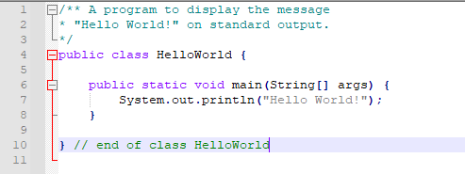
- I save the codes as "HelloWorld"
HelloWorld.java
- Codes Editor asked me for an extension for the file.
- I put ".java" as it is the extension for a Java source file.
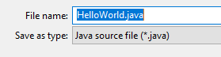
- Save in my folder My_Codes.
- Now I got a HelloWorld.java file in my folder.
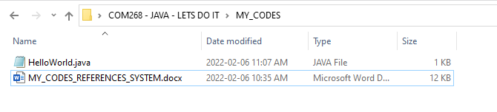
- I open Command Prompt and make my way with the "cd" command to the directory (folder) MY_CODES
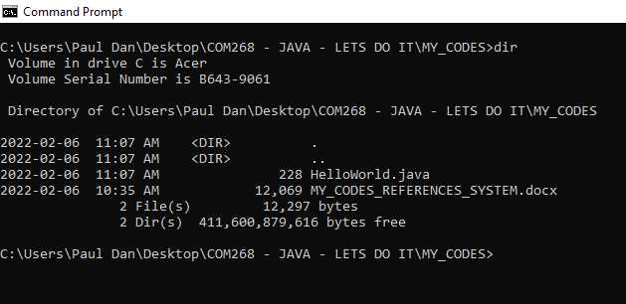
- Compilation of the file.
- I use javac HelloWorld
- I got the following:
- I check on internet - extension ".java" i.e. the complete file name is required to compile the file.
- I will add the error message and the fix to my "Errors" document.
- Compilation of the file:
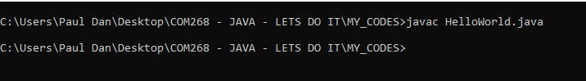
- I got no message.
- Now I got the new file in my directory "HelloWorld.class":
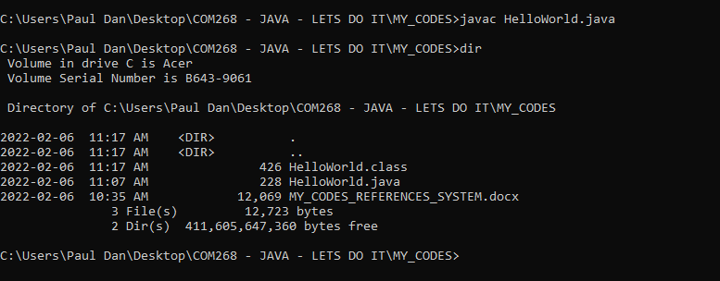
- The extention of the file is ".class".
- Quick check at wikipedia.
https://en.wikipedia.org/wiki/Java_class_file
- The .class is the codes compiled in Java Bytecode.
- This code will be the one used by the JVM at the next step at runtime.
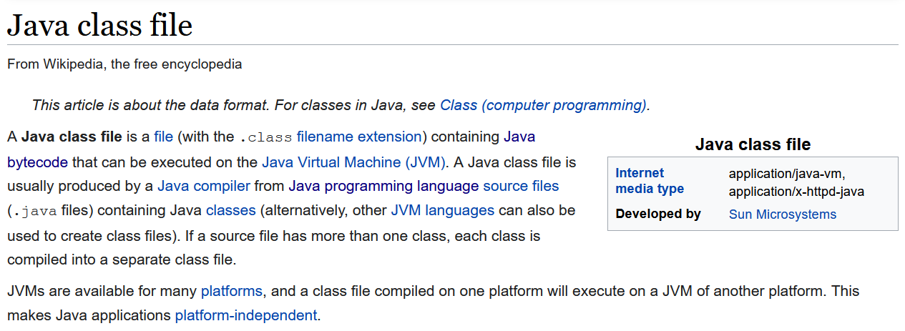
- CLS command to be added to Command Prompt (Windows) Document.
- To run the program java HelloWorld.
- Work.
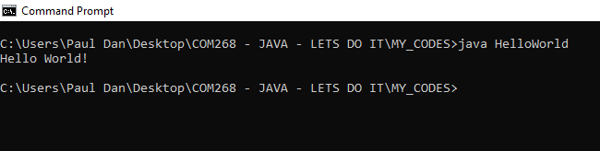
- Why the file extension of the compiled program (in bytecodes) ".class" is not required for running the program but was required to compile the program?
- I am curious to see what bytecodes looks like.
- I will try to open the .class file in Notepad.
- I got:
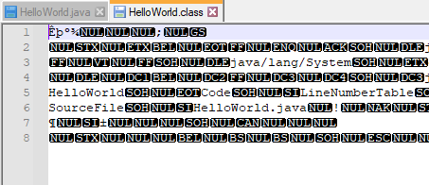
- I suppose this is bytecodes.
- Fast research over the net doesn't tell me if Its bytecodes.
- Nope. looked online again... Bytecode can be read with an extension or a reader...\
- Will play with that later...
- I want to test the relation between the name of the source file in relation to the program.
- I make a copy of the source code under the name Test.java without changing the code in the same MY_CODE directory.
- javac Test.java
- I got:
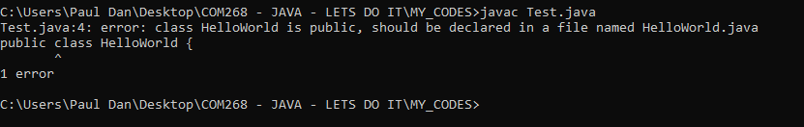
- Report the Error and explanation in Document.
- The file name NEEDS to match the class name.
*- There is only one class in the program. Test later if with a program with many classes.
- My assumption is that the file name needs to match the main class name (TBC). Will see...
- I changed the name of the class to Test, changed nothing else in the codes, save.
- My new codes:
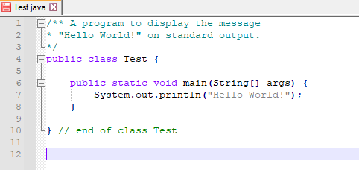
- Compilation:
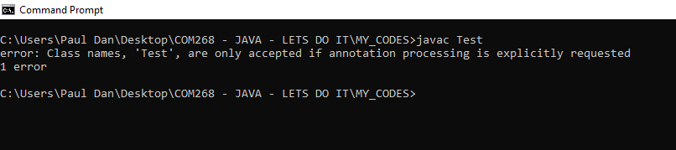
- I guess "Test" is somehow reserved by the compiler.
- I Change Mention of "test" in the codes and the file name to "Clown".
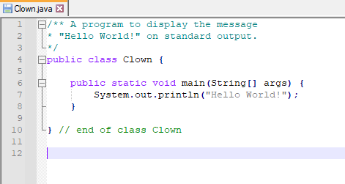

- Compile and try running it.
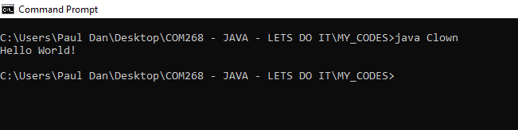
- It works.
- Need to match name and class name (Main TBC).

interestFirstVersion.java
- Eck (28)
interestFirstVersion.java
- The name of the file and my name as plain text in comments as header.
- Later on, I will put the appropriately format: author, version etc. to fulfill course requirement as in the demo codes available in the course documentation.
Code:

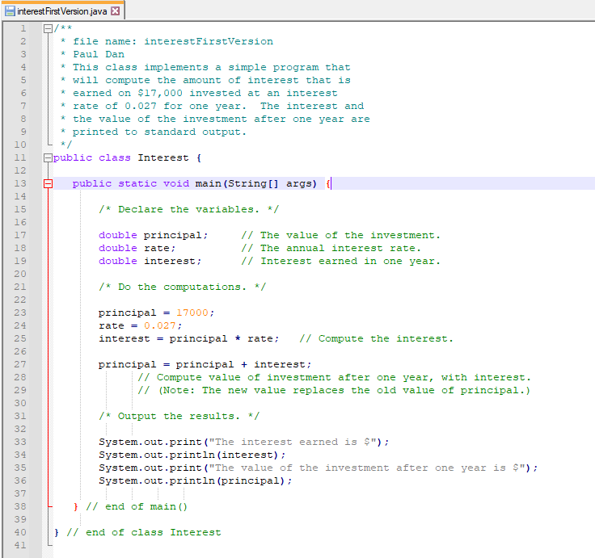

- I like the way Notepad++ make use of colors for the codes underlying logic.
- Matching braces with matching color make the codes easy to understand.
- The simplicity and efficiency of the Notepad++ is more "intuitive" than expected.
- No input from user, so the code is a one-trick-pony.
- For other inputs I would need to change the codes, compile, and then run for each set of numbers I would like to use the code.
- Comments are used as descriptive header in javadoc format with /** <comment> */.
- Regular comments are with "//" to describe the variables and "/*" "*/" (javadoc) for the tree blocks of codes "Declare the variables", "Do the computations" and "Output the results".
- Use of the word "block" in this context - Reverify with "concepts" personal document.
- Program got only one class "Interest".
- "I" in "Interest" is capitalised as it is required for class name as good practice.
- Program got only one method, the main method:
public static void main(String[] args) {
- The main is nested within the class.
- Indentation (note required per se for the codes to run) shows general structure.
- Nested characteristic of those braces, as there are "matching" braces (2 matching sets, one set for the class and one set for the main method).
- For the block "Declare the variables", we have three variables that are declared:
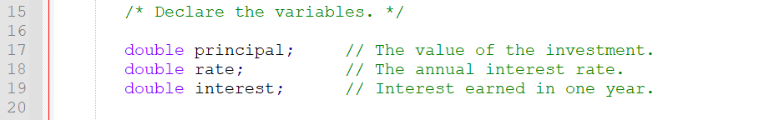
- Local variables to the main method.
- ln15 is a javadoc (block name?)
- ln17, 18 and 19 are the declarations
- variable declaration use the following syntax:
<type-name> <variable-name-or-names>;
- "double" is the <type-name>, the same for the three of them.
- "double" type is 64 bits 15 significant digits floating-point value type.
- "principal", "rate" and "interest" are the respective <variable-name>.
- Each declaration finish with ";".
- The block "Do the computation" assign values to the previously declared variables.
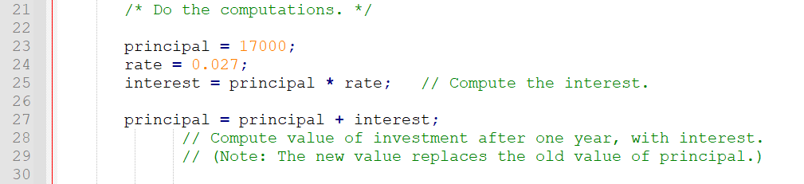
- The Syntax structure - assignment statement:
<variable> = <expression>;
- The <variable> is the variable name.
- <expression> is the value.
- The value type needs to match the type of the corresponding <variable-name> in the value declaration in the previous block.
- ";"
- ln 25 is the line that compute the value of "interest";
- "*" is the multiplication operator in JAVA.
- see JAVA operators in LOWE.
- ln 25 take the value contain in the memory location called "principal", value assigned to principal is 17000; we placed that value in "principal" in ln 23 AND takes the value contain in the memory location called "rate", value assigned to "rate" is 0.27; we placed that value in "rate" in ln 24 AND MULTIPLY THEM ; the value provided by performing the operation is then store in the location named "interest".
- The "=" is NOT the same as in mathematics; it is the assignment operator LOWE.
- ln 27 is the line that compute the value (output).
- ln 26 is left blank for the purpose of making the codes more readable.
- Ln 27 works the same way as ln 25 cetirus paribus.
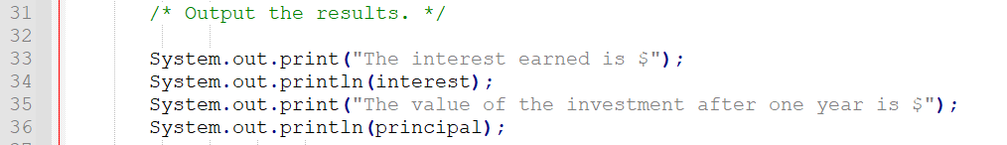

- That block is easy to understand.
- Note the use of " " for the output of the method.
- New text is between ".
- Value that have a literal under a name doesn't need It.
TEST the code:
- I got an error
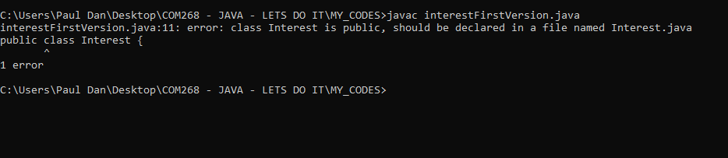
- Same as experienced before: my Class name and my file name doesn't match!
- I typed my codes to get a feel of It and modify them to make them more fit.
- I will need to pay more attention to the matching when modifying the files name to match my futures needs.
- I fix the codes lines 11 and 40, saved, and try again.
Code:
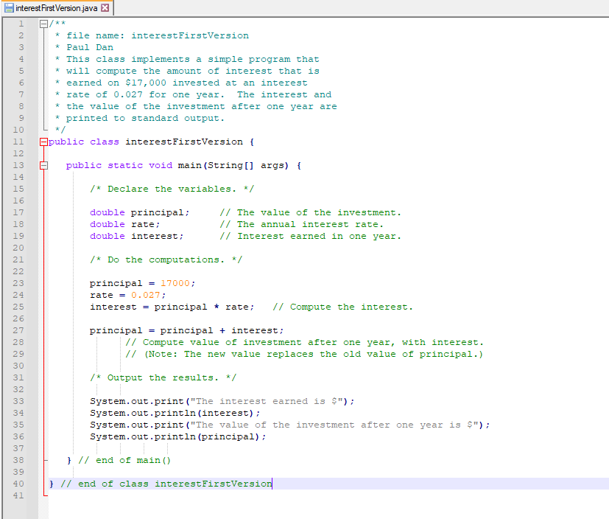
- Then:
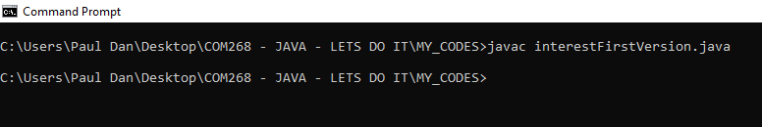
- Now I got my interestFirstVersion.class in my directory.
- I got a "*.java.bak" as well... (Investigate that, no clue why).

- Runtime:
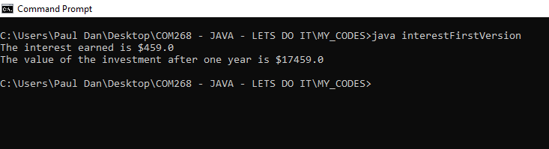
- It works as expected.
- Format of the output (one digit after the dot) could be better.
- Information (between braces) provided to methods allowing them to perform their tasks is called "parameter".
" A parameter provides a subroutine with information it needs to perform its task. In a subroutine call statement, any parameters are listed in parentheses after the subroutine name. Not all subroutines have parameters. If there are no parameters in a subroutine call statement, the subroutine name must be followed by an empty pair of parentheses." Eck (29)
- That supplement my taught about "" and () in the code.

Timed Computation Exercise
Eck (32).
- I commented the code.
- I made more comments than good coding style would call for as a learning technic.
- I change the class name and the .java file name to TimedComputationExercise.
- Because there is only one class, I can compile and run the program in command prompt in one step just by doing:
java TimedComputationExercise.java.
- "If a .java file contains just a single class (...) you can skip the javac command altogether. The "java" command can both compile and run a .java file that contain a single class." LOWE (25)
- see "Java's Comment-Line Tools" and "Java compiler options" LOWE (25-30).
- "javap" command - Makes further reading and research when got time.
- I changed the indentation to reflect the fact that the mathematical functions are embedded within the compTime function - make more logical sense to me since compTime start before the others functions and then get finished at the end.
- There is no Input from user - values remain the same if not changed within the code.
- Save, compile, and run.
Codes as follow:
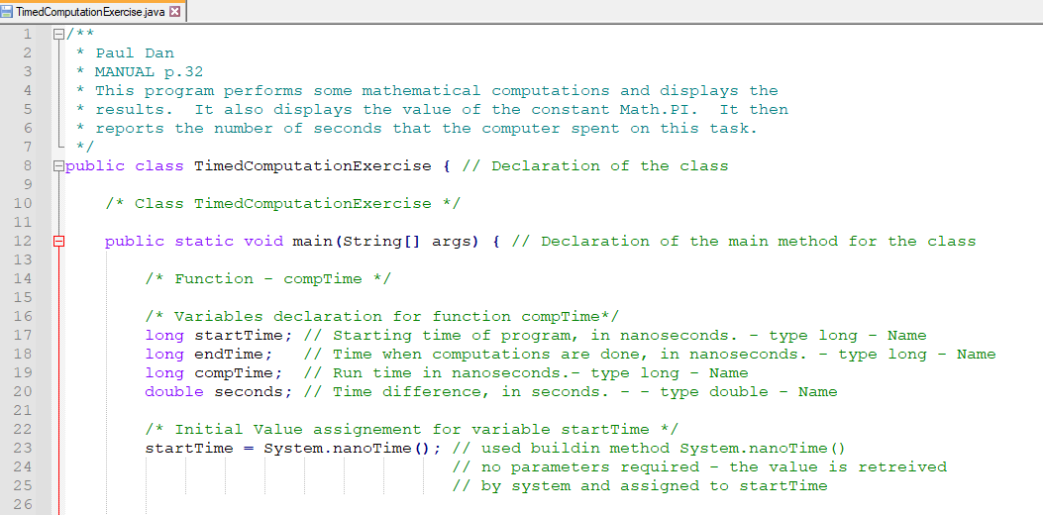
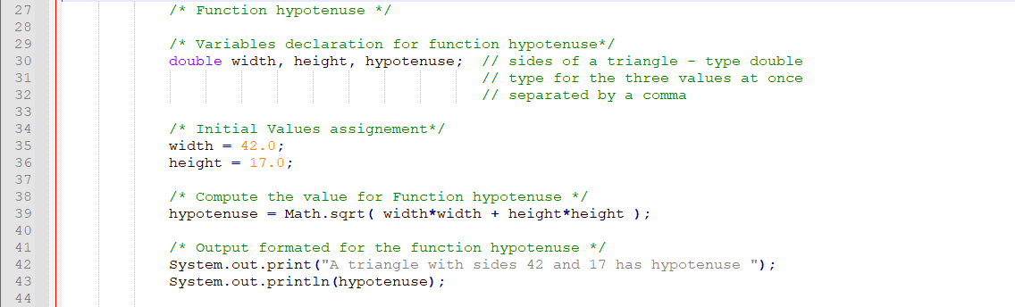
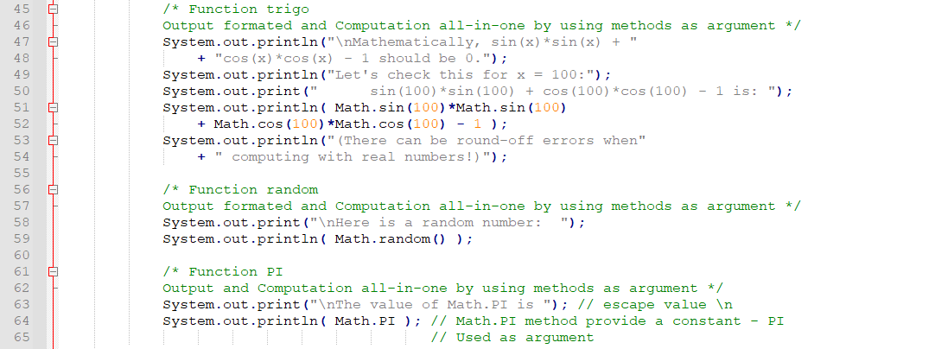
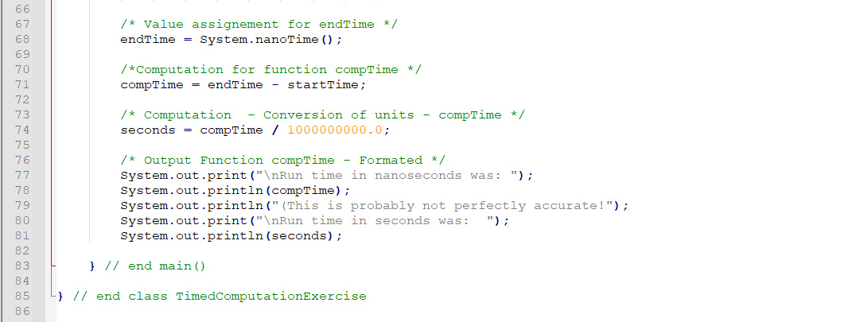

Compilation and runtime:
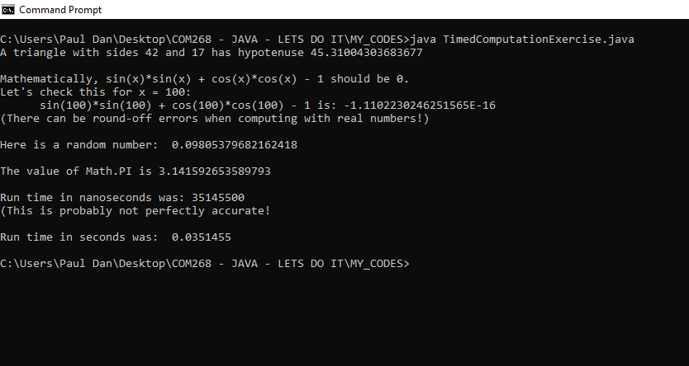

- All worked as expected.
- NOTE: No file .class was created or at least no .class file was saved in my active folder by using "java fileName.java" with a nameFile.java containing only one class.
- I think that way creates the java bytecodes every time at runtime and don't save it. Will check on that.

UNIT 2 (suite)
COMMAND PROMPT:
- I would like to be able in Command Prompt to go directly to the appropriate directory with a shortcut from the code editor...
- After a little bit of research online, I figured out that what I want to accomplish is an "Alias for a long path"...
- Come back to it later - I don't understand...

SCANNER CLASS FOR INPUT:
- Course manual not enough.
- Will make test and exercises from my secondary sources.
- I already read enough material to be able to deal with It and the exceptions online.
- I will not use TEXTIO at all - When input is required in the codes from the MANUAL I will modify the codes accordingly - that will be a good exercise.
- I really don't see the use and interest of TEXTIO.

HANDS-ON CODING AND PRACTICE
- Found the original code online.
https://www.edureka.co/blog/scanner-class-in-java/
My code:
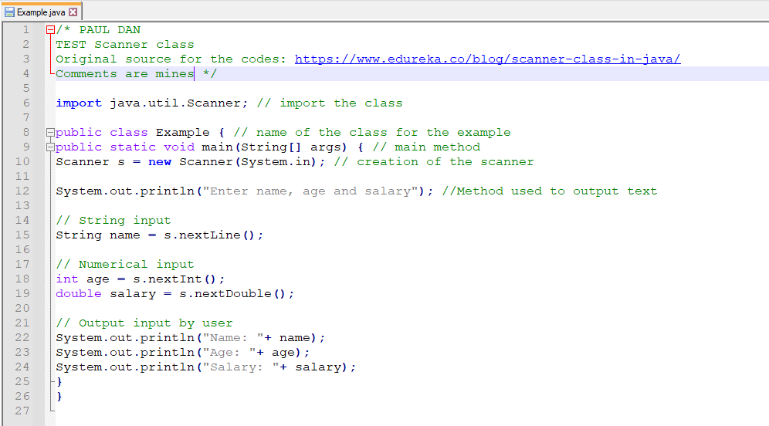
Runtime:
- Don't work the first time.
- I don't know why.
- I compiled with javac, then try with java name.java - don't work.
- .class file created.
- I try after java name.java and It works.

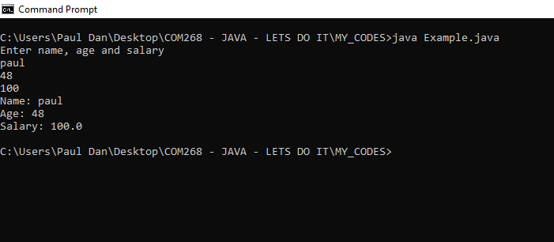
- From an interface point of view I had to run It 2-3 times before understanding I had to press enter for every parts of the user Input.
- I modified the text of line 12

- Exceptions handling is a topic I will need to cover.
- Should rework the code and test the code again and do mistakes of the input type and use "catch".

UNIT 2 (suite)
2.3 Operations on Strings
- The following methods to perform operations on strings are described in the MANUAL pp. 34-36:
.length()
.equals()
.equalsIgnoreCase()
.charAt()
.substring()
.indexOf()
.compareTo()
.compareToIgnoreCase()
.toUpperCase()
.toLowerCase()
.trim()
- The summary description of those methods can be found on the Oracle website and within the STANDARD.
- I will code a program that makes use of all of them as an exercise

HANDS-ON CODING AND PRACTICE
- I coded for too long before testing; had to comment out all the codes and go one method block at the time thereafter until completion.
- This is the not exhaustive list of errors I got before make the codes works as intended:
/* Method - ".length" */
- .length - English not being my mother language, I inversed many times in the codes the "t" and "h"; I will need to pay attention.
- I missed ";"
- At first, I used "uppercase" for my variable names; this is incorrect from a stylistic point of view; I changed them to lowercase.
- On top of that, I had A LOT of error because of inconsistency with capital letter usage (I got no previous experience in visual basic, the source of "natural" tendencies on that matter are from my daily usage of other languages than English and the associated grammar rules; I REALLY NEED TO PAY ATTENTION TO THAT TO AVOID INSANITY.
- I tried to concatenate for the print output but didn't work; I had to first declare a variable name with appropriate type, then assign a value (computed with the method) to a second value and use that second value in my output block.
- ATPIT this is the only way I know but I am pretty sure there is another way. For now, I will just make It work.
- My variable declaration used the wrong type at the beginning: length is int type; At the beginning I declared it as String; type cast will be used in the future but I will keep it simple and stupid for now; need to learn to walk before running.

/* Output - method ".equals()" */
- I adjusted according to the errors from the fist method test block.
- It works the first time.

/* Method - ".equalsIgnoreCase()" */
- NOTE: I just add new variables declaration as I go when needed to test the method.
- The "local" variables" (already declared within the "main" method) for previous method test are ALWAYS available within the main method. Therefore, I just declare new variables as needed to follow the purpose of testing.
- I would make two versions of my codes if I got time.
- One with ALL the variables declared at the beginning and one with the variables declared as the codes goes.
- While coding It is easier to declare them as I go but maybe the result will be harder to read (or the reverse).
- Cut and paste works in Notepad++.
- In Notepad++ when I select a literal anywhere in the codes the other occurrences of the literal highlight in the same time telling me where they are; that's a good features; can modify them all in once if I want to.

/* Method - ".charAt()" */
My preliminary code for that section was the following:
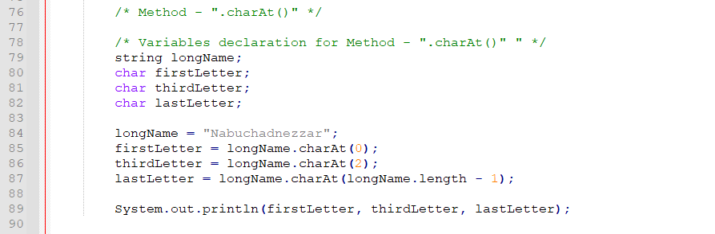
I got the following error at compilation/runtime:
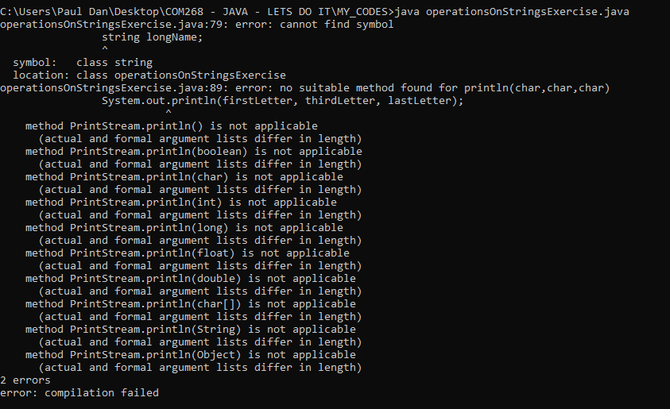
- I checked on stackoverflow.com.
- Few answers tell that to print a char I need to convert It first to a string in that context.
- The java method to do so is .toString
System.out.println(firstLetter.toString() + thirdLetter.toString() + lastLetter.toString() );
- My confusion was that the argument of the method is type int but the output is type char
- I was wrong.
- I got the following error:
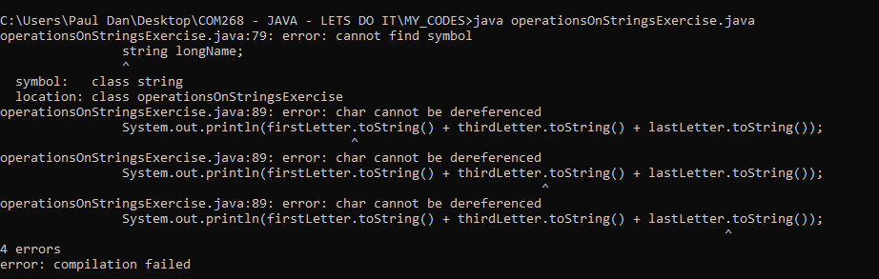
- I will keep it simple for now - Its above my knowledge ITPIT.
- All time remember that "String" is a class and takes a capital letter, if not you get:
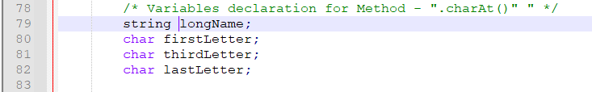
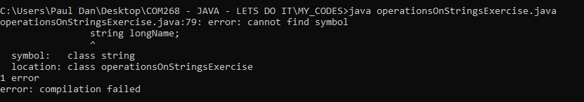
- The little ˆ point exactly where the mistake was.**
- Now I'm wondering if the other error was due to the "s".
- I clear the comment out and retry.
- now I got:
- Error:
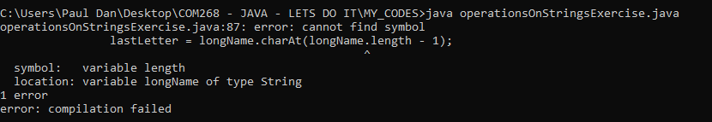
- I look at Oracle and the STANDARD.
- I cannot use a method with a specified type with a variable of another type - that strongly type characteristic of JAVA now appear more real than before - .
- I simplify my code to make it work - It is just a personal exercise - I can expand It later.
- My final code for the section is:
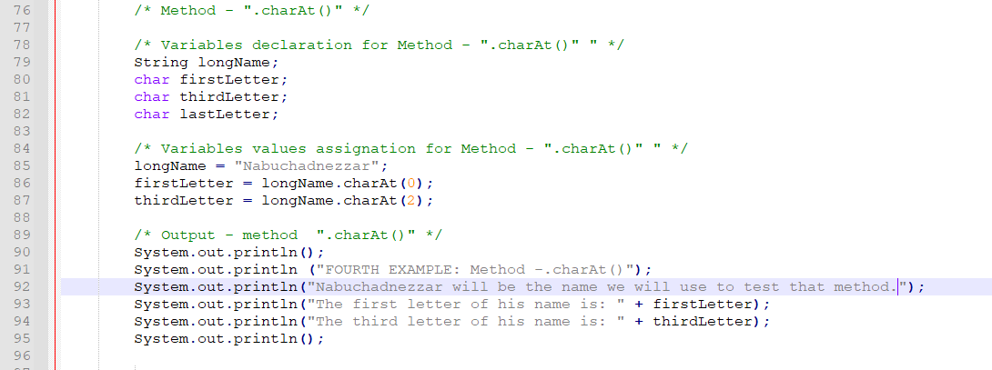
- My output is:
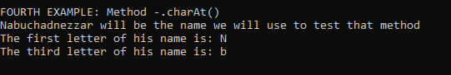

/* Method - ".substring()" */
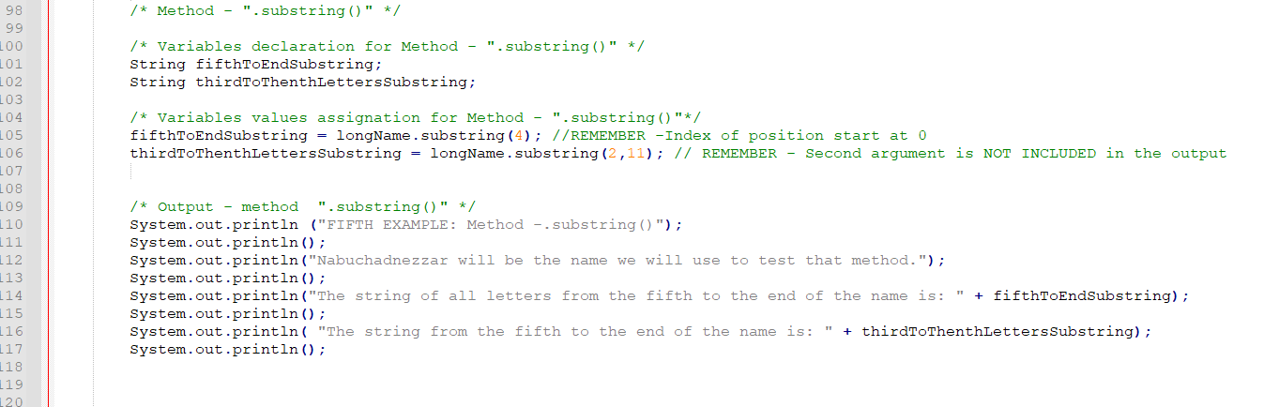
- Code worked as expected.

/* Method - ".indexOf() AND .lastIndexOf()" */
- For that function the return value is of type integer.
- Be cautious of "Off by one" error because count start at 0 as seen previously in other methods.
- "+ 1" added to certain assignment, they are int type and the output is int type, so no type conversion would be required.
- I will use that in this block to get the real number without just put the number readjusted according to my aim in the code.
That's give me the following block:
- I got plenty of errors, among them:
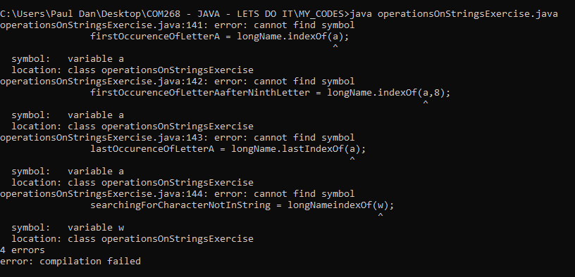
- I will declare values and type in the code to "a" and "w" to see if it works.
- My first idea was that those are automatically having a type of char... maybe some packages need to be imported... don't know at this point...
- Ha! I forget that I was doing operation on STRING... therefore I need to declare AND a value to String a and String w to make it work!
- Code block:

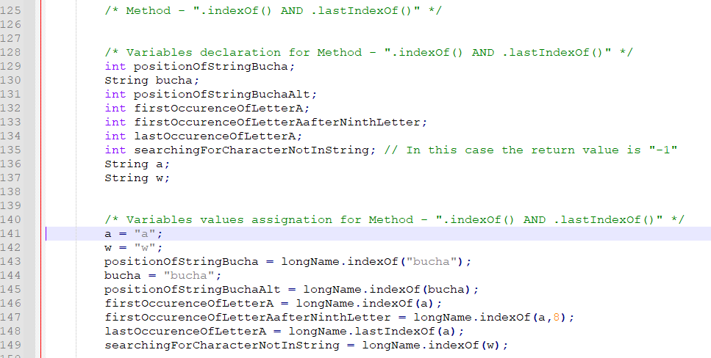
- Now I just need to edit the text to make a nice output and that block is complete. Without the wording I got the appropriate raw output.
-"concatenation" - It's a simple concept to grasp but I got error all the time; need to write all the exceptions and the "tricks" with type and type casting... when I got time.
- I find the return value for the line:
searchingForCharacterNotInString = longName.indexOf(w);
of "-1" not really meaningful.
- I will add if/else statement to convert it to "True" if the value is NOT in the string and makes the adjustments ceteris paribus to the output text in the code.
- My idea was:
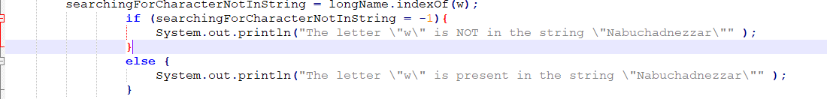
- Again, I am confused with the types.
- I get that error:
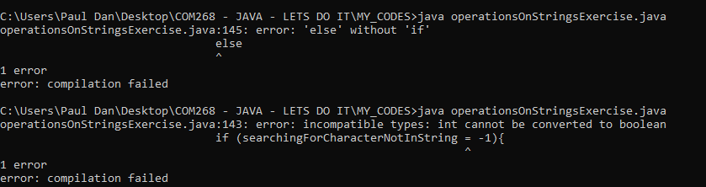
- First time I forgot the braces for the "if/else" statement - That's ok now.
- Second, the line
is wrong because the value and the output value of the method is not the same.
- It's boolean.
- I made the following changes:
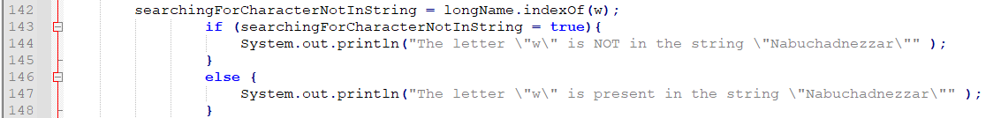
- Not working.

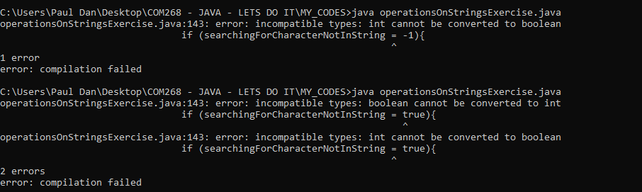
- "boolean cannot be converted to int".
- I will add a new boolean variable and try to solve my problem in two steps.
- I had It but it was useless.
- I just need to put an operator < 0 in my if statement.
- Code block before I made the changes:

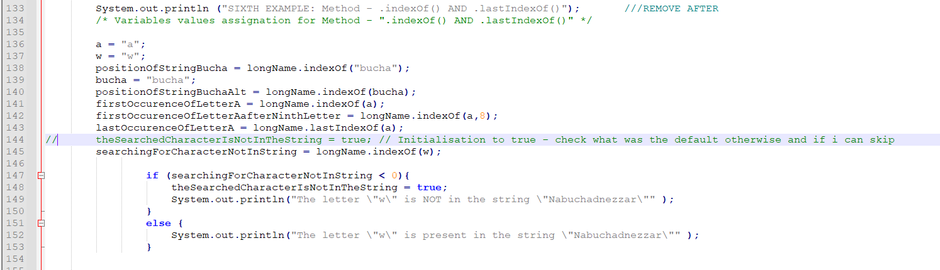
- New code block:
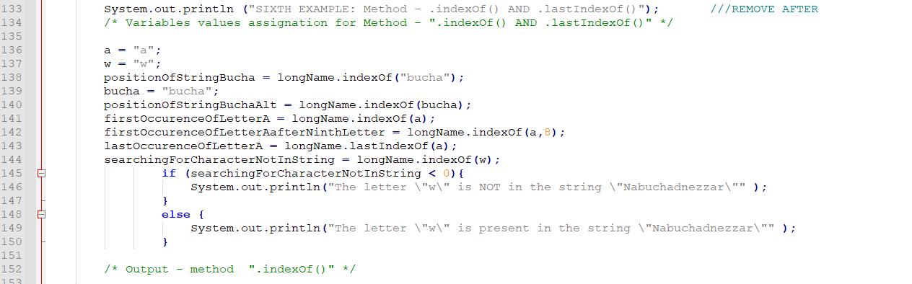
- I will move around the components to keep the same formatting as the other blocks.
- Final code for the block is:
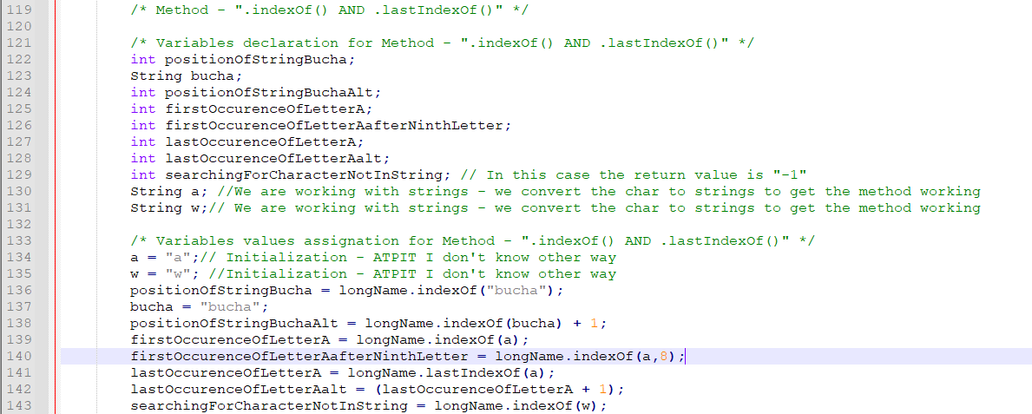
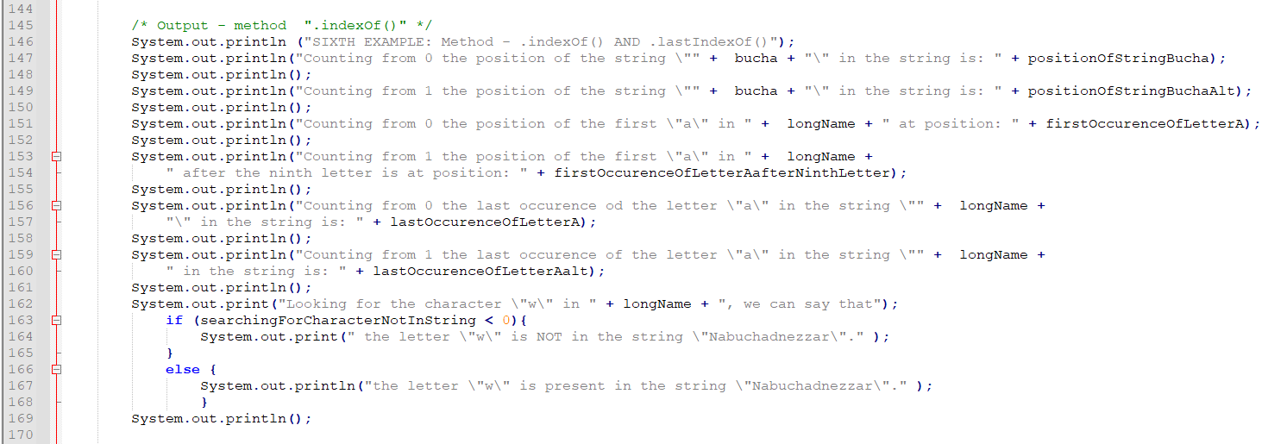
/* Method - ".toUpperCase()" */
- I will output the result.
- I will make a print statement to show that the value is unchanged.
- All work as expected.
/* Method - ".toLowerCase()" */
- I will output the result.
- I will make a print statement to show that the value is unchanged.
- All work as expected.

/* Method - ".compareToIgnoreCase()"*/
- I will only create a new string variable called "mottoAllUpper" and assign the value motto.toUpperCase() to it.
- All work as expected.

/* Method - ".trim()" */
- All work as expected.

Finetuning and editing:
- I am adding print output for each method describing the method so the output will be more descriptive.
- I could add avoid values assignments there and there and use the method directly.
- That would have shortened my code a lot BUT short code was not my objective - practice was.
- I am changing the order of the methods examples to have .toLowerCase() and .toUpperCase() method together.
- I am adding the javadoc that I know for now - will get back to It later.
- Compare to the example in the course materiel my code is missing most of the javadoc.
- I will need to find other specific secondary sources for javadoc to get a complete overview and be able to satisfy the expected assignment requirements.
- I am adding at the end of the code the "expected output".
- That was a long code, but I make less common mistakes at the end of the process.
- I will post the code on the landing and ask for comment to improve It while remaining in the scope.
- I was looking to do a similar exercise with the Math methods but I don't think It will be necessary given the fact that is mostly what is required for assig.1, therefore I will skip It and concentrate on my next coding exercise which is to build a deck of card with ENUM in two versions (1) in a program (2)with external file.
- ATPIT I plan to reuse my deck of cards for the final assignment in a way or other if it makes sense.
- I had few more information in the header.
- I mad Output Editing to make it look nicer.
After code taught:
- It takes far more time to do than expected.
- Escape characters could be used to avoid numbers of blank lines code that I used to make the output looks nice; I will keep that in mind for the final assignment code.
- I am kind of proud of my first self-commissioned utilitarian code.
- It is really basic but made my progress a lot.
- When aligning the "*" for display I need to take in count the escapes characters and add appropriates blank space.
- I would like to clear the command line screen before the program start to display the outputs.
- Made a few researches and get many solutions.

- The simple one I found everywhere is the use of ANSI Escape Codes as follow:
System.out.print("\033[H\033[2J");
System.out.flush();
- It is within the "System" class so I don't see why It should not work.
- It doesn't work!
- Put it at the beginning in the "Main" class.
- Neither.
- Will make further research and get that tuned for the final assignment.
- I was looking for an escape character for parenthesis in JAVA; looks more complicated than expected; get back to that later; just changed the output to avoid the problem.
- With the following code block:
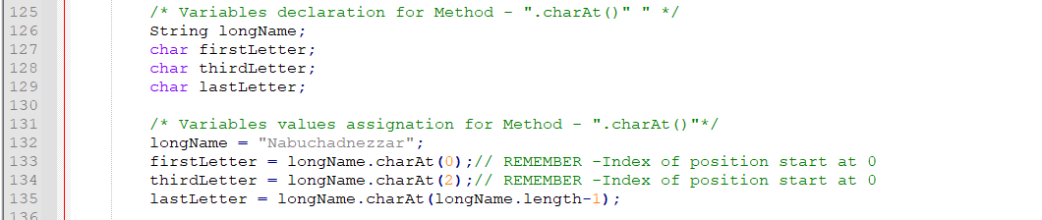

- I got:
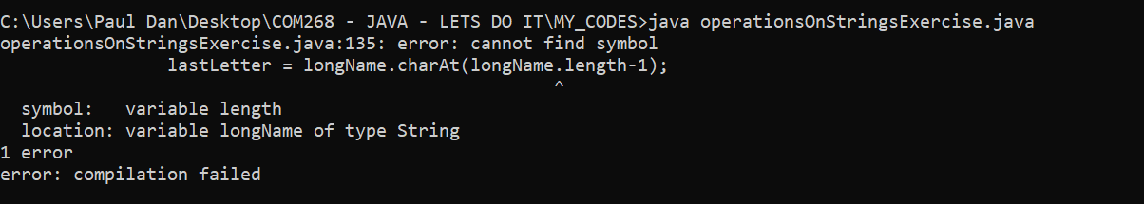
- Changed the type for a string and still don't work:
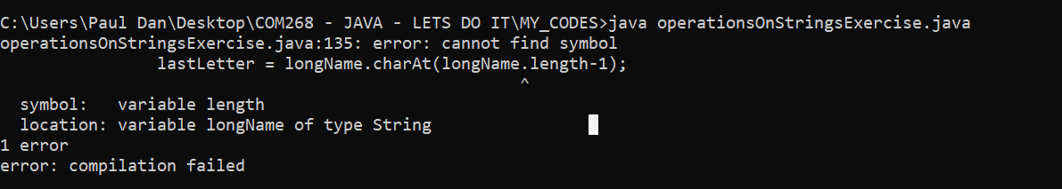

- Now it works with:
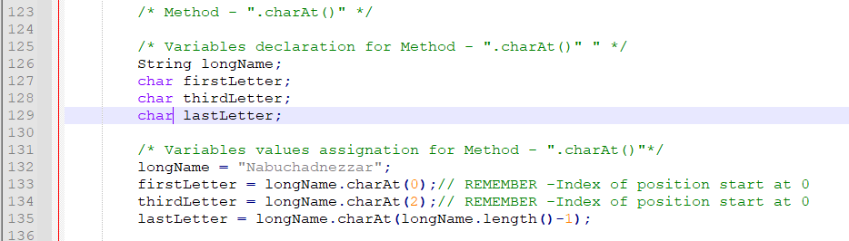
- I made of few manual editing so it looks nicer on the console screen with \n.
- There is probably a better way to do It; will see later.
- Need to find a way to paste it in Word for my coding journal and keeping the formatting of the source file; don't know yet; will keep using the snipping tool until then.
- I am trying to print as a PDF from Notepad++ maybe it's an option.
- The code for now is ok.

HANDS-ON CODING AND PRACTICE
- Eck/Syllabus 2.3.4 ENUM.
- For my enum exercise I will create a deck of cards.
- I will try to do two programs: (1) enum in one file (2) enum in external file.
- Base widely on Eck (36-37).
- I had to retype my enums categories; capital letters; shift+f3 don't work in Notepad++.
- Just figured out: just cut and paste in word round-trip using short key CTRL+C/CTRL+V.
- In Notepad++: right click + UPPERCASE while selecting a word; could be possible to do it for all occurrence of a word in a file TBC.
- Replace works in Notepad++.
- May I assign TWO types to the same name?
- Like that:
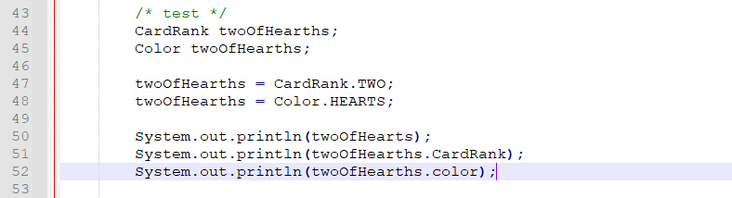

My actual code is like that:
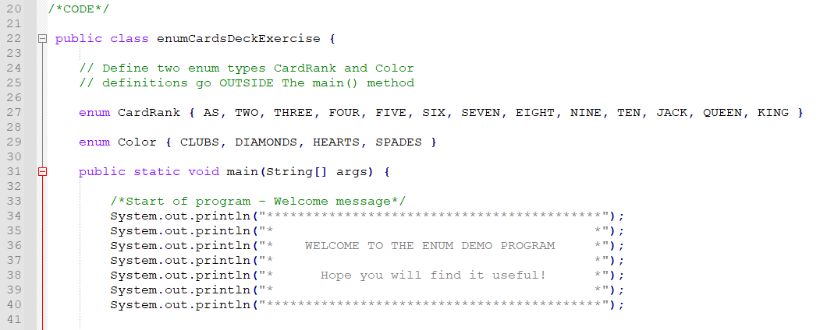
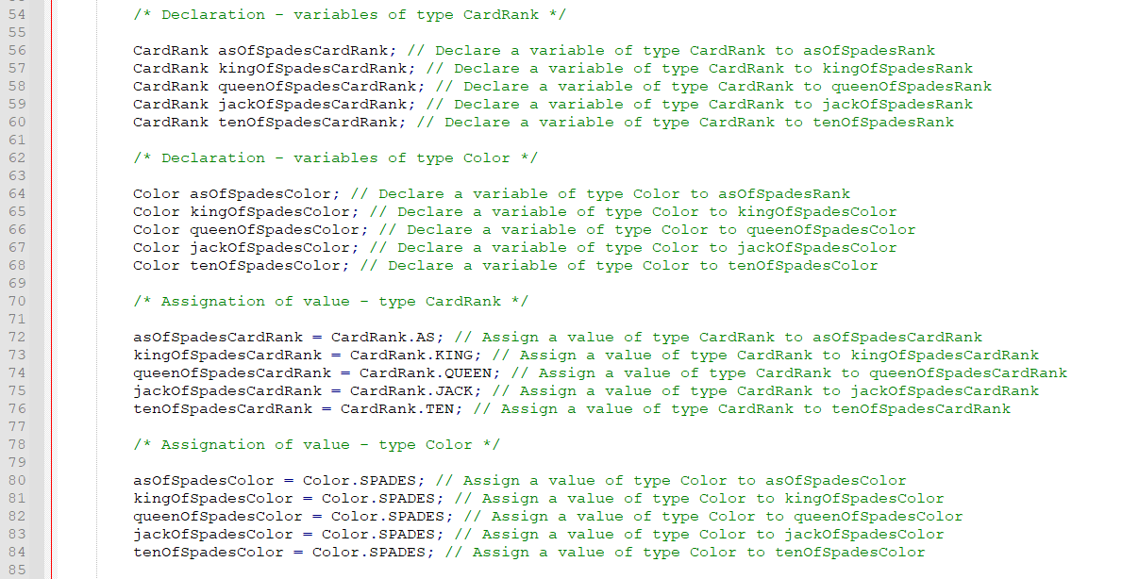

- I am testing the twoOfHearts version and got:
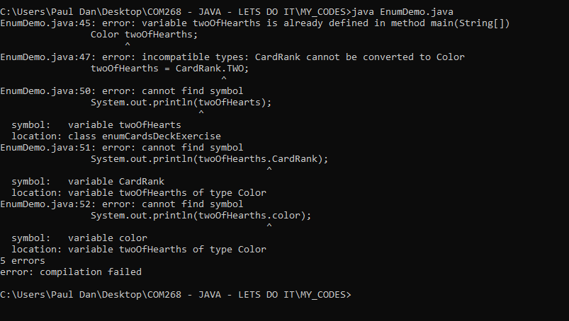
- So, I CANT!
- I will keep It simple and stupid for now.
- I will just add print statements and .ordinal() methods, the only one mentioned in the MANUAL to complete the program.
- I will make research this week and complete the exercise.
- Need to read more often the STANDARD and the Oracle documentation.
- I will revisit the code later on.
- For .ordinal I will try to add a + 1 to offset the counting from 0.
- I could put and if/else to convert It to "first, second and so on....).
- Will see.

- My code for now is:
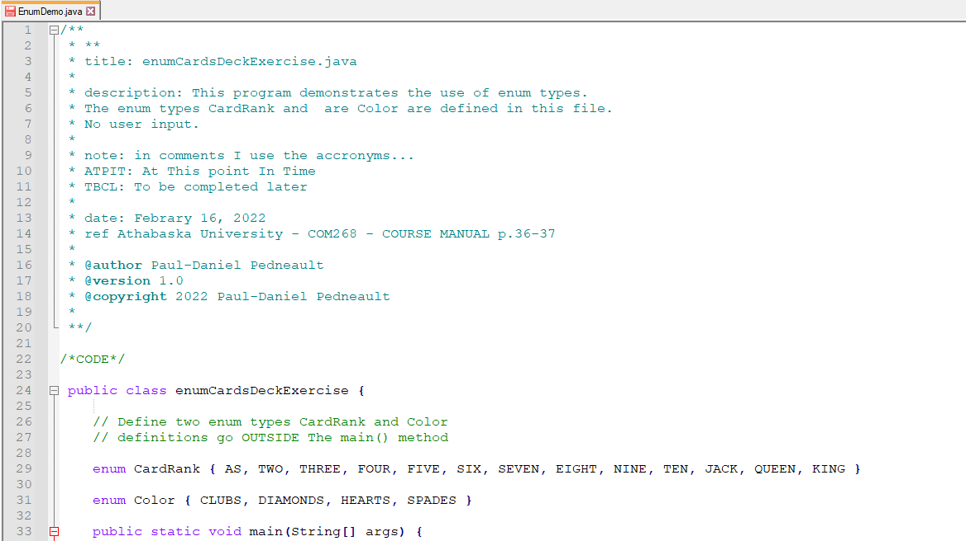
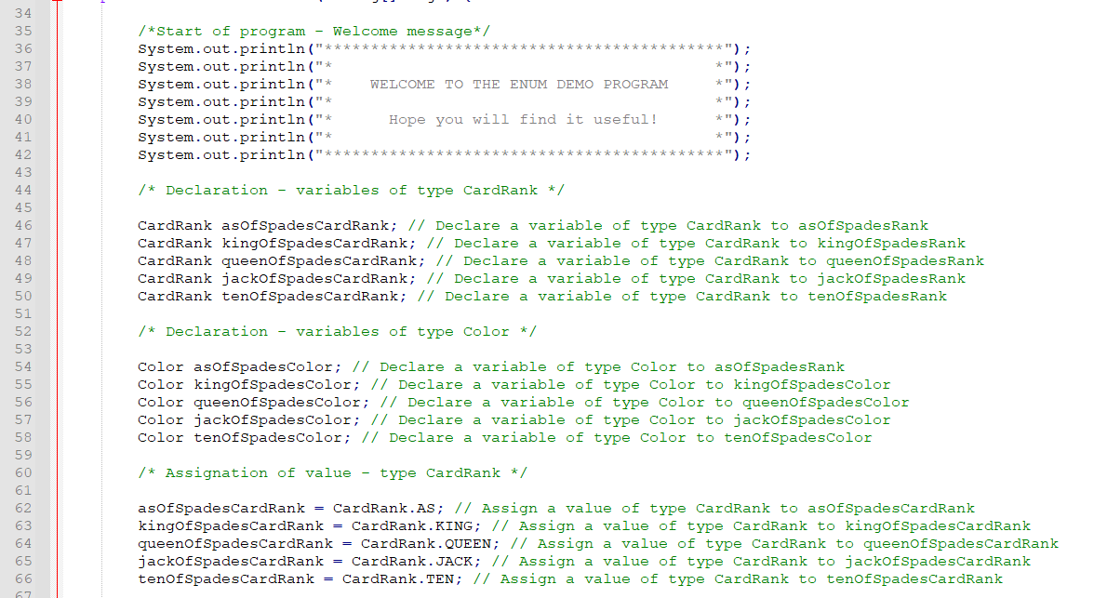
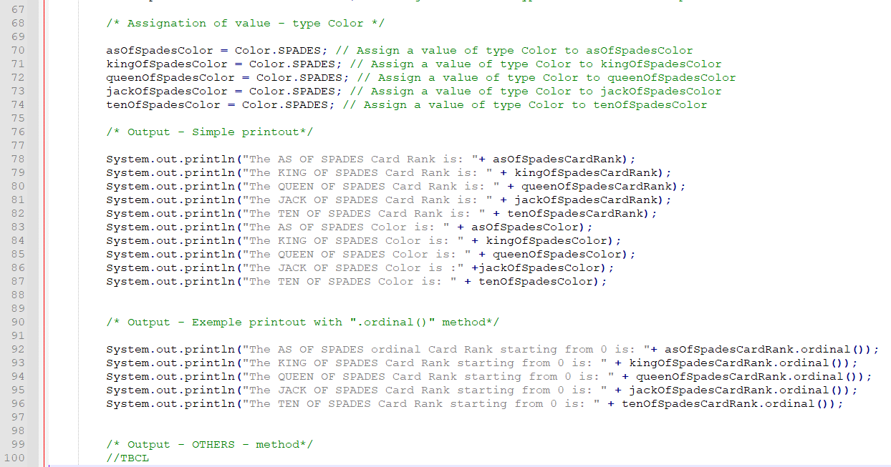
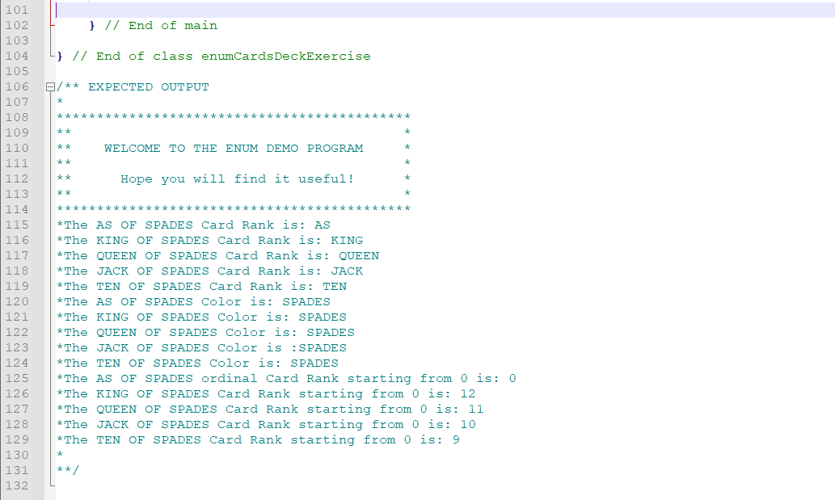
- Output in command prompt:
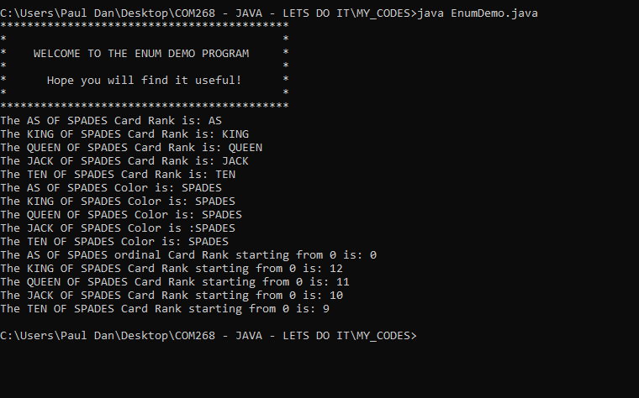
Files:
PDF
CODE
- The version with the enum in separate files was easy to produce.
- I just removed the enum from the main code created, renames et creates 2 files on the same design than the examples provided in the MANUAL website but using as the base my own code with the skeleton cards deck.

Files:
PDF

CODE

Output and formatted output:
- I found other random sources to complete the content of the MANUAL.
- Same websites always show up:
tutorialpoints
geekforgeek
etc...
- They have pretty much all the same content with different examples.

HANDS-ON CODING AND PRACTICE
- Thereafter is a self-commissioned program to review that part of the course material.
- NOTE: with user input code, type and scanner.

NOTE: Input
- As mentioned in the course study guide, TEXTIO is not expected to be used.
- After reviewing the material, I rewrote the examples codes in section 2.4.2, 2.4.3, 2.4.4.
- I started with the code of section 2.4.2 Using Scanner for Input, Therefore, modifying the original code in the MANUAL, using the conventional way in JAVA using the "Scanner class"
- NOTE:
- ATPIT A "bad" input will make the program crash!
- Those codes will be numbered as "version 1.0" (V1...)
- I will modify those codes to handle bad Input later and save them as "version 2.0) V2
- For my personal cheat sheet, I should get a section for
INTPUT
SCANNER CLASS
-Make my way to my java code directory while starting the command prompt...
- I found a way to make a shortcut online at the following address:
https://www.technipages.com/handy-command-prompt-shortcut
- It works perfectly. Now I just have to click the shortcut I made on my desktop (windows) and I open a CMD directly in my directory: C:\Users\Paul Dan\Desktop\COM268 - JAVA - LETS DO IT\MY_CODES>
- I changed the default folder as well in Notepad++.
- Save in the right folder now by default.
- When I click "Open containing folder in cmd" in Notepad++ It goes directly at the right folder now that way as well.
- It should have a way to save a file name as a short cut for when I am working at code that I am testing/debugging so I don't have to type them or cut and past the name (if long) from the "dir" listing every time - NEED TO LOOK AT THAT LATER - like "fasdgefgefeferfreq = j" then "java j, or something like that...
- Found a solution... in Notepad++, put arrow on the name of the file... then right-click... copy name of the file to clipboard... then CTRL+V in cmd... fantastic!
Eck (41)
- ORIGINAL: MANUAL (41) section 2.4.2.
- The original code (except the name and the reference in the header is the following):
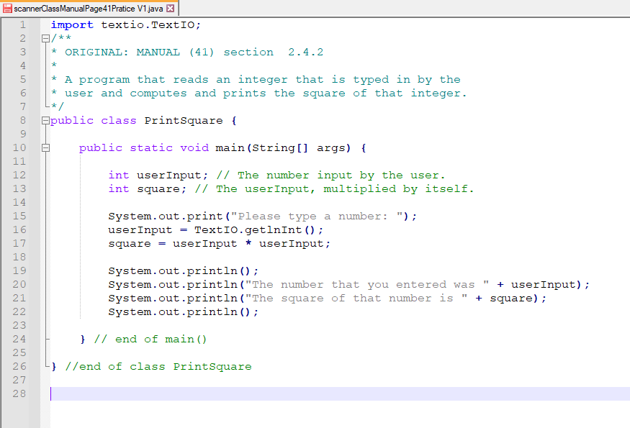
- I will keep the same purpose and scope and make the modification.
- Q: When I import a package there is any difference between importing just one class versus import the whole package with a wild card? There is any "waste" in the program, compiler, etc... when importing the "whole" package compared to specific class importation?
- I used LOWE code LOWE ScannerApp.java LISTING 2-3 BOOK 2 CHAPTER 2 as an example for the structure.
- The code is as follow:
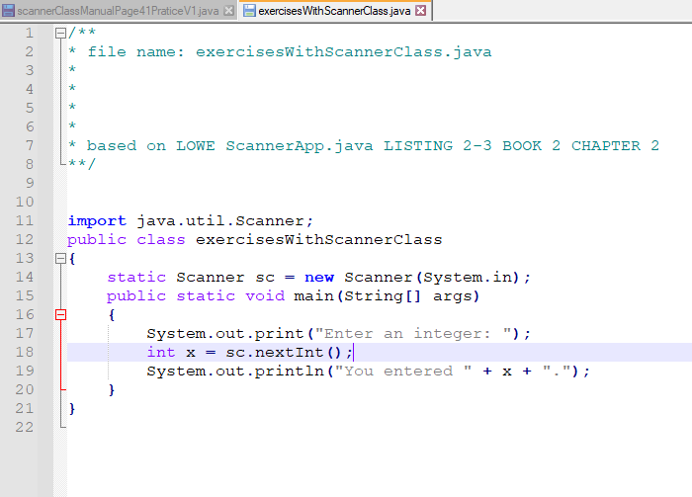

- Final code:
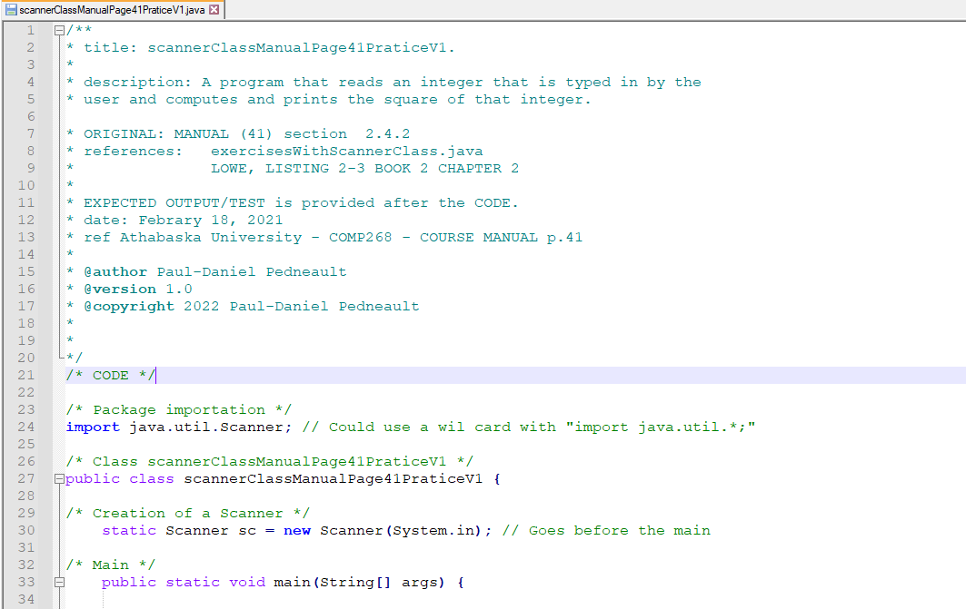
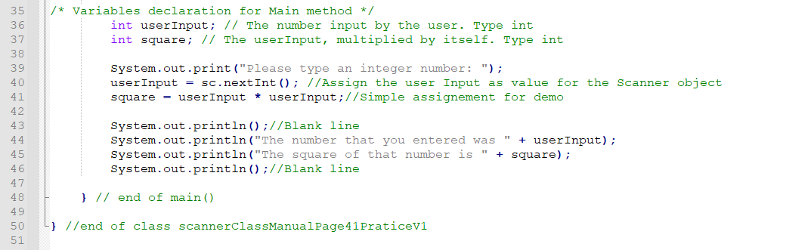
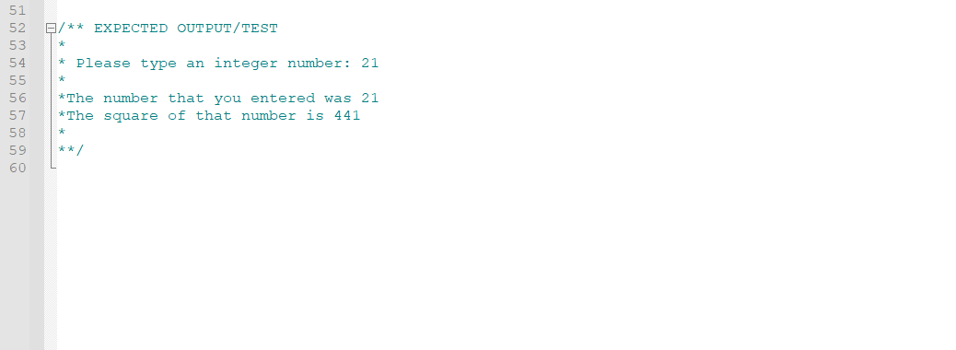
FILES:

HANDS-ON CODING AND PRACTICE
Eck (42-43)
- Scope: Modification of Interest2.java to use it with Scanner class
- Original Code is in the Manual.
- I did not encountered much problem to modify the code for the use of the Scanner class.
- The only problem at the beginning was that I had was that I put the creation of the Scanner sc.
static Scanner sc = new Scanner(System.in);
right after the package importation and therefore outside the public class exerciseInterest2V1.
- The creation of the Scanner goes in the public class BEFORE the main.
- The Scanner is an object. Public. For now, If It works all good. Will be more explained in Unit 5.
- Otherwise the code don't work and I got many cryptic error message.

My CODE (after the modifications)
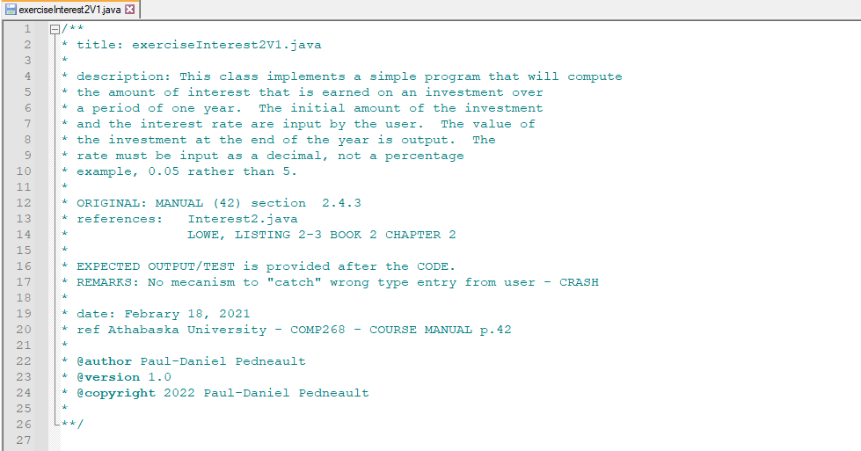
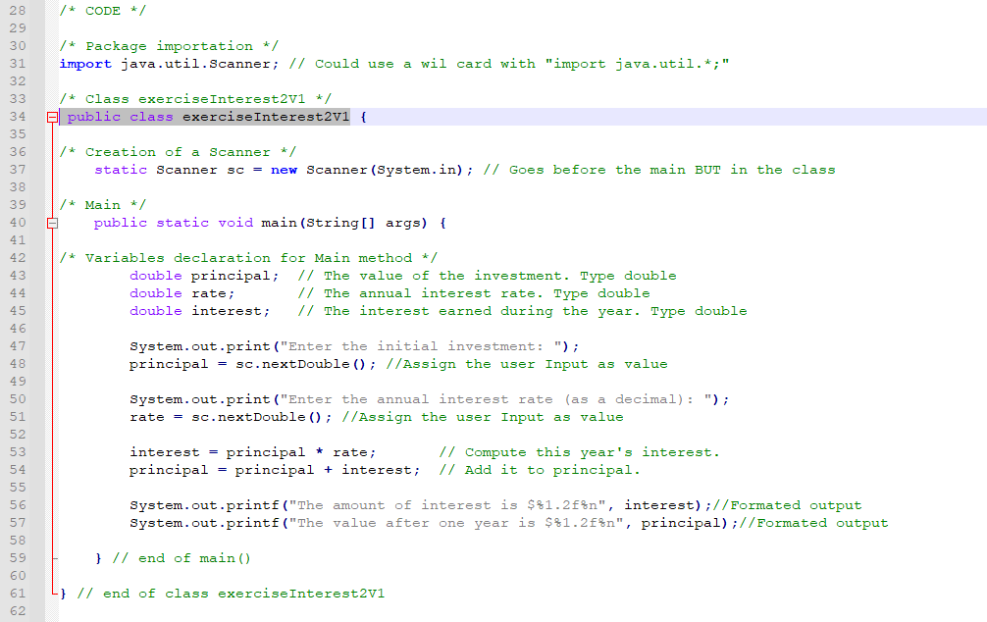
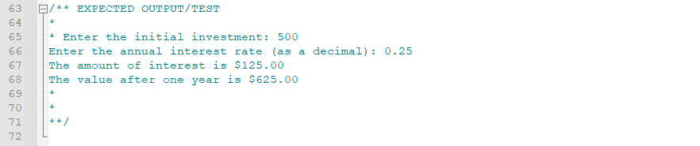
Files:

HANDS-ON CODING AND PRACTICE
- MANUAL p.44 "
CreateProfile.java
- AIM: rewrite CreateProfile.java BUT with no use of TEXTIO.
- My file name:
ProfileModifiedV1.java
- Reference:
- MANUAL 43-45, 46-47
- I PAUSE - TO REVIEW/JUMP TO CHAPT 11 AND 11.1.2 for Scanner.
- Will get back to It.

UNIT 2 (suite)
- Reviewing exception-handling.
https://javawithus.com/tutorial/exception-handling
- Still confused for me the differences handling, try/catch versus make cases in other type of structure... will see...
- I finally understood the author intent with TEXTIO: get possible to carry on in the course material postponing OOP "tricky" concepts... But I still not sure about it...
-To this point in time, my practice with user Input was strait-forward: if the user input is wrong type.... we got crash...
- For the "Scanner class:" I read the MANUAL parts that write about it...
- Eck 2.4.6
- NOT ENOUGHT, had to go 3.6, 4.3.6, 4.3.7, 11 and LOWE.
- What I was looking for was code, simple, to get input, assess if the input is valid, if yes, carry on, if not, message error and re-ask the user.
- I can even put a counter so if we get a really bad user entering 5 time a bad input we get a message and a program ending of some sort.
- I found an example at the following link:
https://javawithus.com/tutorial/exception-handling
This a PDF of the article
- An explanation AND a simple solution for my current need in user input and exception handling without all the explanations nuances and complications that are above my level of knowledge ATPIT.
- That should do the job for now.
- I really want to add a loop with a counter.
- I will practice with that. After will expand It. Write and retrieve from files (with same kind of block).
- That should be enough to complete one of my objectives to rewrite the remaining codes in the chapter 2 of the MANUAL but with no TEXTIO.
- NOTE: Nice explanation of "Stack" in the article - to be added at "Concepts".
- Let explore the code for now.

HANDS-ON CODING AND PRACTICE
- File name:
basicExeptionHandlingExercise.java
NOTE:
REMEMBER - Notepad++
arrow on file name of the window - right-click
File name to Clipboard / Full File Path to Clipboard
paste

UNIT 2 (suite)
Eck
- Text from the MANUAL break down to ideas...
"(...) try catch finally blocks
- A try block encloses the code which may throw Exceptions.
- You can find out if a particular method throws an Exception by looking at the documentation of the class.
- Along with the method names and descriptions, the exceptions that it may throw are also listed.
- The catch blocks provide a means to handle these Exceptions.
- A try block may be followed by any number of catch blocks.
- Each catch blocks handles a particular type of Exception.
- An Exception is an object.
- The corresponding catch block receives the Exception thrown by the try block into a variable specified in eth catch clause and processes the Exception.
- Lastly comes the finally block which contains code that will be executed whether or not an Exception has occurred." (...) Eck
CODE / SYNTAX STRUCTURE
try {
// code
} catch ( <Exception type > < identifier > ) {
// code
} // more catch blocks
finally {
}
"- If no Exceptions are thrown by the try block, none of the catch blocks are executed.
- Control passes directly to the finally block. IMPORTANT.
- However, if an Exception is thrown by the try block, then the remainder of the code in try block is skipped and the type (class type) of the Exception is compared with each of the catch blocks in the same order in which they are defined until a match if found.
- When an appropriate match is found, the corresponding catch block is executed, and the remaining catch blocks are skipped.
- And then the finally block is executed.
- A try block should be followed by at least one catch OR finally block.
- One important thing that should be remembered is that variables defined in any of the try, catch of finally blocks have their scope and lifetime limited to that block itself."
- I DON'T SEE MANY EXAMPLES ONLINE ON THAT STRUCTURE...
- NOTE: Could add a Menu that redirect to the block to be executed
import java.util.Scanner;
import java.util.InputMismatchException;
public class TakeInput {
public static void main(String[] args) {
Scanner s = new Scanner(System.in);
try {
System.out.print(“Enter an integer: “);
int num = s.nextInt();
System.out.println(“You entered ” + num);
} catch (InputMismatchException e) {
System.out.println(“You have entered invalid data”);
}
}
}
- NOTEPAD ++
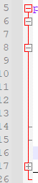
- Use for display or not a Block of code while working in a program - Convenient!

- Modify the above code and include a finally block also, in addition to the try and catch blocks.
// try and catch blocks
finally {
System.out.println(“Finally is always executed”);
}

HANDS-ON CODING AND PRACTICE
basicExeptionHandlingExercise.java
- Need to be completed as a demonstration of the different technics.
- More less a mashup of TakeInputV1-4.java.
Final genesis:
TakeInputV1.java
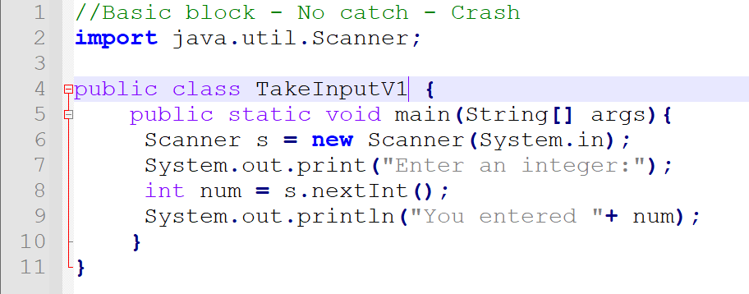

TakeInputV2.java:
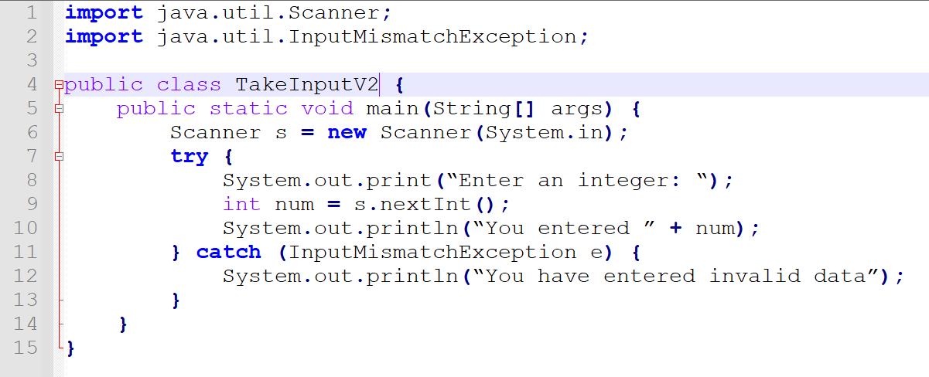

TakeInputV3.java:
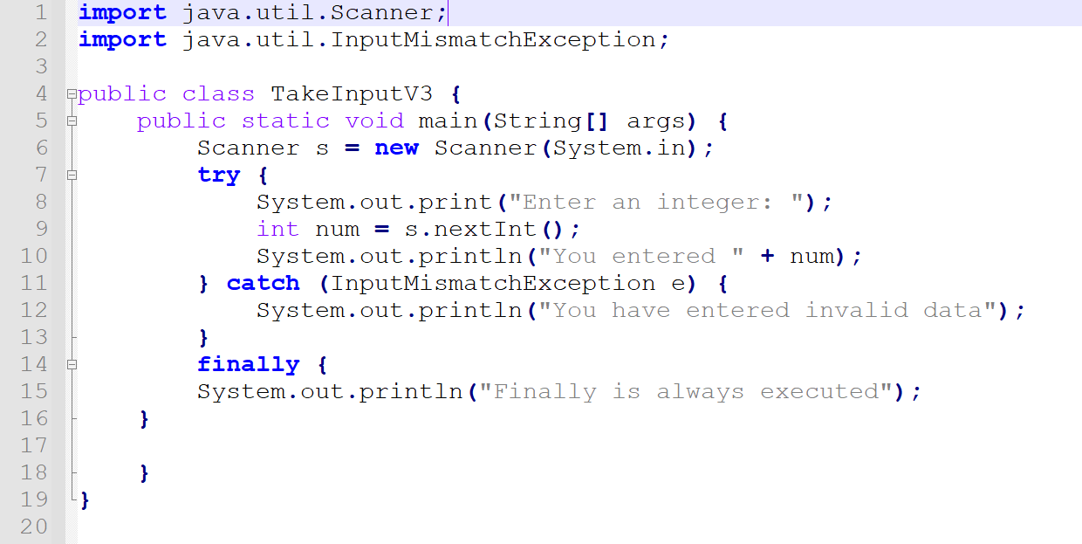

TakeInputV4.java:
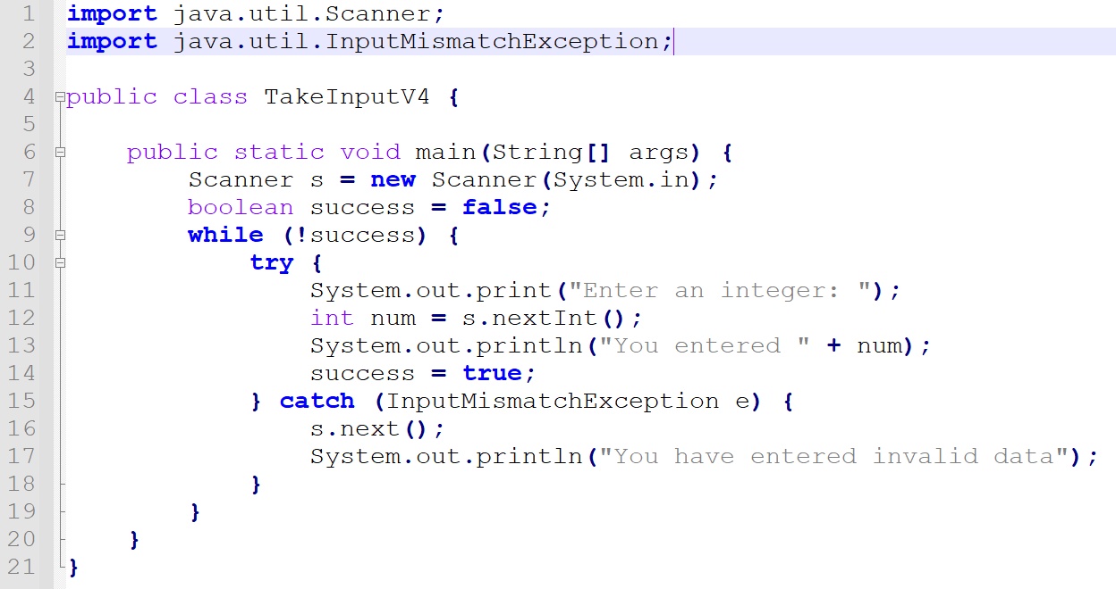

V5
- Will try loop with a count.
- Limit at 5 for example bad input, so the program will carry on, end or break the loop.
- Do - While.
- OK.

UNIT 2 (suite)
JAVADOCS AND COMMENTS:
*** SEE ASSIG REQUIREMENT AS WELL AND COMPLETE
References:
Eck (21)
Java has two types of comments:
(1)
- Begins with "//" and extends to the end of a line.
- Computer ignores the "//" and everything that follows it on the same line.

(2)
Javadoc comment
- Can be use to produce Javadoc documentation for the program
- Starts with "*/" and ends with "*/"
- Can extend over more than one line

javadoc - (suite)
LOWE (30-33; 370-375)

WEB
Oracle.com
https://docs.oracle.com/en/java/javase/17/
https://docs.oracle.com/en/java/javase/17/docs/api/jdk.javadoc/module-summary.html
javadoc
"How to Write Doc Comments for the Javadoc Tool"
https://www.oracle.com/technical-resources/articles/java/javadoc-tool.html

NOTE:
- javadoc help and commands...
- wild cards LOWE (AIO 374).

JAVA GOOD PROGRAMMING STYLE
VARIABLES DECLARATION IN PROGRAMS
Eck (28)
- Declare only one variable in a declaration statement unless the variables are closely related in some way.
- Include a comment with each variable declaration to explain its purpose in the program, or to give other information that might be useful to a human reader.

Method local variable declaration:
- There are three ways:
(1) Declare all the variables at the beginning of the method.
(2) Declare the variable as needed in the method code.
(3)
- Declare important variables at the beginning of the method with a comment to explain the purpose of each variable.
- Declare "utility variables" at the point in the method where they are first used.
Utility variables: Variable that are not important to the overall logic of the method.
NOTE: ***Maybe another way would be to declare all the local variable but to "split" them in two categories with comments TBE.

Class and variable names:
- Remember that all the built-in, predefined names in Java follow the rule that class names begin with an uppercase letter while variable names begin with a lowercase letter. (REFERENCE)
- This is not a formal syntax rule of the language.
- There is no possibility of confusing a variable with a method since a method name in a program is always followed by a left parenthesis.

Enum:
- By convention, enum values are given names that are made up of upper-case letters, but that is a style guideline and NOT a syntax rule.
- An enum value is a constant; that is, it represents a fixed value that cannot be changed.
- The possible values of an enum type are usually referred to as enum constants.

JAVA - SYNTAX:
Syntax
Syntax structure
Syntax meaning - Allegro Verboso

CONVENTIONS:
- I will follow the notation convention of the manual as much as I can with < and >.
- <italic in angle brackets> is a placeholder that describe something we need to type when we write an actual program.
- HOWEVER, the immutable (find a better word) code per se in the structure document could be in bolt characters to better distinguish them when it serves the purpose.
- If it helps the purpose, I can numbered the Syntax structure and the codes to better refer to It in the explanations (as examples in LOWE).

Syntax structure - main method - Eck (22)
Code:
1. public static void main (String[] args) {
2. <statements>
3. }
Explanations:
- When we tell the Java interpreter to run the program, the interpreter calls the main() method, and the statements that it contains are executed.
- It is the statements that make up the script that tells the computer exactly what to do at runtime (when we run the program).
- main() method can call other methods contained in the same class or in other classes (Depend if they are public or private... *** Expend later).
- The main() method determines how and in what order methods are used.

Words:
public: means that the method can be called from outside the program.
- See "Java access modifiers" article online.

Syntax structure - class Eck (22)
1. <optional-package-declaration>
2. <optional-imports>
3. public class <program-name> {
4. <optional-variable-declarations-and-methods>
5. public static void main (String [] args) {
6. <statements>
7. }
8. <optional-variable-declarations-and-methods>
9. }

Explanations
- 1, 2 imports packages when required.
- 3 <program-name> is the name of the class and the name of the file. MUST be the same.
- Blank lines and indentation are NOT part of the syntax or the semantics of the JAVA language.
- Layout is for human readers.
- There are certain style guidelines for layout that are followed by most programmers.
- *** See internet "JAVA Coding style" ... from different Universities.

Syntaxe structure - assigment statement Eck (24)
1. <variable> = <expression> ;
Exemple 1:
rate = 0.07;
Exemple 2:
interest = rate * Interest;

Explanations:
- In Java, the only way to get data into a variable—that is, into the box that the variable names—is with an assignment statement.
- <expression> represents anything that refers to or computes a data value.
- When the computer comes to an assignment statement in the course of executing a program, it evaluates the expression and puts the resulting data value into the variable.
- When a variable is used in an expression, it is the value stored in the variable that matters.
- The variable in our example 2 seems to refer to the data in the box, rather than to the box itself. When the computer executes this assignment statement, it takes the value of rate, multiplies it by the value of principal, and stores the answer in the box referred to by interest.
- When a variable is used on the left-hand side of an assignment statement, it refers to the box that is named by the variable.
- Assignment statement is a command that is executed by the computer at a certain time.
- It is NOT a statement of fact (aka constant).
- Meaning of an assignment statement is completely different from the meaning of an equation in mathematics, even though both use the symbol ”=”.

Syntax structure - Variable declaration Eck (28)
Code:
1. <type-name> <variable-name-or-names>;

Explanations:
- <type-name> is the name of the type for the variable.
- <variable-name-or-names> can be a single variable name or a list of variable names separated by commas.
- ";" at the end of the variable declaration is mandatory.

Exemples:
(1) int numberOfChildrens;
(2) String herName;
(3) double horizontalMeasurement, VertivalMeasurement
(4) boolean isCompleted
(5) char firstLetter, secondLetter, thirdLetter

Syntax structure - Enum
enum <enum-type-name> {<list-of-enum-values>}

- CANNOT be inside a method.
- Outside the main() method of the program OR in a separate file.
- Each value in the <list-of-enum-values> must be a simple identifier, and the identifiers in the list are separated by commas.
- By convention, enum values are given names that are made up of UPPER-CASE LETTERS, but that is a style guideline and not a syntax rule.
- An enum value is a constant; that is, it represents a fixed value that cannot be changed.
- The possible values of an enum type are usually referred to as enum constants.
"Note that the enum constants of type Season are considered to be “contained in” Season, which means—following the convention that compound identifiers are used for things that are contained in other things—the names that you actually use in your program to refer to them are Season.SPRING, Season.SUMMER, Season.FALL, and Season.WINTER. Once an enum type has been created, it can be used to declare variables in exactly the same ways that other types are used. For example, you can declare a variable named vacation of type Season with the statement: Season vacation; After declaring the variable, you can assign a value to it using an assignment statement. The value on the right-hand side of the assignment can be one of the enum constants of type Season. Remember to use the full name of the constant, including “Season”! For example: vacation = Season.SUMMER;" Eck

"You can print out an enum value with an output statement such as System.out.print(vacation). The output value will be the name of the enum constant (without the “Season.”). In this case, the output would be “SUMMER”. Because an enum is technically a class, the enum values are technically objects. As objects, they can contain subroutines. One of the subroutines in every enum value is named ordinal(). When used with an enum value, it returns the ordinal number of the value in the list of values of the enum. The ordinal number simply tells the position of the value in the list. That is, Season.SPRING.ordinal() is the int value 0, Season.SUMMER.ordinal() is 1, Season.FALL.ordinal() is 2, and Season.WINTER.ordinal() is 3. (You will see over and over again that computer scientists like to start counting at zero!) You can, of course, use the ordinal() method with a variable of type Season, such as vacation.ordinal()."

UNIT 3 - Programming in the Small II: Control
- Notepad++
<CTRL> + D
Duplicate current line

Basic building blocks of programs:
variables
expressions
assignment statements
method call statements

Control structure:
- Two types
(1) loops
- Used to repeat a sequence of statements.
(2) branches
- Used to choose among two or more course of action.

Data structure:
Its an organized collection of data chunked together so that it can be treated as a unit.

3.1 Blocks, Loops, and Branches
JAVA control structures:
(1) block
(2) while loop
(3) do..while loop
(4) for loop

(5) if statement
(6) switch statement
- Each of these structures is considered to be a single "statement", but a structured statement that can contain one or more other statements inside itself.

3.1.1 Blocks
- Simplest type of structured statement.
- Its purpose is simply to group a sequence of statements into a single statement.

{
<statements>
}

- Empty block: Block that contain no statement. Useful in certain instances
{ }
- (FIND EXAMPLES)
- Usually occurs inside other statements, where their purpose is to group together as a unit.
- A block can be legally used wherever a statement can occur.
- In main method a block is required.
- Remember: JAVA is a free format language.
- There is no rule about how the language has to be arranged on a page.
- Good programming style:
- Make the structure visually as clear as possible
- Put one statement per line
- Indentation to indicate statements that are contained inside control structures

HANDS-ON CODING AND PRACTICE
unit3ExercisesAndTest.java
- I can comment out the braces for the blocks and it doesn't matter.
- It works anyway.
- So, what is the purpose of block?
- Protect local data?
- Still confused about block.
- It is perfectly legal and of good style to declare a variable inside a block if that variable is used nowhere else but inside the block.
- A variable declared inside a block is completely inaccessible and invisible from outside that block.
- Variable is said to be local to the block.
- When the block is completed, the memory allocated to the variable is discarded.
- Q: Can we use same names between blocks for different data?
- I declared variables x and y outside the block and inside the block.
- If I declare in the main method I got:
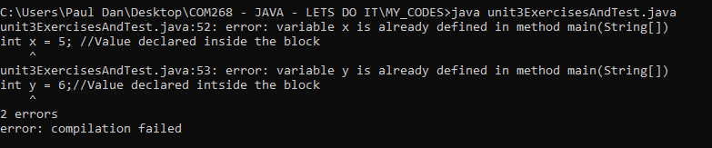
- I create other blocks so the declaration is not in the main but in another block.
- Nested blocks.
- I don't have the problem with #1 because the variable is declared once with no double usage of the identifier.
- I comment out the variable declarations outside the block and the print statement outside the block.
- Got the same.
- What is the "scope" of the "identifiers"?
- With inside block declaration and outside block print statement I got:
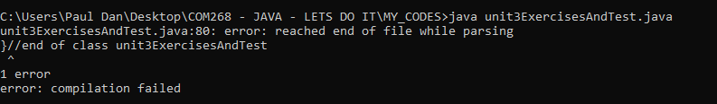

- That prove the local scope of the declarations in blocks.
(...) "Scope of an identifier: The part of the program in which that identifier is valid, (...)
The scope of an identifier is the part of the program in which that identifier is valid. The scope of a variable defined inside a block is limited to that block, and more specifically to the part of the block that comes after the declaration of the variable." Eck (72)
- Now in #4 I will do two blocks with local variables with identifiers a, b, c in both blocks (same level)
CODE SNIP
- Errors
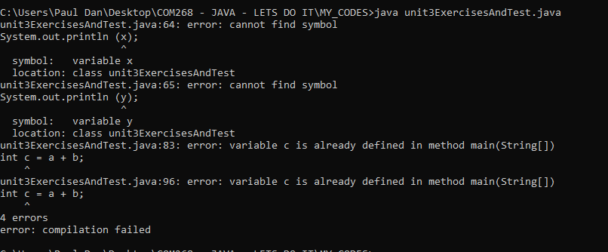

- I will make another file just to see with just those two blocks within a main with the same names.
- New program.
- Same error.
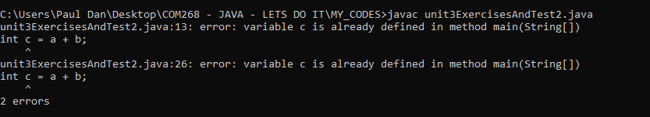
- Identifiers cannot be the same.
- Commented out the second block and put printout statement for the local variable inside the main but outside the block.
- SNIP
- Error
- Let s do it again
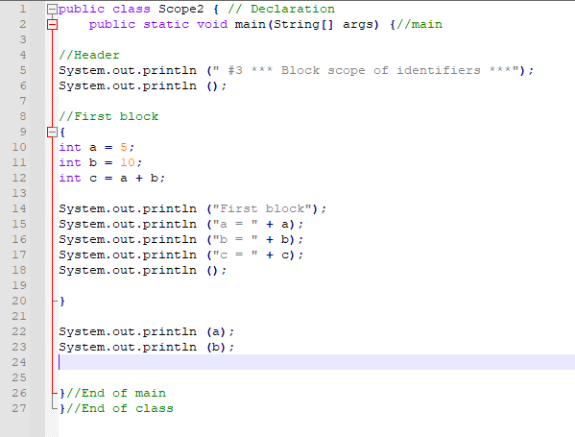
- Same.
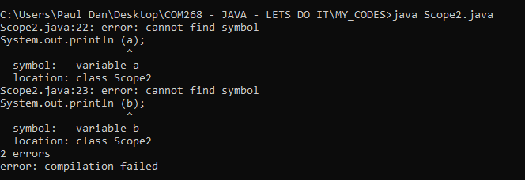

- THEREFORE, until prove otherwise, identifiers are to be unique - block level.

UNIT 3 - Programming in the Small II: Control (suite)
3.1.2 The Basic While Loop
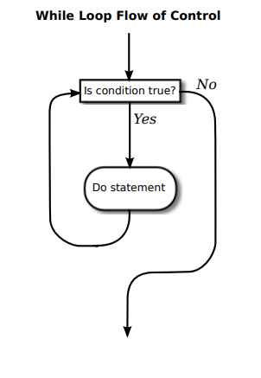
*** from Eck
Definition:
While loop: Control structure that will repeat a statement over and over, but only so long as a specified condition remains true.
Infinite loop: Loop with no stated condition for the loop to end.

Syntax:
while (<boolean-expression>)
<statement>

OR (since most statements are blocks)

while (<boolean-expression>)
{
<statement>
}

Style:
- Braces should always be included as a matter of style, even when there is only one statement between them.

Semantic:
"When the computer comes to a while statement, it evaluates the <boolean-expression> which yields either true or false as its value. If the value is false, the computer skips over the rest of the while loop and proceeds to the next command in the program. If the value of the expression is true, the computer executes the <statement> or block of <statements> inside the loop. Then it returns to the beginning of the while loop and repeats the process. That is, it re-evaluates the <boolean-expression> ends the loop if the value is false and continues it if the value is true. This will continue over and over until the value of the expression is false when the computer evaluates it; if that never happens, then there will be an infinite loop. " Eck

- NOTE: Replace in Word: ^p = carriage return.

HANDS-ON CODING AND PRACTICE
BasicWhileLoopExercise.java
- We cannot put the variable declaration in the block because the "while" is outside the block, it is more like a condition to "enter" and execute the block of code.
- The code:
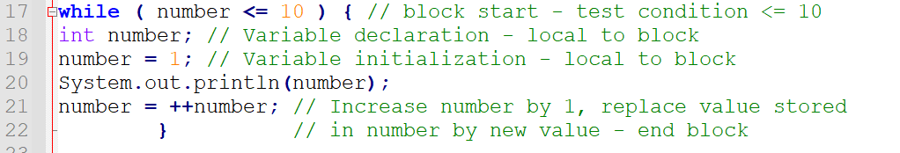
- Give us:
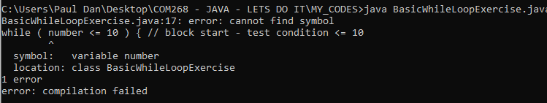
- That was a test.
- Final version is:
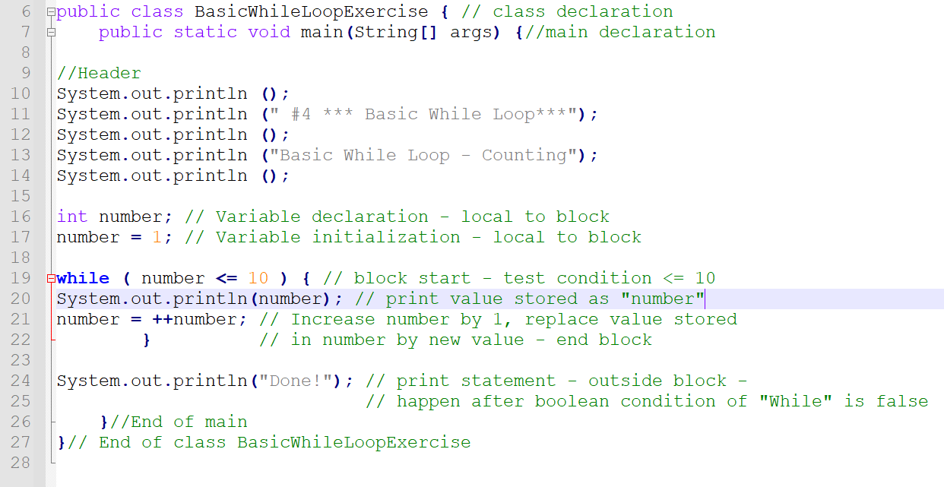

Output:
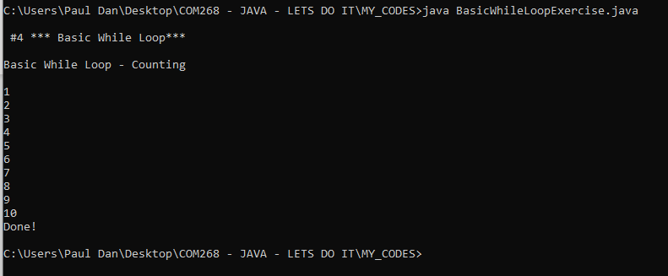

HANDS-ON CODING AND PRACTICE
- Rewrite the code without the use of TEXTIO and comment of the code "interest3", Eck (74).
- Q: Should I put the import before the javadoc header of after?
- It makes visually more senss to me AFTER but the example in the book (for TEXTIO) placed it before...
- I will put the imports before the class declaration but after the javadoc header as seen in the gooddoc example for now.
- Get following error:
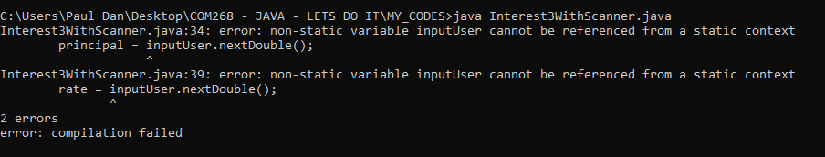
- Its linked to OOP I think.
- I declared my data the wrong way.
- I commented out the variables declaration and change it as a scanner assignment declaration.
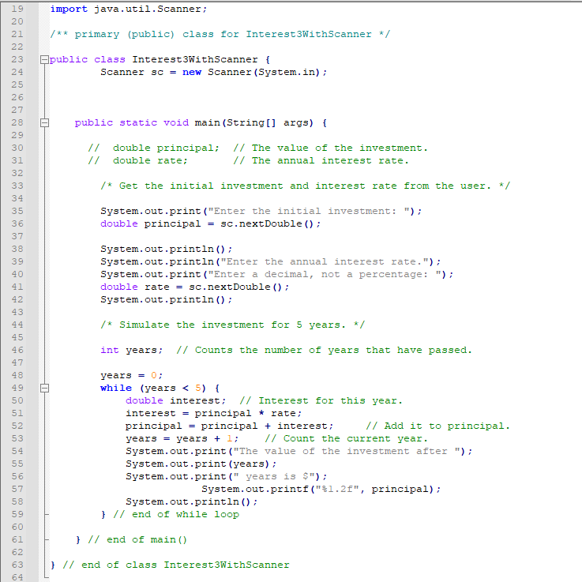
- I missed the "static" word in my scanner creation.
- That was the problem I suspect.
- ATPIT I know really the basic for OOP so I make a lot of mistakes by using codes "to make it work".
- However, I am getting a better feel of It...
- My final code:
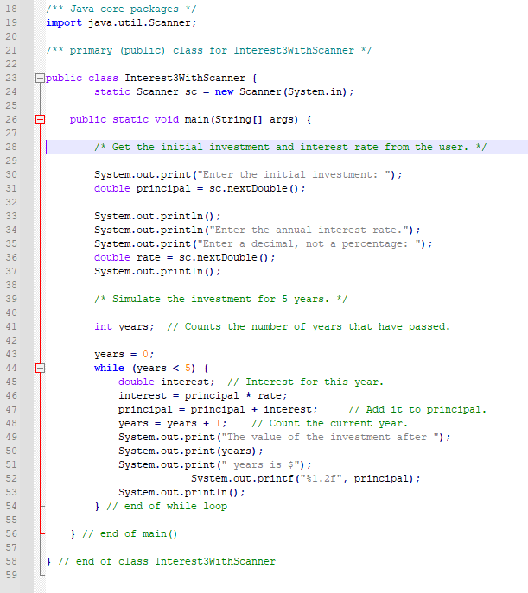

- OUTPUT:
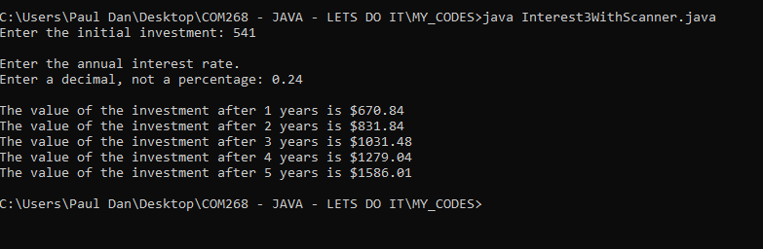
- I should put more comments on the code but I already comment in the MANUAL print out.

- Scanned copy of the original with TEXTIO on which the new version using the Scanner class has been created from:
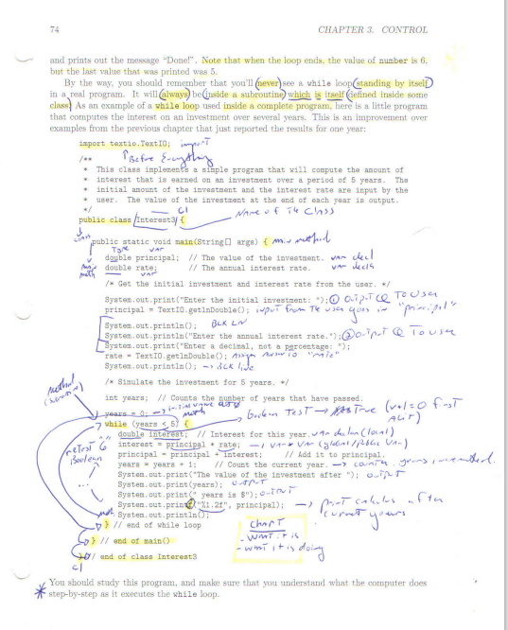

3.1.3 The "Basic" If Statement
Eck (75)
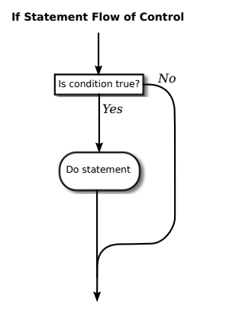
Definition:
- Tells the computer to take one of two alternative courses of action, depending on whether the value of a given boolean-valued expression is true or false. It is an example of a “branching” or “decision” statement.
Syntax:
VERSION WITH "ELSE"
*** Tells the computer to take one of two alternative courses of action, depending on whether the value of a given boolean-valued expression is true or false

if ( <boolean-expression>){
<statement1>
}
else {
<statement2>
}

VERSION WITHOUT "ELSE"
***Tells the computer to choose between doing something and not doing it.

if ( <boolean-expression>){
<statement1>
}

Style:
- Either or both of the <statements> in an if statement can be a block.
- Many programmers prefer to add the braces even when they contain just a single statement.
Semantic:
- To execute the statement, the computer evaluates <boolean-expression>. If the value is true, the computer executes the <statement> that is contained inside the if statement; if the value is false, the computer skips over that <statement>. In either case, the computer then continues with whatever follows the if statement in the program.
- REMEMBER: If statement is executed only once.

HANDS-ON CODING AND PRACTICE
File: BasicIfStatementExercise.java
Eck (76ss)
Notepad++:
- When I click on a brace it turns red and the corresponding brace as well.
BasicIfStatementExercise.java
- I want to make a program using a simple if and an if/else statement.
- I use the model of MANUAL (76) switching value as an example for the simple if.
- For the second if, I just created a + b/ larger / smaller.
- I had problem with the braces and where to put my Scanner (in the main).
- I browse internet and find a pretty good example at the following address that I used as model for the structure:
https://www.studytonight.com/java-programs/java-if-else-program
- CODE
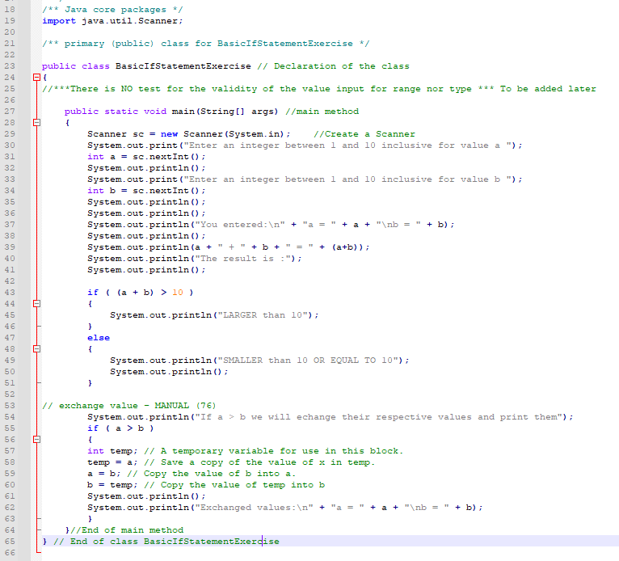
- Braces
- I see inconsistency among material I am reading in different sources (and even in the MANUAL) (1) and (2) are example
(1)
if ( (a + b) > 10 )
{
System.out.println("LARGER than 10");
}
else
{
System.out.println("SMALLER than 10 OR EQUAL TO 10");
System.out.println();
}
(2)
if ( (a + b) > 10 ) {
System.out.println("LARGER than 10");
}
else{
System.out.println("SMALLER than 10 OR EQUAL TO 10");
System.out.println();
}
- I know this do not change anything to the program but I am wondering if there is any particular reason for it.
- From now on I will try to use the (1) method because I find It more readable and easier to use when tracking braces. But, This is not a definitive choice.
- It makes the block more evident as well.
- OUTPUT - BasicIfStatementExercise.java - I ran the program twice with different inputs for the testing.
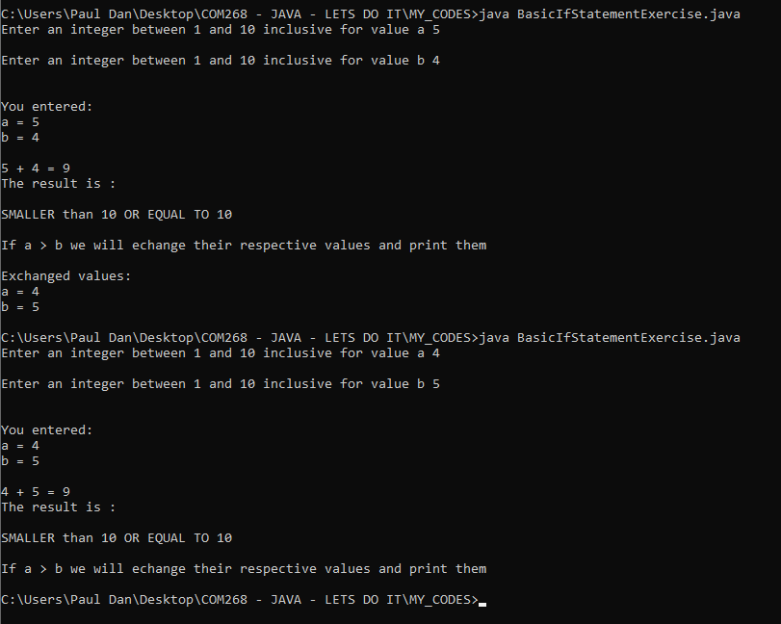
- Everything worked as expected.

DefiniteAssignmentExercise.java
Eck - 3.1.4 Definite Assignment
- Code MANUAL (77).
- Compare both with print statements in file:
DefiniteAssignmentExercise.java

Code:
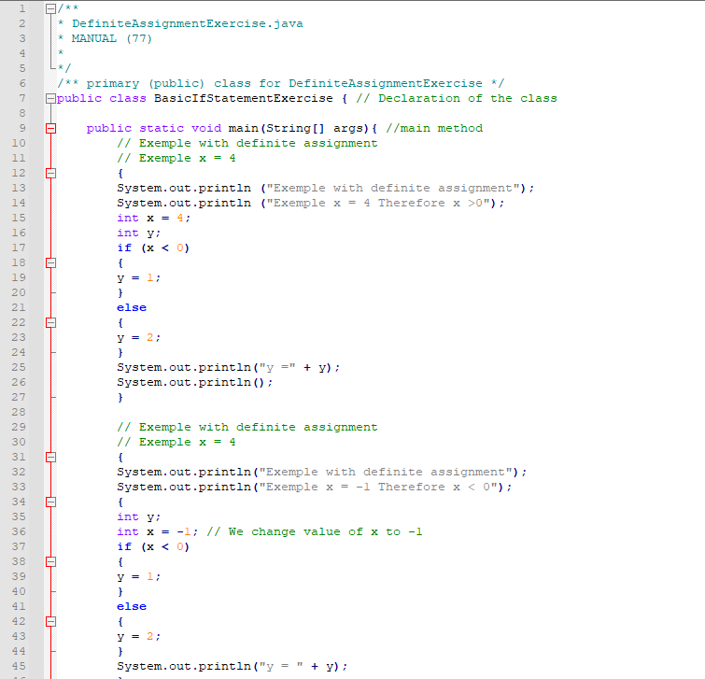
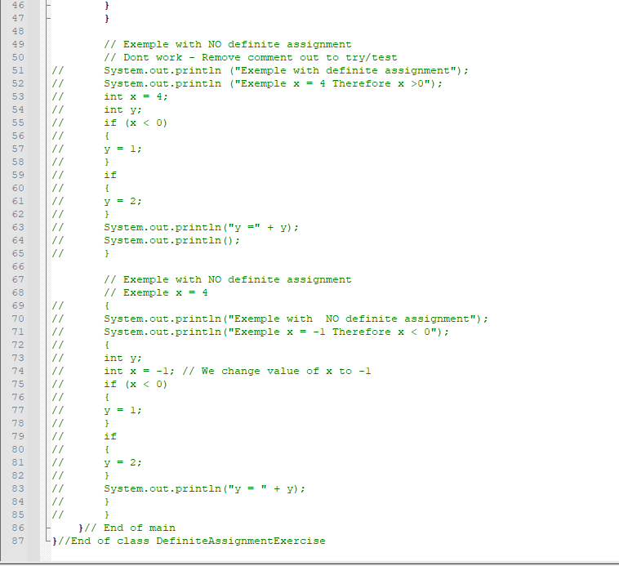

OUTPUT - Definite assignment block:
- It work.
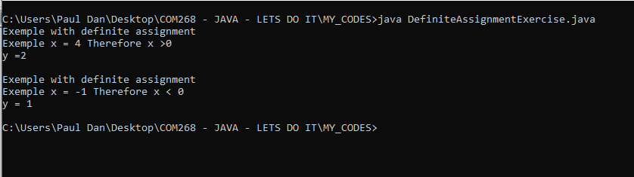
- I commented out the first part of the program and removed the comment out of the second part... Output as expected - Don't work!
- Had to fix the braces of the second part on the original code.
- I missed the statement after the "if" in second part.
- I corrected the mistakes and tuned up the braces.
- My ERROR output is exactly what I was expecting; the value has not been assigned because our assignment of y is NOT DEFINITIVE in this case as stated in the MANUAL.
ERROR OUTPUT:
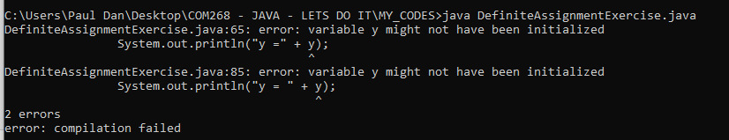

Final CODE:
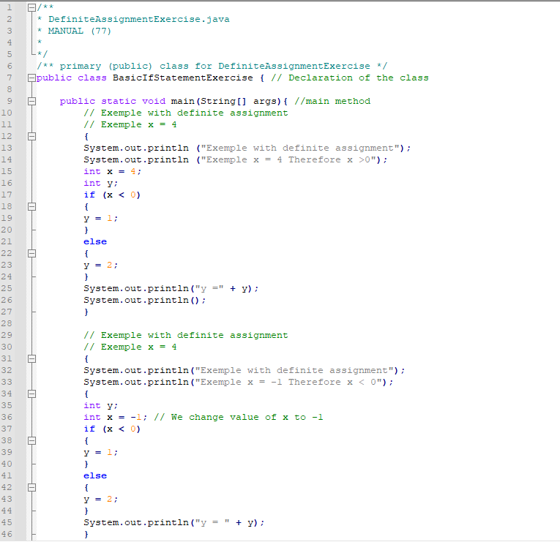
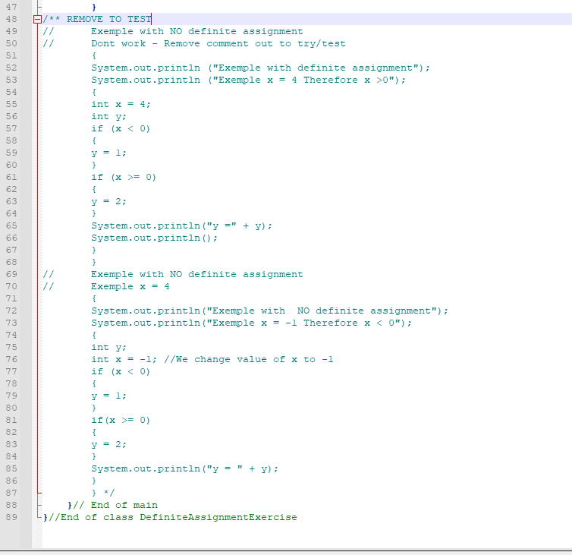
- When I want comment out large chunk of code to play with use "/**" and "*/" that will go faster!
- I could had just take the same code with just one part, put a note to ADD/REMOVE "else" "if" to test. But my aim is to practice coding and have complete standalone codes as possible to be able to fall on them if I want examples.

UNIT 3 - Programming in the Small II: Control (suite)
Theory and concepts
" When an if statement has no else part, the statement inside the if might or might not be executed, depending on the value of the condition. The compiler can’t tell whether it will be executed or not, since the condition will only be evaluated when the program is running. For the code on the right above, as far as the compiler is concerned, it is possible that neither statement, y = 1 or y = 2, will be evaluated, so it is possible that the output statement is trying to print an undefined value. The compiler considers this to be an error. The value of a variable can only be used if the compiler can verify that the variable will have been assigned a value at that point when the program is running. This is called definite assignment. (It doesn’t matter that you can tell that y will always be assigned a value in this example. The question is whether the compiler can tell.)" MANUAL (77)

3.2 Algorithm Development
- NOTE: This part is a review of concepts already seen in COMP200 and already added to my definitions/concepts personal database.

3.2.1 Pseudocode and Stepwise Refinement
- This section is an introduction to program design.
- That material will be cover later on in my cursus and was already cover in COMP200.
- This is a good example.
- The code associated with the example has already been "recoded" without TEXTIO previously therefore I have no coding in this section.

Concepts:
Stepwise refinement: Write a description of the task and take that description as an outline of the algorithm you want to develop. Then we refine and elaborate that description, gradually adding steps and detail, until we have a complete algorithm that can be translated directly into programming language.

Pseudocodes: Informal instructions that imitate the structure of programming languages without the complete detail and perfect syntax of actual program code.

Pseudocode terms:
Set the value of
Get
Compute
Display
Ask
Read
*** Controle structure terms
Contract
Indentation

Taught/Landing discussion:
- Since COM200 I looked, without having found a definite answer, about "standard" or normalized pseudocodes.
- This fact appears to me extremely weird. Every company, University, Scholar, appear to have his own standard. I found a few ideas.
- This is a good subject to post on the course landing to get peer feedback on the matter.
- See: Drakon-Chart on Wikipedia.

3.2.2 The 3N+1 Problem
- Another example of stepwise development.
- BE CAUTIOUS not to confuse "if" and "while" statements.
-REMEMBER: "if" execute only ONCE.

HANDS-ON CODING AND PRACTICE
- MANUAL (83-84).
- Redo the code without TEXTIO as personal exercise.
- I will try to be more accurate in my formatting in the future...
- I am going slowly toward a better format and more standardized from one code to another.
- I need to pay more attention to the braces because it is really time consuming when I got an error with them!
- Some demo online shows the braces always on a separate line and indented to the right margin.
- When we do that, pretty much all the code need to be written with one tab after the declaration of the initial class as required by JAVA.
- Notepad++... Can write the code and THEN select and tab multilines...
- I find it odd - need to verify online if everybody goes that way OR there is no tab after the class declaration and only apply that only after the "main" method.
- If I skip the first tab the rest of the code will be for the main justified to the left.
- For braces, for the initial class declaration and the main, I see widely that the braces are on the same line, at the end, that the declaration; it save space, and in those cases I find It easier to see the logic ITPIT. But visually it looks inconsistent. Will see with time.
- For the javadoc "header", I see inconsistency as well. Some codes get the package "import" before the javadoc descriptive and other after. For now, I will keep the import after.
- I see inconsistency as well for blank lines.
- I have a natural tendency to put liberally blank lines for clarity; an effect of that is that my (basic) codes are longer.
- The same remark apply to print blank line statement for the output; I like when the output is relatively formatted; I will use more often "\n" starting from now.
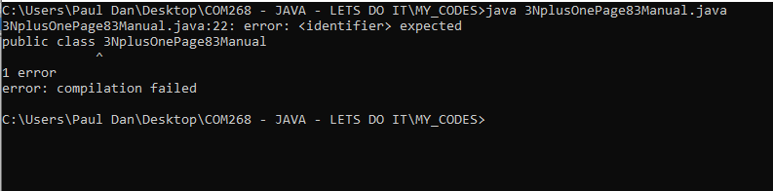

- I forgot that class name cannot start by a number, therefore 3NplusOnePage83Manual.java doesn't worked. Changed it to
treeNplusOnePage83Manual.java

CODE:
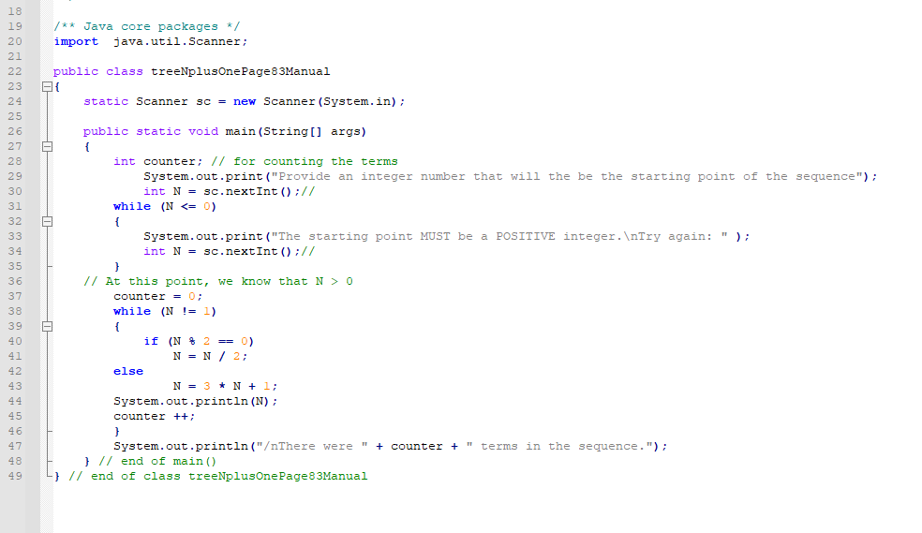
- First try I got:
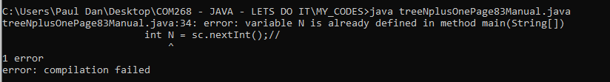

- Then:
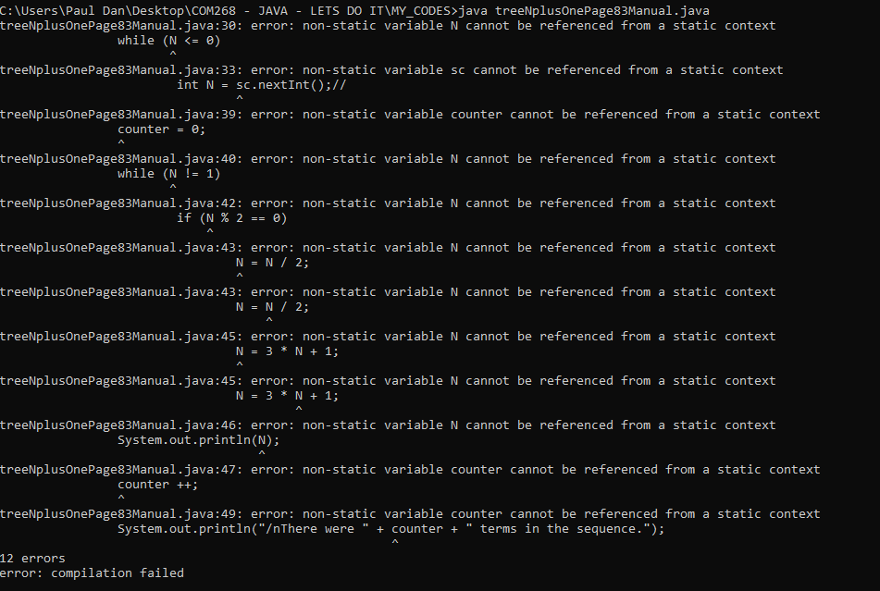
- I know is related to OOP and Scope... I'm looking examples online...
- Well, my code is badly structured.
- I need to pay attention WHERE I put stuff.
- Indentation and use of braces reviewed.
- Look nice. That's an improvement.

CODE:
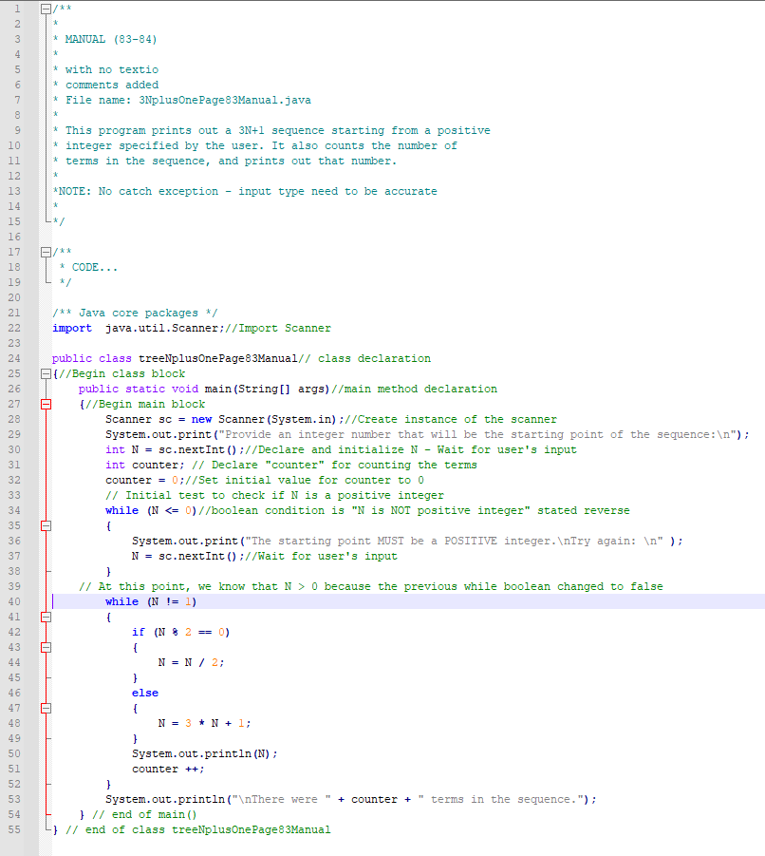
- I tested the program with the value -5, -8, 10 and 11. Then with "a".... the see the error code...
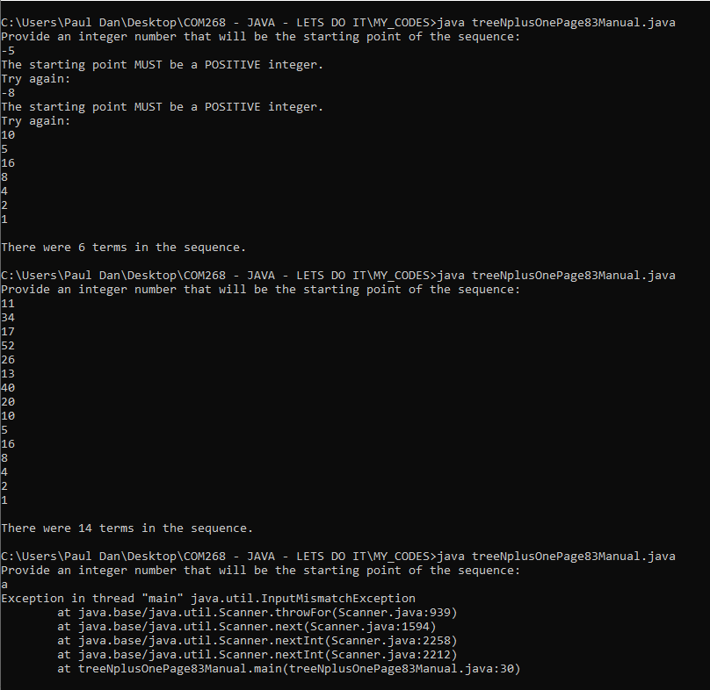
- Output as expected.

HANDS-ON CODING AND PRACTICE
- There is something confusing in my mind between
x += vs x++ vs x = x + 1
- After reviews answers from around the net, I will say that where I am right now in my coding journey It makes no difference at all.
- I will make a little program to test that.
- Just counting from1 to 25 with printout using the three ways of incrementing.
- I got same results for the three approaches.
CODE:
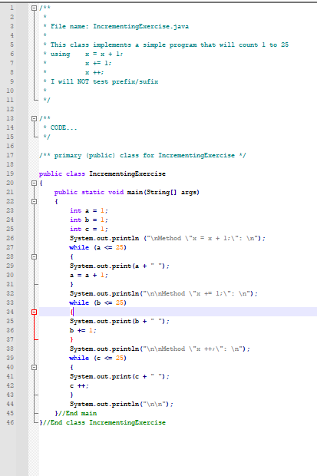

OUTPUT:

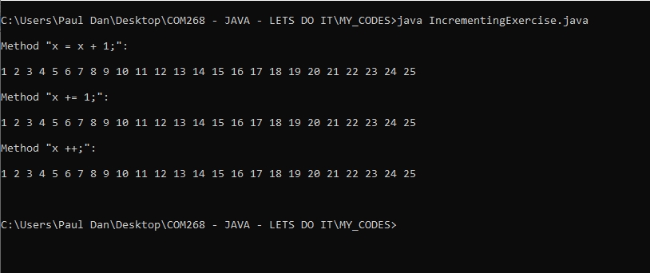

UNIT 3 - Programming in the Small II: Control (suite)
3.2.3 Coding, Testing, Debugging
- Review of concepts:
Bugs
Debugger
Debugging Statements
- I already use debugging statements in my coding journey.

3.3 The while and do..while Statements
Simple statement:
- basic building block of a program.
Compound statement:
- Used to organize simple statements into complex structures, which are called control structures because they control the order in which the statements are executed.

3.3.1 The while Statement
- See 3.1
Definition and concept:
Body of thee loop (<statement>): Repeated as long as the <boolean-expression>)is TRUE.
Continuation condition (AKA the test): (<boolean-expression>)
- If the boolean condition is FALSE in the first place the loop will never be executed, therefore the loop can be executed any number of times (including 0).
- If the boolean condition that is true becomes false somewhere in the middle of the loop body the computer continues executing the body of the loop until it gets to the end. Only then does it jump back to the beginning of the loop and test the condition, and only then can the loop end.
Sentinel value: Ex.: 0 for average. End of data. Not part of the data. Therefore, need to be placed accurately in the program so it is not process. Adjustment needs to be done as well to the counter ceteris paribus to avoid counting the sentinel value when we don't want to and when doing it doesn't make sense (Case of 0).
Priming the loop: Setting things up so that the test in a while loop makes sense the first time it is executed is called priming the loop. Example, we can simply read the first integer before the beginning of the loop.
Off-by-one errors: Sentinel value is "0" since JAVA start counting to zero. Pay attention to that. Common source of errors.

Type-casting:
Example:
int sum ;
int count;
average = ((double)sum)/count;
Syntax:
while (<boolean-expression>)
{
<statement>
}

HANDS-ON CODING AND PRACTICE
- MANUAL (87-88)
- Redo the code without TEXTIO.
NOTE: CANNOT have "-" in class name BUT yes in file name... weird
CODE:
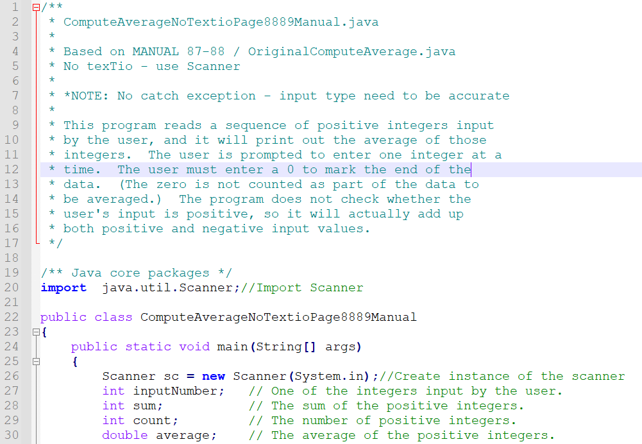
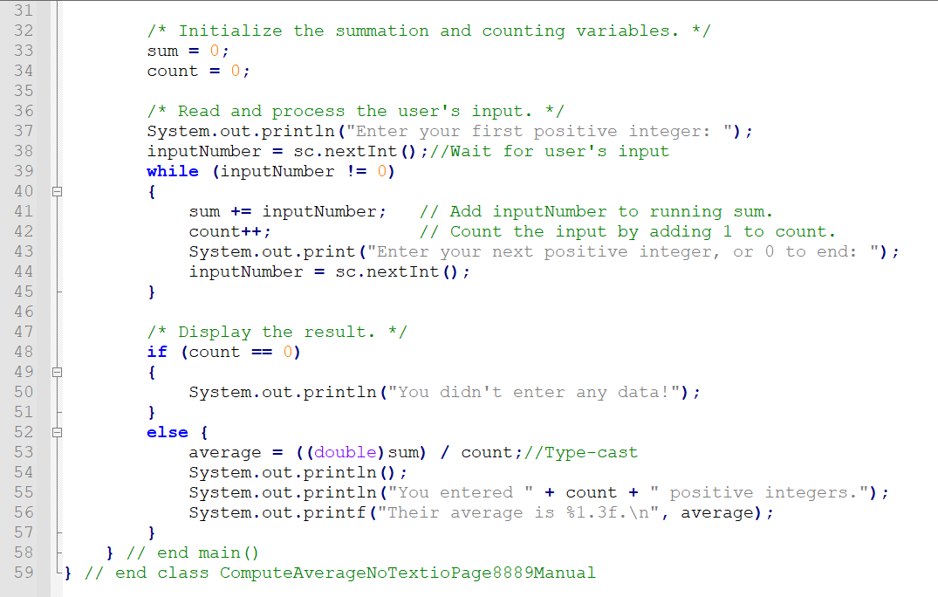

OUTPUT:
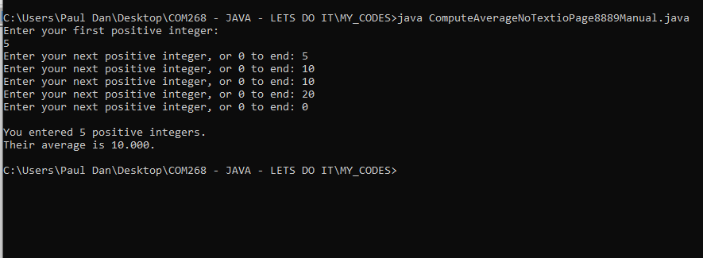
- Worked as expected.
- When I will get back to this code I want to work out the output format and use a standardized header with appropriate javadoc formatting.

3.3.2 The do..while Statement
Definition:
- Test the continuation condition AT THE END of the loop.
- The do..while statement is very similar to the while statement, except that the word “while,” along with the condition that it tests, has been moved to the end.
- The word “do” is added to mark the beginning of the loop.
Flag/Flag variable:
Examples of equivalent codes for flag value:
(1) while (wantsToContinue == true) / while
(wantsToContinue)
(2) while (flag == false) / flag / while (!flag)
- do..while statement is sometimes more convenient than a while statement.
- Keep that in mind.
Syntax:
do
<statement>
while ( <boolean-expression> );

or, since, as usual, the <statement> can be a block,

do
{
<statements>
}
while ( <boolean-expression> );

- NOTE: the semicolon, ’;’, at the END.
- Semicolon is PART of the statement.
- Omitting it is a syntax error.
- Any problem that can be solved using do..while loops can also be solved using only while statement and vice versa. (SEE my code example wantPlayWantPlay.java).
- MANUAL (90)
This... is the "same" that.... | this one
do  {  <doSomething>  }  while (<boolean-expression>); | <doSomething>  while (<boolean-expression>)  {  <doSomething>  }
while (<boolean-expression>)  {  <doSomething>  } | if (<boolean-expression>)  {  do  {  <doSomehting>  }  while (<boolean-expression>);

Semantic
"To execute a do loop, the computer first executes the body of the loop—that is, the statement or statements inside the loop—and then it evaluates the boolean expression. If the value of the expression is TRUE the computer returns to the beginning of the do loop and repeats the process; if the value is FALSE, it ends the loop and continues with the next part of the program. Since the condition is not tested until the end of the loop, the body of a do loop is always executed at least once." MANUAL (89)

HANDS-ON CODING AND PRACTICE
- My aim is to make a simple example of every structure/equivalent structure of my table.
- That will help grasp the concept of boolean condition.
- I understand the concept but it is not "natural" in my head.
- This exercise will help.
- My programs will ask a user if he wants to play.
- User will answer TRUE or FALSE.
- Print statement "PLAY" will be the < doSomething >.
- I will add System.out.println (wantPlay + "<REFERENCE>") where "wantPlay" is a boolean type variable at different part in the program to follow the program flow and "<REFERENCE>" will be a marker for my own understanding.
- I will takes time within the next section of the course material to pause and fast forward to get "functional" knowledge of "method" in JAVA.
- It is more advanced than my actual level BUT, as with what I did with the Scanner class before, I can certainly grasp the ways to make use of It within my littles basics programs without understand the complete nuances. Using simple methods, mainly print statement, count etc, will shorter my codes, improve reusability and give me more chances to practice core concepts of control flow....

- Notepad++
- It is possible to "tokens colors"...
- NOTE: I should try to make a document about Notepad++ and post it on the landing... That should had been available already, but I don't see any... will see... life is short...

Compare the four different programs
FIRST
do
{
<doSomething>
}
while (<boolean-expression>);

doDoWileControlStructureExample1.java

- At my first try with the code, I got an infinite loop; the boolean value of
while (wantContinue = true);
never got changed. I think it is because the value is changed only within the block.
- The part of the code:
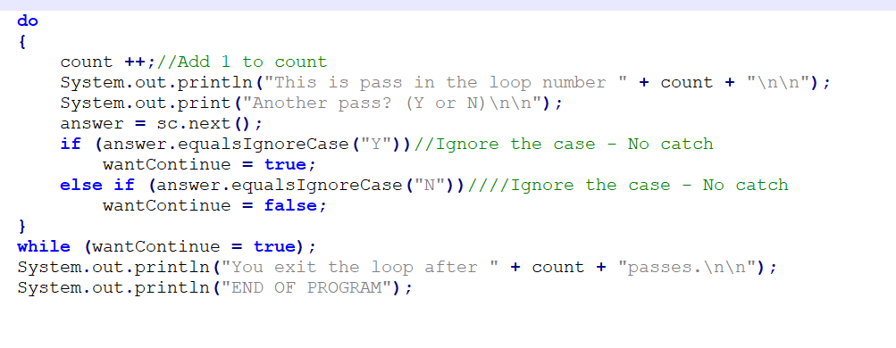
- I am adding:
System.out.print("<number>" + wantContinue);
(...) at different spots in the code to see what's the value of wantContinue at different spots.
CODE:
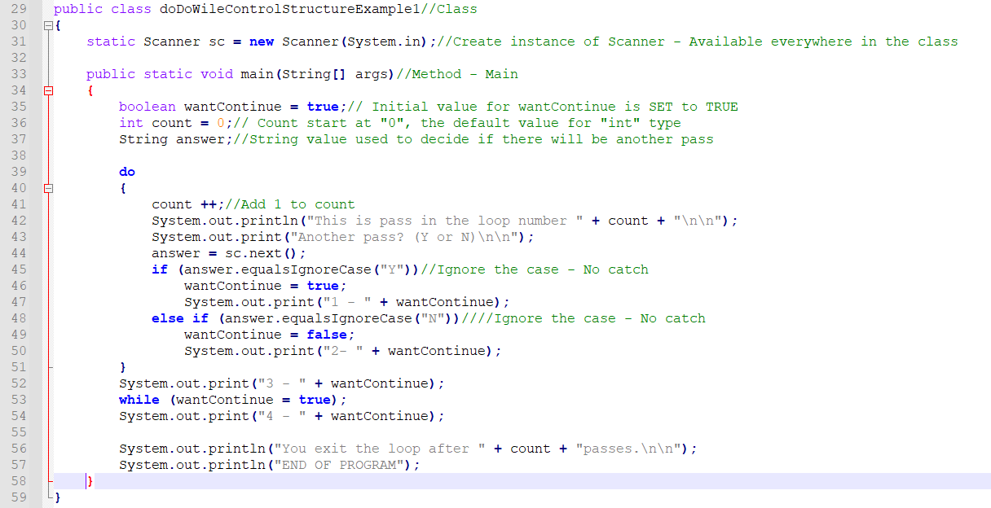

I GOT:
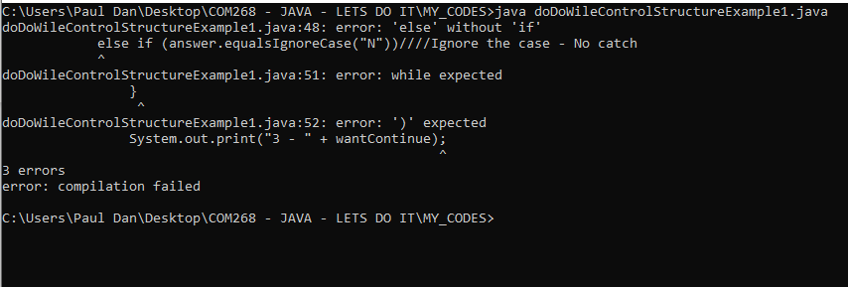
- I just spent a lot of time commenting in and out lines of code until I figured out that: while (wantContinue = true);
- Should be:
while (wantContinue);
- It means "while it's true" - not used to It!
- Basically I was resetting the value to TRUE in an eternal loop.
- I was looking only to the lines above.
- Now It works.
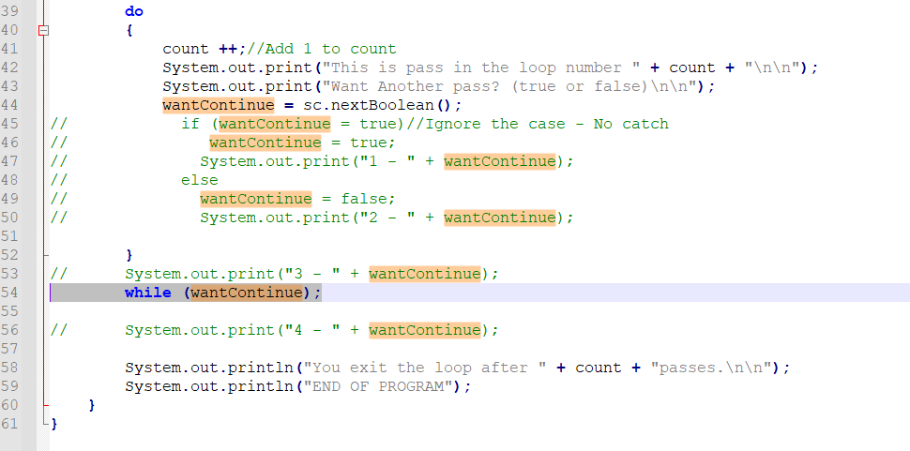

OUTPUT:
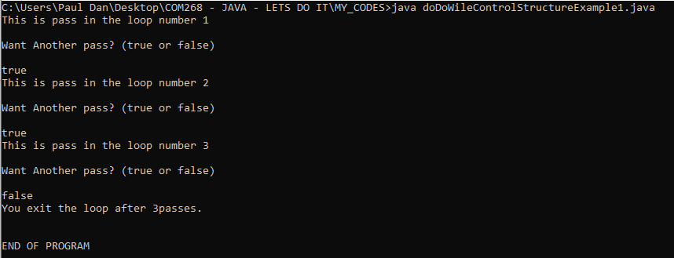

- I am going back to make work the conversion if else loop for user input as I was aiming at the beginning in a different program for more exploration.
- The simplified program is the following:
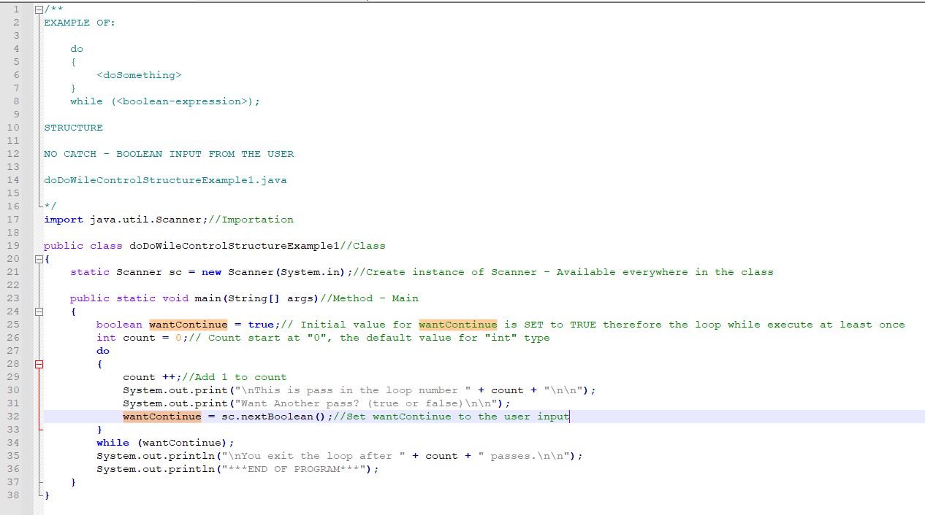

OUTPUT:
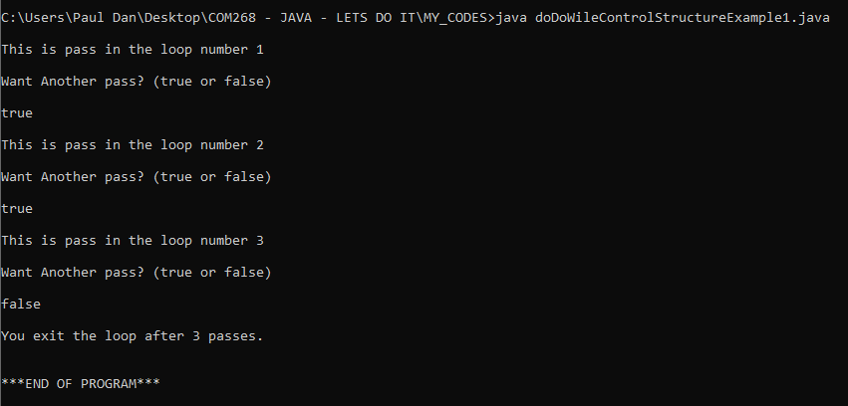

doDoWileControlStructureExample1-1.java
- It is pretty much the same exercise from a structure point of view, but the User input will be an object (String) that I will convert to a boolean in my loop. (At least I will try!)
- I will make some tests to "catch" some bad user's input. (No pain no glory!)
- Happy with that version.
Code (without reference header):
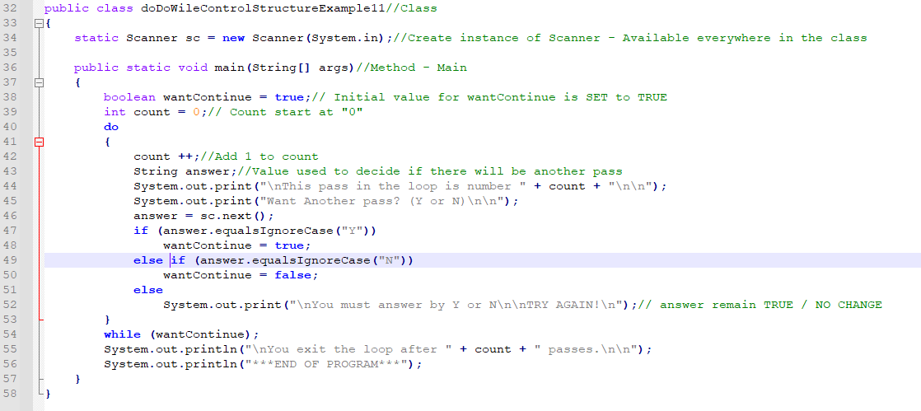
- This is not bad at all.
- Because the user input is a string, the if/else kind of foolproof the program for MUST of the cases. (For now)
- < ENTER > makes it crash! (!)
OUTPUT:
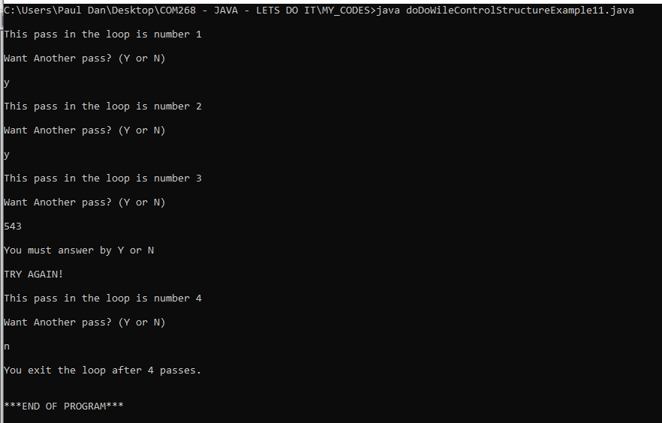

SECOND VERSION OF THE do..while
The structure is the following:
<doSomething>
while (<boolean-expression>)
{
<doSomething>
}
File name:
doDoWileControlStructureExample2.java
- I played a bit on the web to find something cool to print and I found a model of the Canadian flag as follow:
XWXWXWXWXWXWXWXWXWXWX WXWXWXWXWXWXWXWXWXWXW
WXWXWXWXWXWXWXWXWXWXW A XWXWXWXWXWXWXWXWXWXWX
XWXWXWXWXWXWXWXWXWXWX AWA WXWXWXWXWXWXWXWXWXWXW
WXWXWXWXWXWXWXWXWXWXW AA AWXWA AA XWXWXWXWXWXWXWXWXWXWX
XWXWXWXWXWXWXWXWXWXWX VXWXWXWXWXV WXWXWXWXWXWXWXWXWXWXW
WXWXWXWXWXWXWXWXWXWXW AA VWXWXWXWV AA XWXWXWXWXWXWXWXWXWXWX
XWXWXWXWXWXWXWXWXWXWX VWXWXWXA VWXWXWV AXWXWXWV WXWXWXWXWXWXWXWXWXWXW
WXWXWXWXWXWXWXWXWXWXW XWXWXWXWXWXWXWXWXWXWXWXWX XWXWXWXWXWXWXWXWXWXWX
XWXWXWXWXWXWXWXWXWXWX AXWXWXWXWXWXWXWXWXWXWXWXWXWXA WXWXWXWXWXWXWXWXWXWXW
WXWXWXWXWXWXWXWXWXWXW VXWXWXWXWXWXWXWXWXWXWXV XWXWXWXWXWXWXWXWXWXWX
XWXWXWXWXWXWXWXWXWXWX WXWXWXWXWXWXWXWX WXWXWXWXWXWXWXWXWXWXW
WXWXWXWXWXWXWXWXWXWXW AXWXWXWXWXWXWXWXWXA XWXWXWXWXWXWXWXWXWXWX
XWXWXWXWXWXWXWXWXWXWX I WXWXWXWXWXWXWXWXWXWXW
WXWXWXWXWXWXWXWXWXWXW I XWXWXWXWXWXWXWXWXWXWX
XWXWXWXWXWXWXWXWXWXWX I WXWXWXWXWXWXWXWXWXWXW
WXWXWXWXWXWXWXWXWXWXW XWXWXWXWXWXWXWXWXWXWX

- I could not find a "cut-and-paste" copy of, just archive image in format I don't know how to get it.
- It so it took me a long time to adapt It and make It manually. (Too long...)
- I spent already a bit of time working on learning about method to simplify my code example but I am not finished yet.
- However, I will try for the next few tests to use a method, i.e. calling a method that print my Canadian flag.
- In the same section at the end of Unity 3, I will rework the < get from file > aspect of JAVA if I get time, with my secondary source as well to be able to use external files as It will be required for the last assignment of the course. (Will see. There are other way around.)
- I will make a complete personal part after "3.8.5 Two-dimensional Arrays" about "Method" and "data on files" before going on unit 4 if I get a chance. This way I will be able to reuse some of my work and plays more with the nuances of JAVA. Meanwhile, I go back and forth in my learning diary to that "method" section as needed to make my code works.
- Up to now, I wrote a lot of menial codes for the purpose of getting the beginner errors and see where I need to pay attention.
- Now I am more confident, and I want start doing more interesting coding project without having to edit a tons of basic codes.
- I already understand the underlying mechanic. (I think)
- To print the canadianFlag I come up with:
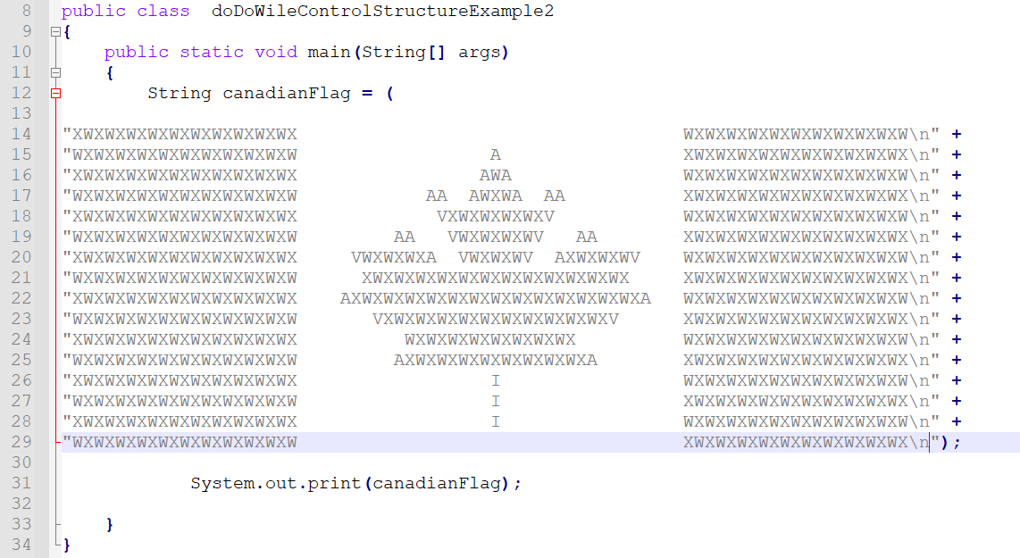
OUTPUT:
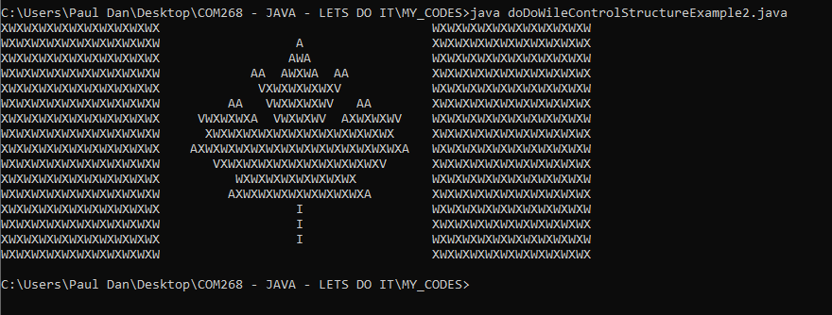
- Now, I want to make two methods:
(1) canadianFlag()
Will print my canadian flag as seen above

(2) wantAnoterFlag()
Will change boolean that print the flag
- Thinking about It, I will make two other methods
(3) welcomeToProgram()
- Welcome message script.
(4) endOfProgram
-End of program script.
- Going back to the structures I am currently working on in the section I came up with a modified version of my table to compare the structure of the current section:
This... is the "same" that.... | CODE STRUCTURE | this one | CODE STRUCTURE
A1  do  {  <doSomething>  }  while (<bool-expression>); | welcomeToProgram()  do  {  canadianFlag()  }  while(wantAnoterFlag());  endOfProgram() | A2  <doSomething>  while (<bool-expression>)  {  <doSomething>  } | welcomeToProgram()  canadianFlag()  while(wantAnoterFlag());  {  canadianFlag()  }  endOfProgram()
B1  while (<bool-expression>)  {  <doSomething>  } | welcomeToProgram()  while(wantAnoterFlag());  {  canadianFlag()  }  endOfProgram() | B2  if (<bool-expression>)  {  do  {  <doSomehting>  }  while (<bool-xpression>); | welcomeToProgram()  if (wantAnoterFlag());)  {  do  {  canadianFlag()  }  while(wantAnoterFlag());  endOfProgram()

- Kind of proud of my table.
- Now I gone create my methods.
- By testing them I will be able to make another table with "where" and to "which" value I need to initialize my variables.
- I will test as well after the "default value" concept; for now, it remains abstract in my head.
Methods:
(1) canadianFlag()
Contrat of the method: Print the flag
Code:
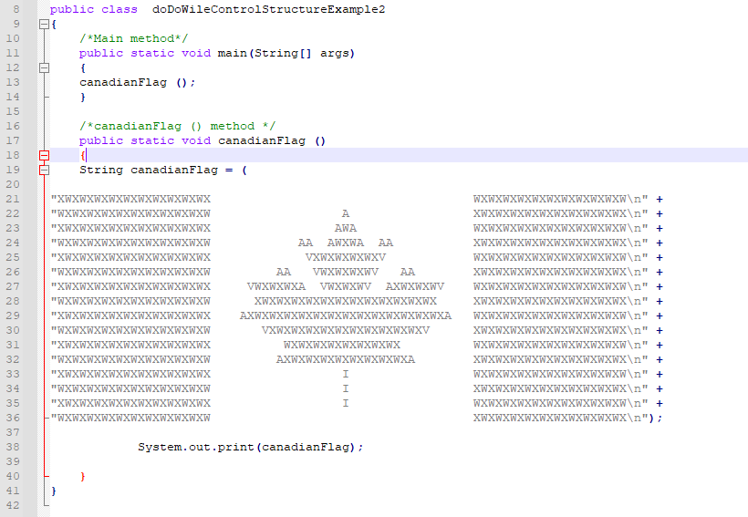
OUTPUT:
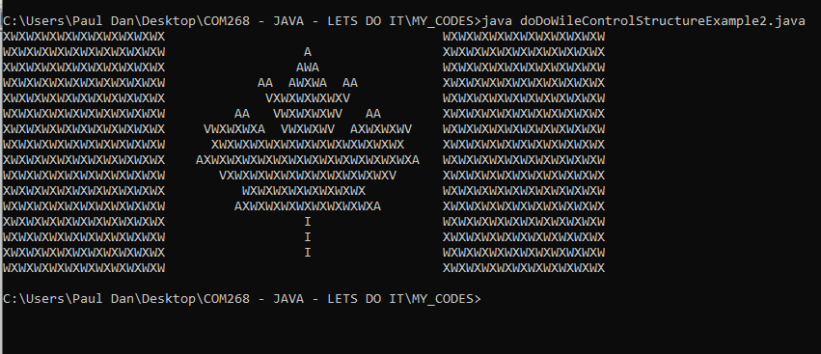
- It Works.

(2) wantAnotherFlag()
Contrat of the method: Ask the user if he wants another flag; change the corresponding boolean value accordingly
- I will use the model of the loop similar that I created in
doDoWileControlStructureExample11.java
- That looks like:
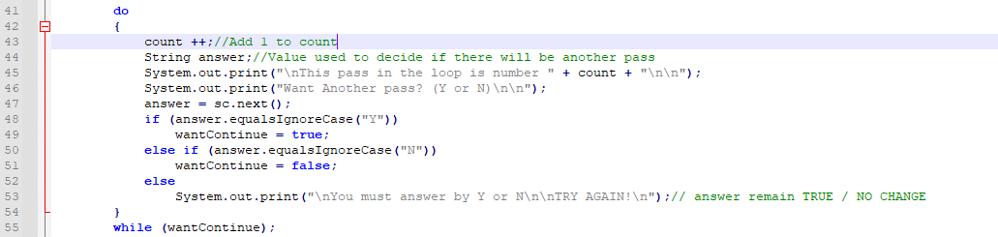

- Pretty much the pattern.
- boolean wantAnotherFlag = false; will initialize in main.
Will change boolean that print the flag
- GOT ALL kind of errors with the "else if".
- Look in my secondary sources to review the structure of the statements in that method.
- I made a handwritten flowchart that look genius and accurate but the compiler doesn't share my view.
- I put it aside for now.
- Will get back to It in an hour.
- Need to check online if/if else/ if if else else before be able to carry on.
- The structure of the syllabus of the course and the sequence in the MANUAL is counter-intuitive for me. I feel that I don't have the right tools at the right moment to explore appropriately my new endeavor of "coding".
- OK - PAUSE - I spent way too much time in the program for what I want to accomplish
I got:
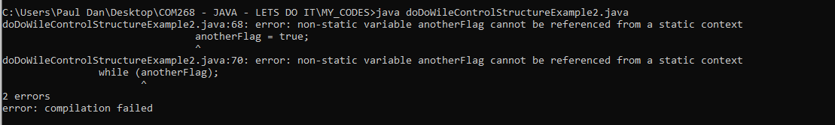
- I put It aside.
- I cloned the file to another name.
- Will come back to It later.
doDoWileControlStructureExample2Version2.java
- I am modifying it to take boolean answer from the user.
- Not fool proof.
- Create a secondary file to test my method.
wantAnotherFlag.java
Code:
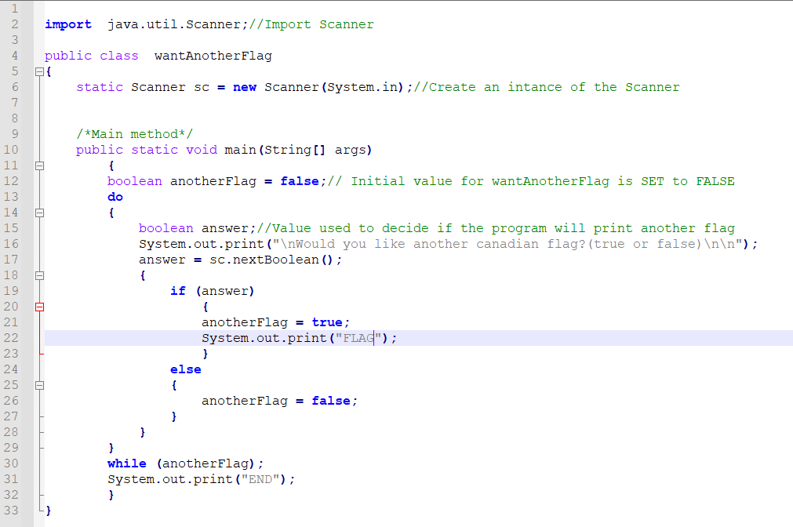
- Took my awhile to make it work.
- I was confuse with the literals and the while () scheme.
- The value declaration and initialization would need to be placed before the loop in my other program.
OUTPUT:
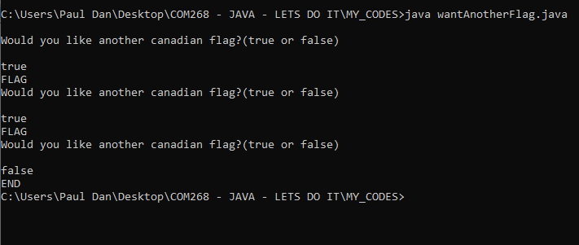
- So, the mechanic works.
- Back to my doDoWileControlStructureExample2Version2.java and the design of my method to call the method that draw the flag.
Code:
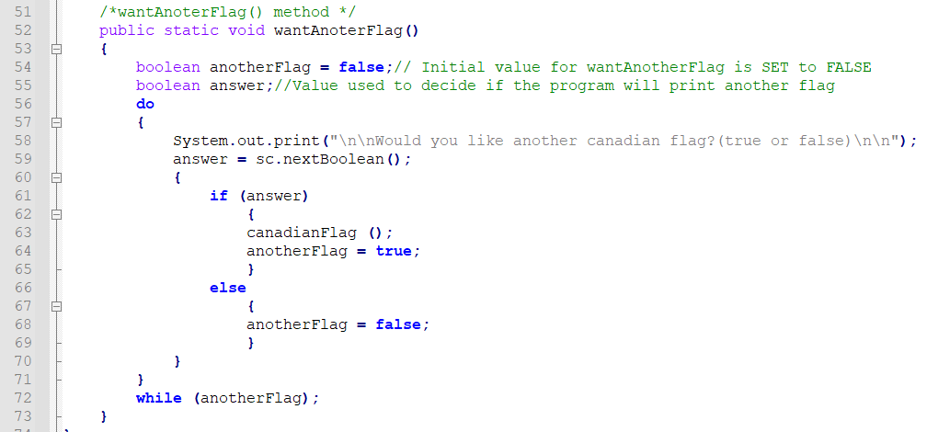
- I initialized both boolean values but gave only a "false" to anotherFlag;
- By default they are initialized to "false" according to the STANDARD.
- ATPIT my main method is the following:
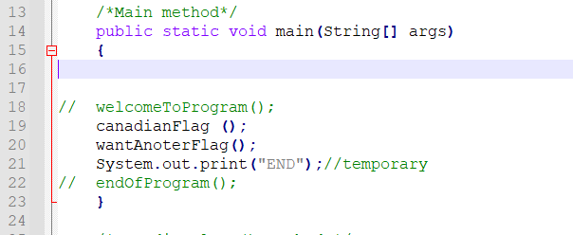

OUTPUT:
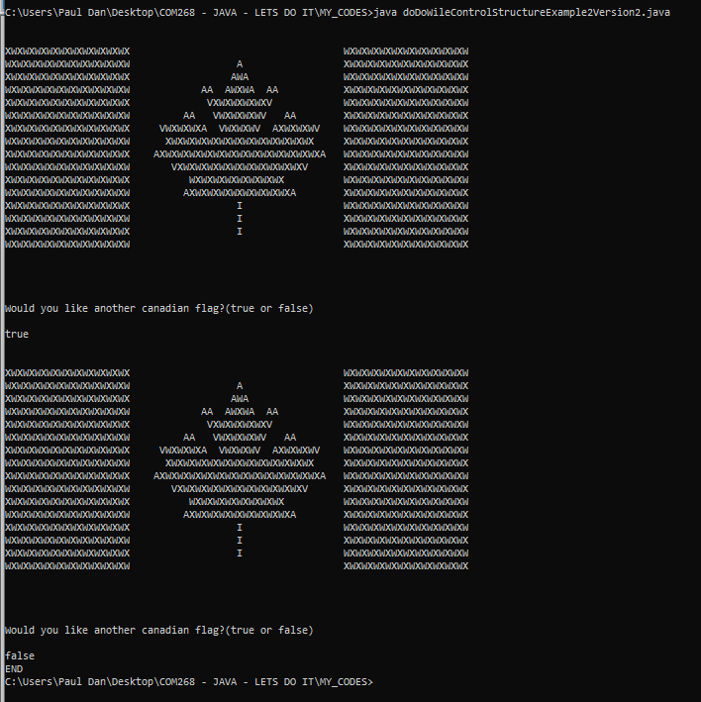
- All good; works as expected

THIRD METHOD:
(3) welcomeToProgram()
- Welcome message script.
- Complete and works.

FOURTH METHOD
(4) endOfProgram
-End of program script.
- Complete and works.

ATPIT CODE:
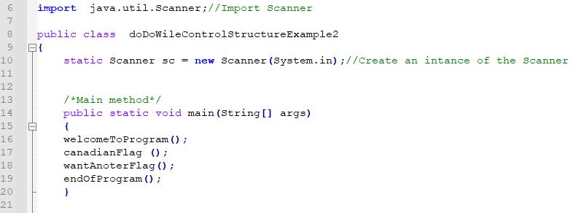
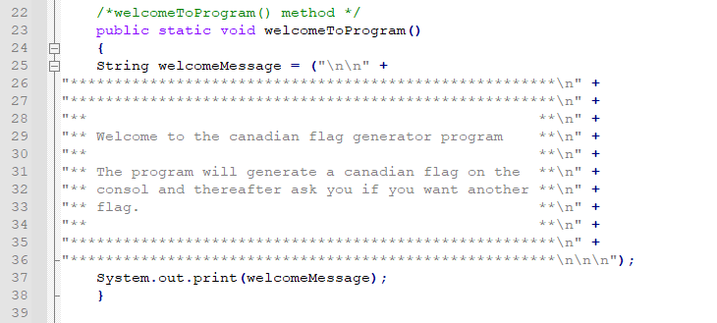
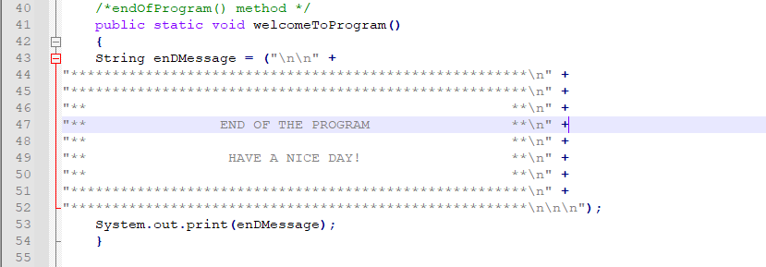
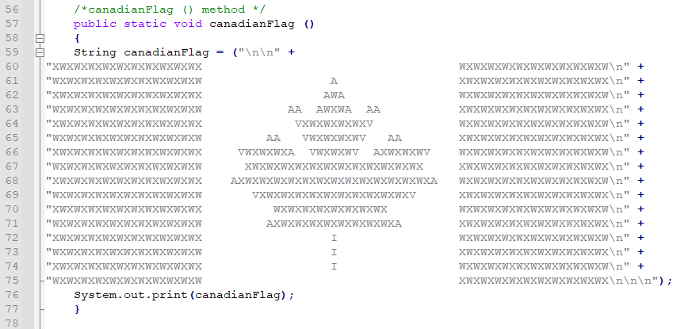
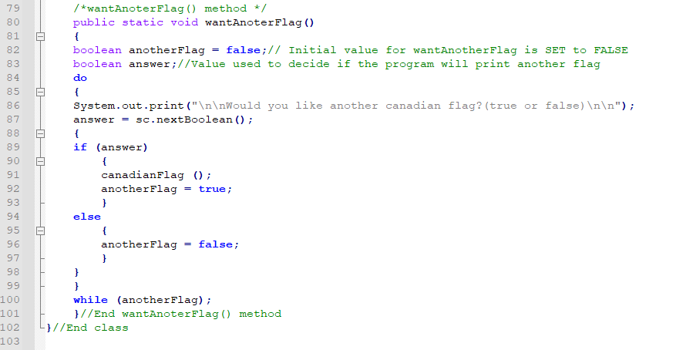
OUTPUT:
- Was working but no longer working. (!)
- Error:
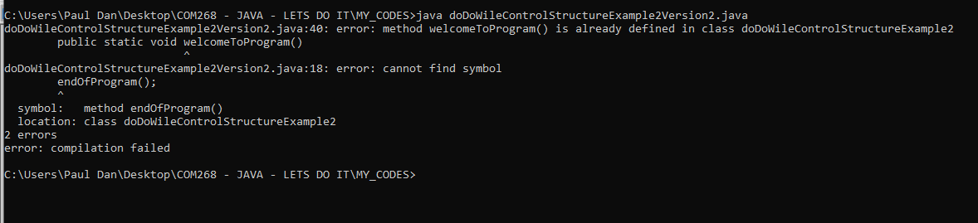
- Forgot to change the name of the class...
- Mmmmm... will get back to it...

UNIT 3 - Programming in the Small II: Control (suite)
- SEE: Method - LOWE book 2 chapter 7

HANDS-ON CODING AND PRACTICE
- GuessingGameMethod2.java
- (...)
- Nothing to mention. Works as expected,

UNIT 3 - Programming in the Small II: Control (suite)
3.3.3 break and continue
Definition:
"The syntax of the while and do..while loops allows you to test the continuation condition at either the beginning of a loop or at the end. Sometimes, it is more natural to have the test in the middle of the loop, or to have several tests at different places in the same loop. Java provides a general method for breaking out of the middle of any loop. It’s called the break statement, which takes the form break; When the computer executes a break statement in a loop, it will immediately jump out of the loop. It then continues on to whatever follows the loop in the program." MANUAL (90)

Syntax:
break;

HANDS-ON CODING AND PRACTICE
breakExample1.java
- Test the "while(true)" loop structure.
- CODE:
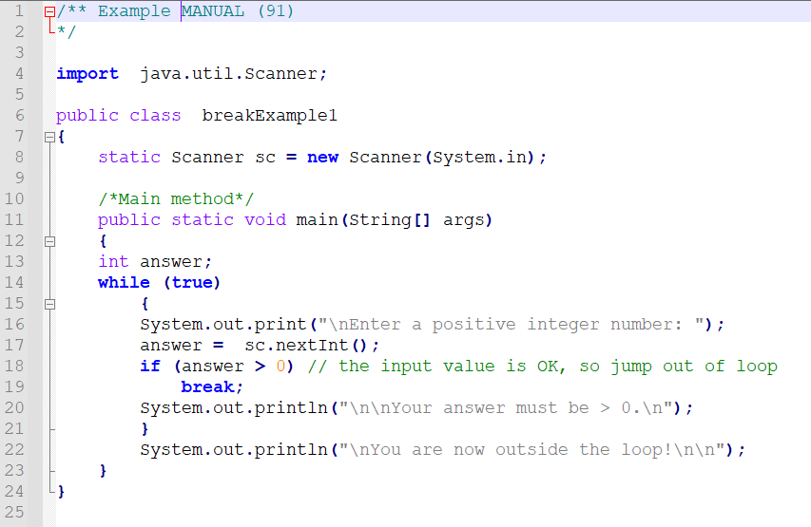

OUTPUT:

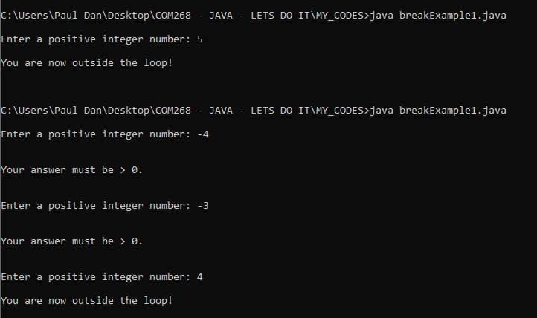

UNIT 3 - Programming in the Small II: Control (suite)
From Eck:
- The condition in a while loop can be any boolean-valued expression.
- The computer evaluates this expression and checks whether the value is true or false. The boolean literal “true” is just a boolean expression that always evaluates to true. So “while (true)” can be used to write an infinite loop, or one that will be terminated by a break statement
- A break statement terminates the loop that immediately encloses the break statement.
- It is possible to have nested loops, where one loop statement is contained inside another. If you use a break statement inside a nested loop, it will only break out of that loop, not out of the loop that contains the nested loop.
- There is something called a labeled break statement that allows you to specify which loop you want to break.
- This is not very common. ( *** Why????)
- You can put a label in front of any loop. A label consists of a simple identifier followed by a colon. For example, a while with a label might look like “mainloop: while...”. Inside this loop you can use the labeled break statement “break mainloop;” to break out of the labeled loop.
- For example, here is a code segment that checks whether two strings, s1 and s2, have a character in common.

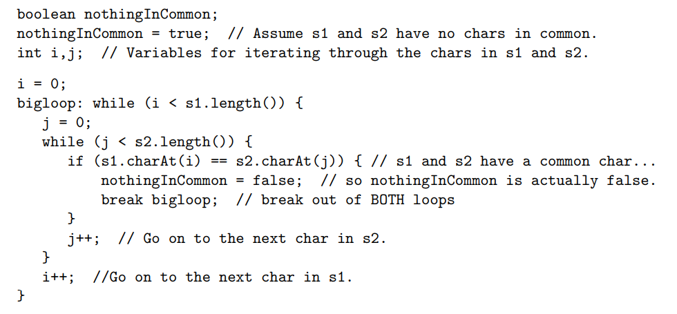

HANDS-ON CODING AND PRACTICE
File:
myVersionNothingInCommon.java
- SEE:
https://www.javatpoint.com/why-non-static-variable-cannot-be-referenced-from-a-static-context-in-java
- SEE:
https://www.edureka.co/blog/java-string/
TAKUZU:
myExampleBreakNestedLoopTakuzu.java
- All works.

UNIT 3 - Programming in the Small II: Control (suite)

Eck:
The continue statement is related to break, but less commonly used. A continue statement tells the computer to skip the rest of the current iteration of the loop. However, instead of jumping out of the loop altogether, it jumps back to the beginning of the loop and continues with the next iteration (including evaluating the loop’s continuation condition to see whether any further iterations are required). As with break, when a continue is in a nested loop, it will continue the loop that directly contains it; a “labeled continue” can be used to continue the containing loop instead. break and continue can be used in while loops and do..while loops. They can also be used in for loops, which are covered in the next section. In Section 3.6, we’ll see that break can also be used to break out of a switch statement. A break can occur inside an if statement, but only if the if statement is nested inside a loop or inside a switch statement. In that case, it does not mean to break out of the if. Instead, it breaks out of the loop or switch statement that contains the if statement. The same consideration applies to continue statements inside ifs.

3.4 The for Statement
- For statement is another type of loop.
- Any for loop is equivalent to some while loop
- Easier to construct and read for certain type of problem than the corresponding while loop.

3.4.1 For Loops
Definition:
- The for statement is used in "for loop".
- Any for loop is equivalent to some while loop but provide for a certain type of problem be easier to construct and read structure than the corresponding while loop.

Syntax:
General form:
<intialization>
while (<continuation-condition>)
{
<statements>
<update>
}

HANDS-ON CODING AND PRACTICE
numberOneToTenV1.java
int numberOneToTen = 1;
while (numberOneToTen =<10)
{
System.out.print(numberOneToTen + " ");
numberOneToTen ++;

CODE :
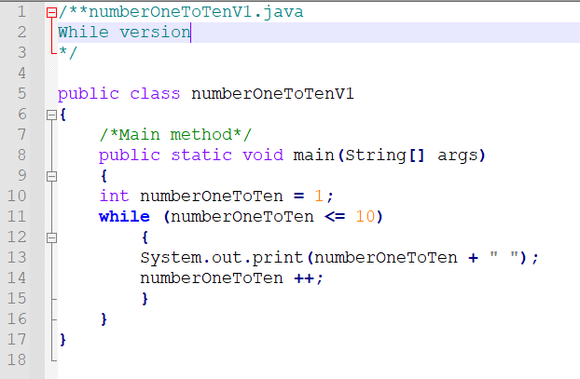
OUTPUT:
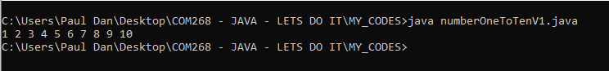

- The loop can be written as the following equivalent "for" statement.

numberOneToTenV2.java
Code:
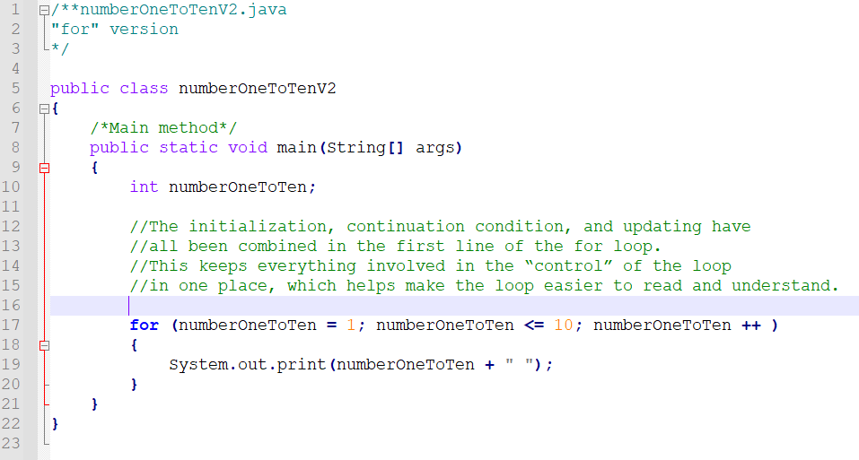
Output is the same:
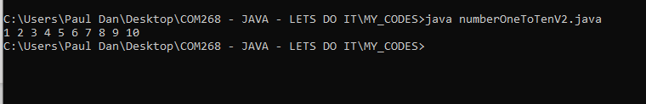

//The initialization, continuation condition, and updating have
//all been combined in the first line of the for loop.
//This keeps everything involved in the “control” of the loop
//in one place, which helps make the loop easier to read and understand.
- BUT... not the variable declaration...
- Need to declare the variable FIRST.

UNIT 3 - Programming in the Small II: Control (suite)
Semantic:
- The initialization part is executed once before the loop begins.
- The continuation condition is executed before each execution of the loop (including the first execution), and the loop ends when this condition is false. The update part is executed at the end of each execution of the loop, just before jumping back to check the condition.

Syntax:
- No block statement:

for ( <initialization> ; <continuation-condition>; <update> )
<statement>

- With block statement:
for ( <initialization> ; <continuation-condition>; <update> )
{
<statements>
}

- <continuation-condition> MUST be a boolean-value expression.
- <initialization> is usually declaration or an assignment statement, but it can be any expression that would be allowed as a statement in a program.
- <update> can be any simple statement, but is usually an increment, a decrement, or an assignment statement.
- Any of the three parts can be empty.
- If the continuation condition is empty, it is treated as if it were “true,” so the loop will be repeated forever or until it ends for some other reason, such as a break statement.
- NOTE: Some people like to begin an infinite loop with “for (;;)” instead of “while (true)”.

Counting for loop syntax:
for ( <variable> = <min> ; <variable < = (max)>; <variable>++ )
{
<statement(s)>
}
Eck:
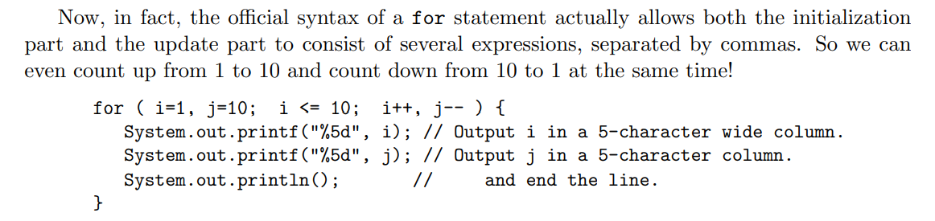
Flow control diagram for a for statement:
- MANUAL (93)
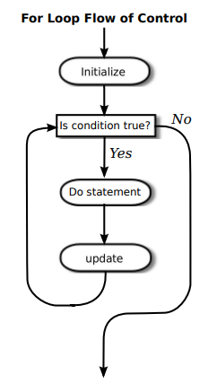
- REMEMBER: Off-by-one error concept.
- Usually, the initialization part of a for statement assigns a value to some variable, and the update changes the value of that variable with an assignment statement or with an increment or decrement operation. The value of the variable is tested in the continuation condition, and the loop ends when this condition evaluates to false. A variable used in this way is called a loop control variable. In the example given above, the loop control variable was years. Certainly, the most common type of for loop is the counting loop, where a loop control variable takes on all integer values between some minimum and some maximum value
- Perhaps it is worth stressing one more time that a for statement, like any statement except for a variable declaration, never occurs on its own in a real program.
- A statement must be inside the main routine of a program or inside a method.
- A method must be defined inside a class.
- Every variable must be declared before it can be used, and that includes the loop control variable in a for statement.
- It is not required that a loop control variable be an integer.
(...) Here, for example, is a for loop in which the variable, ch, is of type char, using the fact that the ++ operator can be applied to characters as well as to numbers. (...)

HANDS-ON CODING AND PRACTICE
bunchOfExamplesAndPratice.java
- For practice I will create a program with a few examples of for loops with a header for each loop describing what it is.
- They all will be part of the main method and make a print statement with the description, the code and the output.
- That exercise will help me to memorize the structures.
- All as expected.

UNIT 3 - Programming in the Small II: Control (suite)

3.4.2 Example: Counting Divisors
- Walk through...
MANUAL (95-97)
myVersionCountDivisors.java
Comments on the example and adaptation of the code:
- The algorithm displays a common programming pattern that is used when some, but not all, of a sequence of items are to be processed.
- The general pattern is:
for each item in the sequence:
if the item passes the test:
process it
- translated into Java code:
for (testDivisor = 1; testDivisor <= N; testDivisor++)
{
if ( N % testDivisor == 0 ) divisorCount++;
}
- Complete PSEUDOCODE ALGORITHM in the header of the file (...)

PSEUDOCODE ALGORITHM:
Get a positive integer, N, from the user
Let divisorCount = 0 // Number of divisors found.
Let numberTested = 0 // Number of possible divisors tested
// since the last period was output
for each number, testDivisor, in the range from 1 to N:
if testDivisor is a divisor of N:
Count it by adding 1 to divisorCount
Add 1 to numberTested
if numberTested is 10000000:
print out a ’.’
Reset numberTested to 0
Output the count

- NOTE: Use of ":" within pseudocode in the MANUAL
- Everything works as expected

3.4.3 Nested for Loops
- Example walk through.
Eck
- Control structures in Java are statements that contain other, simpler statements.
- Control structures can contain control structures.
- Any combination of one control structure inside another is possible.
- Nested: One structure is contained within another structure
- Multilevel of "nesting" are possible and JAVA doesn't set any limit of the number of levels

- Nested for loops arise naturally in many algorithms, and it is important to understand how they work.
myCodemultiplicationTableExample.java
PSEUDOCODE ALGORITHM:
for each rowNumber = 1, 2, 3, ..., 12:
for N = 1, 2, 3, ..., 12:
Print N * rowNumber
Output a carriage return
- Everything worked as expected.

for ( rowNumber = 1; rowNumber <= 12; rowNumber++ )
{
for ( N = 1; N <= 12; N++ )
{
System.out.printf( "%4d", N * rowNumber ); //4-character columns
}
System.out.println(); // Add a carriage return at end of the line.
}

HANDS-ON CODING AND PRACTICE
File:
myVersionlettersStringCountLoopExample.java
- REMEMBER: Class names start by Capital letter... I don't do It all the time...
- Header and comment in full and include two steps of the algo.
- Pay attention to inner loop break mechanism.
- Removed TEXTIO and changed to Scanner class for the user input.
-Everything worked as expected.

ALGORITHM:
(1)
Ask the user to input a string
Read the response into a variable, str
Let count = 0 (for counting the number of different letters)
for each letter of the alphabet:
if the letter occurs in str:
Print the letter
Add 1 to count
Output the count
(2)
Ask the user to input a string
Read the response into a variable, str
Convert str to upper case
Let count = 0
for letter = ’A’, ’B’, ..., ’Z’:
for i = 0, 1, ..., str.length()-1:
if letter == str.charAt(i):
Print letter
Add 1 to count
break // jump out of the loop, to avoid counting letter twice
Output the count

- Everything worked as expected
- REMARK: Same could be achieved with str.indexOf(letter) method.

3.5 The if Statement
IfExamplesAndExploration.java
- Worked as expected.

UNIT 3 - Programming in the Small II: Control (suite)
REVIEW OF SYNTAX:
VERSION WITH "ELSE":
*** Tells the computer to take one of two alternative courses of action, depending on whether the value of a given boolean-valued expression is true or false

if ( <boolean-expression>)
{
<statement1>
}
else
{
<statement2>
}
VERSION WITHOUT "ELSE":
***Tells the computer to choose between doing something and not doing it.

if ( <boolean-expression>)
{
<statement1>
}
- The statements inside an if statement can be blocks.
- The if statement represents a two-way branch. The else part of an if statement—consisting of the word “else” and the statement that follows it - can be omitted.

3.5.1 The Dangling else Problem
- Either <statement-1> or <statement-2> in a if statement can itself be an if statement.
- It is forbidden by the syntax of Java that <statement-1> be an if statement that has NO else part.
- That can be fixed by nesting it in a block when needed.

3.5.2 Multiway Branching
if ( <boolean-expression-1>)
<statement-1>
else
if (<boolean-expression-2>)
<statement2>
else
<statement3>
BECAUSE INDENTATION MEANS NOTHING IN JAVA IT IS WRITTEN MOST
OF THE TIME:
if (<boolean-expression-1>)
<statement-1>
else if (<boolean-expression-2>)
<statement2>
else
<statement3>
- You should think of this as a single statement representing a three-way branch.
- When the computer executes this, one and only one of the three statements <statement-1>,<statement-2> or <statement-3>will be executed.
- The computer starts by evaluating <boolean-expression-1>.
- If it is TRUE, the computer executes <statement-1> and then jumps all the way to the end of the outer if statement, skipping the other two <statements>
- If is (<boolean-expression-1>)IS FALSE, the computer skips <statement-1> and executes the second, nested if statement.
- To do this, it tests the value of (<boolean-expression-2>) i and uses it to decide between <statement-2> and <statement-3>.

MULTIWAY BRANCHES
- You can go on stringing together “else-if’s” to make multiway branches with any number
of cases:

if (<boolean-expression-1>)
<statement-1>
else if (<boolean-expression-2>)
<statement-2>
else if (<boolean-expression-3>)
<statement-3>
else if (<boolean-expression-4>)
<statement-4>
(...)
else
<statement-"x">
- The computer evaluates the tests, which are boolean expressions, one after the other until it
comes to one that is TRUE.
- It executes the associated statement and skips the rest.
- If none of the boolean expressions evaluate to TRUE, then the statement in the ELSE part is executed.
- One and only one of the statements will be executed.
- The final ELSE part can be omitted.
- In that case, if all the boolean expressions are FALSE, none of the statements are executed.
- Each of the statements CAN be a block, consisting of a number of statements enclosed between braces.

MULTIWAY BRANCH - FLOW CHART (MANUAL (103))
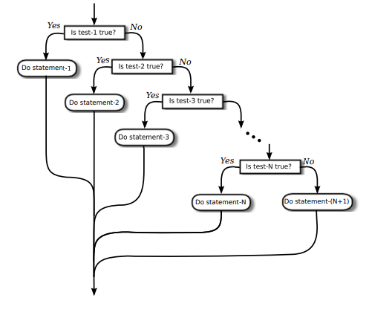
3.5.3 If Statement Examples
IfExamplesAndExploration.java
- That code is pretty much the two sort algorithm directly taken from the MANUAL (103-104).
- I reviewed the code step by step to understand the mechanic.
- *The are a lot of different sorting algorithms; SEE "Sorting Algorithms" in WIKIPEDIA.
TakuzuV1.java
- Self-commissioned example.
- Generate all Takuzu possibilities with only JAVA control structures.
- To be rework.
- Notepad++:
- Select code CTRL+H "in selection" find-replace replace-all
- The window doesn't close; can do that for many lines with different values.
- CTRL+Q Comment Out a line or a block.
HANDS-ON CODING AND PRACTICE
MyVersionLengthConverter.java
- Based on LengthConverter.java from MANUAL (106-107).
- Removes TEXTIO.
- Import Scanner / create Scanner for user's input.
- The original program as seen in the MANUAL is missing a second question for the "units".
- I added the option to quit at the second step of user input.
- *ALL GOOD COMPLETED

UNIT 3 - Programming in the Small II: Control (suite)
- Notepad++
- To od: Make shortcut list;
- Find/Explain Comment overlay with "levels".

3.5.4 The Empty Statement
- Statement that consists simply of a semicolon, and which tells the computer to do NOTHING.
- (;)
- Sometime useful.
- { }, empty block can be equivalent.
- Aim to makes legal some constructs like if with no else part.

3.6 The switch Statement
- The switch statement is used far less often than the if statement, but it is sometimes useful for expressing a certain type of multiway branch.
- Personally, I like it better. "Clearer".

3.6.1 The Basic switch Statement
- A switch statement allows you to test the value of an expression and, depending on that value, to jump directly to some location within the switch statement.
- Only expressions of certain types can be used.
- The value of the expression CAN be one of the primitive integer types int, short, byte, the primitive char type, String or an enum type.
- CANNOT be a double or float value.
- Case labels.
- Takes the form: case <constant>:
- Marks the positions within a switch statement to which it the computer jumps to when
the expression evaluates (i.e. "is the same") to the given case <constant>:
- case <constant>: it's a literal of the same type as the expression in the switch.
- You can also use the label default:
- It provides a default jump point that is used when the value of the expression is not listed in any case label.

Most USED syntax:
switch (<expression>) {
case <constant-1>:
<statements-1>
break;
case <constant-2>:
<statements-2>
break;
(...)
. // (more cases)
case <constant-N>:
<statements-N>
break;
default://optional default case
<statements-n+1>
}//end of switch statement

- We can achieve the same effect as the following multiway if statement:
if (<expression>) == <constant-1>) { // but use .equals for String!!
<statements-1>
}
else if (<expression> == <constant-2>) {
<statements-2>
}
(...)
else if (<expression> == <constant-N>) {
<statements-N>
}
else {//That is the default case
<statements-(N+1)>
}

- Both accomplish the same.
- The switch statement can be more efficient because the computer can evaluate one expression and jump directly to the correct case, whereas in the if statement, the computer must evaluate up to N expressions before it knows which set of statements to execute.
***Experience: ADD TIMER AS PREVIOUSLY SEEN IN THE EXAMPLE TO SEE THE DIFFERENCE IN TIME FOR EACH OF THEM TO ACCOMPLISH THE TASK - MAYBE IT IS TOO SHORT A CODE TO SEE ANY DIFFERENCE - TEST IT ANYWAY
- The break statements in the switch are not actually required by the syntax of the switch statement.
- You can leave out one of the groups of statements entirely (including the break). You then have two case labels in a row, containing two different constants. This just means that the computer will jump to the same place and perform the same action for each of the two constants. (SEE ex. MANUAL (109) bottom of page)
break; The effect of a break is to make the computer jump past the end of the switch statement, skipping over all the remaining cases. If you leave out the break statement, the computer will just forge ahead after completing one case and will execute the statements associated with the next case label. This is rarely wanted but it is legal in JAVA.
return; Inside a method the break statement is sometimes replaced by a return statement, which terminates the method as well as the switch.
continue;

HANDS-ON CODING AND PRACTICE
SwitchStatementsSyntaxExampleManual109.java
- SEE:
NewSwitchStatementsSyntaxExampleManual113.java
(...) of section 3.6.5 to compare Syntax for "switch".
- Try CODE AND OUTPUT.

IfVersusSwitchExample.java
- I will code an example using if and switch to accomplish the task of giving the international alphabet for a letter input from the user.
- (I am really good at making a "supposed to be 5 minutes project" into a 3 hours one OR I am too ambitious!).
- It's good practice anyway.
- Missed "" in the boolean condition for the ifs statements.
- My first idea was to use char type.
- Play around switch between String and char type.
- A lot of logical and editing errors.
- I fixed most of It but now I got "Zulu" all the time as output for the first example.
- That mean only my "else" part is executed.
- I will try to switch back to char type and remove the "" in the boolean condition for the different ifs statements.
- I got
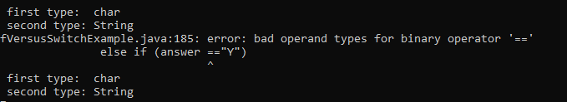
- That's wrong
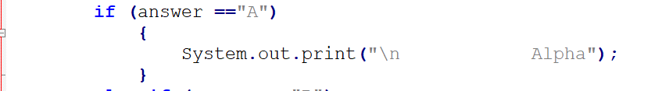
- ' NOT " as in French.... while working with char....
- Need to pay attention to that...
- I will add some fool proofing with while to re-ask the user for invalid input, e.g. if more than one character as input or a number...
- First example working now. But the "else" got everything that's not a to y.... mmm
- Has to create second variable for the conversion to uppercase.
- Working on second example with case.
- Code and output now as expected.

UNIT 3 - Programming in the Small II: Control (suite)
3.6.2 Menus and switch Statements
- One application of switch statements is menus.
- User selects one of the options among a list of options
- In a command-line program, the menu can be presented as a numbered list of options, and the user can choose an option by typing in its number.
- Examples MANUAL (110-111) .
- IMPORTANT: int (#) String ("") chart(' ') for switch statement.

3.6.3 Enums in switch Statements
See Eck 3.6.3
- The type of the expression in a switch can be an enumerated type. In that case, the constants in the case labels must be values from the enumerated type.
- SEE example MANUAL (112).
- When an enum constant is used in a case label, only the simple name, such as “SPRING” is used, not the full name, such as “Season.SPRING”.
- The computer already knows that the value in the case label must belong to the enumerated type, since it can tell that from the type of expression used, so there is really no need to specify the type name in the constant.

3.6.4 Definite Assignment and switch Statements
- "default:" will cover and tell compiler that all cases are cover as "else" with if statements
- Interesting code example from MANUAL (113) where the case that will be executed is NOT from a USER input but by an expression
- In this case a random int generated
- Could be a way to generate a random hand of poker consisting of 5 cards - I will try to build a poker hand generator using that model leteron...

HANDS-ON CODING AND PRACTICE
BlackJackGameWithSwitch.java
- I got enough JAVA to create a game of Black Jacks if I use switch.
- I will make a first try and see how it goes.
- Compare to poker, in Black Jack there is many decks in the dealer pile.
- Therefore, at one against one, no more than 10 cards can be shows; therefore I don't have to worry for my random generation of cards assuming the dealer got 10 decks and reshuffle after every game! (!)
- I need to find a way to convert string or chart Input to boolean for "Another card" "Play again" and so on... I will look at It online... for now is confusing
- There are examples online.
- This coding project would be a pretty good review all the concepts from unit 0 to 3.
-QQ: Does "terminal" print Unicode characters or just ASCII ?
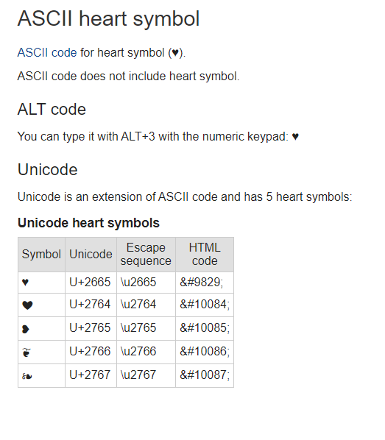
- I will make a few tests with:
OutputTest.java

- My code:
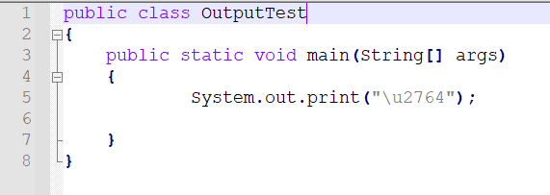
- Output
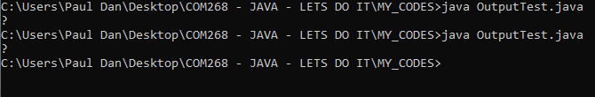
- The "?" is normal according to this reference:
https://stackoverflow.com/questions/44878530/print-unicode-character-in-java
- There are a few options recommended is that thread... I will try a few until I get a result...
- If it is possible to do that, that will improve my text game for assignment 4. I would like to give It some kind of vintage ASCII interface but with extended Unicode it will help as well...
- This:
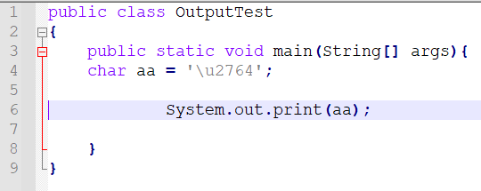

- That:
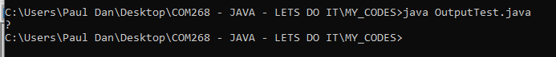
- This answer within the Stackoverflow threat...
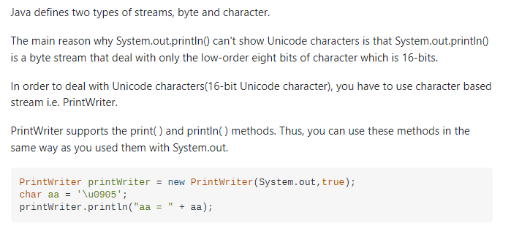
- Looking how to import the package
https://www.programiz.com/java-programming/printwriter
- Now I try this:
https://www.programiz.com/java-programming/printwriter
- GET BACK TO IT.
- TOO complicated for now.

UNIT 3 - Programming in the Small II: Control (suite)
3.6.5 A New switch Statement Syntax
- New version of the switch statement has been added to the Java language in Java 14.
- The new version uses -> in place of a colon after a case, and the code in a case is a single statement, possibly a block statement consisting of several statements enclosed in braces.
- No break statement is required, although one can be used to end a case early.
- Instead of allowing just one value per case label, a case can take several values separated by commas.
CODE EXAMPLE (MANUAL (113-114)
NewSwitchStatementsSyntaxExampleManual113.java

ORIGINAL SYNTAX:
String computerMove;
switch ( (int)(3*Math.random()) ) {
case 0:
computerMove = "Rock";
break;
case 1:
computerMove = "Paper";
break;
default:
computerMove = "Scissors";
break;
}
System.out.println("The computer’s move is " + computerMove);

NEW SYNTAX:
String computerMove = switch ( (int)(3*Math.random()) ) {
case 1 -> "Rock";
case 2 -> "Paper";
default -> "Scissors";
};
- Original switch syntax is still available.
- Along with the improved switch statement, a new “switch expression” has been introduced. Like any expression, a switch expression computes and returns a single value.
- The syntax is similar to a switch statement, but instead of a statement in each case, there is an expression as in example (2).
- A switch expression must always compute a value and therefore will almost always have
a default case.
- The expression in a case can be replaced by a block containing several statements; the value for that case should then be specified by a yield statement (such as “yield 42;”) rather than a return or break statement.

"yield" statement
- ATPIT not described int the MANUAL, just mentioned.
- SEE:
https://www.codejava.net/java-core/the-java-language/yield-keyword-in-java#:~:text=The%20yield%20keyword%20is%20added%20to%20the%20Java,case%20arm%20that%20is%20a%20block%20of%20code.

3.7 Introduction to Exceptions and try..catch
try..catch
- SEE MANUAL (SON 8.3) for complete explanation.
- This section is only an overview.
- In addition to the control structures that determine the normal flow of control in a program, Java has a way to deal with “exceptional” cases that throw the flow of control off its normal track.
- When an error occurs during the execution of a program, the default behavior is to terminate the program and to print an error message.
- However, Java makes it possible to “catch” such errors and program a response different from simply letting the program crash.
- This is done with the try..catch statement.

3.7.1 Exceptions
- "Exception" is used to refer to the type of event that one might want to handle with a try..catch.
- An exception is an exception to the normal flow of control in the program.
- The term is used in preference to “error” because in some cases, an exception might not be considered to be an error at all. You can sometimes think of an exception as just another way to organize a program.
- Exceptions in Java are represented as objects of type Exception. Actual exceptions are usually defined by subclasses of Exception.
- Different subclasses represent different types of exceptions.
- We will look at only two types of exception in this section:
(1) NumberFormatException
- Occur when an attempt is made to convert a string into a number.
- Such conversions are done by the functions Integer.parseInt and Double.parseDouble. (See 2.5.7.).
Example:
- Consider the function call Integer.parseInt(str) where str is a variable of type String.
- If the value of str is the string "42", then the function call will correctly convert the string into the int 42.
- However, if the value of str is, say, "fred", the function call will fail because "fred" is not a legal string representation of an int value.
- In this case, an exception of type NumberFormatException occurs.
- If nothing is done to handle the exception, the program will crash.

(2) IllegalArgumentException
- IllegalArgumentException occur when an illegal value is passed as a parameter to a method.
Example:
- A method requires that a parameter be greater than or equal to zero.
- A negative value is passed to the method.
- IllegalArgumentException might (WHY "MIGHT???) occur.
- How to respond to the illegal value is up to the person who wrote the METHOD.
- We can’t simply say that every illegal parameter value will result in an IllegalArgumentException.
- However, it is a common response.
SEE:
https://www.mimirhq.com/blog/understanding-common-errors-in-java
https://rollbar.com/blog/java-exceptions-hierarchy-explained/
https://examples.javacodegeeks.com/java-lang-illegalargumentexception-how-to-solve-illegal-argument-exception/
https://www.google.ca/search?q=generate+all+combinaison+numbers+for+loop&ie=UTF-8&oe=UTF-8&hl=en-ca&client=safari
https://www.javatpoint.com/java-int-to-string
https://www.makeuseof.com/notepad-plus-keyboard-shortcuts/amp/
https://stackoverflow.com/questions/43359850/how-can-i-print-this-2-variables-in-the-same-println-system-out-println
https://www.studytonight.com/java/try-and-catch-block.php
https://www.java67.com/2012/11/how-to-read-file-in-java-using-scanner-example.html

3.7.2 try..catch
- When an exception occurs, we say that the exception is “thrown.”
- When an exception is thrown, it is possible to “catch” the exception and prevent it from crashing the program.
- This is done with a try..catch statement.

Simplified form syntax for a try..catch statement:
try {
<statements-1>
}
catch ( <exception-class-name> <variable-name>) {
<statements-2>
}

How It works:
- <exception-class-name> is the exception class.
- When the computer executes this try..catch statement, it executes
<statements-1> inside the try part.
- If no exception occurs during the execution of <statements-1> the computer skips over the catch part and proceeds with the rest of the program.
- If an exception of type <exception-class-name> occurs during the execution of <statements-1> the computer immediately jumps from the point where the exception occurs to the catch part and executes <statements-2>, skipping any remaining statements in
<statements-1>.
- Only one type of exception is caught.
- If some other type of exception occurs during the execution of <statements-1>, it will crash the program as usual.
- During the execution of <statements-2>, <variable-name>) represents the exception object.
- It contains information about the cause of the exception including an error message, which will be displayed if you printout the exception object.
- After the end of the catch part, the computer proceeds with the rest of the program.
- The exception has been caught and handled and does not crash the program.
- Braces are part of the syntax of the try..catch statement.
- Required even if there is only one statement between the braces.
- This is different from the other statements we have seen, where the braces around a single statement are optional.

HANDS-ON CODING AND PRACTICE
- Example of try..catch
TryCatchExamples.java
- With that:
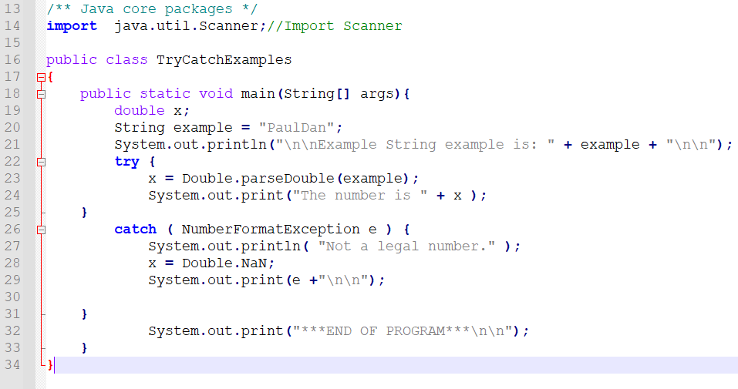
- I got:
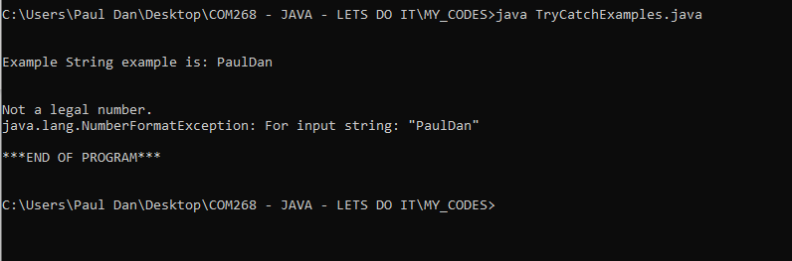
- Is the literal "e" for the exception object is "standard" or given by me?
- I changed it to zzz
- I got:
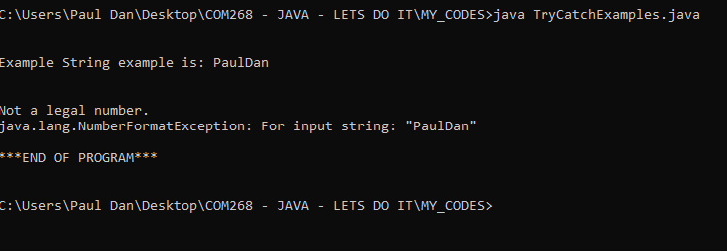
- Therefore, I choose the name for the exception object.

OriginalComputeAverage2.java
- Example of try..catch.
- I will modify OriginalComputeAverage2.java from MANUAL (116) to remove the TEXTIO.
MyVersionComputeAverage2.java
- I modify the code to use "Q" for <blankLine>.
- Worked as expected.

CODE and OUTPUT:
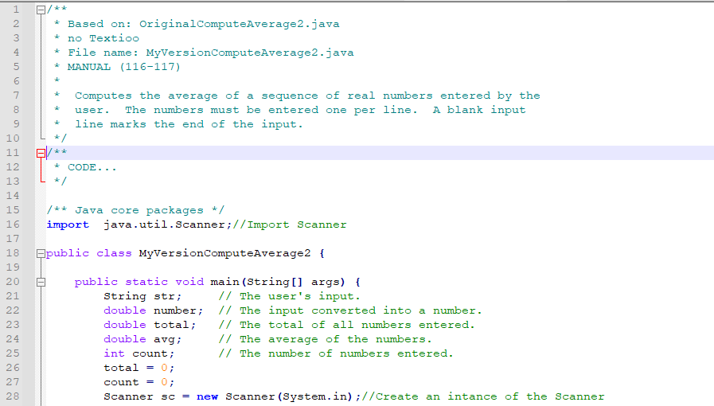
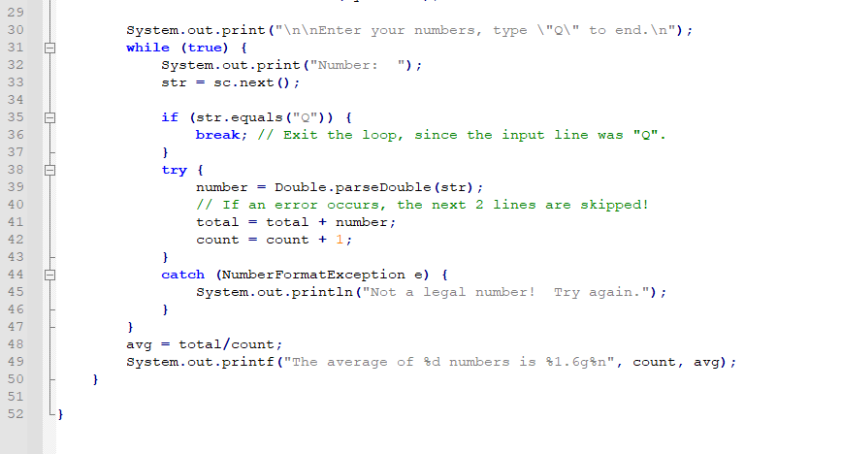
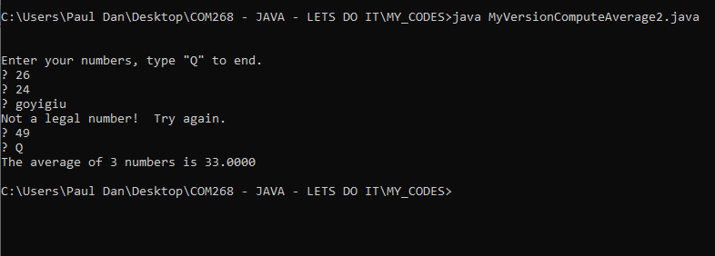

Unit 4 - Programming in the Large I: Methods
Eck (141-200)
- In JAVA methods can be either static or non-static.

Section 4.1 Black Boxes
(Eck 141)
Method | - Used to break up complex program into manageable pieces  - Grouped instructions with a name for carrying out a certain task  - Computer executing a program, whenever it encounters a method call statement will "jump" to the given method "block of code" and executes all the instructions necessary to carry out the task associated  - Reusable  - Can be nested  - Can be static and non-static  Method (computer programming) - Wikipedia  https://en.wikipedia.org/wiki/Method_(computer_programming)

Eck (143)
Interface | - " In computing, an interface is a shared boundary across which two or more separate components of a computer system exchange information."  - Has a semantic and a syntactic component.  - The semantic tells you exactly what task the method will accomplish.  - The syntactic is "how" to interact with the method.  Interface (computing) - Wikipedia  https://en.wikipedia.org/wiki/Interface_(computing)
Interface specification | - What the method does and how it can be controlled.
Contract of the method | - The semantic and syntactic of the method  - What it does and how to ask to do It

"Golden rules" for Method (Design):
1. The interface should be: 1.1 Fairly straightforward
1.2 Well-defined
1.3 Easy to understand
2. To use a Method, black box all you need to know is its interface.
3. The implementor (coder/developer) of a method do not need to know anything about the larger systems in which the box will be used.
- As a conceptual "requirement" only in my view for 3.
- I will add a fourth one inferred by the course manual...
4. Method needs to be appropriately documented and commented

4.2 Static Methods and Static Variables
Eck (143)
- In JAVA every method must be defined inside some class.
Static method | - Member of the class itself
Non-static method | - Only relevant to "object" and exist only when "objects" are created  - Then, the non-static method themselves become itself member of the objects

- Class can contain definition for both static and non-static methods.
- ATPIT we will only deal with static method
- Non-static methods will be covered in Unit 5

4.2.1 Method Definitions
Eck (144)
Syntax - Method (General)
<modifiers> <return-type> <subroutine-name> (<parameter-list>) {
<statements>
}
<modifiers>:
- Optional words that set certain characteristics of the method.
- ATPIT we seen “static” and “public”
- There are other modifiers.

<return-type>:
- When the method computes some value, the <return-type> is used to specify the type of value that is returned.
- If the method doesn't return value(s), then the <return-type> is replaced by the special value void indicating that the return value is empty or non-existent.
<subroutine-name>:
- Self explanatory.
<parameter-list>:
- Part of the interface of the method.
- They represent information that is passed into the method from outside, to be used for the method's internal computations.
- Can be empty or have many.
- With many parameters the declarations are separated by commas.
<statements>:
- Instructions that the computer executes when the method is called.
- Between braces {}

4.2.2 Calling methods
Eck (145)
- Define a method and calling a method are two different things.
- Defining a method is telling the computer that the method exists and what it does. The method is not executed.
- Calling a method, within a program, is what actually start the execution of the method.
Syntax - Method call statement - Static method
Method that is being called is in the same class
<method-name> (<parameters>);
Method that is being called is NOT in the same class
<class-name> . <method-name> (<parameters>);
(<parameters>):
- Can be empty.
- In that case we use empty parentheses.

4.2.3 Subroutines in Programs
Eck (146)
- IMPORTANT: It is not legal to have one method physically nested inside another (not even in the main()).
- The main method contains only the method call statement NOT the definition.
- The definition call goes before of after the main method; there is not specific order but the order needs to follow certain underlying logic and consistency for readability and style.

4.2.4 Member Variables
Eck (149)
- A class can include other things besides methods, including variable declarations.
local variables | - Variables declared inside a method.  - A local variable in a method exists only while that method is being executed and is completely inaccessible from outside that one method.  - Don't keep their values between one method call and the next. (lOGIC)  - Gets a new value each time that the method that contains it is called.  - When you declare a local variable in a method, you have to assign a value to that variable before you can do anything with it.
member variables or  global variable | - Variables not part of a method.  -They are members of a class.  - Can be either static or non-static.  - Keep their values between one method call and the next.  - When you declare a member variable, they are automatically initialized to the default value of their type.  - We can assign a value to a variable at the beginning of the main() routine if we are not satisfied with the default initial value, or to make the initial value more explicit.
Static member variable | - Belongs to the class as a whole, and it exists as long as the class exists.  - Any assignment statement that assigns a value to the variable changes the content of that memory, no matter where that assignment statement is located in the program.  - The value of a static member variable can be set in one method and used in another method.  - Static member variables are “shared” by all the static subroutines in the class.  - The member variable is declared outside any method (but inside a class), and the declaration can be marked with modifiers such as static, public, and private.  - Static member variable that is not declared to be private can be accessed from outside the class where it is defined, as well as inside. When it is used in some other class, it must be referred to with a compound identifier of the form:  <class-name> <variable-name>

- ATPIT we’ll stick to static variables
- If you leave out modifiers for global variable (public or private) and method, they can be used anywhere in the same package as the class where they are defined, but not in other packages. Classes that don’t declare a package are in the default package.
- It is considered to be good practice to make member variables and subroutines private, unless there is a reason for doing otherwise. (But then again, it’s also considered good practice to avoid using the default package. Cannot be clearer!

HANDS-ON CODING AND PRACTICE
- Based on Eck (150-151).
SCOPE: I will rewrite the final version of the GuessingGame program as showed in the course manual but for a simple 52 decks of cards as I did in
MyCodeGuessingGame.java
- I will use the scanner class not TEXTIO.
- Based on: Eck (150) GuessingGame2.java, renamed as
OriginalGuessingGame2.java
- My program:
MyCodeGuessingGame2.java
- My program will generate a random card number AND a random "color" for the card.
- I am starting from the original code.
- Get back to it when I get a chance.
4.3 Parameters
Eck (152)
Parameter | - Mechanism for passing information from the outside the method to the method.  - It's a part of the interface of the method.  - It allows to customize the behavior of a method to adapt it to a particular situation.

Eck (152-153)

4.3.1 Using Parameters
- 3N+1 problem

HANDS-ON CODING AND PRACTICE
- Based on Eck (152)
SCOPE: Wrap together the example of the manual
MyCode3N1problemFirstTry.java
- All as expected.

Unit 4 (suite) - Programming in the Large I: Methods
4.3.2 Formal and Actual Parameters
Eck (153)
formal parameters or dummy parameters | - Parameters used in a method definition.  - Must be a name, that is, a simple identifier.  - Has a specified type.
actual parameters or arguments. | - Parameters that are used in a method call statements.  - Its a value and therefore it can be specified by any expression provided that the expression computes a value of the correct type.  - The type of the actual parameter must.  be one that could legally be assigned to the formal parameter with an assignment statement.

- When a method is called, the actual parameters in the method call statement are evaluated and the values are assigned to the formal parameters in the subroutine’s definition. (SEQUENCE)
- THEN the body of the method is executed.

4.3.3 Overloading
Eck (154)
Signature of the method | - Name, formal parameters with their respective type.  - Does not include the names of the parameters.  - Names are not part of the interface.  - To use the method, there is no need to know the formal parameter names!  - Does not include the method’s return type
overloaded (name of the method is) | - Character of having two different methods in the same class with the same name with different signature.  - Because the signature doesn't include the return type, it is illegal to have two methods in the same class that have the same signature but  different return types.  - Not sure what could be the benefit of doing it. My first idea about it is that's increase the possibility of confusion with really low (no) benefits.  - Maybe for something like, for example, methods that do the same thing but differently according to the parameters provided (by a parser for example. But still, I see no benefits to It ATPIT. I will just remember that is LEGAL in JAVA.

4.3.4 Subroutine Examples
Eck (155-157)
- Read examples and It's clear. I made examples with my "Canadian flag" program. Will review It at the end of the section.
- IMPORTANT: It is up to the caller of the method to make sure that the assumptions of the method contract are satisfied.
- Where do we put the "catch"? The "test"? Should be BEFORE the method call if not It will crash the problem. There are exceptions related to that in the exception chart. Will get back to It later if it's not covered when I gone feel that I need to know about It.

HANDS-ON CODING AND PRACTICE
- I will do the examples of the section p 156 ss
FIRST EXAMPLE:
Sect434Examples.java
- Code:
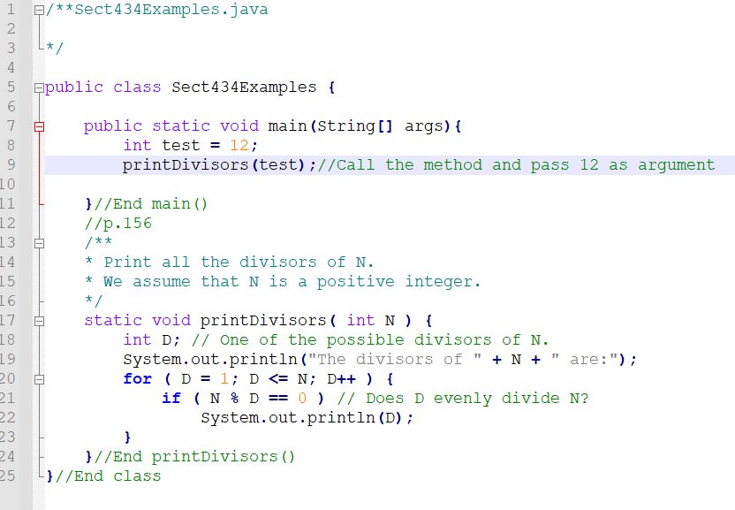

- Output:
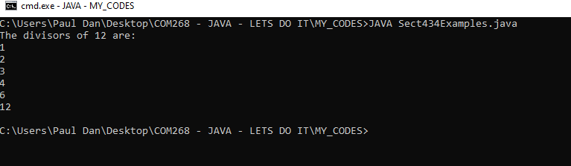

SECONDE EXAMPLE:
- printRow()
- Added to the same file:
Sect434Examples.java
- Code for testing: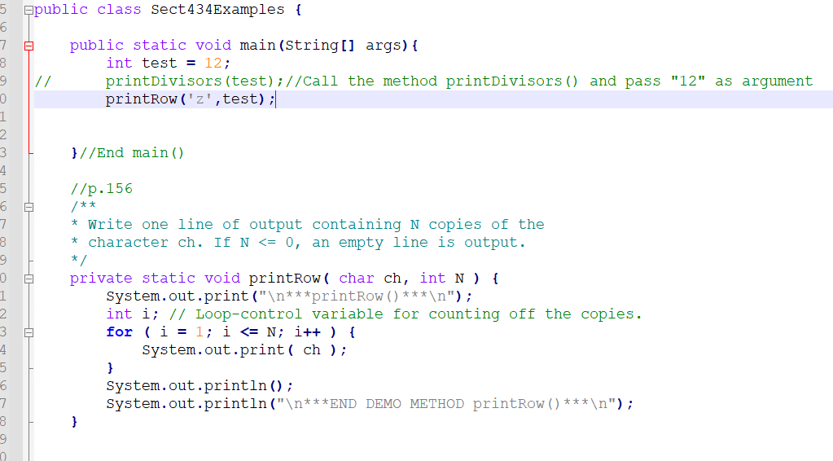

- Output:
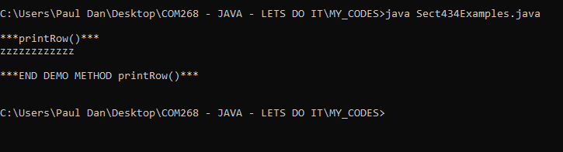
- Arguments passed can be number, variables, functions etc...

OriginalGuessingGame.java
- Based on Eck (146-149).
SCOPE: I will rewrite the final version of the GuessingGame program as showed in the course manual but for a simple 52 decks of cards.
- I will use the scanner class not TEXTIO.
- Based on: Eck (148) GuessingGame.java, renamed as
OriginalGuessingGame.java
- My program:
MyCodeGuessingGame.java
- My program will generate a random card number AND a random "color" for the card.
- I am starting from the original code.
- First, I am working out the transition to Scanner class for the user input
- Add the imports, create instance of scanner "sc".
- Change the lines of input by sc.next <type> (); according to the expected input.
- Made the Scanner " public" in the class.
- Code don't work.
- Frozen after first question.
- Add a print statement at ln 51 to see in the problem is at ln 48, which would mean the system doesn't generate the random number.

- Code:
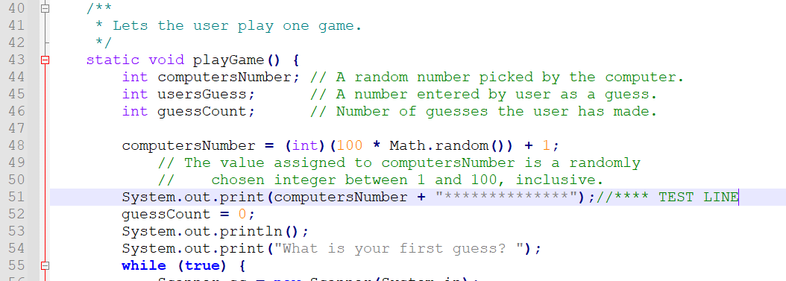
- Output:
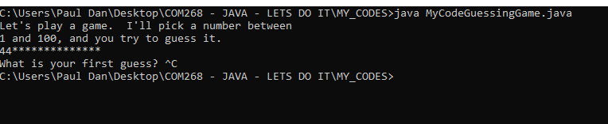
- It works until ln 54.
- I add the following block to see if my scanner works for the input (I know that I don't know enough YET to use the Scanner class, but the exercise is good...)
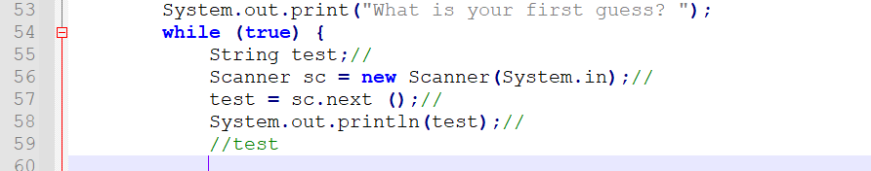
- I got as output:
- Still crashing at the same spot...
- I had System.out.println(" input string for test");

- Output:
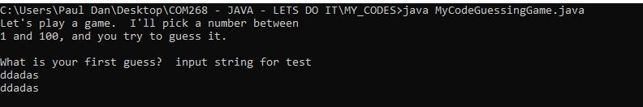
- My scanner doesn't work:
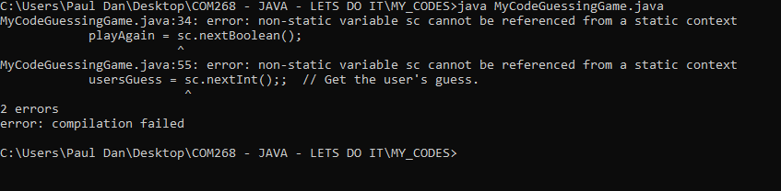
- Going online to find what that means.
- STILL FROZEN GET BACK TO IT ***NEXT***
- Version just the codes in main:
MyCodeGuessingGameV2test.java
- Other...
MyCodeGuessingGame.java
- I am restarting from the beginning with the original code.
- Add imports.
- Create an instance of the scanner public.
- Now It Works! I just changed the line for input for the scanner and did not change the structure yet for the game with a card I am aiming at...
Partial Code:
- Now let modify it so it will be a random card...
- Will use String.valueOf() method... to convert my random number to a string representing a card...
- I am splitting the code to test It in a different file.
- I am sidetracking but What I am looking to do is a method that generate a card.
- That method would be reusable in my examples.
- Actually, after a few readings of chapter 4, I want to build a library of methods I would be able to use in my codes I do for practice. (Will see after OOP and leaning libraries)
- I am creating a new file:
PersoLib.java
- That would be a "personal library of methods"; I will add methods over my next examples and use them in my codes; for now, I will develop them, put them in PersoLib.java and cut and paste them in the code I will be working on; I know later I will be able to use them just by calling them; Still unclear in the details.
- I want to do a list of the "useful" methods I could add into It.
- welcomeMsg() ; endOfProgramMsg(); formattedIntroduction(); and so on ...
- That will be reusable, for my last assignment as well!
- Back to the generation of a random card method.

Code:
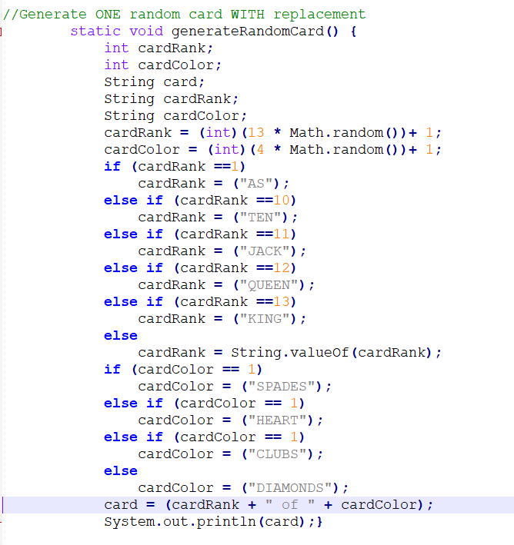
- For now, I am just making a print statement for the output.
- I will modify it to "return" the card later...
- I will try to get time to make another version WITHOUT replacement.
- Probably using an array to track the deck, still thinking about it.
- Could have an option to have many decks, and output many cards, with or without replacement...
- I am making a script to generate 5 cards to test It as well.
- I could output them as an ASCII drawing. (Some interesting ASCII card decks online. Will investigate it further)
OUTPUT for one card at the time:
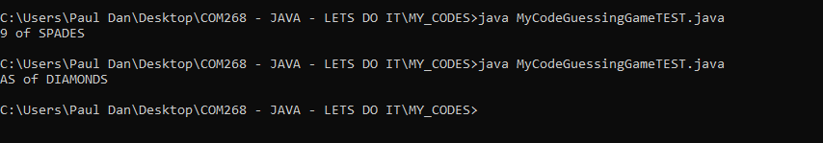
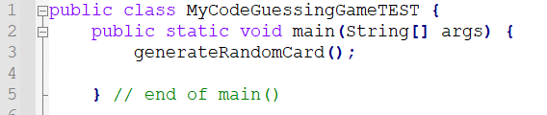

OUTPUT for 5 cards at the time:
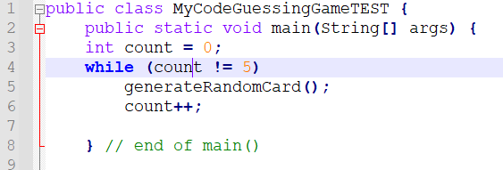
Ooops... never stop...

- Changed to:
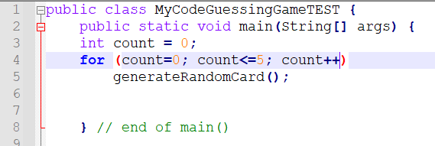
Output:
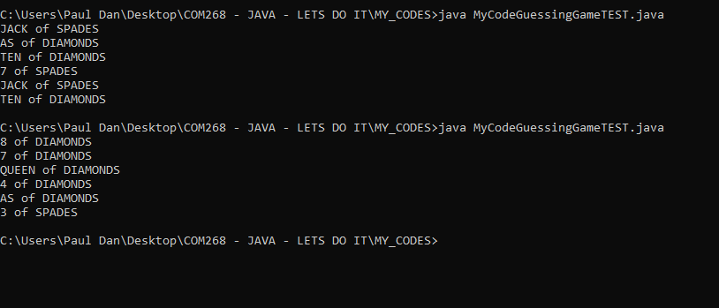
- I am putting It aside for now.
- I did some drawing to understand the different codes of this section.
- That helped me understand.
- I am doing some codes structure by hands as well for the structures with my library using a methods library.
- Got many ideas.
- I need to make a graphic on the "scope" for public, private, etc... still unclear in my head...
- I found some cheat sheets online... All good... for now...
- I need to find a way to have a displayCards() method that would process nicely the cards visually. ASCII art or something.
- Got some kind of idea about It for my Blackjack personal project.
doDoWileControlStructureExample2.java
- Will rework on my self-commissioned project of methods with Canadian flag that I put aside previously when testing methods calls BUT while doing unit 2
doDoWileControlStructureExample2.java
- The codes look right at the time, but the problem was exactly the topic of the current section.
- I got:
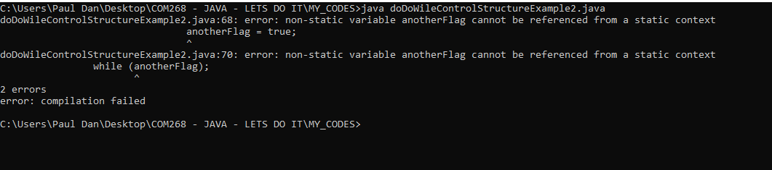
- My code:
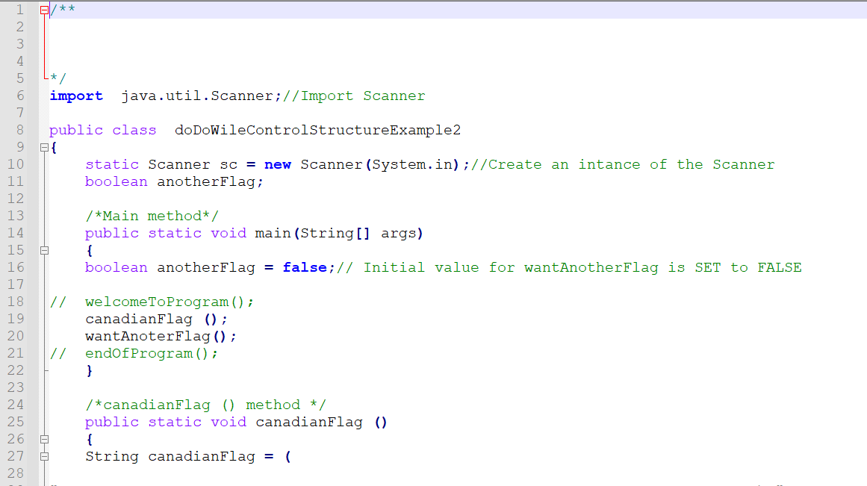
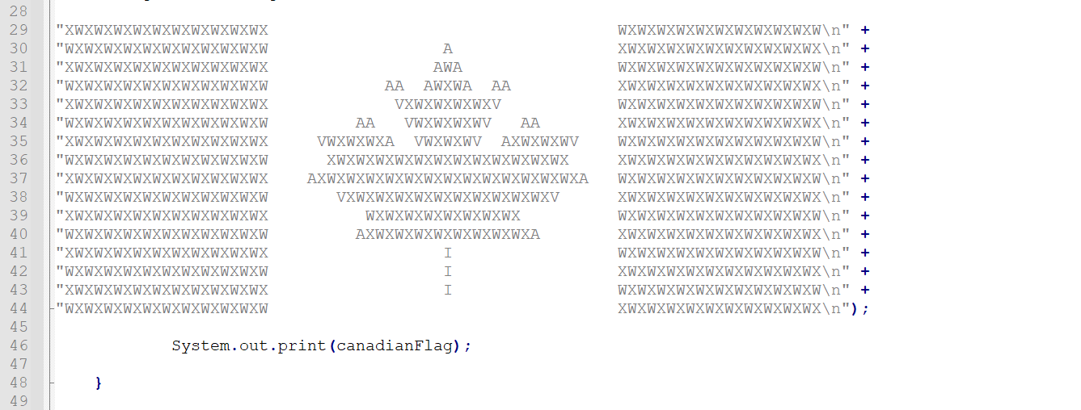
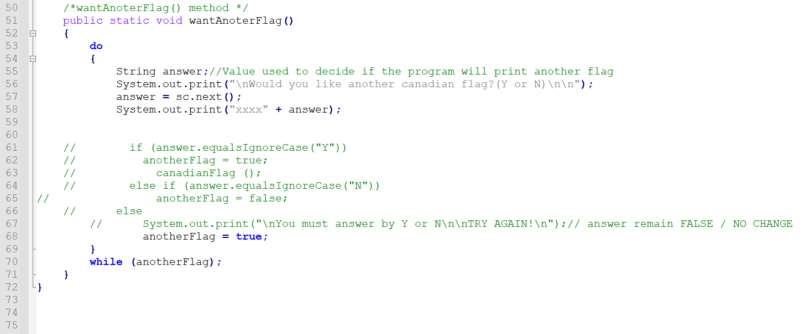
- I will print the code and go in It, now armed with knowledge on the requirements of parameters, modifiers, and scope of variables.
- My structure is wrong.
- I will print out the codes for the examples provided in this section and work on them. Thereafter I will redo the structure of my own codes.
- PRINT OUT ANNOTADED (1) examples (2) my codes (3) new codes
- USE Do While vs anotherflag()... see previous code could be an option rather than having a method for It...
- All good. Carry on.

4.3.5 Array Parameters
Eck (157)
- It’s possible for the type of a parameter to be an array type. In this case, an entire array of values is passed to the method as a single parameter.
- I will just keep in mind that is a possibility and refers to my secondary sources in if I need to do it for more in depth.

4.3.6 Command-line Arguments
Eck (158)
- That material links to assignment 2 but is really "thin".
command-line arguments | - When using a command-line interface, the user types a command to tell the system to execute a program.  - The user can include extra input in this command, beyond the name of the program.  - This extra input becomes the command-line arguments.  - Those entered values come from "outside" the program.  - The system takes the command-line arguments, puts them into an array of strings, and passes that array to main() method of the program.  - If there are many command-line arguments, the system puts these strings into an array of Strings and passes that array as a parameter to the main().  - That array can be empty, i.e. with a length of "zero" (no arguments).  - "Since most programs are run in a GUI environment these days, command-line arguments aren’t as important as they used to be."(158)

- That's interesting. That's how command line utilities work.

.3.7 Throwing Exceptions
Eck (159)
- SEE 3.7 for chart and previous explanations.
throw statement | - Response to bad parameter values.  - An exception is an object.  - In order to throw an exception, we must create an exception object.  - We will revisit the concept in Unit 5

- Syntax for a throw statement that throws an IllegalArgumentException:
throw new IllegalArgumentException ( <error-message > );
- <error-message >:
- Check whether the values of the parameters are legal. If not throw the exception.
- “new” creates the exception object, a String that describes the error that has been detected.
- Example Eck (160):
static void print3NSequence(int startingValue) {
if (startingValue <= 0) // The contract is violated!
throw new IllegalArgumentException( "Starting value must be positive." );
.
. // (The rest of the subroutine is the same as before.)
.

4.3.8 Global and Local Variables
Eck (160)
- Sorts of variables that can be used inside a subroutine:
local variables | - Declared in the method.  - Have no connection to the outside world; they are purely part of the internal working of the method.
formal parameter (names) | - Parameters are used to “drop” values into the method when it is called, but once the method starts executing, parameters act much like local variables. Changes made inside a method to a formal parameter have no effect on the rest of the program (at least if the type of the parameter is one of the primitive types—things are more complicated in the case of arrays and objects, as we’ll see later).
Global variable  static member variables  aka class member/variable | - Declared outside the method.  - A global variable can be used in the entire class in which it is defined and, if it is not private, in other classes as well.  - Changes made to a global variable can have effects that extend outside the method where the changes are made.  - That variable exists independently of the method, and it is accessible to other parts of the program as well.  - When we use global method in a method then the variable has to be considered part of the method’s interface.  - The method uses the global variable to communicate with the rest of the program.  - This is a back-door communication channel that is less visible than communication done through parameters, and it risks violating the rule that the interface of a black box should be straightforward and easy to understand.  - Before you use a global variable in a method, we should consider whether it’s necessary.

"I don’t advise you to take an absolute stand against using global variables inside subroutines(method). There is at least one good reason to do it: If you think of the class as a whole as being a kind of black box, it can be very reasonable to let the subroutines inside that box be a little about communicating with each other, if that will make the class as a whole look simpler from the outside." Eck (161)

4.4 Return Values
Function | - Method that returns a value.
Return type of the function | - A given function can only return a value of a specified type, the return type of the function.
Function call  Method call | - Occurs generally in a position where the computer is expecting to find a value, such as the right side of an assignment statement, as an actual parameter in a method call, or in the middle of some larger expression.  - Can be used as the test condition in an if, while, for or do..while statement (boolean-valued function).  - It is also legal to use a function call as a stand-alone statement, just as if it were a regular method.

4.4.1 The return statement
Eck (161)
Syntax for method that return value(s) (Function):
- Same form as a regular method, except that the value that is to be returned by the method is specified.
- This is done with a return statement that can only occur inside the definition of a method with the syntax:
return <expression>;
- The type of <expression> must match the return type that was specified for the method.
- More exactly, it must be an expression that could legally be assigned to a variable whose type is specified by the return type of the function.
- When the computer executes this return statement:
(1) - It evaluates the expression
(2) - It terminates the execution of the method
(3) - It uses the value of the expression as the returned value.
- A return statement does not have to be the last statement in the method definition.
- It can be at any point in the method where we know the value that we want to return.
- Returning a value will end the method immediately skipping any subsequent statements.
- There are cases where the method definitely does return some value, no matter what path the execution of the function takes through the code.
- We can also use a return statement inside an ordinary method, one with declared return type void.
- Since a void method does not return a <value>, the return statement does not include an <expression>
- It simply takes the form:
return;
- The effect of this statement is to terminate execution of the method and return control back to the point in the program from which the method was called.
- This can be convenient if you want to terminate the execution somewhere in the middle of the method.
- The <return statements> are optional in method that return no value.
- In method that return value(s) (i.e. function), a <return statement>, with <expression>, is always required.
- A return inside a loop will end the loop as well as the method that contains it.
- A return in a <switch statement> breaks out of the <switch statement> as well as the method.
- Sometimes we can see the use of return in contexts where we are used to see a break.

4.4.2 Methods Examples
- Will do the code for the different examples of this section.

HANDS-ON CODING AND PRACTICE
Eck (162-165)
- I wrote a code to test the two models provided in the MANUAL for 3N sequence
FunctionExamples442.java
Code:
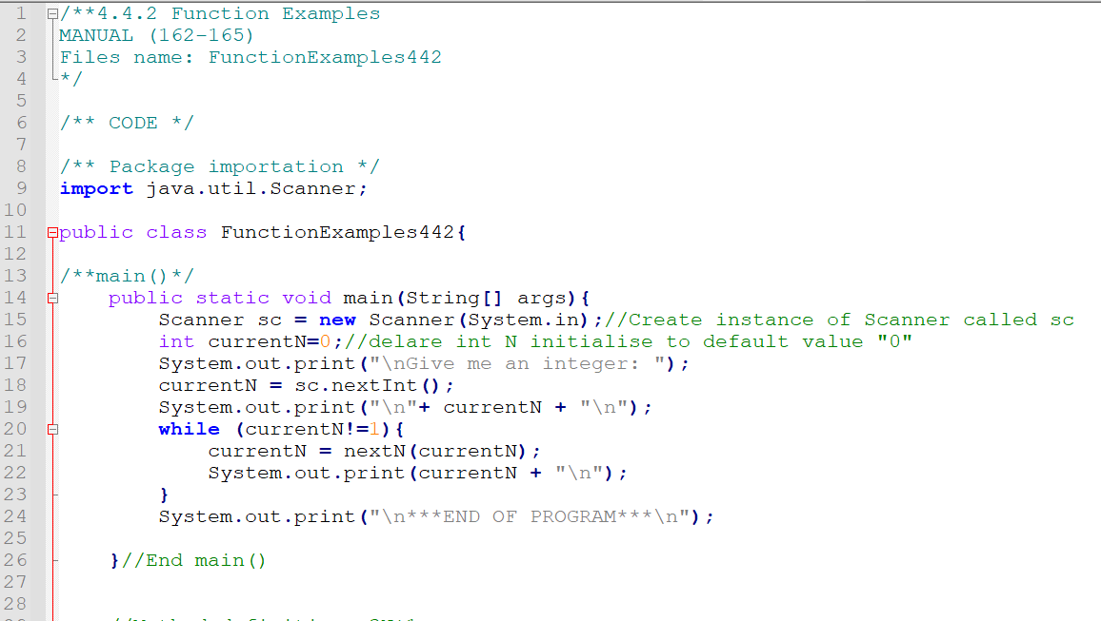
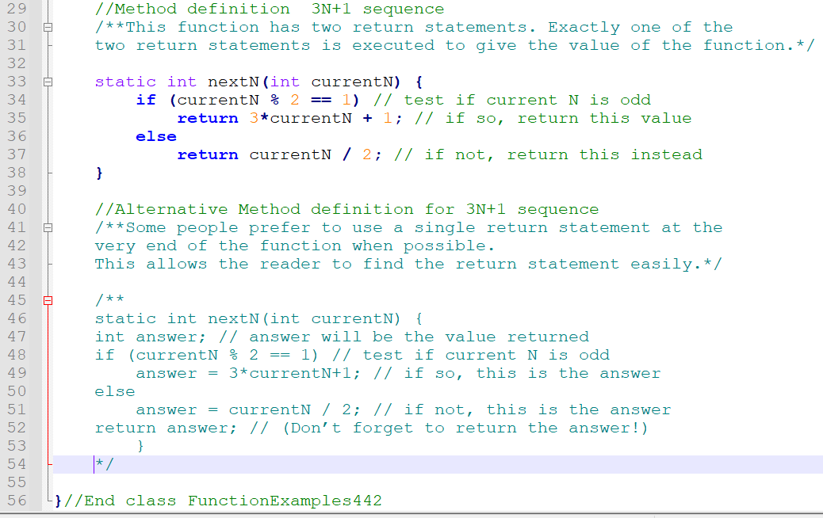
- Worked as expected for the two examples.

- Output:
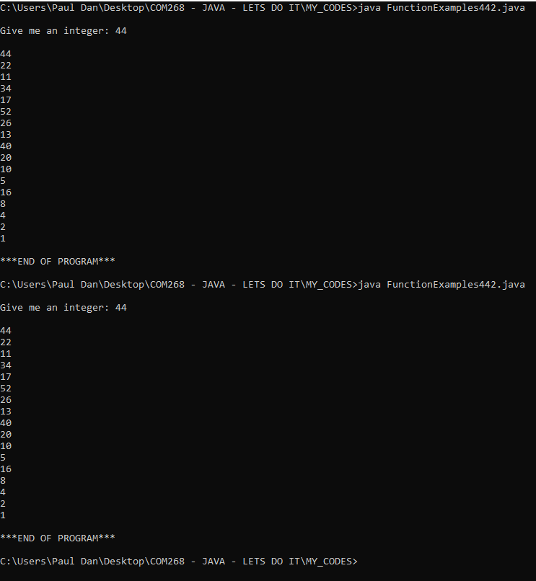

FunctionExamplesManualP163.java
- This example has a main method that call a method that itself call another method to compute the values.

Code:
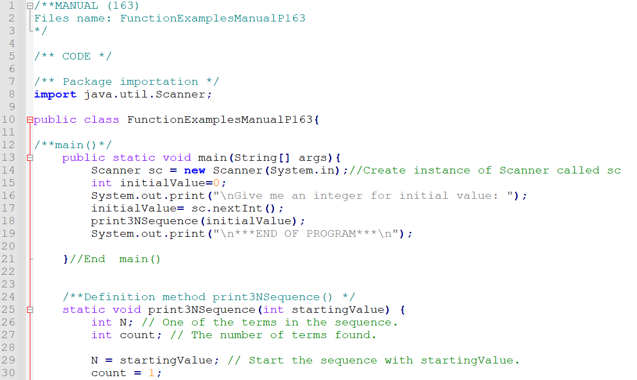
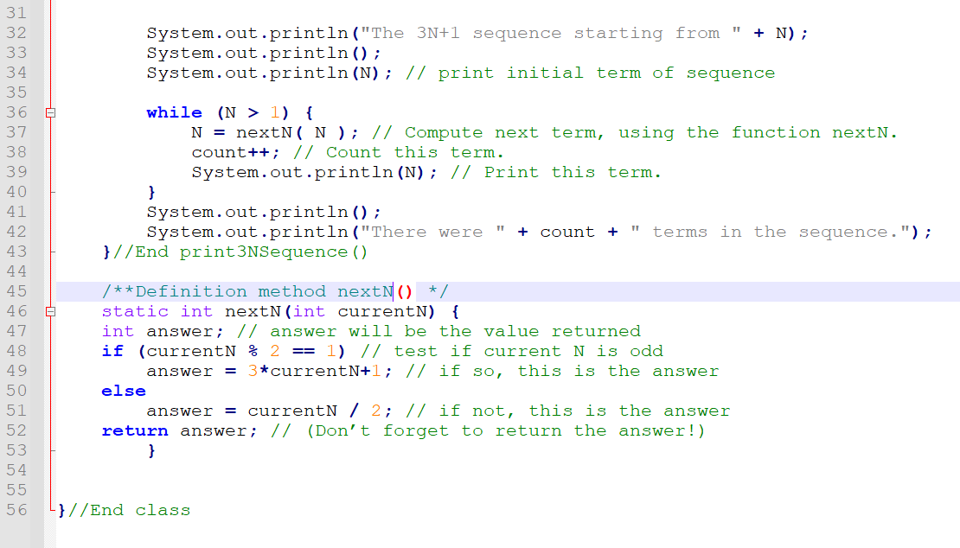

Output:
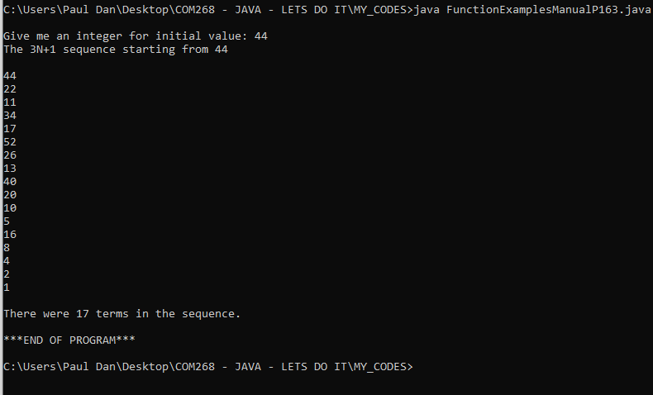
- All worked as expected
- The use of method defined outside the main certainly make the code "cleaner" and easier to debug and manage

HANDS-ON CODING AND PRACTICE
Eck (163)
- letterGrade() example
- File name:
letterGradExampleP163.java

- Code:
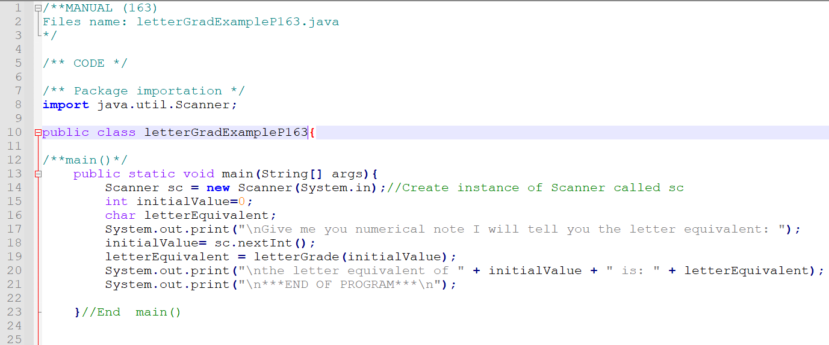
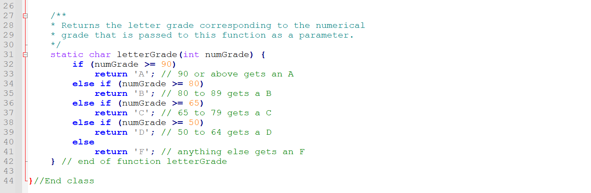
- Output as expected:
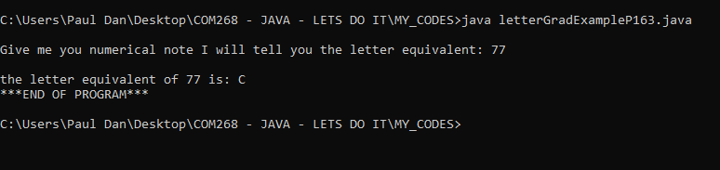

HANDS-ON CODING AND PRACTICE
Eck (164)
- isPrime() example
- Revisit my draft for question 5 assignment 1 after the exercise
- File name:
isPrimeExampleP164.java
- I understand the code for the method isPrime () but ATPIT I did not have examples of how to process the true or false that is returned in a larger code.
- Get back to It when I get a better example
- How to "process" the returned value? ATPIT It is unclear for me. Need to check that out.
- There are many returns... that's what confuse me

HANDS-ON CODING AND PRACTICE
Eck (164-165)
- Reverse String method
- File name:
StringReverseMethodExampleP164.java
- Code:
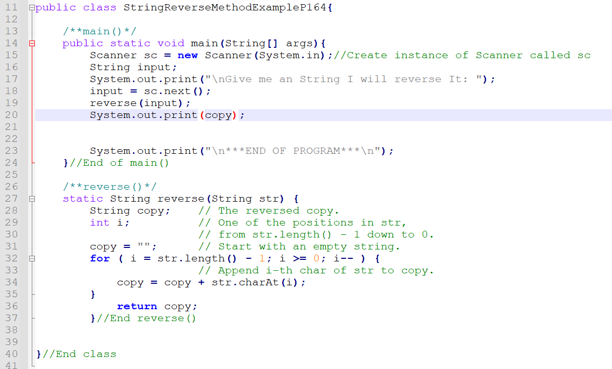

- I got:
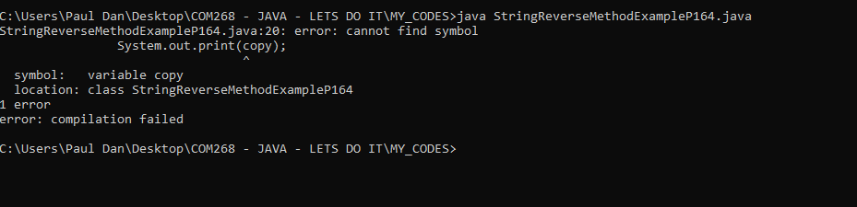
- Getting better to look for answers on stackoverflow now that I know how to "phrase" what I am looking for...
https://stackoverflow.com/questions/39069336/how-to-print-a-return-value-from-a-method
java - How to print a return value from a Method - Stack Overflow
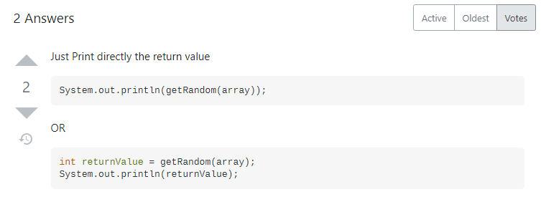
- Let's try:
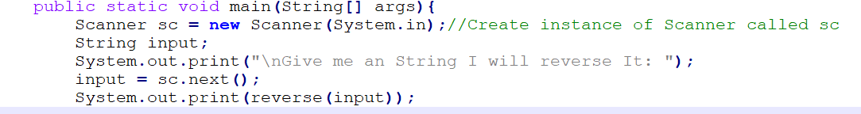
- Output:
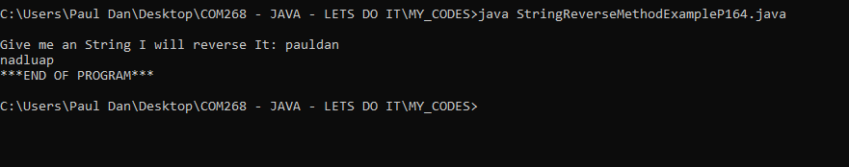
- Ok that works

4.4.2 (...) Function Examples
- This is important:
"By the way, a typical beginner’s error in writing functions is to print out the answer, instead of returning it. This represents a fundamental misunderstanding. The task of a function is to compute a value and return it to the point in the program where the function was called. That’s where the value is used. Maybe it will be printed out. Maybe it will be assigned to a variable. Maybe it will be used in an expression. But it’s not for the function to decide." (Eck 165)
- I understand in general the concept of function now.
- When using print statement in function I did to "check" that my information flow was accurate not as a finality. It is part of my testing and debugging process.

4.4.3 3N+1 Revisited
Eck (165)
- File name: MyCodeThreeN2.java
- Based on: OriginalThreeN2.java
- Code:
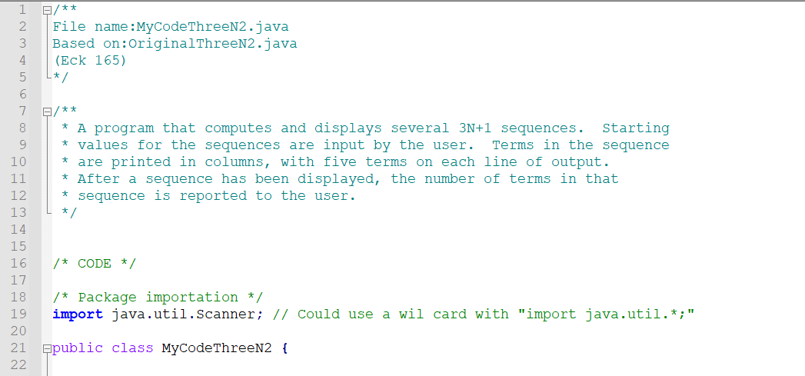
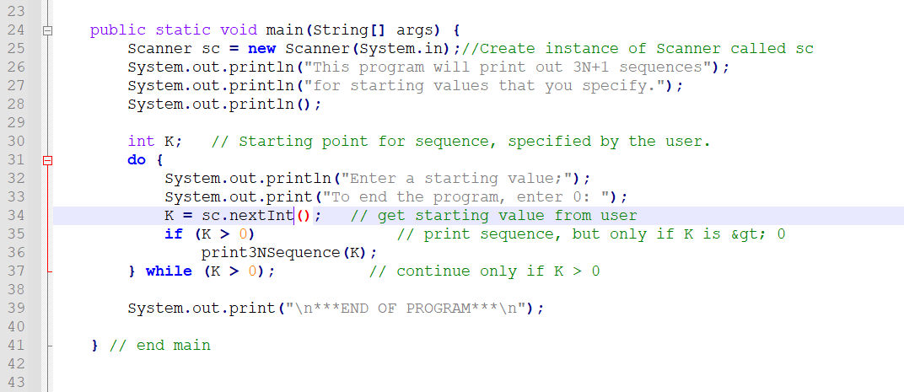
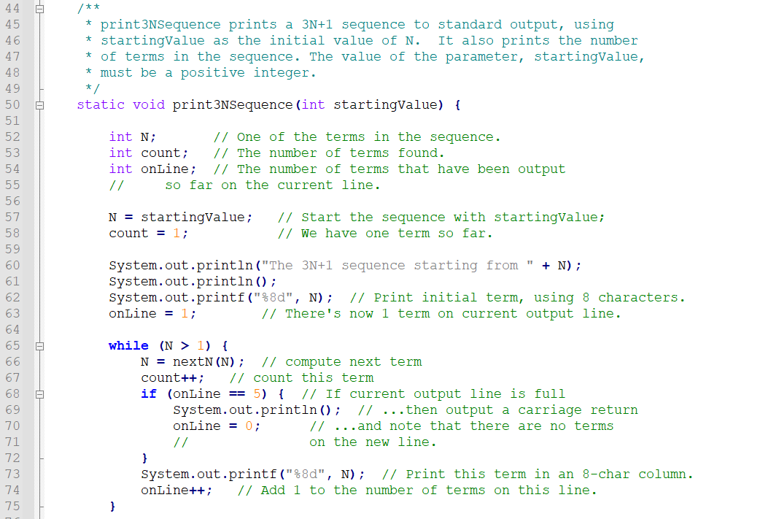
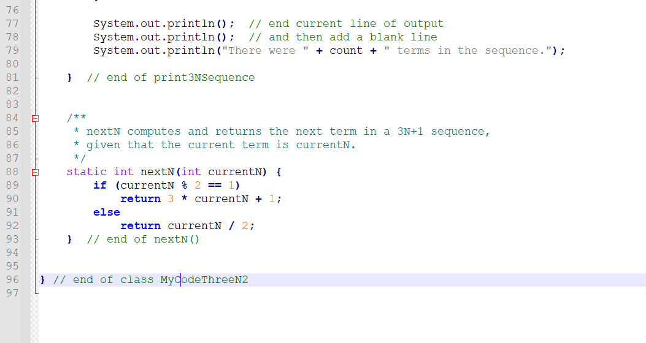
Output:
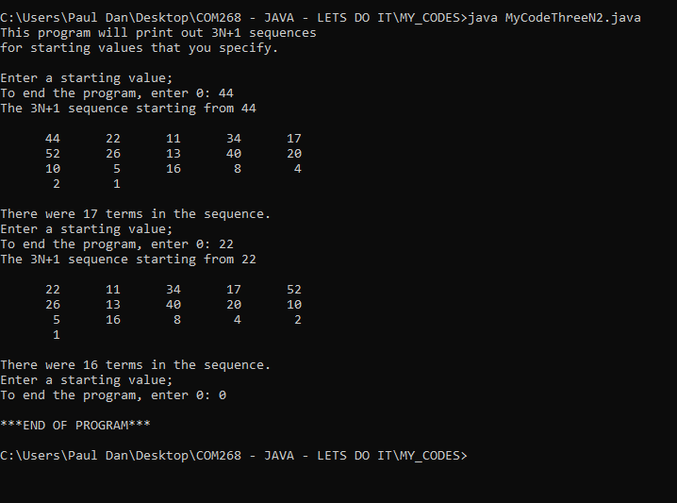
- All works as expected.
- Interesting code.
Notepad++
- When confuse where a variable is from or where a value is to be computed, we can highlight the literal and all other occurrence of the literal within the code will highlight.
- It is even possible to apply a highlighted color to a literal in all the code automatically.
- Find it really useful.
- I should make a "how-to" guide for Notepad++ and make It available on the landing when I will be further in the course material.
- It is unfortunate that such a resource wasn't included in the Unit 0 documentation of the course or the instructor manual. That would help me along the course.

4.6 APIs, Packages, Modules, and Javadoc
Eck (171ss)

4.6.1 Toolboxes
Eck (172)
Applications programming | - Take all the already designed and available tools (methods, etc) and apply them to some particular project or problem
API  Application  Programming Interface | - Interface for the programmer.  - It is a specification of what the methods (in the available toolbox) are, what parameters they use, and what tasks they perform.  - How to "communicate" with them
Java API | - Java has a large, standard API in the form of different methods to do so and so  - They are not part of the language  - They are technically methods that have been written and made available for use in Java programs.  - Java is platform-independent.  - Therefore, the same Java API must work on all platforms.  - But that it is the interface that is platform-independent; the implementation of some parts of the API varies from one platform to another.  - A Java system on a particular computer includes implementations of all the standard API methods.  - A Java program includes only calls to those routines.  - When the Java interpreter executes a program and encounters a call to one of the standard routines, it will pull up and execute the implementation of that routine which is appropriate for the particular platform on which it is running.  - It means that you only need to learn one API to program for a wide variety of platforms.

4.6.2 Java’s Standard Packages
Eck (173)
Java programming language organization:
- Methods in the standard API are grouped into classes.
- Classes can be grouped into packages (to provide larger-scale organization).
- Packages can also contain other packages.
- Package can contain both classes and other packages.
- A package that is contained in another package is (sometimes) called a sub-package.
- The most basic package is called java.lang.
- The standard Java API includes thousands of classes in hundreds of packages.

4.6.3 Using Classes from Packages
Eck (174)
- Remember: class are "type" which means that you can use it to declare variables and parameters and to specify the return type of a method (function).
- One way to do this is to use the full name of the class as the name of the type.
- Java makes it possible to avoid using the full name of a class within the program by importing the class with an "import directive" at the beginning of the program after the package statement, if there is one.
- The only effect of the import directive is to allow you to use simple class names instead of full “package.class” names.
- If you leave out the import directive, you can still access the class—you just have to use its full name.
- There is a shortcut for importing all the classes from a given package by using "*" as a wildcard. The effect of the wildcard is that it matches every classes in the package.
ex: import java.util.*;
- NOTE: The use of a "wildcards" does not match sub-packages
- "Some programmers think that using a wildcard in an import statement is bad style, since it can make a large number of class names available that you are not going to use and might not even know about."( Eck 175)
- When we are importing lots of packages with wildcards, we need to be careful because It is possible for two classes that are in different packages to have the same name.
- If we have imported packages containing classes with the same name, if we try to declare a variable with the class name as the type, we will get a compiler error message about an ambiguous class name. We can still use both classes in the program, but we will need to use the full names.
- The package java.lang is so fundamental, all the classes in java.lang are automatically imported into every Java program.
- Even when a package has been imported or is by default accessible, it still perfectly legal to use the longer forms of the names.
- Programmers can create new packages.
- Suppose that you want some classes that you are writing to be in a package named utilities. Then the source code files that defines those classes must begin with the line
package utilities;
- This is exactly what I want to do to help me with my coding examples! Will get back to it!
- This would come even before any import directive in that file.
- The source code file would be placed in a folder with the same name as the package, “utilities” in this example.
- Class that is in a subpackage must be in a subfolder.
(Eck 176)
- For example, a class in a package named utilities.net would be in folder named “net” inside a folder named “utilities”.
- Class that is in a package automatically has access to other classes in the same package; that is, a class doesn’t have to import classes from the package in which it is defined.
- In projects that define large numbers of classes, it makes sense to organize those classes into packages.
- It also makes sense for programmers to create new packages as toolboxes that provide functionality and APIs for dealing with areas not covered in the standard Java API.
- The standard packages are always available to the programs that you write.
- Every class is actually part of a package.
- If a class is not specifically placed in a package, then it is put in something called the default package, which has no name.

4.6.4 About Modules
Eck (176)
- A module is a collection of packages.
- It represents another level of containment.
- Modules contain packages which contain classes which contain variables and methods.
- A package does not have to be in a module to be used, but all of the standard classes in Java and in JavaFX have been divided into a set of modules.
- A "public" class that is defined in a module it's "public" only within the module where it is defined.
- A class that is declared "public" and it's not inside a module can be used anywhere, from any class in any package, as can its public variables and methods.
- Module can explicitly export a package.
- Exporting a package from a module makes the public classes in the package accessible from anywhere, including from other modules and from classes that are not part of any module.
- It is even possible to export a package just to certain specified modules, providing an even finer level of access control.
- Consequently, it is now possible to have entire packages that are essentially private: They provide services to other packages in the same module but are invisible from outside that module.
- Modularity on this scale is really only important for very large-scale applications.
- A class can be defined outside of any module, and it is possible for that class to use packages from modules, provided that those packages are exported by the modules where they are defined.
- NOTE: When using Java 11 or later, things are different for GUI programs that use JavaFX, which has been removed from the JDK and is distributed as a separate set of modules.

4.6.5 Javadoc
Eck (177)
- /**< comment > */
- The Javadoc comment always immediately precedes the thing it is commenting on.
- We can have Javadoc comments for subroutines, for member variables, and for classes.
- Javadoc comment is ignored by the computer when the file is compiled.
- The javadoc tool reads Java source code files, extracts any Javadoc comments that it finds, and creates a set of Web pages containing the comments in a nicely formatted, interlinked form.
- By default, javadoc will only collect information about public classes, subroutines, and member variables, but it allows the option of creating documentation for non-public things as well.
- If javadoc doesn’t find any Javadoc comment for something, it will construct one, but the comment will contain only basic information such as the name and type of a member variable or the name, return type, and parameter list of a subroutine.
- This is syntactic information. To add information about semantics and pragmatics, you have to write a Javadoc comment.
- In a Javadoc comment, the *’s at the start of each line is optional. The javadoc tool will remove them.
- In addition to normal text, the comment can contain certain special codes.
- Javadoc comment can contain HTML mark-up commands.
- The javadoc tool will copy any HTML commands in the comments to the web pages that it creates.
- NOTE: the characters & and < have special meaning in HTML and should not be used in Javadoc comments except with those meanings; they can be written as &amp; and &lt;.
- Javadoc comments can include doc tags, which are processed as commands by the javadoc tool.
- A doc tag has a name that begins with the character @.
@author
- Can be used only for a class, and should be followed by the name of the author.
@param
@return
@throws
- This three tags are used in Javadoc comments for a subroutine to provide information about its parameters, its return value, and the exceptions that it might throw. These tags must be placed at the end of the comment, after any description of the subroutine itself.
- The syntax for using them is:
@param <parameter-name> <description-of-parameter >
@return <description-of-return-value>
@throws <exception-class-name> <description-of-exception>
- The <descriptions> can extend over several lines.
- The description ends at the next doc tag or at the end of the comment.
- We can include a @param tag for every parameter of the subroutine and a @throws for as many types of exception as you want to document.
- You should have a @return tag only for a non-void subroutine.
- These tags do not have to be given in any particular order.
- The javadoc tool in a command line interface similarly to the way that the javac and java commands are used.

HANDS-ON CODING AND PRACTICE
- Having a look at the example file from the course.
GoodDocs.java
- NOTE: in folder "MyCodes"
- Did a few tests.
- There are a lot of "cheatsheets" online for javadoc, including the tags.
- SEE LOWE.

4.7 More on Program Design
Eck (180)
- Review of the following concepts already in my database:
- pseudocode
- stepwise refinement
- algorithm
- subroutines (method)
- top-down process
- top-down approach
- top-down analysis (of the problem)
- bottom-up approach
- bottom-up element
- problem domain
- sub-task

4.7.1 Preconditions and Postconditions
Eck (180)
Contract of the method | - Specification of how a method interacts with the rest of the program
Preconditions | - That must be true when the method is called if the method is to work correctly.  - The obligation of the caller for the method.  - If a method is called without meeting a precondition requirement It may crash or give incorrect results.  - Most often give restrictions on the acceptable values of parameters passed to the method.
Postconditions | - Obligations of the method.  - Task that it performs. For a function, the postcondition should specify the value that the function returns.

- Good code include comments those elements.
- Need to be done for (in) my course assignments!
4.8 The Truth About Declarations
4.8.1 Initialization in Declarations
- Eck (188) - It is legal to include the initialization of the variable in the declaration statement.
- I already use most of what is covered in this part of the course material.
- It is legal to initialize several variables in one declaration statement.
- Computer still executes the statement in two steps (1) declare (2) assign.
- This feature is especially common in for loops since it makes it possible to declare a loop control variable at the same point in the loop where it is initialized.
- A member variable can also be initialized at the point where it is declared, just as for a local variable.
- A static member variable is created as soon as the class is loaded by the Java interpreter, and the initialization is also done at that time.
- In the case of member variables, this is not simply an abbreviation for a declaration followed by an assignment statement. Declaration statements are the only type of statement that can occur outside of a method. Assignment statements cannot.
- Declarations of member variables often include initial values. In fact, if no initial value is provided for a member variable, then a default initial value is used.
- Array variables also can be initialized at the same time that they are declared and the length of the array is determined by the number of items in the list.
- This syntax for initializing arrays cannot be used in assignment statements. It can only be used in a declaration statement at the time when the array variable is declared.
- It is also possible to initialize an array variable with an array created using the new operator which can also be used in assignment statements. In this case all the array elements will have their default value.
Examples:
int count;  count = 0; | in count = 0;
char firstInitial;  char firstInitial = ’D’;  char secondInitial ;  char secondInitial = ’E’; | char firstInitial = ’D’, secondInitial = ’E’;
{  int i;  for ( i = 0; i < 10; i++ ) {  System.out.println(i);  }  } | for ( int i = 0; i < 10; i++ ) {  System.out.println(i);  }
public class Bank {
private static double interestRate = 0.05;
private static int maxWithdrawal = 200;
.
. // More variables and subroutines. .
}
 | int[] smallPrimes = { 2, 3, 5, 7, 11, 13, 17, 19, 23, 29 };
 | String[] nameList = new String[100];

4.8.2 Declaring Variables with var
Eck (189-190)
var
- Used instead of specifying an explicit type for the variable.
- Can only be used for local variables, that is for variables that are declared inside method.
- Variable that is declared using var must be given an initial value.
- A variable that is declared with var has a defined type, just like any other variable.
- The Java compiler uses the type of the initial value to define the type for the variable.
- Useful for “parameterized types” (will be developed later).

4.8.3 Named Constants
(Eck 190)
Named constant | - Variable with a value that is not supposed to change after it is initialized.  - Its value remains constant for the whole time that the program is running.  - Static member variable that is declared to be final  - The readability of a program can be greatly enhanced by using named constants to give meaningful names to important quantities in the program.  - The recommended style rule for named constants is to give them names that consist entirely of upper-case letters, with underscore characters to separate words if necessary.  - Easier to change in the context of a whole program in which the named constant is used in many places.
final | - Modifier that can be applied to a variable declaration to ensure that the value stored in the variable cannot be changed after the variable has been initialized.  - It is legal to apply the final modifier to local variables and even to formal parameters, but it is most useful for member variables.

4.8.4 Naming and Scope Rules
Eck (193)
Scope (of) | - The portion of the program source code where variable, method names and formal parameter names are valid.
Scope of a static method | - Entire source code of the class in which it is defined, no matter Were, even within itself.  - If the method is not private, it can also be accessed from outside the class where it is defined, using its full name
Recursion | - When a method is called within itself.
Scope of a variable declared static variable in a class | - It is legal to have a local variable or a formal parameter that has the same name as a member variable. In that case, within the scope of the local variable or parameter, the member variable is hidden.
- For a variable declared static variable in a class, when there is another local variable with the same name, the full name is used.
- As a general rule full name are only used outside the class where the variable is defined.
- However, there is no rule against using it inside the class.
- That is the way to solve that issue.
- The full scope rule is that the scope of a static member variable includes the entire class in which it is defined, but where the simple name of the member variable is hidden by a local variable or formal parameter name, the member variable must be referred to by its full name of the form <className>.<variableName>.
- Scope rules for non-static members are similar to those for static members, except that, as we shall see, non-static members cannot be used in static subroutines.
 | - The scope of a formal parameter of a subroutine is the block that makes up the body of the subroutine.
 | - The scope of a local variable extends from the declaration statement that defines the variable to the end of the block in which the declaration occurs.
 | - It is possible to declare a loop control variable of a for loop in the for statement, as in for (int i=0; i < 10; i++). The scope of such a declaration is considered as a special case: It is valid only within the for statement and does not extend to the remainder of the block that contains the for statement
- In java, it is not legal to redefine the name of a formal parameter or local variable within its scope, even in a nested block.
- Once the block in which a variable is declared ends, its name does become available for reuse in Java.
- The syntax of java allows:
- variable name
- return type of a method
- function name
- type of formal parameter
- name of a formal parameter
to all have the same name.
- The context tells the computer what is what!

