Open Learning Analytics: an integrated & modularized platform

Proposal to design, implement and evaluate an open platform to integrate heterogeneous learning analytics techniques

George Siemens & Dragan Gasevic

Athabasca University, Canada
Caroline Haythornthwaite & Shane Dawson
University of British Columbia, Canada
Simon Buckingham Shum & Rebecca Ferguson
Open University, United Kingdom
Erik Duval & Katrien Verbert
Katholieke Universiteit Leuven, Belgium
Ryan S. J. d. Baker
Worcester Polytechnic Institute, United States

July 28, 2011

Project Overview

The Society for Learning Analytics Research (SoLAR – www.solaresearch.org) is an inter-disciplinary network of leading international researchers who are exploring the role and impact of analytics on teaching, learning, training and development. Our mission as an organization is to: a) pursue the development of research opportunities in learning analytics and educational data mining, b) increase the profile of learning analytics in educational contexts, and c) serve as an advocate for learning analytics to policy makers

Significant potential exists for analytics to guide learners, educators, administrators, and funders in making learning-related decisions. Learning analytics represent the application of “big data” and analytics in education. This proposal expresses the importance of a planned and integrated approach to developing insightful and easy-to-use learning analytics tools. Three critical beliefs underpin our proposal:

- Openness of process, algorithms, and technologies is important for innovation and meeting the varying contexts of implementation.

- Modularized integration: core analytic tools (or engines) include: adaptation, learning, interventions, and dashboards. The learning analytics platform is an open architecture, enabling researchers to develop their own tools and methods to be integrated with the platform.

- Reduction of inevitable fragmentation by providing an integrated, expandable, open technology that researchers and content producers can use in data mining, analytics, and adaptive content development. Educators, learners, and administrators benefit from modularized functionality: with customizable and extendable core analytics, intervention, and content tools to meet needs of learners and educators (particularly in identifying at-risk students). Administrators benefit from integrated tools that track learning-related activity and then influence resource allocation across multiple tools and spaces of learning. Learners will benefit from having timely and relevant feedback on their performance, as well as content, activity, and social network recommendations to improve and guide their learning.

Analytics in Education 4
Benefits of Analytics 5
The Challenge and the Opportunity 6
Envisioning user scenarios we will support 7
Learner user scenario 7
Educator user scenario 10
Administrator user scenario 11
Researcher user scenario: Analytics on learning analytics use 12
Technical strategy 13
Analytics Engine 13
Learning Adaptation and Personalization Engine 14
The Intervention Engine 14
The Dashboard 15
Context and Depth of Analysis 16
Datamart 17
Modularized Development 18
Investigator Biographies 18
Considerations 19
Getting Involved 19
Concluding Thoughts 19

Analytics in Education

Data and analytics have captured the attention of business leaders and technology companies. The broad promise of analytics is that new insights can be gained from in-depth analysis of the data trails left by individuals in their interactions with others, with information, with technology, and with organizations.

The rapid development of “big data” methods and tools coincides with new management and measurement processes in corporations. The term “business intelligence” is used to describe this intersection of data and insight. When applied to the education sector, analytics fall into two broad sectors (Table 1): learning and academic.

Learning analytics (LA) is the measurement, collection, analysis and reporting of data about learners and their contexts, for purposes of understanding and optimizing learning and the environments in which it occurs. Learning analytics are largely concerned with improving learner success.

Academic analytics is the improvement of organizational processes, workflows, resource allocation, and institutional measurement through the use of learner, academic, and institutional data. Academic analytics, akin to business analytics, are concerned with improving organizational effectiveness.

Type of analytics | Level or object of analysis | Who Benefits?
Learning analytics | Personal level: analytics on personal performance in relation to learning goals, learning resources, and study habits of other classmates.  Course-level: social networks, conceptual development, discourse analysis, “intelligent curriculum” | Learners, educators and teaching staff
 | Departmental: predictive modeling, patterns of success/failure | Learners, educators
Academic Analytics | Institutional: learner profiles, performance of academics, knowledge flow, resource allocation | Administrators, funders, marketing
 | Regional (state/provincial): comparisons between systems, Quality and standards | Funders, administrators
 | National & International | National governments, UNESCO, OECD, League Tables
Table 1: Learning and Academic Analytics

In spite of the potential of LA, it is important to emphasize that analytics are not the end goal. We envision LA as a means to provide stakeholders (learners, educators, administrators, and funders) with better information and deep insight into the factors within the learning process that contribute to learner success. Analytics serve to guide decision making about educational reform and learner-level intervention for at-risk students. The broad goals of LA are to improve completion rates, provide decisions makers with needed information, and assist learners in developing increased responsibility for their learning activity. As learning and interaction are increasingly distributed across different tools and environments, analytics can serve pull together and analyze the impact of those various interactions and identities. Additionally, the use of LA will help researchers ground their research in learning on real data, enabling what is currently a collection of beliefs and opinions to become more scientific and empirically grounded.

Benefits of Analytics

Learning analytics hold the promise of improving learning efficiency and effectiveness in primary, secondary, and post-secondary education. LA are directed toward providing educators, learners, and chairs/deans with actionable insight to classroom and course level activities. The benefits of LA include:

- Reduce attrition through early detection of at-risk students and generating alerts for learners and educators.
- Personalize and adapt learning process and content, ensuring that each learner receives resources and teaching that reflects their current knowledge state.
- Extend and enhance learner achievement, motivation, and confidence by providing learners with timely information about their performance and that of their peers, as well as providing suggestions on activities and content that address identified knowledge gaps.
- Improve teacher time and effort by providing information on which students need additional help, which students are candidates for mentoring others, and which teaching practices are making the biggest impact.
- Higher quality learning design and improved curriculum development processes through the utilization of data generated during real-time instruction and learning activities.
- Interactive visualizations of complex information will give learners and educators the ability to “zoom in” or “zoom out” on data sets, depending on the needs of a specific teaching or learning context.
- More rapid achievement of learning goals by giving learners access to tools that help them to evaluate their progress and determine which activities are producing the best results.

Academic analytics target higher-level analysis and target the needs of senior administrators, policy makers, government officials, and prospective funders. The benefits of academic analytics include:

- Improved knowledge flow across the organization
- Benchmarking and comparisons with other universities
- Learner success in relation to other school systems
- Reduced costs
- Better decision making through increased insight into factors impacting learning achievement
- Better resource allocation as a consequence of accurate, up-to-date information of activities within the organization

The Challenge and the Opportunity

In spite of the attention given to analytics as a concept and the development of methods (statistical analysis, “big data”), educators do not have access to integrated toolsets that allow for varied and complex evaluations of learner performance and comparisons between different sets of learners. Learners also lack needed information about their performance. Numerous social media tools have advanced search, ratings, and related analytics that can be motivating for continued involvement in a community or around a specific topic. LA can similarly contribute to learner motivation by providing detailed information about her performance.

In response to this weakness, we propose the development of an integrated and extensible toolset that can assist academics and organizations evaluate learner activity, determine needed interventions, and improve advancement of learning opportunities. This toolset will be learner facing as well, permitting individuals to track their own progress and take advantage of analytics in improving their learning activities. To be effective and reduce inaccurate assessment, analytics need to be broad-based, multi-sourced, contextual and integrated. The analysis of any interaction data must be in alignment with the intended teaching practice and curriculum goals and outcomes. This provides for more accurate analyses and subsequent learner and instructor recommendations as well as identifying particular learning and teaching activities that promote individual student success. An understanding of the learning and teaching context for the course offerings will also assist in addressing the need for institutional comparisons and benchmarking.

This funding proposal addresses the need for integrated toolsets through the development of four specific tools and resources, which will be elaborated on later in this proposal:

- Learning analytics engine
- Adaptive content engine
- Intervention engine: recommendations, automated support
- Dashboard, reporting, and visualization tools

Envisioning user scenarios we will support

In the following examples we envision the kinds of user scenarios that the proposed platform will support. We focus on tools for four key stakeholder groups:

- Learners
- Educators
- Administrators
- Researchers and data analysts

We provide mockup dashboards of visual analytics to serve as indicators of the kinds of end-user experience we aim to design. A key part of the project’s work is, of course, to develop more detailed analyses of user activities in consultation with the wider community to elicit the features they would like to see.

Learner user scenario
Kris is a first year politics and environment student at XYZ University. Like all students, he has access to a dashboard of analytics which provide him with feedback on his progress. Kris has set the dashboard to send him a weekly summary of what’s changed, since it is aggregating his activity on quite a few sites provided by his course, as well as some of the social web tools he has given access to, since he does a lot of his learning using external tools such as Google Scholar, several online libraries, several open education sites, Wikipedia, Facebook and SocialLearn.

The dashboard, image 1, provides basic statistics on his attendance at lectures and online activities, participation rates in forums, pass rates on the online tests, and his marks on formal written assignments and exams. However, what he finds most useful for reflection are the visual ‘mirrors’ that the system presents to him, plus suggestions of ways in which he might become a more effective, strategic learner. He knows that when it comes to applying for environmental policy jobs, employers will be looking not only at his exam scores, but at him as a person, and he wants to build an evidence base on this front too: his creativity, critical thinking, collaboration and presentation skills, emotional intelligence, agility in coping with unexpected events, and so forth. Kris also benefits from reflecting on his achievements compared to others in his group or his peers. Possible learning paths are also recommended based on previous activities of his peers or learners with a profile similar to Kris’. If Kris begins to fall behind, the system can also recommend small strategies on how to catch up with the rest of the class.

His dashboard therefore uses a range of analytics technologies tuned to such skills and dispositions, as illustrated and numbered in the mockup below.

- This is an example Discourse Analytic, providing feedback from computational linguistics tools that can differentiate very simple texts from those using the kinds of argumentative forms exemplified by more advanced students. Kris needs to learn to make this thinking visible in his writing, in order to demonstrate that he is mastering scholarly genres of discourse.
- This shows Kris his profile from ELLI, the Effective Lifelong Learning Inventory, a web survey tool in which learners reflect on their skills and dispositions as learners. The spider diagram shows the extent to which they perceive themselves on dimensions such as Critical Curiosity, Learning Relationships, Creativity and Resilience. Under this is an analytic which interprets patterns in the online behavior which seem to evidence activity against different dimensions.
- This shows Kris where he sits in relation to the social network of co-learners on the course, based on an algorithm which weights different levels of interaction with peers via different modalities and media. He can jump back in time to see how this network has changed in shape and density. The network map provides a way to link to the online record of interactions he has had with a given person.
- This analytic shows an embedded knowledge map which expresses meaningful relationships between ideas on which Kris is working.
- The fifth analytic focuses on the emotional dimension of learning which is increasingly recognized to be central to effective learning. This mood chart reflects back to Kris a timeline of blog posts in his learning journal in which he indicated how he was feeling about his work, and why.

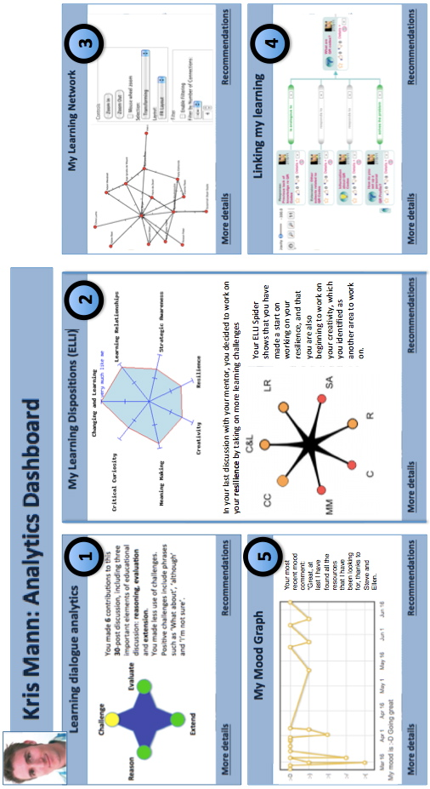
Image 1: Learner dashboard, various analytics methods

Educator user scenario
Jenny is running the course Kris is taking and has a different dashboard, designed for educators. Her priority is to track and gain insight into the range of different factors known to impact sustained learner engagement in the first year of this challenging course.

First, the visualizations (image 2, left column) show the results of “at risk” analytics, as defined by a range of algorithms that match online behavior to predictive models based on past cohorts. These algorithms are a combination of what she has found to be best suited to the characteristics of courses run at her university, the student demographic and learning styles, and the mix of technologies they use.

Second, Jenny’s dashboard also shows (on the right) aggregates of all the personal learner analytics described in Kris’s dashboard, providing a deeper level of insight into how students are self-reporting their sense of progress and evidencing it through their online engagement. On other tabs, she can see how a given student has moved within the social network generated from course activity. This is of particular interest since this course teaches the importance of social capital and social media in next generation environmental policy strategy.

Third, Jenny is not locked into a single platform for these analytics. As hinted above, as she gets familiar with the new course, and gets to know her students, she can configure the analytics that best illuminate problems and progress of different sorts. This is possible because the platform is the de facto place for developers to add their tools as new plugins, which are easy to add as a new plugins in her WordPress blog. She can choose only to go with tried and tested algorithms from well known groups, or she can experiment with new ones. Ratings and reviews from fellow educators provide rapid alerts to new releases and features.

Fourth, the open platform means she can also compare current analytics with other, anonymized datasets within the faculty, but also with other faculty data, and indeed, with data from similar courses in other universities.

Fifth, Jenny has access to tools that reflect the somewhat less tangible aspects of learning, such as sentiments of learners in relation to a topic, the liveliness of debate around a topic, or engagement levels of different learners. She is also able to reflect on the effect of her (and the LA platform’s) interventions where students show signs of difficulty or needing additional help.

Finally, analytics are of no use if she can’t figure out what to do with them. She has been on professional development courses for 2 years now to understand the different approaches as generic tools, but also working closely with disciplinary colleagues to contextualize them to Policy and Environment analytics, and to design and map pedagogical interventions to different analytics patterns. Some of these interventions are ‘manual’ (e.g. she simply needs to prioritize a conversation with a given student), while others are patterns amenable to coding in the recommender engine as suggested actions for the student to consider, and in some cases, dynamic changes to the sequence and manner in which course materials are presented, better suited to students’ characteristics.

As a reflective practitioner, she has a new kind of workbench to reflect on her effectiveness. A key part of her academic research is the design and evaluation of new analytics, contributing to the debate on the ethics and pedagogy of analytics-driven practice, and the design of appropriate interventions.

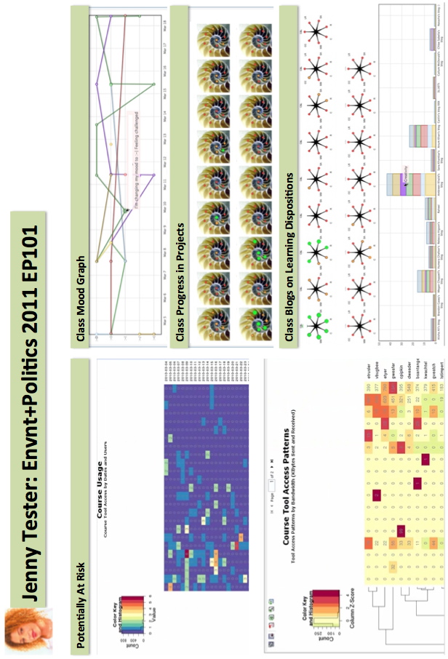
Image 2: Instructor dashboard, various analytics methods

Administrator user scenario
The administrators of the faculty, and of the broader institute of which this faculty is a member, also have a view onto Jenny’s course. They are understandably less interested in the fine detail of Kris’ progress – which is rightly the joint concern of Jenny and Kris. They are interested in high level summary statistics on Jenny’s course, and how this connects with the university’ strategic priorities on student success and satisfaction, course completion rates and resource allocations – for which there is another dashboard. Administrators will have greater abilities to analyze, across their institutions, the effectiveness and efficiency of programs and learning resources. Such will greatly facilitate improved quality in the development and provision of learning materials, course design, and teaching. While cross program comparison is complex, the data will allow areas of commonality to be determined allowing for cross-institutional and inter-program improvement.

A new dimension for them is that all universities in the Next Generation Analytics Consortium, and all faculties within a given institution, share anonymized data with each other, in order to facilitate benchmarking, and promote ethical, effective practices within and between institutions.

We have not mocked up this dashboard, but envisage visual analytics summarizing key outputs tuned to the administrators’ priorities.

Researcher user scenario: Analytics on learning analytics use
The broader “big data” movement in education, and specifically learning analytics, educational data mining, and recommender systems, are still in the early stages of development. The proposed platform is intended to ensure that as soon as possible, we have a ‘commons’ where the questions and technical possibilities that researchers from many communities bring, can meet with the priorities and constraints that learners, educators and administrators bring in their daily lives (e.g. in skills, and in the technologies to which they have access).

The following highlight three distinctive ways in which the platform will enable this:

Bringing researchers into Jenny’s ‘classroom’. The platform provides a bridge over the traditional research/practice divide, since those researchers/developers who build and develop tools good enough that University XYZ, Kris or Jenny choose to use them are rewarded with authentic, timely data – but in the spirit of the initiative, this is data open to all. We have a mechanism for more rapid feedback loops and design iterations. When researchers are connected with the different scenarios of LA use, they can quickly develop and deploy prototypes to improve the analytics process. Essentially, the researcher is part of a feedback loop that questions and evaluates the analytics tools and strategies used by stakeholders.

Meta-analysis within and across tools. The research community adds a meta-analytic layer on top of the platform, ensuring that the system itself is being analyzed and evaluated. Naturally, the platform will itself generate analytics to inform usability, technical decisions, and questions around the dynamics of adoption of such novel tools. Which analytics are most helpful in assisting learners like Kris in managing their learning? How do administrators alter processes based on new insights gained from analytics tools? Which tools are used by educators like Jenny, and do we see how her social network may in fact help spread her experiences and peers’ adoption of her preferred tools? What are the most urgent feature requests, as declared by learners, educators, and administrators?

Combinatorial analytics. Given multiple analytics on the same dataset, each of which provides a lens that adds more contextual insight, researchers (and likely policy analysts and reflective educators) will have, for the first time, the possibility to look for patterns. Is Kris’s position in his social network correlated with the way he uses language? Is his pass rate correlated with the number of questions he asks? When Jenny focuses student attention on their team-working, does this have any impact on their collaboration behavior, and how does this impact dropout rates?

Technical strategy

How can such a platform be delivered, which as emphasized, enables them to compare and contrast tools, and datasets, from diverse sources? Fundamentally, we require an open platform with standards for adding new “plugins” (see image 3). As long as developers of analytics, recommender services, visual user interfaces, and intervention strategies, comply with these standards, their work can become part of this ecosystem. (We do not detail in this outline document the technical issues in defining such standards, though numerous examples of similar approaches exist, most notably, Moodle, the open source learning management system).

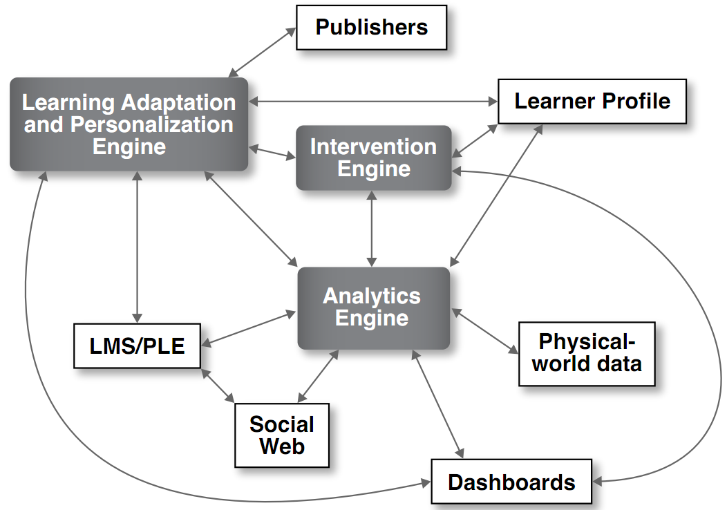

Image 3: Integrated learning analytics system

Analytics Engine
The analytics engine is the central component in the LA system. It is a framework for identifying and then processing data based on various analysis modules. For example, the analysis of a discussion forum in an LMS would involve identifying and detailing the scope of the forums and then applying various techniques (see image 4) such as natural language processing, social network analysis, process mining (to consider the degree of compliance between instructional design and the log data of learner activities), trace analysis of self regulated learning, the development of prediction models based on human assessment of interactions, or the process of concept development in small peer groups. As LA develops as a field, plugins developed by other researchers or software vendors can be added as modules for analysis. The analytics engine incorporates data from learning management systems, social web, and physical world-data (such as classroom attendance, use of university resources, GPS-data when completing activities such as surveying), and will leverage best practices from both the learning analytics and educational data mining communities.

Learning Adaptation and Personalization Engine
The learning adaptation and personalization will include adaptivity of the learning process, instructional design, and learning content. For example this adaptation engine could connect the analytics engine with content developers. Developers could include existing publishers such as Pearson or McGraw-Hill as well as institutional developers such as instructional designers and any implemented curriculum documentation processes and tools. When learning materials are designed to reflect the knowledge architecture of a domain, the content delivered to individual learners can be customized and personalized. The personalization and adaptation engine draws from the learner’s profile as defined in the learning management system and social media sources (when permitted by the learner).

The Intervention Engine
The intervention engine will track learner progress and provide various automated and educator interventions using prediction models developed in the analytics engine. For example, a learner will receive recommendations for different content, learning paths, tutors, or learning partners. These soft interventions are nudges toward learner success by providing learners with resources, social connections, or strategies that have been predictively modeled to assist others. Recommendations have become an important part of finding resources online, as exemplified by Amazon (books), Spotify (music), and Bing or Google (search). In education, recommendations can help learners discover related, but important, learning resources. Additionally, the intervention engine can assist learners by tracking progress toward learning goals.

Automated interventions also include emails and reminders about course work or encouragement to log back in to the system when learners have been absent for a period of time that might indicate “risky behavior”.

Interventions will also be triggered for educators and tutors. When a learner has been notified by automated email, but has failed to respond, the intervention engine will escalate the situation by sending educators and tutors notices to directly contact the student. The value of direct intervention by a teacher as a motivating condition for return to learning tasks is well documented by existing education research.

The Dashboard
The dashboard is the sensemaking component of the LA system, presenting visualized data to assist individuals in making decisions about teaching and learning. The dashboard consists of four views: learner, educator, researcher, and institutional. Learners will be able to see their progress against that of their peers (names will be excluded where appropriate), against learners who have previously taken the course, against what they themselves have done in the past, or against the goals that the teacher or the learner herself has defined. Educators will be able to see various representations of learner activity, including conceptual development of individual learners, progress toward mastering core concepts of the course, and social networks to identify learners who are not well connected with others. Analytics for educators will, depending on the context, be generated real time as well as hourly or daily snapshots. The dashboard will provide institution-level analytics for senior administrators to track learner success and progress. When combined with academic analytics, this module will be valuable for analyzing institutional activities (business intelligence).

Based on criteria established through research of the learning analytics system (such as the impact of social connectivity on course completion, warning signals such as changes in attendance patterns, predictive modeling), automated and human interventions will be activated to provide early assistance to learners demonstrating a) difficulty with course materials, b) strong competence and needing more complex or different challenges, and c) at risk for drop out.

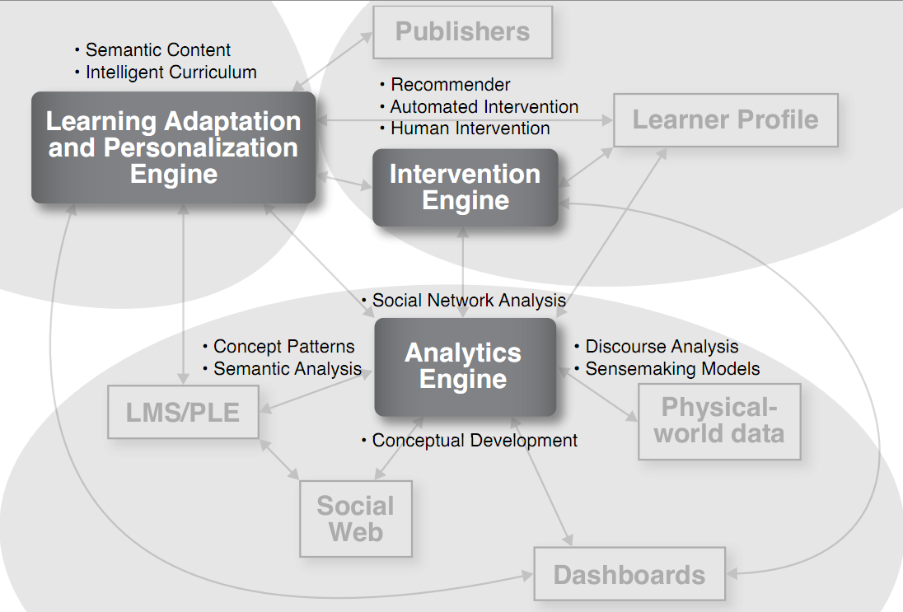

Image 4: Sample techniques for the analytics engine

Context and Depth of Analysis
Learners and educators require different depths of information in dashboards, based on the context and type of analytics. As a result, dashboards will be constructed to allow for “drilling down” to get more detailed and nuanced analysis of learning trends. Image 5 details drill down option for learners, helping to enhance their experience in a course and image 6 details drill down options for instructors, particularly in identifying learners who might be at risk for drop out or who face academic challenges..

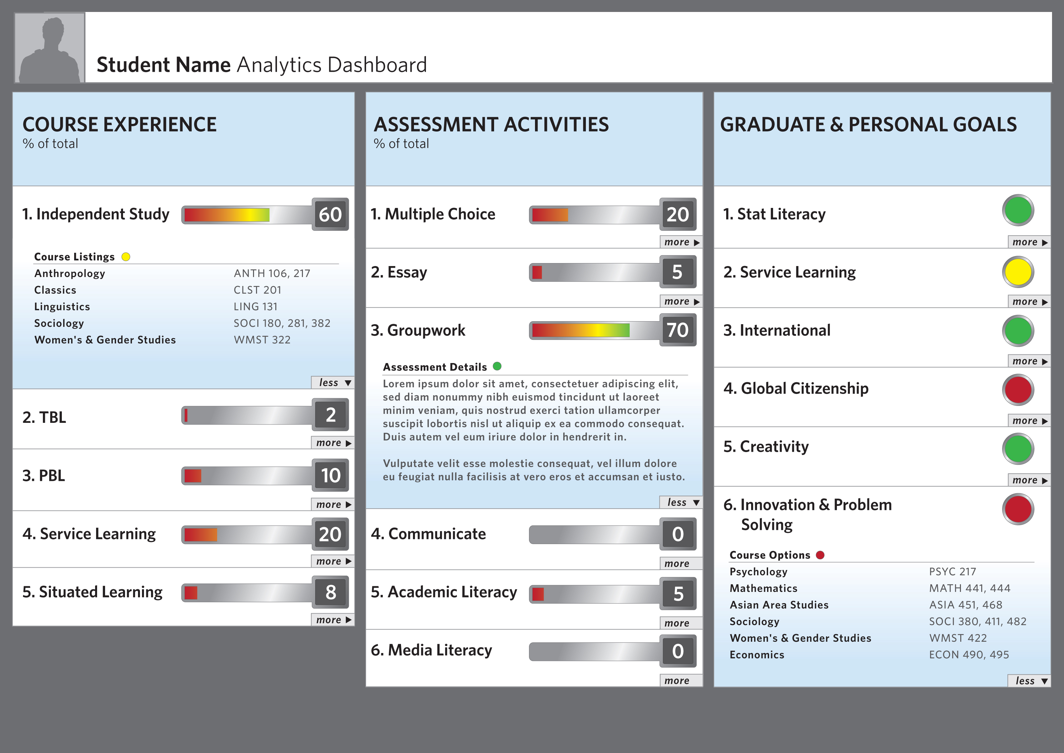
Image 5: Learner dashboard, showing “drill down” options

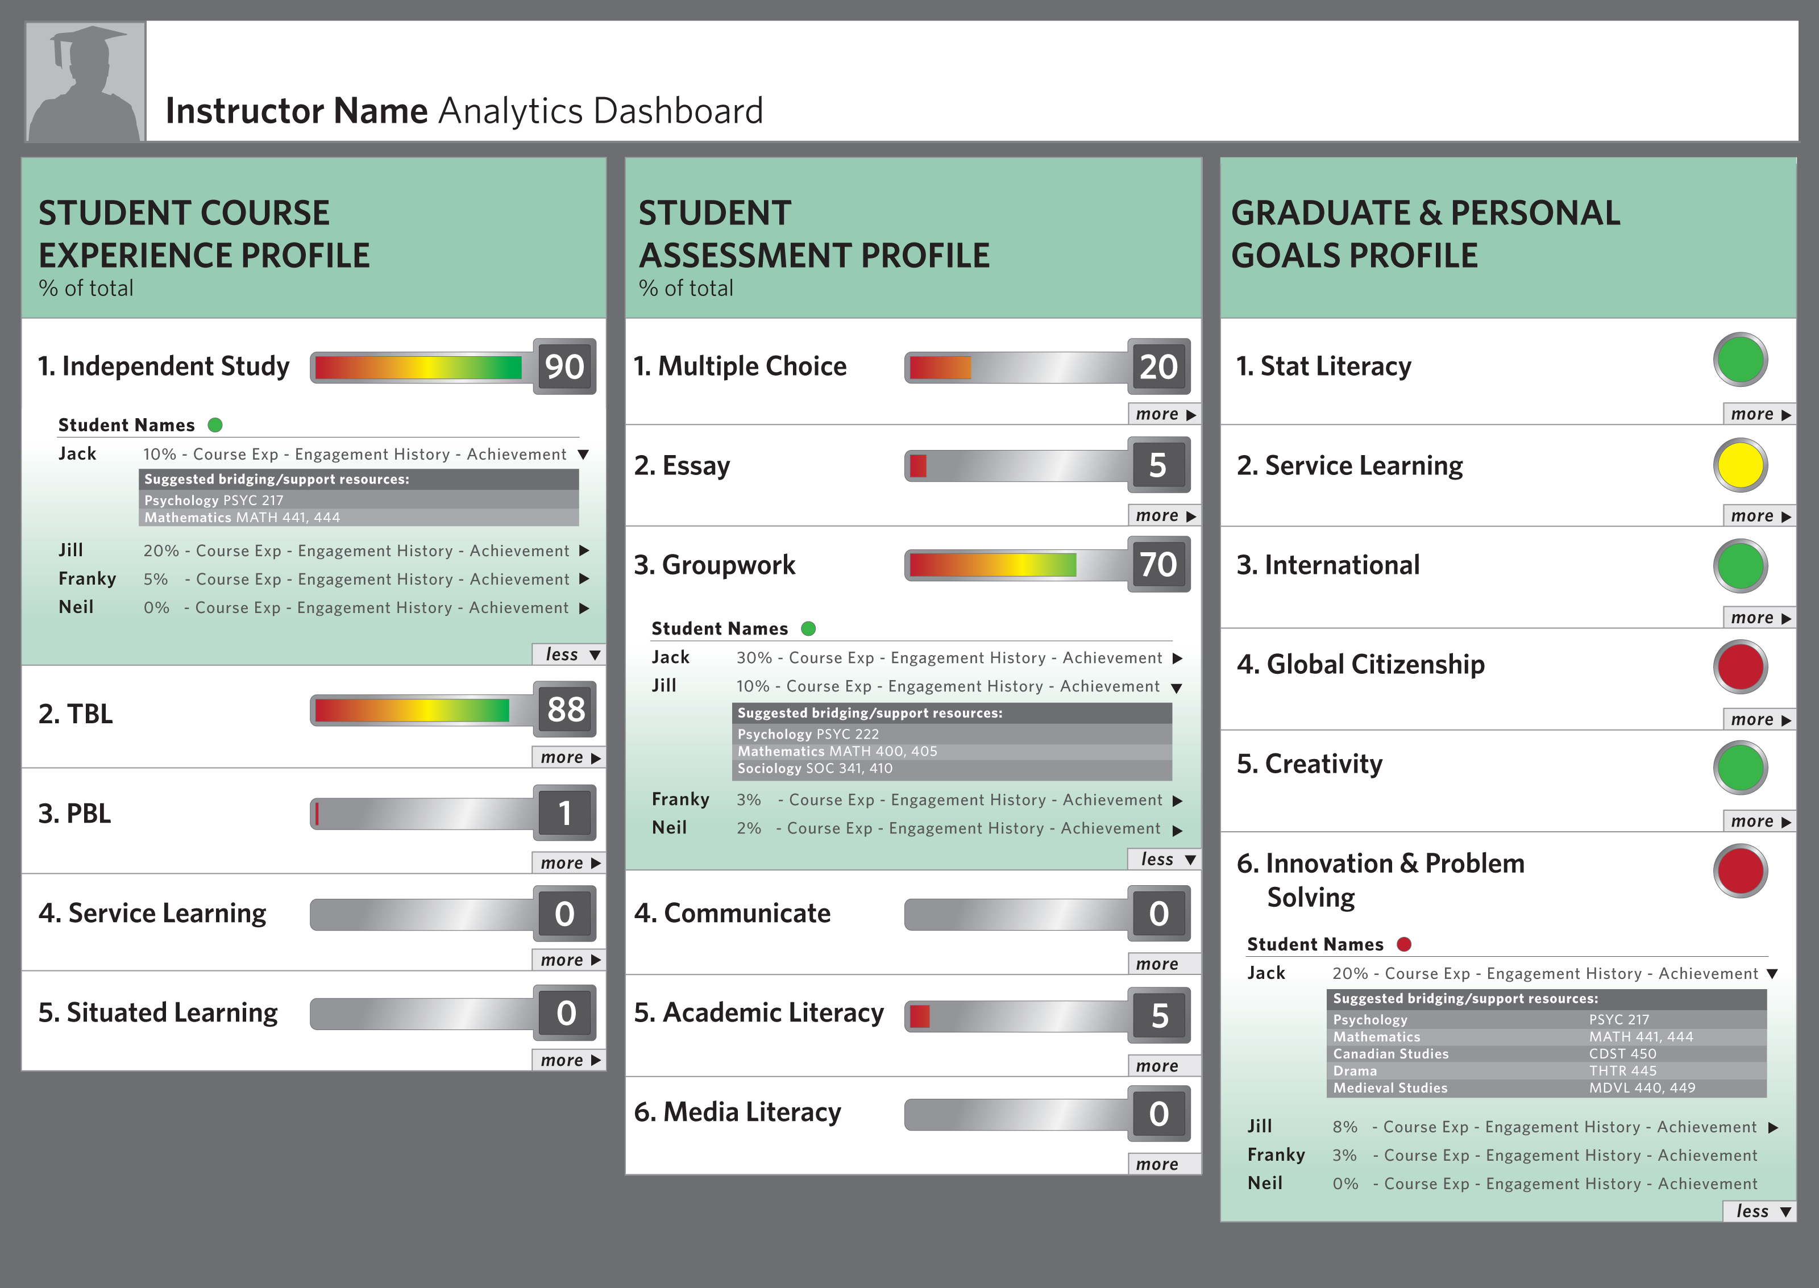
Image 6: Instructor dashboard, showing “drill down” options

Datamart
In order to apply learning analytics at a broader scale, it is imperative that an infrastructure be created that can support the development of tools and services. Such an infrastructure will need basic technical agreement on common standards and protocols.

A first question is how to model the relevant data. Our early work on Contextualized Attention Metadata (CAM) defines a simple model to structure attention meta-data, i.e. the interactions that people have with objects. The ontology-based user interaction context model (UICO) focuses more on the tasks that people carry out while interacting with resources. The Pittsburgh Science of Learning Center DataShop provides a framework for structuring data from the interaction between learners and various types of interactive learning environments, potentially providing lessons that can be adapted to the different types of data this project will encompass. More work is needed to develop a widely applicable such paradata schema.

Similar to the way that learning learning objects and their metadata can be managed, we will need a service architecture that can power a plethora of tools and applications. One interesting approach is to rely on widget technologies that enable the dynamic embedding of small application components - an approach at the core of Personal Learning Environments (PLE’s), researched in the ROLE project on Responsive Open Learning Environments (see http://www.role-project.eu). Another approach is the Learning Registry architecture that makes ”user data trails” available through a network of nodes that provide services to publish, access, distribute, broker or administer paradata (see http://www.learningregistry.org/). Where relevant, it may be feasible and desirable to export data to existing analytical tools, for instance the tools for profiling learner performance and modeling learner skill in the Pittsburgh Science of Learning Center DataShop (see https://pslcdatashop.web.cmu.edu).

Modularized Development

The proposed Open Learning Analytics platform will be developed in several research stages, including the development of sample courses (for personalization and adaptivity), the deployment of the analytics engine in online and blended university level courses, and the evaluation of dashboards with multiple courses and programs to ensure data is clearly presented and evaluated.

The scope of the integrated learning analytics toolset is broad, but the modularized development of the analytics engines, and the specific widgets or plugins that extend those engines, will be handled by individual researchers and research teams. For example, the dashboard will be lead by researchers with expertise in the visual display of information. This research team will interact extensively with the content, analytics, and intervention research teams. The approach of modularized, but integrated allows for connected specialization where research teams are connected with a broader vision, but still develop their specific research area.

Investigator Biographies

The investigators are at the forefront of the Learning Analytics field, leading at an international level, the conferences, research and publications that are shaping the scope of this emerging field. They represent a cross-section of researchers in both technical and social domains from an international set of universities.

More information on investigators can be found on the following sites:

George Siemens: https://tekri.athabascau.ca/content/george-siemens
Dragan Gasevic: http://www.sfu.ca/~dgasevic/
Simon Buckingham-Shum: http://people.kmi.open.ac.uk/sbs/
Rebecca Ferguson: http://kmi.open.ac.uk/people/member/rebecca-ferguson
Caroline Haythornthwaite: http://www.slais.ubc.ca/people/faculty/faculty.htm
Shane Dawson: http://www.arts.ubc.ca/faculty-amp-staff/arts-isit/staff.html
Erik Duval: http://erikduval.wordpress.com/about/
Katrien Verbert: http://people.cs.kuleuven.be/~katrien.verbert/
Ryan S.J.d. Baker: http://users.wpi.edu/~rsbaker/

Considerations

Our intent for this project is to create the architecture for researcher and practitioner innovation in education through access to tools that provide insight into the teaching and learning process. As part of this work, in addition to the broad conceptual overview of our integrated learning analytics platform, we emphasize the following goals:

- Development of common language for data exchange.
- Analytics engine: transparency in algorithms so learners and educators are aware of data being gathered and researchers can customize analytics methods to reflect the needs of different contexts (schools, circumstances, policy or administrative priorities).
- Dashboards and reporting tools to visualize information and provide real-time information to learners, educators, administrators, and researchers.
- Open repository of anonymized data for training and research development
- Connect to and amplify the existing research being conducted by EDUCAUSE, the International Educational Data Mining Society, Next Generation Learning Challenge, and related analytics initiatives such as the EU dataTEL initiative.

Getting Involved

The Society for Learning Analytics Research (www.Solaresearch.org) welcomes partners – universities as founding members and researchers, to join in the Open Learning Analytics initiative. Please contact us at info@solaresearch.org for more information.

Concluding Thoughts

All stakeholders in the education system have access to more data than they can possibly make sense of or manage. In spite of this abundance, however, learners, educators, administrators, and policy makers are essentially driving blind. New technologies and methods are required to gain insight into the complex abundant data encountered on a daily basis. The history of technology adoption in education suggests a consistent and challenging model: important ideas and innovations developed piecemeal and in isolation, resulting in a fragmentation and confusion for end users who are most in need of efficient solutions. Our proposed integrated learning analytics platform attempts to circumvent the piecemeal process of educational innovation by provided an open infrastructure for researchers, educators, and learners to develop new technologies and methods. In today’s educational climate – greater accountability in a climate of reduced funds – suggests new thinking and new approaches to change are required. Analytics hold the prospect of serving as a sensemaking agent in navigating uncertain change by offering leaders with insightful data and analysis, displayed through user-controlled visualizations.

John P. Campbell, Peter B. DeBlois, and Diana G. Oblinger (2007), EDUCAUSE Review, vol. 42, no. 4 (July/August 2007), pp. 53–54
1st International Conference on Learning Analytics & Knowledge
Siemens, G., Long, P. (2011). Penetrating the Fog: Analytics in learning and education. EDUCAUSE Review, vol. 46, no. 4 (July/August 2011)
Siemens, G. (2007) “Connectivism: Creating a Learning Ecology in Distributed Environment,” in Didactics of Microlearning: Concepts, discourses, and examples, in T. Hug, (ed.),Waxmann Verlag, New York, pp. 53-68
The basis for this envisioned Learner Dashboard comes from techniques reviewed in: Buckingham Shum, S. and Ferguson, R. (2011). Social Learning Analytics. Available as: Technical Report KMI-11-01, Knowledge Media Institute, The Open University, UK. http://kmi.open.ac.uk/publications/pdf/kmi-11-01.pdf
Deakin Crick, R., Broadfoot, P. and Claxton, G. (2004). Developing an Effective Lifelong Learning Inventory: The ELLI Project. Assessment in Education, 11, (3), pp. 247-272
Adapted from EnquiryBlogger: http://learningemergence.net/tools/enquiryblogger
These two mockup examples are adapted from Desire2Learn’s demonstration movie: http://www.desire2learn.com/demos/Analytics
Haythornthwaite, C. (2008). Learning relations and networks in web-based communities. International Journal of Web Based Communities, 4(2), 140-158.
Hadwin, A. F., Nesbit, J. C., Code, J., Jamieson-Noel, D. L., & Winne, P. H. (2007). Examining trace data to explore self-regulated learning. Metacognition and Learning, 2, 107-124
Baker, R.S.J.d., de Carvalho, A. M. J. A. (2008) Labeling Student Behavior Faster and More Precisely with Text Replays. Proceedings of the 1st International Conference on Educational Data Mining, 38-47.
Baker, R.S.J.d., Yacef, K. (2009) The State of Educational Data Mining in 2009: A Review and Future Visions. Journal of Educational Data Mining, 1 (1), 3-17.
Romero, C. Ventura, S. (in press) Educational Data Mining: A Review of the State-of-the-Art. IEEE Transaction on Systems, Man, and Cybernetics, Part C: Applications and Reviews.
Dawson, S., Heathcote, L. and Poole, G. (2010), “Harnessing ICT Potential: The Adoption and Analysis of ICT Systems for Enhancing the Student Learning Experience,” The International Journal of Educational Management, 24(2), pp. 116-129.
Macfayden, L. P., & Dawson, S. (2010). Mining LMS data to develop an "early warning" system for educators: a proof of concept. Computers & Education, 54(2), 588–599.
Duval, E. Verbert, K. “On the role of technical standards for learning technologies.” IEEE Transactions on Learning Technologies 1, no. 4 (October 2008): 229-234. https://lirias.kuleuven.be/handle/123456789/234781.
J. Najjar, M. Wolpers, and E. Duval. Contextualized attention metadata. D-Lib Magazine, 13(9/10), Sept. 2007.
M. Wolpers, J. Najjar, K. Verbert, and E. Duval. Tracking actual usage: the attention metadata approach. Educational Technology and Society, 10(3):106–121, 2007.
A. S. Rath, D. Devaurs, and S. Lindstaedt. UICO: an ontology-based user interaction context model for automatic task detection on the computer desktop. In Proceedings of the 1st Workshop on Context, Information and Ontologies, CIAO ’09, pages 8:1—-8:10, New York, NY, USA, 2009. ACM.
Koedinger, K.R., Baker, R.S.J.d., Cunningham, K., Skogsholm, A., Leber, B., Stamper, J. (2010) A Data Repository for the EDM community: The PSLC DataShop. In Romero, C., Ventura, S., Pechenizkiy, M., Baker, R.S.J.d. (Eds.)Handbook of Educational Data Mining. Boca Raton, FL: CRC Press, pp. 43-56.
S. Ternier, K. Verbert, G. Parra, B. Vandeputte, J. Klerkx, E. Duval, V. Ordonez, and X. Ochoa. The Ariadne Infrastructure for Managing and Storing Metadata. IEEE Internet Computing, 13(4):18–25, July 2009.

