Unit 1 Site Design

Main Theme
This website will be a mock up for George N Jackson, a company that wholesales drapery hardware and fabrics. As well as fabrics for other things such as automobiles, boats, and upholstery. The company mainly sells to other companies such as interior designers and not directly to the consumers. For this reason, the websites focus should be on simplicity and ease of access to find what they are looking for. On top of this the drapery fabrics selection is constantly rotating so it must be very easy to add and remove fabrics to only display the most up to date selection.

Site Map
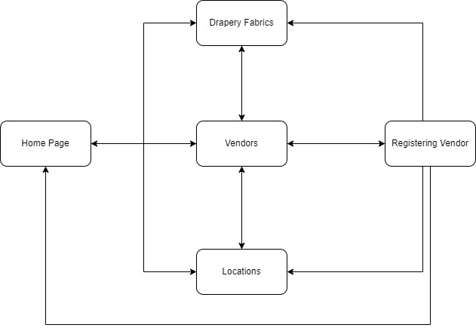

Personas & Scenarios
Persona 1 – Ashley Dover
Age: 30
Profession: Interior Designer
Bio: Ashley is an interior designer who primarily works with large businesses as some rich individuals looking to increase the aesthetic of their house. Ashley offers many services including providing multiple options for her clients to pick as well as full installation of the chosen design. Ashley always contracts out her manual labour on large jobs.

Scenario 1:
Ashley is creating multiple designs for rooms in a new hotel being built. She wants to provide multiple different styles for each type of room. She arrives at our website being a known wholesale company that could fulfill such an order. She then searches the website to see all possible designs of blinds which he could choose from.

Scenario 2:
Ashley has decided on the blinds for all the rooms, as well as an awning for the entrance. She now wishes to find contractors to come in and install them all. She finds a couple vendors in his area who specialize in installing blinds and awnings, then collects their contact information so she can reach out to hire them.

Scenario 3:
Ashley is trying to create a new look for a client’s house. She presents them with many different options, but the client doesn’t seem to like any of them. Ashley instead now wishes for the client to pick out their own style for the room on which she can base the room from. She sends the client a link to our drapery fabrics page so they can quickly view tons of styles and colors to get back to him with the ones they like.

Persona 2: Mark Smith
Age: 51
Profession: Marine Mechanic
Bio: Mark is a marine mechanic based in Vancouver currently running his family-owned business. They primarily work on individuals’ boats to perform routine maintenance or install new parts.

Scenario 4:
After a large storm, one of Mark’s clients shows up with lots of damage done to the boat. Mark needs to order a variety of parts including a new frame kit. After searching around online he finds our company which sells them. From the homepage he is easily directed to the marine section of our supply catalog, where he can view our full selection then order the part that he needs.

Scenario 5:
Mark is working on a boat that the client wanted back at the end of the day. He realized he is missing one of the parts required to complete the job. He normally orders the part and has it delivered to his shop, but he does not have time to wait for the delivery. As he normally orders the part from George N. Jackson, he goes to their website to see if he can pick it up instead of waiting for delivery. From there he sees the locations page and finds out he is only a 15-minute drive away and can easy go there to pick up the part himself in order to finish his job on time.
Persona 4: John Fenton
Age: 22
Profession: Contractor
Bio: John works for a small contracting business. They complete many smaller services for home improvement projects such as installations of blinds, painting, and other services. John’s company is always looking for more work and he receives a finder’s fee for any job that he finds them.

Scenario 6:
John just completed installing awnings for a business that purchased from George N. Jackson. He was hoping to reach out to more of their customers to land more jobs. He goes to our website to see any way he may want to advertise. From our website he finds a page where vendors can list their services and any customer who may require them can reach out to negotiate prices. So from the website he sends off a request to be added to the list of available vendors.

Page Mock-Ups

Index page:
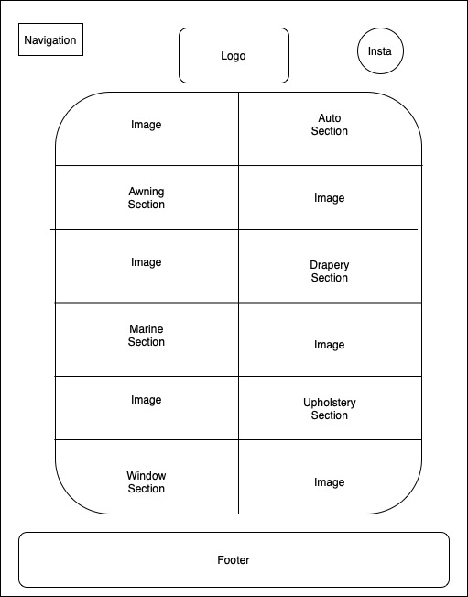
Drapery Fabrics
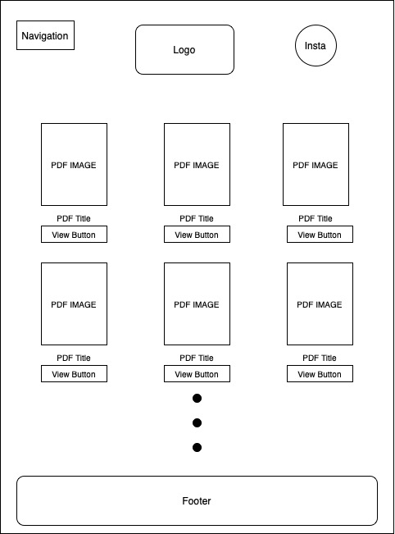
Vendors
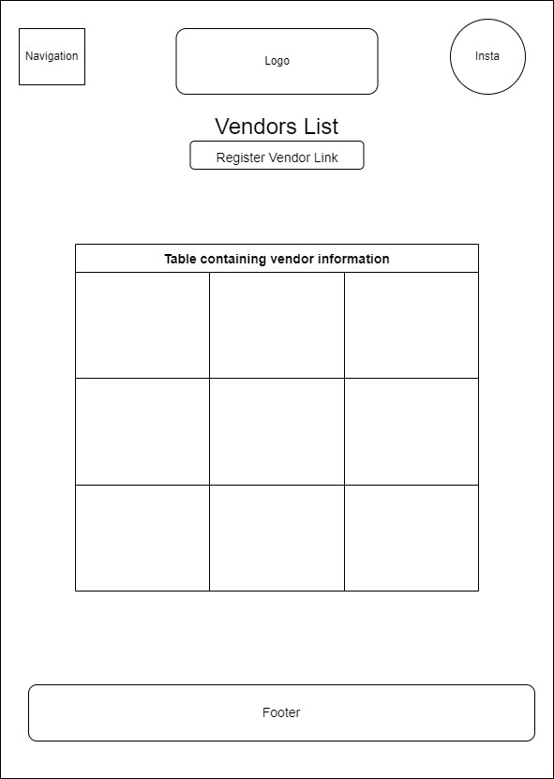

Registering Vendor
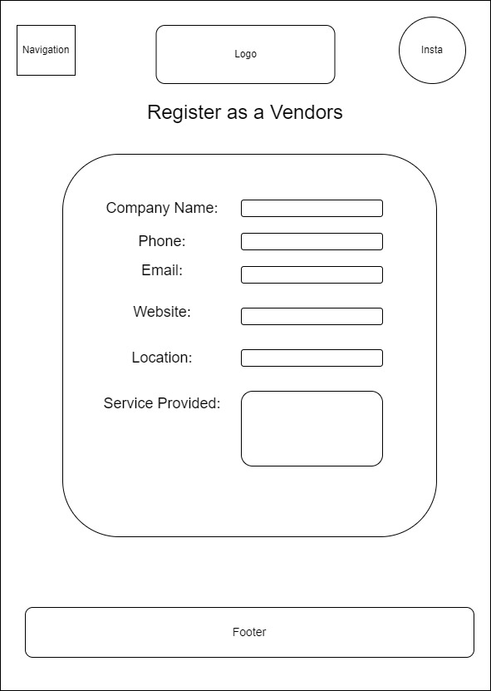

Locations
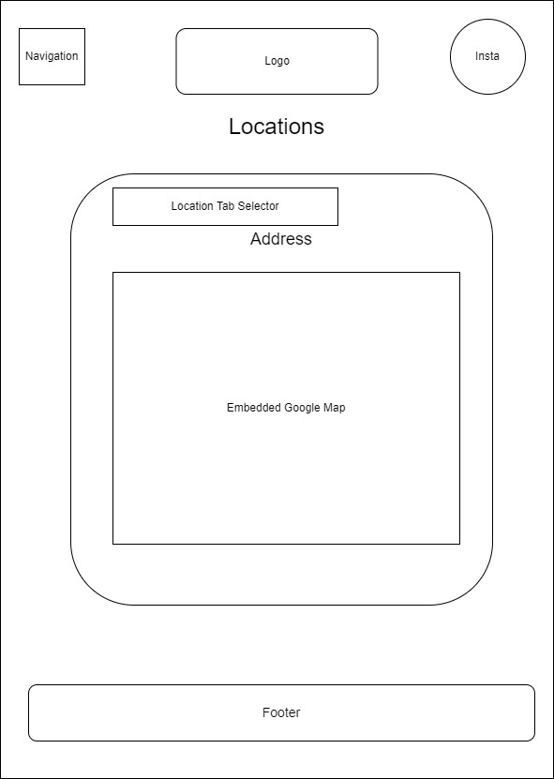

Learning Diary

In this unit, I created documentation outlining the website that I will be creating. This documentation included the theme for the site, a site map showing how each of the pages will be linked together, mock ups for each page, as well as personas and scenarios of people using the website. As the company sells only business to business, I felt a simple easy to use and navigate website would be much more effective than a flashy one as many of the customers already know what they want, they just need to find it. For the site map I made the decision of linking every page to one another, other than the registering a vendor page which can only be accessed from the vendor page. I made this decision as most people accessing the website are not there to use that functionality and I didn’t want it to distract customers from what they are looking for.

