MDE603 Assignment #1b
A Water Utility - Drinking Water Complaints Rich Picture Soft Systems Analysis

Submitted by: Kenneth Grant Murphy
Learner Number: 2515643

Athabasca University
Masters of Distance Education

Course: MDE 603

Date: October 9, 2006

Introduction
This paper utilizes Checkland’s “Rich Picture” methodology to complete a soft systems analysis and focuses on a water utility’s efforts to acquire accurate information about drinking water quality based on customer complaints. Ensuring accurate collection of customer complaint information assists in the response by water utility staff to water quality events and the development of long term solutions for persistent problems in an area of the water distribution system. This situation is not an isolated problem and is deemed to be a “mess” in the terms of Naughton’s text.

Unstructured Problem Situation
Over the past five years, the Ontario government has enacted several drinking water regulations under the Safe Drinking Water Act (2002). Ontario Regulation (O. Reg.) 170/03 regulates municipal and private water systems that provide water to year-round residential developments and designated facilities that serve vulnerable populations such as children and the elderly. Along with O.Reg. 169/03, these regulations ensure that all municipalities operating a drinking water treatment or distribution system closely monitor these systems to achieve specific levels of drinking water quality.
Two general categories of information related to water quality are tracked — operational and customer driven. Operational data is collected and monitored about the quality (along with quantity) during the production of drinking water and the delivery of it the utility’s customers. This information is collected due to regulatory requirements and is proactive in nature; in other words, it assists the utility in operating a drinking water system that includes a conventional water treatment facility (filtration, coagulation, flocculation, sedimentation, and chlorination) along with pumping stations, water storage tanks, and several hundred kilometres of underground watermains. It is very important to have appropriate operating information at an operator’s fingertips to optimize chemical usage and achieve water quality targets. Examples of data include the turbidity of the raw river water tracked by the supervisory control automated data acquisition (SCADA) technology or the level of chlorine residual (to help kill bacteria) in the underground water distribution system (pipes or mains) collected manually by system operators.
The other source of information for a water utility comes from their customers and is related to complaints about water quality and are very reactive in nature. Typically water utility staff try to address customer complaints over the telephone, or perform follow-up site visits and acquire water samples for testing, as necessary. If these samples exceed provincial regulatory standards then staff report to the Medical Officer of Health that appropriate corrective action has been initiated and the situation rectified. This a standard and accepted practice for many water utility across the Province, in order to manage their drinking water system.
The problem situation is that this information is not being tracked in a consistent manner and is not accessible in timely fashion. It is the perception of some staff that an optimal and effective response to customer concerns is not being completed by the water utility. This perception is related to the inconsistent nature of tracking, the completion of follow-up activities, and continuing re-occurring problems within certain areas of the distribution system.

Rich Picture – Issues and Primary Tasks

Structure
There are four departments affected by this situation — Customer Service (CS), Engineering Services (ES), Water Treatment Plant (WTP), and Water Distribution (WD). The main actors are the Vice President of Water Utility, the Water Distribution Superintendent, the Water Treatment Plant Superintendent, the Manager of Engineering Services, clerks, customer service representatives, and of course the customers who make the complaints. The Manager of Engineering Services is completing the analysis and is involved in the problem situation.
The departments are part of a utility services company that is under contract by the local water utility commission. The water utility commission is a board appointed by the local municipality to oversee the water system on behalf of its citizens.

Process
Customer calls are directed to the appropriate service department so that the call can be addressed and follow-up action taken by staff, if necessary. A customer complaint response procedure was developed some years before by the senior manager of the water utility. This procedure has been revised several times by the senior manager as Regulatory changes occurred.
Customer calls come into the utility through any one of these departments (CS, ES, WTP, WD), as some customers dial through to the department that they think will solve their problem, while other calls are directed by internal staff based on the procedure or their best guess.
The approach taken by staff was to exclude some calls and not track every complaint to completion. Some staff indicated that many customer calls were noted but were related to some obvious operational issue (such as watermain flushing or other construction activity) that causes a disturbance in the water system. These are not tracked as they would respond to the customer that the problem would go away once the work was completed and if it persisted to call back later.
This process formed “organically”, based on the perceptions of the individuals in those departments (i.e. their needs were different), with no overarching requirement to coordinate this information because “it was too much work” and there was no corporate need for it. For example, WD and WTP utilize customer complaint information to determine a course of corrective action, while ES attempts to utilize water quality information in order to develop capital improvement projects to improve system quality and reliability.

Climate
The procedure did not indicate the type of information to be monitored and there was inconsistent information collection of the customer complaints. Coupled with inconsistent reporting was the fact that there were three (3) places where this information was tracked and it proved difficult to summarize this data. This posed problems when it came to responding to reoccurring problems or analyzing information by the engineers to specify capital infrastructure renewal programs (to remedy persistent water system problems).

Facts
This is a highly regulated industry due to provincial requirements. There are several procedures and work practices developed including a customer complaint response procedure.

Queries
An issue that is on the regulatory horizon for drinking water authorities is a quality management standard (QMS). In a nutshell, this standard will require operating authorities to institute processes, and procedures that will ensure consistency in the drinking water product, identify critical control points in the system, and demonstrate to third party auditors that what they say they are doing, they’re really doing. About two years ago in this specific water utility, it was determined that there was a need to work towards developing a quality management system.
There will be more regulations in the future and as such this will likely cause the utility’s operating costs to increase, these costs will be transferred to its customers. How will these new regulations affect water rates and the utility’s ability to sustain the system? There will be increased pressure by the water users to justify these rate increases and there will be a need to better plan. Better planning normally requires more accurate information in order to make better decisions, so where will this information be coming from?
How will the changing demographics of the water utility affect its corporate memory? As more of the “baby boomer generation” retire, information will be lost about problem areas of the water system and how they were rectified.
Finally, what of the public’s perception of drinking water and their confidence levels in the systems that they are paying for? A perfect example is the inroads that bottled water has had on the lives of the average consumer; instead of taking a glass of water from the tap, they are taking it from a bottle of water, because they believe that it tastes better and is safer to drink.

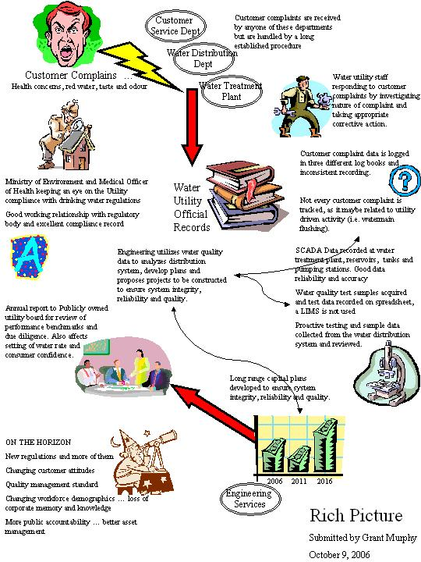

Relevant Systems and Root Definitions (CATWOE)

The first attempt at a system definition was the following; “a system that provides clean and safe drinking water to Utility customers while achieving the provincial regulatory requirements in a fiscally responsible manner.” It described the key objectives of the Utility based on its environment, ensuring public health and safety requirements, achieving regulatory compliance, and completing supporting activities in a way that optimizes costs in order to keep water rates affordable for customers. But it was found to be too generalized and utilized the CATWOE checklist and items developed from this critique are listed below.

Customers of the system (beneficiaries or victims)
Water Utility Customers, Water Utility Commission, City Council, Ministry of Environment

Actors
Water utility employees, provincial environment ministry officials, water utility customers.

Transformation Process
To produce clean safe drinking water from the Otonabee River source and supply this to Utility customers in accordance with provincial regulations.

Weltanschauung (Worldview)
In May 2000, the world of Ontario’s drinking water utilities was literally transformed overnight due to the negligent acts of public servants operating the Town of Walkerton’s water treatment system, resulting in the deaths of seven people and the illness of thousands of others. As a result, Justice O'Connor (2002) was commissioned by the Province of Ontario to investigate the tragedy; his report made over 90 recommendations that resulted in new regulations and tougher drinking water standards, additional controls and monitoring; clarification of responsibilities for operators, public health officials, and other drinking water agencies; and higher standards of care for municipal officials who oversee the Ontario’s drinking water systems. The water utility is now operating within this new worldview.

Owner

Ministry of Environment as they would be able to make the system cease to exist.

Environmental constraints

Limited resource pool of trained and competent water operators, significant and numerous changes in regulations over the last five years, ...

Final System Definition

After the CATWOE analysis was completed the revised definition grew to be the following; “a system that provides clean and safe drinking water to Utility customers as determined by; i) provincial regulatory requirements, ii) following good utility industry practice, iii) monitoring of drinking water quality, iv) completing appropriate operational activities in a consistent manner, v) implementing capital improvement projects that optimize system costs, and vi) educating the public about the importance of a safe drinking water supply.”

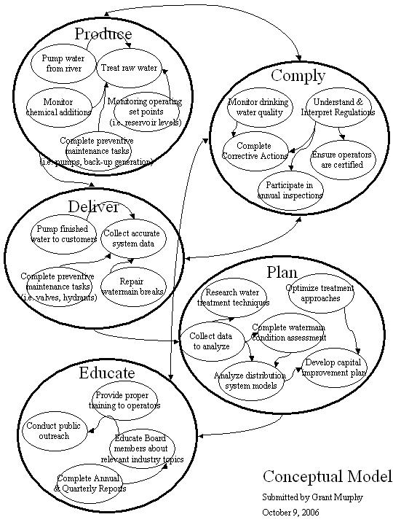

Comparison of Conceptual Model with Rich Picture

A comparison describing the differences between the conceptual model and the rich picture shows the manner in which information is obtained, stored and retained in the organization (this is a very narrow and condensed analysis). Information about customer complaints needs to be collected, monitored and stored in an accurate and consistent manner. This is important in two areas — operations (WD and WTP) and also in engineering (ES). The key aspect is that this information eventually will be assessed, either at an operational level where immediate action is necessary or at engineering level where longer term plans are drawn up to prevent the problem from happening again.
The objective is to have accurate information such that repetitive information is eliminated (i.e. the same complaint event recorded more than once); necessary information is collected (based on specifications identified by the stakeholders); required information is disseminated to the operating staff to determine and then execute the correct action; information is easily accessible dot hat reporting can take place after the fact, and analysis of this same information is completed to develop necessary long range plans by engineering.

Concluding Remarks
In reality, some measure of process review and improvement was actually undertaken by the water utility and in this light a few comments are provided. Traditionally, a top down edict from the senior manager would have described to the departments what was required and how it was to be collected. But in this case the senior manager agreed with an approach that incorporated a systems analysis (unknowingly at the time) be taken. Some of the items addressed were:
- Development of new paper forms that provided checklists and menus to select from, which is improving the consistency of data collection.
- Development of a web–based interface software application that is linked to the customer information system (CIS) application. Significant effort was expended by frontline staff to test and suggest enhancements during testing.
- Staff learned about how and why other departments collected and used this information. This broadened knowledge and helped to develop consistency.
- The information can be transferred from the CIS application to the engineering geographical information system (GIS) to produce drawings which show where complaints (type, date, frequency) have occurred in order to identify patterns that may be rectified by capital improvements to the water distribution system.

Finally, one of the lessons that was reinforced for the authour was that the “solution” is never really solved. It just opens new issues — now that we have this centrally compiled information (and easily accessible) how can we most effectively utilize the information in our engineering department or at our water treatment plant to improve our drinking water system? We are now experimenting with this information and discovering all sorts of new questions we didn't have time to think about (i.e. because it was too hard to get at the information or that we weren't confident in the data quality).

References

Naughton, J. (1984). Soft systems analysis: An introductory guide. The Open University. United Kingdom.

O’Connor, D. (2002). Part two report of the Walkerton Commission of Inquiry. Ontario Ministry of Attorney General. Retrieved October 9, 2006 from MAG web site: http://www.attorneygeneral.jus.gov.on.ca/english/about/pubs/walkerton/part2/

