European Weather Extremes in the Lifetime of Charlemagne (c.742–814 CE) Conor Kostick & Francis Ludlow

1. From the Black Sea to the North Sea
Charlemagne (c.742 – 814 CE) had such a successful political and military career that for the entire subsequent medieval period his reign was portrayed as a model one for all European rulers to aspire to. But for all his achievements in expanding and governing a realm that stretched from the north coast of France down to northern Spain, across Italy and up through modern day Austria and Germany to Denmark, the Frankish king experienced a number of difficulties, including hazards created by extreme weather conditions.

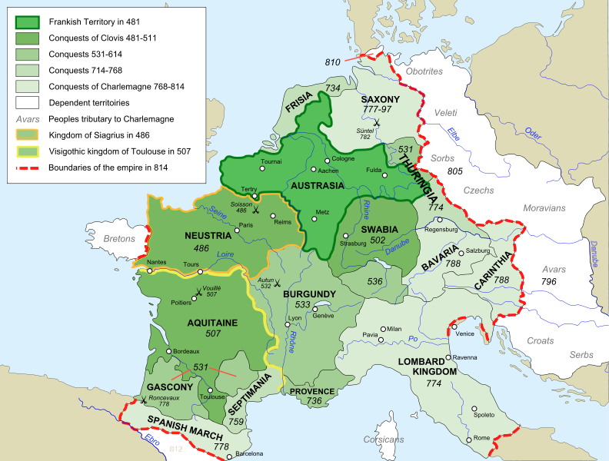
Figure 1: The Expansion of the Kingdom of the Franks, 481 – 814 CE.

2. Charlemagne’s Canal
One of Charlemagne’s greatest undertakings took place during the entire autumn of 793 CE, when, with a massive mobilisation of manpower, he attempted to build a canal between the Danube and the Main at Graben near Treuchtlingen. If he had succeeded, he would have created a waterway connecting the North Sea, via the Rhine delta (at modern day Rotterdam in the Netherlands) and the Danube Delta in eastern Romania, to the Black Sea. The main purpose of this effort was to allow Charlemagne’s war fleet to campaign along the Danube, but perhaps also, it was a test of his powers to levy labour upon a recently conquered people.

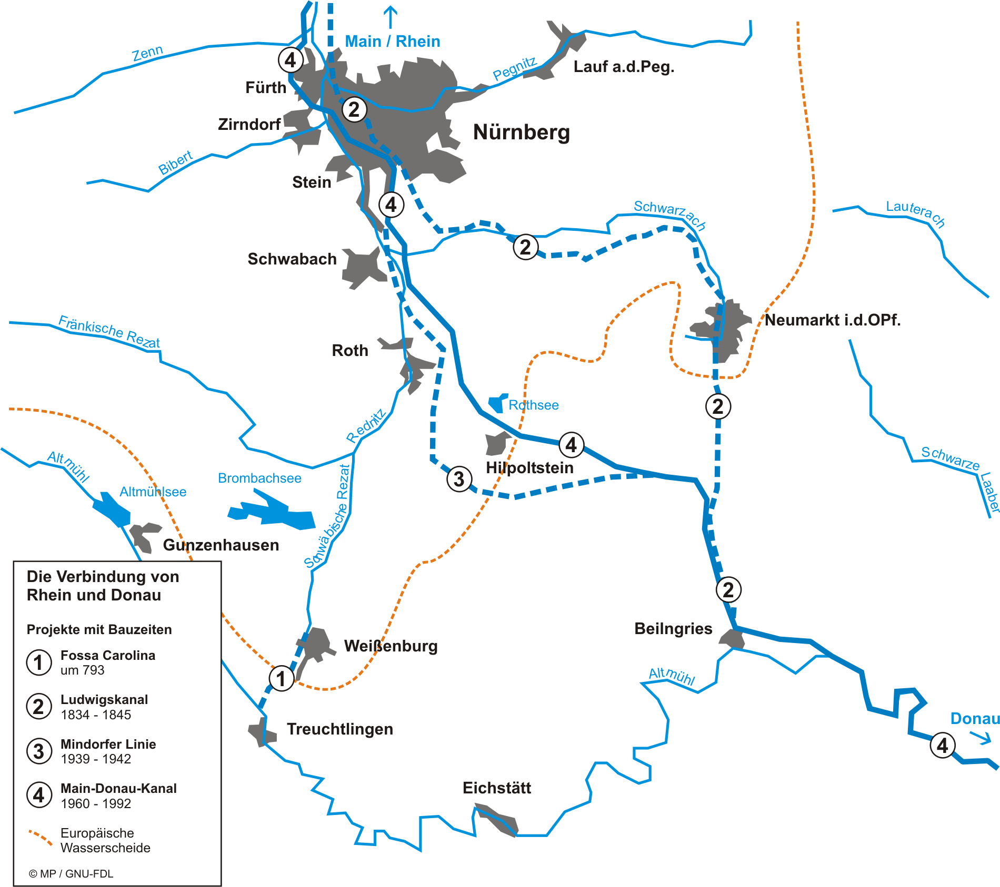
Figure 2: Historical Canal Building in the Vicinity of Nürnberg.

The surviving archaeology shows that the projected canal would have been 2.5m deep with 6m bounding banks. The shape of the canal was that of a flattened V, whose base was 9m wide, with a width across the top of 60m. In this ambition Charlemagne was ahead of his time as a canal linking the Main and Danube was not completed until 1846.
3. Wet Weather
The contemporaries of Charlemagne who wrote about their lord wished in the main to record only his successes. The archaeological evidence of his canal workings would thus have been a mystery for modern scholars if not for two more critical works. The Chronicle of Moissac is named after the abbey it was found in, at Moissac (in the Pyrenees region of France), but from its focus on Catalonian events, the chronicle is thought to have in fact been compiled at Ripoll in Catalonia and was thus some distance from the centre of Charlemagne’s power. Although the Chronicle of Moissac follows the Royal Frankish Annals closely in its entry for 793, its late-tenth-century editor saw fit to insert an additional notice, that after King Charles celebrated Easter near Regensburg, ‘he wished to go with the navy to Francia, so he ordered a massive ditch to be built between two rivers, the Alimonia and the Ratanza, and he was held up in that place a long time.’
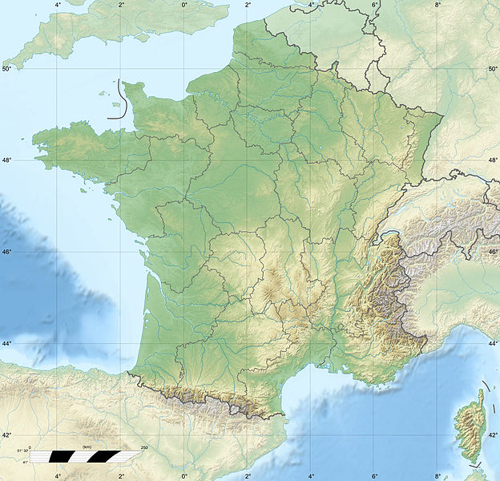

Moissac

Ripoll

Figure 3: Location of Moissac and Ripoll.

A more precise report of Charlemagne’s canal digging endeavour comes from a major revision of the Royal Frankish Annals – sometimes (but unconvincingly) attributed to the same Einhard who wrote a well-known Life of Charlemagne - that a Frankish cleric undertook, probably in 801 or 812 CE. The author of the revision was well-informed about royal affairs and had access to one of the better libraries of the era. Although happy to repeat the phrases in praise of Charlemagne that are present in the Royal Frankish Annals, the reviser seems to have felt able to speak more freely of the emperor’s setbacks, and did so several times.
From this historian we learn that having been persuaded by certain people who declared it was sure to be a success, Charlemagne left camp with all of his following (omni comitatu) to connect the waters of the Rhine and the Danube.

With a great multitude of people having been brought together, the whole of the autumn period was squandered in that work. It was commanded that a ditch of two thousand paces long and three-hundred feet wide be made between the aforementioned rivers. But in vain, for, because of continual rains and the marshy earth being naturally imbued with too much moisture, he was not able to make such works stand. However much earth the diggers lifted out by day, so much was subsiding at night, falling back in to the ground again in the same place.

An army of people, digging for a whole season, yet their efforts end in muddy ruin. Was it a project that was doomed from the start? Our main source gives two reasons for the failure: the marshy earth and continual rains. It is this latter aspect that stands out as being of interest to historical climatologists. Did abnormal weather count against Charlemagne in this instance?
The same region had experienced unusually heavy rainfalls and floods just a decade earlier. The chronologically reliable Royal Frankish Annals state that in 784, ‘the lord King Charles went on a journey, he crossed the Rhine at the Lip and entered Saxony in order to travel about and lay waste to the land, all the way as far as Hockeleve [modern Petershagen]. In that place a plan was made, because of the excessive floods of water that had occurred, to invade the eastern part of Eastphalia from Thuringia, and his son lord Charles was dispatched together with a troop against Westphalia, which therefore took place.’
The ‘reviser’ of these annals who gives us the detail of the failed canal project explains this incident with a slight variation in the report. ‘And while he [Charlemagne] had encamped in that place which is called Hockeleve, with the armies being placed above the river, he had wished to see himself established in the northern parts of Saxony. Because of excessive floods of water, which suddenly appeared from the continual fall of rains, it was not possible to cross. Therefore he turned around to journey in Thuringia and ordered his son Charles with part of the army to camp at the boundary of Westphalia.’

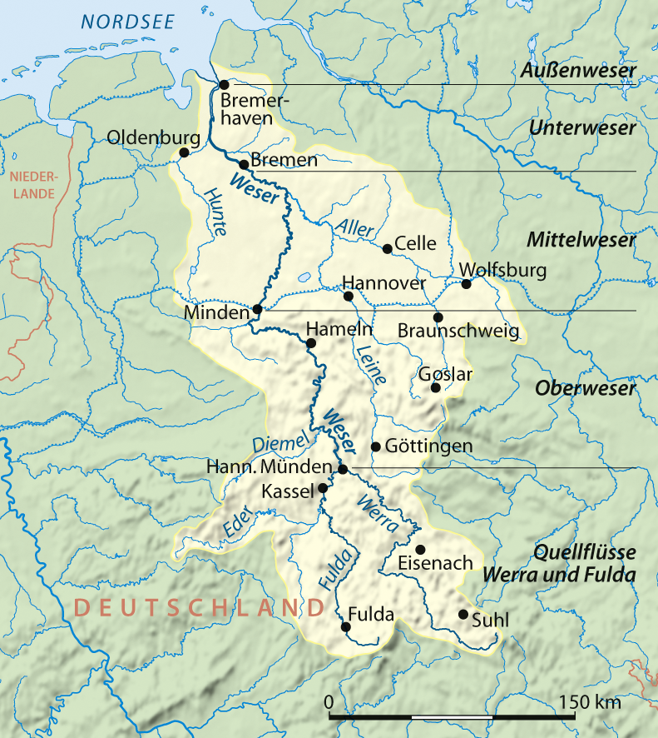

Petershagen

Lorsch
Figure 4: Location of Petershagen and Lorsch.

The wet weather of 784 is confirmed by the Annals of Lorsch, which state briefly that ‘a powerful flood of water happened’. Up to the year 785, the Annals of Lorsch are identical to the Moselle Annals, and another fragmentary annal. Irrespective of the which of these is the root source, or whether there is a missing exemplar for all three, the fact that they diverge at 785 (rather than, say, a century later) suggests that the respective authors were writing original entries soon after this date and would hence be eyewitnesses to the floods of 784.
Rather less authoritative, because it was written just over a hundred years later (889-91), is the work known as that of the Saxon Poet. This is treatment in verse of annalistic information and is heavily dependent on the Royal Frankish Annals, but the poet also read annals now lost to us, so it is of some interest that he writes of Charlemagne in 784 that ‘he was struggling both with a harsh winter as well as with water courses overflowing violently from continual rains.’
Nor were Charlemagne’s difficulties over with that year. For in the following year once again his military activities had to be curtailed due to the flooding of rivers. The Royal Frankish Annals’ report for 785 includes the following: ‘Then the lord, King Charles, completing the aforementioned journey, came all the way to the district of Rehme on the river Weser, where it comes together with the Werre. And because of excessive floods of water, he returned to Eresburg.’
Taken together then, the historical evidence indicates that heavy rain and floods occurred in 784, that winter was severe that year and that the rivers north of the Alps were experiencing floods in 785. With heavy rain reoccurring in 793, the swampy condition of the land around Treuchtlingen was completely unsuited to Charlemagne’s construction project.
In the search for a correlation between these events and the natural proxy data, it is important to note that in 783, the year before the heavy downpours, there was a drought. The Annals of Lorsch have a report, echoed in the (at this point derivative) Mossaic Annals that the heat of summer ‘was so vehement that many people expired from this hot weather.’ So a dendrochronological (i.e. tree-ring) survey from northern continental Europe might expect to find periods of quite variable growth 783-5 with very different meteorological origins.
The extreme and variable weather of this decade was probably a factor in the appearance of plague and societal stress. In 786, an unusual celestial event (or sequence of events) triggered a major panic. As the Annals of Lorsch put it:

In this year during the month of December terrible battle-lines appeared in the sky, of a kind that had never appeared before in our times, and besides signs of the cross appeared on people’s clothing, and several people said they saw blood fall like rain: as a result of which an enormous panic and fear rushed upon the people, and afterwards a great mortality was observed.

A fragmentary supplement based upon the Annals of Lorsch repeated that signs of the cross appeared in clothing, that blood seemed to flow from the sky and that along with other signs this caused a great panic and fear. Thunder and lightning strong enough to shake the cathedral at Mainz was heard through nearly all Francia, killing birds and people. An arch of the sky was visible in the clouds throughout the night of 19 December ‘and afterwards, a really great mortality occurred.’
Such reports are likely to have a foundation in genuine medieval experience. The red hue of some Saharan dusts and sands has led to descriptions of ‘blood rain’ even in the twentieth century when this material is swept northwards from Africa to Europe and deposited in sufficiently visible quantities (Figure 5). The bright red filaments of the aurora borealis have, too, been frequently described in terms of the sky shedding blood (Figure 6). After a long lull in activity spanning up to seven decades and corresponding to a grand minima in solar activity, the sudden return of spectacular aurorae to the skies of Europe from the 740s is likely to have made an impression on less-familiarized observers. Combined with the sequential occurrence of multiple extreme events, it is hardly surprising that rare or unusual natural phenomena with the potential for interpretation as divine portents could be described as promoting widespread panic in the 780s.

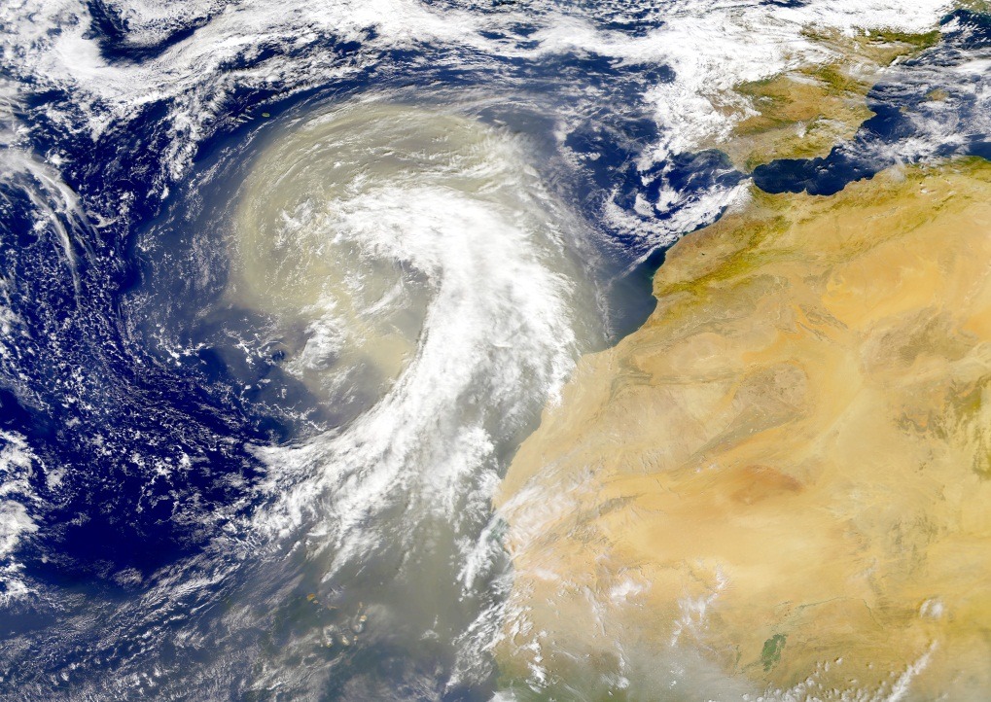
Figure 5: Saharan dust plume transported north by tropic cyclone remnant, November 1998.

Figure 6: Red brushstroke filaments of the aurora borealis, seen at Newchapel, Staffordshire, England.

The above reports from the Rhineland are matched by entries in the Annals of Ulster for 786, indicating that a ferocious windstorm took place in January; the island of Dairinis (Co. Mayo) was flooded; a horrible vision was recorded in Cluain Moccu Nóis (Clonmacnoise, Co. Offaly); a pestilence called schamach broke out and a mass popular desire to perform penance took hold of Ireland. This Irish plague might well have been the same as that which carried off so many lives in continental Europe.
In 793, the same year as the failed attempt to construct the canal, the Annals of Lorsch report a severe famine in northern Italy, Burgundy and parts of France.
What these entries point to, in sum, is that Charlemagne had to contend with violent blows from nature as well as his political and military opponents. Yet much remains unanswered in terms of the patterns of reporting of weather extremes and societal stresses throughout Charlemagne’s life and reign, and their real influence upon the history of this period. The dramatic winters following the major eruption of a volcano (candidates being Cerro Bravo, Columbia and Oshima, Japan) in c. 764 CE have been much discussed, but these only form part of the wider picture of severe weather, societal stress, famine, and plague that we are continuing to explore.

4. Extreme Weather & Societal Stresses during Charlemagne’s Life
In what follows we present a first exploratory analysis of reported weather extremes and societal stresses based upon our ongoing survey of continental annals and other documentary sources. Our approach is to contrast and combine historical evidence with available natural climate proxies. These proxies are abundantly available for the region of Charlemagne's empire, but obtaining data for the particular period 742 – 814 CE is problematic. Natural proxies start to become scarce as one proceeds into the centuries before the 1500s and acutely scarce prior to the 1000s. We also present the results of a survey of annals maintained in Ireland for this period. These provide a useful counterpoint to the material reported in continental chronicles in registering extremes and societal stresses that occurred in a maritime climate quite distinct from much of Charlemagne’s empire.
Figure 7 shows the total number of reported events according to several broad categories of extremes and societal stresses. In creating these categories we have let the content of the various annals guide us, and despite the climatic and cultural differences between Charlemagne’s empire and Ireland, many categories of extreme events are directly comparable. One notable difference is the attention given to big storms and windy seasons in Ireland (combined under the category of ‘Windy Seasons’), the closest parallel in continental annals in this period being reports of warm and damp winters. Climatically, both tend to be associated with periods of stronger westerly airflow that sweeps mild maritime Atlantic air across Europe. Differences also manifest themselves in the number of events in each category. The six reports of storms and windy seasons in Ireland can be compared to the two reports of mild winters in continental annals. The historical evidence in this period thus faithfully reflects what is known of Ireland’s climate from modern instrumental meteorological data, with Atlantic cyclones frequently bringing storm force winds to Ireland’s shores.
By contrast, continental annals pay more attention to major flooding events. This may be a symptom of over-familiarity with wet weather and flooding in Ireland (e.g. although annals were systematically recorded for up to five centuries at the monastery of Clonmacnoise on the banks of Ireland’s largest river, the Shannon, they bother to note major floods on only two occasions). Different agricultural vulnerabilities may also play their part here, with Irish agriculture being predominantly pastoral (e.g. focusing on cattle rearing and dairying) as opposed to arable, whereas the importance of cereal crops on the continent may have made society here more vulnerable to flooding, and consequently made continental annalists more inclined to note such events.
Despite contrasting climate and agricultural regimes, neither region appears particularly more vulnerable to famine, with seven famine events reported in Ireland and six in continental annals across this period. Whether or not these broad inferences will withstand further scrutiny will become known as we extend our survey to further sources over a more lengthy time-span.

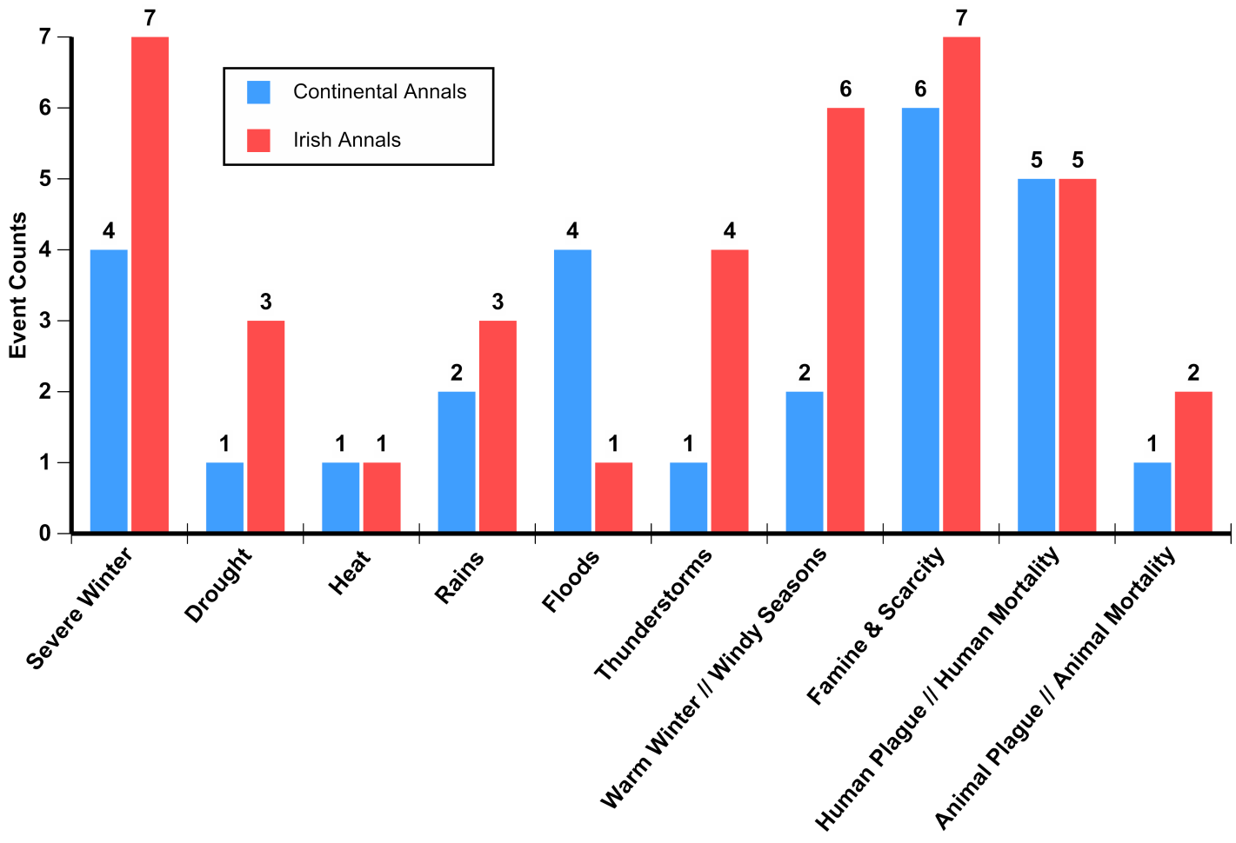
Figure 7: Major categories of extremes and societal stresses reported in continental and Irish annals.

Some 15 extremes and 12 societal stresses are reported between 740-814 CE in continental annals, with 25 and 14 in Irish annals (note that independent reports of the same events/conditions are not double counted in these totals). The distribution through time of reported events is depicted in Figure 8, from which it is apparent that the majority of events in continental annals occur from c.780 onwards, whereas in Irish annals their reporting is more evenly spread (albeit with the most notable concentration falling between c.760-790). It is also notable that relatively few extreme events and societal stresses correspond precisely in date between both regions. One of several exceptions is the severe winter of 764 noted in Irish and continental annals and likely arising from the spatially extensive climate cooling induced by the major volcanic eruption of c.764, as noted above.

Figure 8: Distribution through time of extreme events and societal stresses reported in continental and Irish annals.

A key question when using documentary sources to explore past climate conditions (and the impacts of extreme events on historic societies) is the reliability of the evidence. This pertains not only to issues of the potential exaggeration or fabrication of events, but also the likely completeness with which events are reported in a given period. With respect to the patterns observed in Figure 8, it is important to know to what extent these reflect the climatic reality of the period of Charlemagne’s life. Although continental annals are available that make implicit claim to report events for the entirety of this period, any number of factors could render the coverage provided by these sources incomplete. Examples include periods wherein scribes are disinterested in weather or have less information on extremes occurring beyond their immediate geographical area. Periods in which society was less vulnerable to extremes (with a consequent reduction in related societal stresses such as poor harvests) may also have rendered extremes less worthy of reporting. Available natural proxies provide one means of exploring this issue.

Figure 9: Extremes of wet and dry weather from continental annals compared to a recent April to June precipitation reconstruction from European oak trees.

Figure 9 shows a recent (2011) reconstruction of precipitation based upon large numbers of European oak trees from northeastern France, northeastern and southeastern Germany. This reconstruction encompasses much of Charlemagne’s empire and is representative of the locations at which many continental annals were compiled. Annual growth in these trees is strongly influenced by precipitation from April to June, as can be inferred in the widths of their annual rings. Wider rings equate to greater precipitation, and vice versa. Comparison of documented extremes in continental annals to this precipitation reconstruction provides a strong indication of the veracity of the historical evidence. Five of six documented flood and heavy rain events correspond directly to years identified as particularly wet in the trees. Of the years directly described as experiencing low precipitation (i.e. drought, 772 CE) or from which low precipitation can be safely inferred (i.e. the heatwave, 783 CE), the trees indicate extremely low precipitation in 773 and 782 CE. Small, sporadic dating discrepancies in the annals may be the reason for these slight mismatches (this is supported by the dating of severe drought in Ireland at 773 CE). Given the magnitude of these events as described in the continental annals, and the severity of the dry conditions as indicated by the trees, it seems unlikely that such close (even if imperfect) timing could be random.
Understanding the biological responses of oaks to extremes of precipitation offers a potential alternative explanation for the discrepancy between the reported drought in 772 and the apparent response in the trees in 773. It is well-known that oaks may express the impact of an extreme event in the year after its occurrence, drawing upon stored energy and groundwater reserves to maintain growth rates during the year of the event. Regarding the apparent mismatch between the flooding reported in 809 and the quite low tree-growth in the same year (which nominally suggests low precipitation), it is possible that the flooding occurred outside of the April to June growing season, when oaks become dormant and less responsive to extremes. Alternatively, it is feasible that so much precipitation occurred in this year’s growing season that the net effect was in fact detrimental to tree-growth. Further examination of the growth response to extreme events across a longer time-span should serve to test the reality of these hypotheses.
It has been argued that gradual trends in climate, towards drier/wetter, warmer/colder weather, pose less hazard for society than periods of enhanced variability (and less predictability) with an increased frequency of contrasting extremes. We explore this in a simple and provisional manner in Figure 10, which shows a cumulative count of all historically documented extremes and societal impacts. As one proceeds through time (left to right) from 740-814 CE, each reported extreme event or societal stress causes an upward step in the coloured lines. The steeper the slope of these lines, the more frequently extremes and stresses are reported in a given period. To compare these trends to extremes as identifiable in the trees for the same period, we create a cumulative count of extreme precipitation years (positive and negative). We determine extreme years in a simple but objective manner by identifying those years that fall more than 1.25 standard deviations from the average across 740-814 period.

Figure 10: Cumulative documented extreme events and societal stresses, and also precipitation extremes (wet and dry combined) in European oaks, 740-814 CE.

This exercise reveals a steady occurrence of precipitation extremes from the mid-740s to the mid-760s, with a period of greater stability and fewer extremes until the late 780s. Thereafter, extremes occur with quite a considerable frequency (i.e. the green line shows a sustained steep slope). That this suggest a more variable precipitation regime is borne out by once more consulting Figure 9, which shows an ongoing succession of pronounced swings between growing seasons with high and low precipitation. Reported extremes and societal stresses show a comparable increase from the early 780s and late 770s, respectively (with sustained steep slopes). This provides some support for the contention that the continental annals capture broad trends in the occurrence of extremes (if not every extreme), at least from the 780s, and probably from the 760s.
Whether the broad silence of the annals before 760 represents the climatic reality of this period is more debatable. We note, however, that only four extremes are identified in the trees from 740-760. It is conceivable that these did not have a sufficient societal impact to motivate their reporting (e.g. societal coping mechanisms may have been sufficient to negate the impacts of these more isolated extremes in the context of a more stable climate). By contrast, the more frequent occurrence of precipitation extremes later in Charlemagne’s life could have had a more significant cumulative impact on society (and in some obvious cases on particular military and infrastructural ventures undertaken by Charlemagne), thereby motivating the annalistic scribes to report these events.

Figure 11: River Rhone flood intensity from 720-820 CE, with reported extremes and societal stresses in Charlemagne’s lifetime superimposed.

An additional perspective on the climatic stability of Charlemagne’s lifetime is provided by a reconstruction of flooding intensity of the River Rhone as based upon the volume of sediment transported by the river and deposited in Lake Le Bourget, NW Alps, France. This record has a roughly decadal resolution (i.e. each data point represents c.8 years of sedimentation in sediment cores taken from the lake). Figure 11 plots this data against historically documented extremes and societal stresses. Charlemagne’s lifetime is highlighted by the grey shading. This data clearly suggests a period of wet but remarkably stable climate from c.720 to c.750, with flooding intensity beginning to vary quite considerably thereafter.
Meaningfully comparing historical documentary data that report events with very precise and specific dating to a record with a decadal resolution is challenging. Sediment transported in a single flood event (or even a single wet year with many floods) will tend to be disguised through averaging with the sedimentation delivered in other years. This, in fact, makes the variability apparent in this data from c.750 onwards more striking as it suggests sustained oscillations between drier and wetter weather. A further unknown is the degree to which this flooding record is spatially representative of climatic conditions elsewhere in Charlemagne’s empire. But despite these caveats, the available natural proxy data suggest, in sum, that throughout Charlemagne’s life the climate proceeded from relative stability to great variability, and provides support for the veracity of the trends in reporting of extreme events in the available continental chronicles.

6. Conclusions
When, in 793, Charlemagne embarked on the most significant engineering endeavour of his career, he must have had high hopes that through the efforts of the thousands of labourers he had mobilized (one modern estimate is 3,000), that he would build a famous canal that would unite the North Sea and the Black Sea. Despite spending all autumn in person at the works, Charlemagne’s ambition was thwarted by the opposition of natural forces. In part, the failure of the effort can be explained by the nature of the soil in the region: having cut through a layer of clay, the excavators would have hit waterlogged quicksand in the subsoil. But the Frankish ruler might also have fallen victim to the increased variability of the climate of this period. Had heavy rainfall and flooding been a persistent feature of the previous decades, Charlemagne might well have been discouraged from investing so heavily in the enterprise, but the previous decade had witnessed both years of flooding and drought. Unfortunately for Charlemagne, 793 brought furthering flooding and his considerable efforts came to nothing.
Climatologists have long had a great interest in the historical record, in the hope that chronologically reliable documents can assist in the reconstruction of climate patterns and help resolve the uncertainties inherent in natural climate proxies. For the early medieval period, an unfortunate perception exists that the available documentary evidence from Europe is almost non-existent or otherwise unreliable. This view can be held at least partly responsible for the dearth of historical climatological explorations of this period relative to later centuries. In this paper we hope to have shown that as well as serving to illustrate the climate characteristics of the early medieval period, the available documentary evidence can, when treated with care, serve to illustrate the environmental context of major historical events.

Source: http://commons.wikimedia.org/wiki/File:Frankish_Empire_481_to_814-en.svg
Paolo Squatriti, ‘Digging Ditches in Early Medieval Europe’, Past & Present, 176, (2002), pp. 11 – 65.
Source: http://upload.wikimedia.org/wikipedia/commons/3/3d/Verbindung_main_donau.png
John Haywood, Dark Age Naval Power (Ely, Cambs., 1999), pp. 103 – 109.
Chronicon Moissiacense, Monumenta Germaniae Historica Scriptores (in Folio), ed. G.H. Pertz, (Hannover, 1826), [hereafter MGH SS], I.300: Rex vero Karolus cum apud Reganesburg iterum celebrasset pascha, et in aestivo tempore voluisset cum navibus venire in Francia, iussit fossatum magnum facere inter duo flumina, id est inter Alimonia et Ratanza; ibique multum demoratus est.
Physical map, France, Eric Gaba: http://commons.wikimedia.org/wiki/File:France_relief_location_map.jpg
Roger Collins, ‘The ‘Reviser’ Revisited: Another Look at the Alternative Version of the Annales Regni Francorum’, in A.C. Murray, ed., After Rome’s Fall (Toronto, 1998), pp, 191 – 213.
Revision of the Royal Frankish Annals, MGH SS 1.179: … ac magna hominum multitudine congregata, totum autumni tempus in eo opere consumpsit. Ducta est itaque fossa inter praedictos fluvios duum milium passuum longitudine, latitudine trecentorum pedum; sed in cassum. Nam propter iuges pluvias et terram, quae palustris erat, nimio humore naturaliter infectam, opus quod fiebat consistere non potuit; sed quantum interdiu terrae a fossoribus fuerat egestum, tantum noctibus, humo iterum in locum suum relabente, subsidebat.
Royal Frankish Annals, MGH SS 1.166: Tunc deinde domnus Carolus rex iter peragens, Renum transiit ad Lippiham, et ingressus est Saxoniam circuiendo et vastando, usque quod pervenit ad Huculvi [Petershagen, Westfalen]. Ibi consilio inito, eo quod nimium inundaciones aquarum fuissent, ut Toringiam de orientale parte introisset super Ostfalaos, et filium suum domnum Carolum dimisisset una cum scara contra Westfalaos: quod et ita factum est.
Revision of the Royal Frankish Annals, MGH SS 1.179: Cumque in eo loco qui Huculbi dicitur [Petershagen, Westfalen], castris super fluvium positis consedisset, vidit se in aquilonales Saxoniae partes, sicut statuerat, propter nimias aquarum inundationes, quae tum subito ex iugitate pluviarum acciderant, transire non posse. Ideireo iter in Thuringiam convertit, et filium suum Karolum cum parte exercitus in Westfalaorum finibus sedere iussit.
Source: http://upload.wikimedia.org/wikipedia/commons/2/22/Weser_Einzugsgebiet.png
Annals of Lorsch, MGH SS 1.32: … inundatio aquarum valida fuit.
Annales Moselanni, MGH SS 16.497.
Fragmentum Annalium Chesni, MGH SS 1.20.
Poeta Saxo, Paul von Winterfeld ed., MGH Poetarum Latinorum Medii Aevi Tomus IV, i (Berlin, 1909) 4.1.1-71.
Ibid. p. 22: Temporis obstabat simul asperitas hiemalis, / Atque iugis pluviae cursus vehementer inundans…
Royal Frankish Annals, MGH SS, 1.166: Tunc domnus Carolus rex supradictum iter peragens, usque ad Rimie [the district of Reheme, west bank of Weser] pervenit super fluvium Wisora [the Weser], ubi confluit Waharna [the Werra]. Et propter nimias inundationes aquarum inde reversus est Aeresburgum.
Annals of Lorsch, MGH SS, 1.32: Et fuit estus tam vehementer calidus, ita ut plurimi homines de ipso calore expirarent
Ibid p. 33: Eo anno mense December apparuerunt acies terribili in coelo tales, quales numquam antea apparuerunt nostris temporibus; nec non et signa crucis apparuerunt in vestimentis hominum, et nonnulli sanguinem dixerunt se videre pluere: unde pavor ingens et metus in populo irruit, ac mortalitas magna postea secuta est.
Fragmentum Annalium Chesni, MGH, SS, 1.33: Et postea vero mortalitas magna fuit.
S. Burt, ‘Falls of Dust Rain Within the British Isles’, Weather, 46, (1991), pp. 347 - 353.
Umberto Dall’Olmo, “Latin terminology relating to aurorae, comets, meteors and novae’, Journal for the History of Astronomy, 11, (1980), pp. 10 - 27. See also, Paul Edward Dutton, ‘Observations on Early Medieval Weather in General, Bloody Rain in Particular’, in J.R. Davis and M. McCormick, eds., The Long Morning of Medieval Europe: New Directions in Early Medieval Studies (Aldershot, 2008), pp. 167 – 180.
George L. Siscoe, ‘Evidence in the Auroral Record for Secular Solar Variability’, Review of Geophysics and Space Physics, 18, 3, (1980), pp. 647 - 658. See also, I. G. Usoskin, S. K. Solanki and G. A. Kovaltsov, ‘Grand minima and maxima of solar activity: new observational constraints’, Astronomy & Astrophysics, 471, (2007), pp. 301 - 309.
Source: http://commons.wikimedia.org/wiki/File:Sahara_dust_plume_Nov_1998.jpg
Image courtesy of Michael Pace.
U786.3, 786.9. Sean Mac Airt and Gearoid Mac Niocaill, The Annals of Ulster (to A.D. 1131) (Dublin, 1983). See also, W.P. MacArthur ‘The identification of some pestilences recorded in the Irish annals’, Irish Historical Studies 6 (1948/9), pp. 169 – 188.
G.A. Zielinski, P.A. Mayewski and L.D. Meeker et al., ‘Record of Volcanism Since 7000 B.C. from the GISP2 Greenland Ice Core and Implications for the Volcano-Climate System’, Science, 264, (1994), pp. 948 – 952.
Michael McCormick, Paul Edward Dutton and Paul A. Mayewski, ‘Volcanoes and the Climate Forcing of Carolingian Europe, A.D. 750-950’, Speculum, 82, (2007), pp. 865 - 895. See also, C. Pfister, J. Luterbacher and C. Schwarz-Zanetti et al., ‘Winter air temperature variations in western Europe during the Early and High Middle Ages (AD 750-1300)’, The Holocene, 8, (1998), pp. 535 – 552.
John Sweeney ‘A Three-Century Storm Climatology for Dublin 1715-2000’, Irish Geography, 33, (2000), pp. 1-14.
Francis Ludlow, The Utility of the Irish Annals as a Source for the Reconstruction of Climate (Unpublished Ph.D. Thesis, School of Natural Science, Trinity College Dublin, 2010).
For discussion of Irish agriculture of this period, see Finbar McCormick, ‘The Decline of the Cow: Agricultural and Settlement Change in Early Medieval Ireland’, Peritia, 20, (2008), pp. 210 - 225. For discussion of Carolingian arable agriculture and its vulnerability to weather extremes, see Paul Edward Dutton, ‘Thunder and hail in the Carolingian countryside’, in D. Sweeney, ed., Agriculture in the Middle Ages (Philadelphia, 1995), pp. 111 – 137.
Note that there is currently an incompatibility between the mortality categories in Figure 7, in which Human and Animal ‘Mortality’ in Irish annals do not include plague mortality. We will rectify this in future work.
Francis Ludlow, ‘Assessing non-climatic influences on the record of extreme weather events in the Irish Annals’, in P.J. Duffy and W. Nolan, eds., At the anvil: Essays in honour of William J. Smyth’ (Dublin, 2012), pp. 93-133.
Ulf Büntgen et al., ‘2500 years of European climate variability and human susceptibility’, Science, 331, (2011), pp. 578 - 582.
A.J. Dugmore, D.M. Borthwick and M.J. Church et al., ‘The role of climate in settlement and landscape change in the North Atlantic islands: an assessment of cumulative deviations in high resolution proxy climate records’, Human Ecology, 35, (2007), pp. 169 - 178.
Fabien Arnaud et al., ‘7200 years of Rhone river flooding activity in Lake Le Bourget, France: a high-resolution sediment record of NW Alps hydrology’, The Holocene, 15, 3, (2005), pp.420-428.
Haywood, Dark Age Naval Power, p. 108.
Ibid. p. 106.
For a review of efforts in historical climatology, see R. Brázdil, C. Pfister and H. Wanner et al., ‘Historical Climatology in Europe – The State of the Art’, Climatic Change, 70, (2005), pp. 363 - 430.
National Research Council, Surface Temperature Reconstructions for the Last 2,000 Years (Washington, D.C., 2006).

