Ofure Vaughan Molen. 3566046
Unit 1: Design Documentation

Main Theme – Audience, Purpose and Process
This website will be the official website for Tetravon Energy Inc. Tetravon Energy Inc is company that provide Environment Engineering services to the Oil and Gas industry. The company will mostly have visitors from oil and gas professionals and companies varying across several positions and geographical locations in Western Canada. The website will contain a landing page/tab (home page), the services offered page, the blog page, the contact us tab/page with email text box,

Site Map
Emissions Management Registry
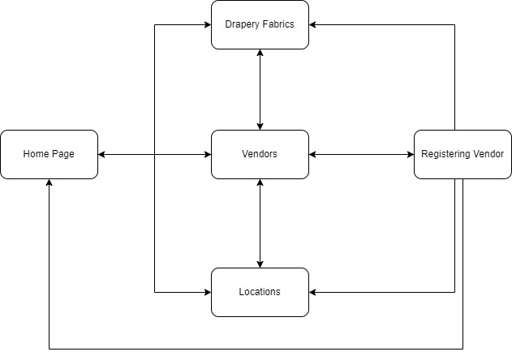
GHG – Measurement and reporting and Verification
Environment
Substainable Energy projects

Personas & Scenarios

Personas
- Persona 1: Emily Greenfield
  - Age: 32
  - Occupation: Environmental Scientist
  - Goals:
    - Stay updated on the latest environmental regulations and technologies.
    - Find solutions for reducing emissions in her research projects.
    - Collaborate with industry experts and gain insights into best practices.
  - Challenges:
    - Limited access to comprehensive resources.
    - Difficulty in navigating complex regulatory frameworks.
    - Balancing multiple projects and deadlines.
- Persona 2: David Johnson
  - Age: 45
  - Occupation: Sustainability Manager at a Manufacturing Company
  - Goals:
    - Implement sustainable practices in the manufacturing process.
    - Monitor and report on emissions data to meet compliance requirements.
    - Identify cost-effective solutions for reducing environmental impact.
  - Challenges:
    - Limited budget for sustainability initiatives.
    - Difficulty in tracking emissions data across multiple facilities.
    - Resistance to change from stakeholders within the organization.
- Persona 3: Sarah Lee
  - Age: 28
  - Occupation: Graduate Student in Environmental Engineering
  - Goals:
    - Research innovative technologies for emissions reduction.
    - Network with professionals in the environmental engineering field.
    - Find internship or job opportunities in environmental consulting.
  - Challenges:
    - Lack of practical experience in the field.
    - Navigating academic requirements while seeking career opportunities.
    - Finding reliable sources for her research projects.
Scenarios
- Scenario 1: Researching Emissions Reduction Technologies
  - Emily is looking for the latest advancements in emissions reduction technologies for her upcoming research project. She visits the website to access white papers, case studies, and articles related to innovative solutions.
- Scenario 2: Compliance and Regulatory Guidance
  - David needs to ensure that his manufacturing facility complies with new environmental regulations. He searches the website for resources that explain the regulatory requirements and offers guidance on how to meet them.
- Scenario 3: Networking and Collaboration
  - Sarah is interested in connecting with professionals in the emissions and environmental engineering field. She visits the website to find forums, webinars, and networking events where she can engage with industry experts and peers.
- Scenario 4: Emission Monitoring Tools
  - Emily wants to implement a new emissions monitoring tool in her research. She browses the website for information on various monitoring technologies, comparing their features and benefits to make an informed decision.
- Scenario 5: Cost-Effective Sustainability Solutions
  - David is tasked with proposing cost-effective sustainability solutions to his management team. He visits the website to find case studies showcasing successful projects that demonstrate a return on investment from emissions reduction initiatives.
- Scenario 6: Job Search and Career Development
  - Sarah is nearing graduation and is actively looking for job opportunities in environmental consulting. She visits the website to explore job postings, internship opportunities, and resources for career development in the environmental engineering sector

Page Mock-Ups

Index page:
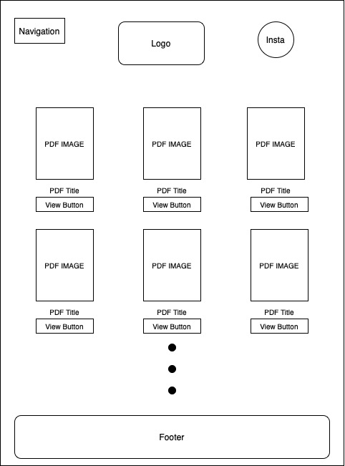
Services
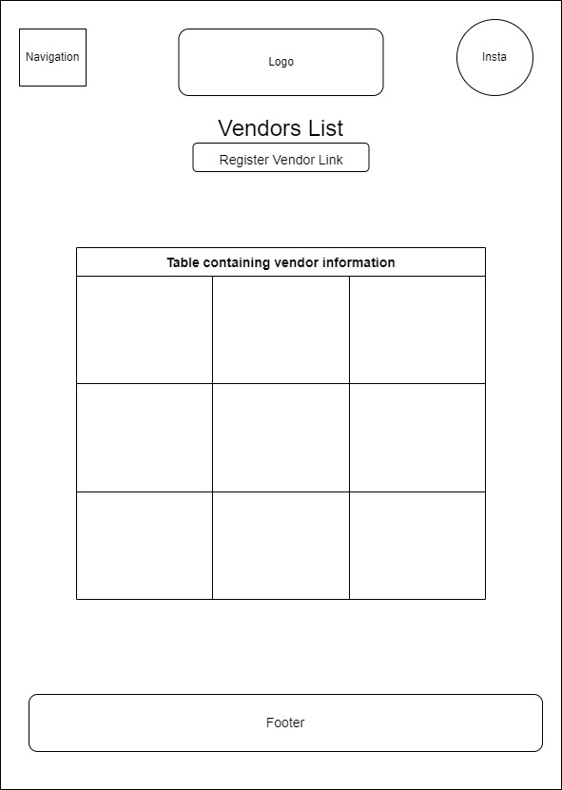
Sevices offered
Tetravon Energy is a reputable company providing solutions to industries in areas of Emissions, air, water and soil monitoring, waste management, regulatory and compliance objectives

Contact Us
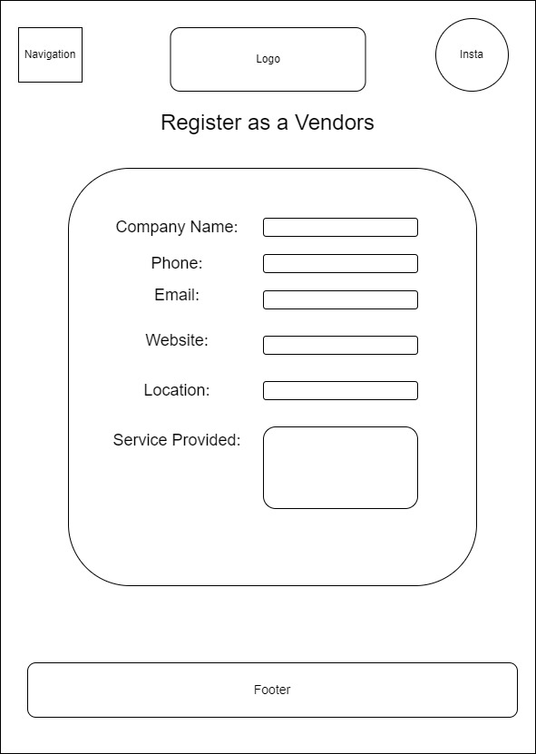
COMPANY ADDRESS, PHONE NUMBER EMAIL, INSTAGRAM LINKDIN
Contact us
Comments

Locations
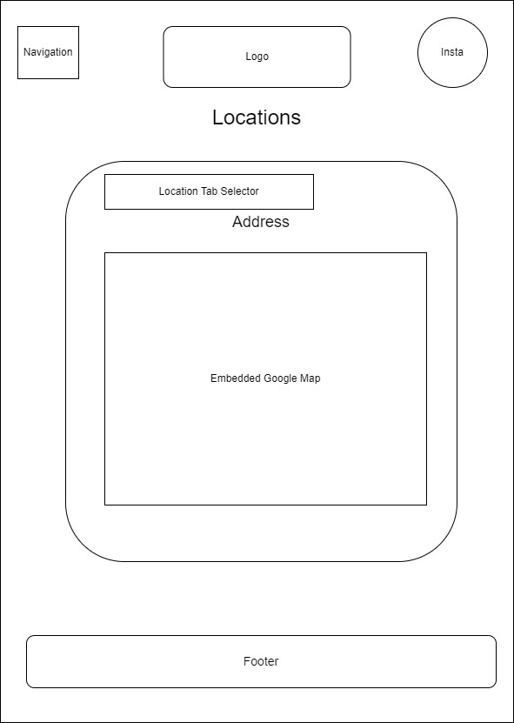

Learning Diary

In this unit, I created documentation outlining the website that I will be creating. This documentation included the theme for the site, a site map showing how each of the pages will be linked together, mock ups for each page, as well as personas and scenarios of people using the website. As the company sells only business to business, I felt a simple easy to use and navigate website would be much more effective than a flashy one as many of the customers already know what they want, they just need to find it. For the site map I made the decision of linking every page to one another.

