Promise and/or Peril: MOOCs and Open and Distance Education
Terry Anderson
Athabasca University
March 2013
The New Times declared 2012 to be the year of the MOOC (Pappano, 2012) and certainly 2013 is becoming the year to talk about MOOCs! Questions related to the design and inherent pedagogies, registration numbers, persistence rates, revenue models, neo-liberal agenda, fears and aspirations of all of us in postsecondary education have been ignited by this combination of technology and pedagogy. MOOCs are rapidly becoming the type of disruptive technology described by Christensen (1997) as cheaper, smaller, initially less fully featured and attracting a new set of consumers into an existing market.
Much has been written and much more will by the time you are reading this article, from when I write it in March 2013 - the MOOC terrain is under very rapid development. John Daniel (2012) article, does a good job of defining and describing MOOCs and clearly notes the different models and pedagogy (xMOOCs, cMOOCs) that differentiate pedagogies, practices and profits involved in today’s MOOC offerings. In this article, I attempt to update our map of the terrain and provide a lens through my 2003 Interaction Equivalency Theorem (Anderson, 2003) to help us understand and explain this latest development and/or fad in higher education.
I begin with a short description of the characteristic of the four words included in the MOOC acronym and try to show how each contributes to the complexity of this education phenomena.
Massive
Attempting to define the necessary size of a course to warrant a description of massive, is a challenging task. Much as the proverbial question of ‘how long is a piece of string?’, the ‘massive’ in MOOCs refers more to capacity to scale, than to a particular number of students. Many MOOCs have less than a few hundred users, but conversely some have had over 100,000 registered students. Scalability refers to the capacity of the course to expand to large numbers, without causing major disruption to any of the component parts or activities of the educational experience. By this notion campus based course are certainly not scalelable because at some point the campus runs out of physical seating room- even as lecture theatres are expanded. Scalability is of course linked to costs. This capacity was nicely captured in a pecuniary sense by Daphne Koller, Founder of Coursera, the largest commercial MOOC company when she noted that “The students who drop out early do not add substantially to the cost of delivering the course. (cited in (Kolowich, 2012). As distance education institutions have long been aware, the most expensive students are those who hang around long enough to write the final examinations and in other ways use the support services available to registered students.
Further confusion arises when we determine the massiveness of a MOOC by the traditional means of counting the number of registered students. In traditional campus and distance education systems, this number has been a relatively easy figure to determine from a quick glance at number of students in good standing as tallied by the Registrar’s office. However, as we shall see in later discussions, the massiveness of a MOOC can be determined by the number of students who register (requiring only the completion of an online form), the number who actually login to the course when it begins, the number who participate by completing even one assignment or quiz, the number who complete the course (as determined by their successful completion of all exercises and assignments), or by the number who complete some sort of invigilated examination confirming their identity and capacity to at least remember the course content long enough to pass a final examination. We shall see that these numbers can show as much as two order of magnitude difference in their massiveness.
Openness
The use of the term ‘open’ in Moocs, brings back memories of ongoing (and still continuing) debates related to very different understanding of ‘openness’ that have marked education from earliest times and more recently open universities(Peter & Deimann, 2013).
Like all forms of distance education, a primary driver of MOOCs is to expand access to students beyond those who could inhabit a particular geographic local. A second sense of the term often used in education is both ideological and political and speaks to a sense of academic freedom and free speech. Thirdly, open is used in the sense of learning content having no restrictions on revision, re-use, sale and enhancement as the term is used in open source software and most open educational resources (OERs). A fourth definition relates to openness in the sense that all may enroll with out regard to prerequisite knowledge or other demographic data such as gender or religion. At Athabasca University we also use the term to describe the freedom to start and to determine the pace of a course in our continuous enrollment undergraduate programs. A sixth definition of openness is as how the term is used in the economic sense of gratis or free of charges for participants.
From these separate and different definitions, it is apparent that any form of educational organization that includes the word ‘open’, begs for further elaboration. Using these quite separate definitions, we can conclude that most MOOCS are open in the sense of allowing participation anywhere, to anyone and are open gratis for participation. However, they may or may not be open in the sense of allowing access to and revision of course content or in allowing and encouraging open communication of ideas and ideals. They also may or may not be open to allow continuous enrollment and student control of pacing.
A final and to some most disturbing notion of opneness in MOOCs resonate with ideals and advocates of the ‘open market’ and appeal to those seeking to enter the higher education marketplace from a for-profit motivation (Gilde, 2007). Higher education and especially universities have long been sheltered from the competition from the open marketplace due to a number of factors including government protection, alumni loyalty, conservative reputation measures and (until recently) the traditional costs associated with constructing and maintaining a campus based facility (Christensen & Eyring, 2011).
Perhaps a final sense of open is captured in Alfie Kohn’s paraphrase of line from songwriter Kristofferson “Freedom’s just another word for something left to learn.”(Kohn, 1993). Indeed for all of us, there is a great deal left to learn, and systems that open access to learning are both necessary and should be welcomed.
Online
Perhaps the least contentious of the terms in the MOOC acronym is online. Online education and online educational resources have expanded to encompass all forms of media - from text, to video, from sound recordings to immersive worlds, thus the term in the acronym does not define or preclude any type of mediated interaction. The necessary scalability at low cost as well as the capacity to use and re-use would not be possible using any of the campus based educational delivery contexts or tools. However, sufficient students numbers or massiveness can also provide enough students in a particular geography to meet face-to-face, and some MOOCs actively encourage study groups, formal campus classes and Meet-ups of students who are co-located and thus this model move MOOCS from being strictly online to being blended with face-to-face interaction and support.
Course. The term ‘course’ is used in higher education both to define a program of studies (especially in Europe) and to describe a single set of classes on a particular subject, usually led by a single instructor to a small or medium number of registered students (the standard North American use of the term). However within a single jurisdiction the term is still confusing such that the Higher Education Statistics Agency in the UK commissioned a whole paper entitled “What is a course?” (Youell, 2011) and in it defined course as a “coherent academic engagement with a defined set of learning outcomes.” This definition quite accurately describes most MOOCs in 2013. Moreover, a MOOC is unlike a community of practice or an ongoing professional network, in that a MOOC has a defined length of time duration (though that time may be self or group paced). A MOOC is also not the same as an open educational resource (OER) though it may contain any number of OERs because the MOOC content is likely not to be open for re-use by others and the granularity of the MOOC is typically larger, encompassing a set of activities and content that is studied over some weeks or months.
To conclude this discussion on the acronym, we can see that a MOOC is derived from four words, each of which has led to discussion, debate and mutual misunderstanding in educational circles for at least the past century. It is then perhaps, no surprise that our understanding of MOOC is now and likely will be contentious for the foreseeable future.

Pedagogy of MOOCs

Different MOOCs (as in any other form of educational delivery or organization) employ different pedagogies. In this section I link to the discussion of three generations of distance education pedagogy that my colleague Jon Dron and I identified (2011). Secondly I talk about the way in which MOOCs achieve scalability by substituting student-content interaction and to a lesser degree student-student interaction for student-teacher interaction .

Many critics of the popular xMOOCs (those achieving scalability by extensive use of streaming video, automated quizzes and other activities typical of cognitive-behavioural pedagogies) have been criticized for using dated pedagogy based on the transmission of content. Cathy Davidson argues that “far too many of the MOOC's … use talking heads and multiple-choice quizzes in fairly standard subject areas in conventional disciplines taught by famous teachers at elite universities.” She further notes that this tends to “massively scale what is broken” (Davidson, 2012).
I am not so quick to denigrate this pedagogy and indeed we note in our three generations article that this form of cognitive-behaviorist teaching is dominant at many levels of education – including the universities. It also has a long tradition in distance education with its paper-based and broadcast modalities and remains cornerstone of training activities in commercial and military domains. I also argue that different disciplines, different students and different media require different mixes of pedagogical approaches.

In order to achieve scalability, xMOOCs digitize teachers on video and use machine scoring of quizzes, thus morphing lectures, discussions, tutorials and feedback from classroom student-teacher interaction into student-content interaction. By contrast cMOOC induce students to take more active roles in their learning and to construct, share and distribute and comment upon artifacts of their learning experience. Thus, they are gaining scalability by substituting student-teacher interaction by scaling student-student interaction. In my interaction equivalency theory (Anderson, 2003) I argue that high levels of learning can and do occur when any of these three modes of interaction (student-student, student-content, student-teacher) are at a high level. The other two may be reduced or even eliminated. However, additional forms of interaction may enhance teacher and student interaction, but these come at a cost of time and/or money. In this sense MOOCs can be used as a supplement by students or by teachers to the many other forms of learning opportunity afforded on the net through either formal or informal learning opportunities.

Deskilling, Academic Jobs and the world best teachers
The substitution of teacher interaction raises the specter of mass unemployment and the fear of one ‘super teacher’ destroying the livelihood of hundreds of thousands of teachers with less talent. This argument is usually very self-serving and by analogy, superstars in the entertainment, sports, political arenas have not destroyed jobs and opportunity for aspiring athletes, actors or politicians, but they certainly introduce market forces to a profession that has long been shielded. Since the first mass media were introduced in the 19th century technophiles have been making predictions and teachers dreading the possibility of their replacement by advanced communications technologies. Prior to MOOCs these promises have not materialized, despite the development of paper-based television and online courses.
The strongest arguments against these notions of job loss relate to the increasing demand and inability of the current system to meet this demand at affordable costs. In Canada, and most other countries, the costs of higher education have for some time increased much faster than rates of inflation with resulting high levels of student debt (Macdonald & Shaker, 2012). Much of this increase can be attributed to reductions in state support for high education, but there is little evidence that the existing system has been successful at reducing costs, even as the demand increases. John Daniel noted as far back as 1996 that we need to see one new sizable university open every week if we are to meet global demand (Daniel, 1996). However, at least in Canada we are not opening new universities and government support continues to decrease, leaving little option but changes that make education more efficient. It is quite surprising to me how many of my educational colleagues seem so skeptical of any potential improvement in education effectiveness, as if our profession is incapable of exploiting technological and pedagogical innovations that are available to us.
MOOC participants
While our knowledge of motivations and identities of MOOC participants is at best rudimentary, we can say with some certitude that MOOC students (or at least their behaviors) are not typical of fee paying undergraduate students. Just as there are many kinds and subject focus of MOOCs, there many different types of students attracted and they have wide variety of expectations and commitments. Early research is showing that many students enroll in MOOCs as auditors with no intention of completing assignments or quizzes. They may just be curious, be testing the waters, experiencing how other teachers handle the teaching or just curious about MOOCs. These students are usually passive participants, or lurkers, who may drop out (or even drop in to active participation) later in the course. What is perhaps most surprising is the large number of students who enroll in a MOOC but fail to login even a single time once the course starts. For example, Duke University’s/ Courera 2012 MOOC on BioElecticity had 12,000 registrants but 4,000 of these failed to login during the first week of the course. In this same course only 313 students (4% or registrants) from 37 countries completed all of the assignments and quizzes and were awarded certificates of completion. Given the high number of non completions, one could argue that this Duke MOOC was a failure, but I am sure that sentiment is not shared by the 313 successful students, nor by an unknown number of learners who received as much learning as they wanted (or had time for) about BioElectrcity.
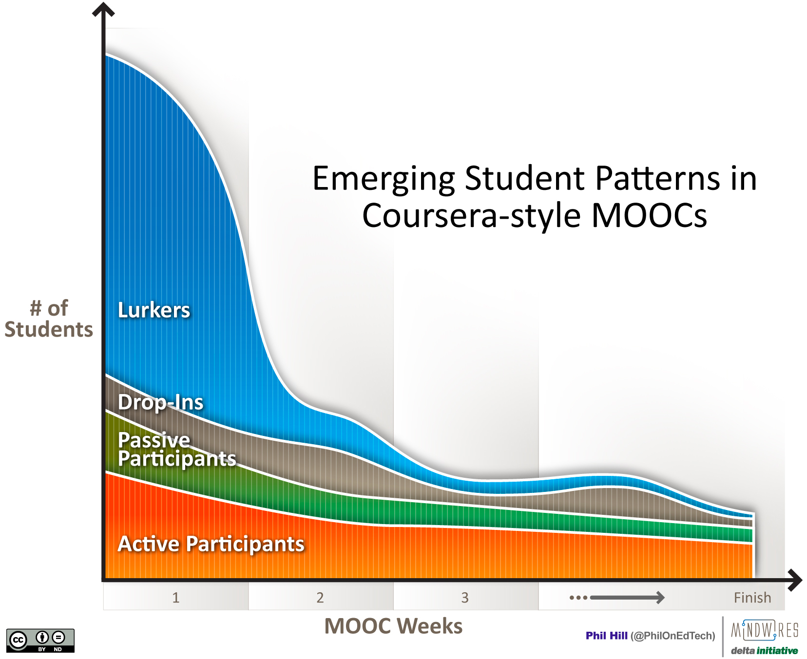
Figure 1. Student activity patterns in xMOOC (Hill, 2013)
These patterns, typified by Clow’s (2013) “funnel of participation” indicate that learners use MOOCs in very different ways for different reasons. It may be best to conceptualize MOOCs as learning resources (much as a library) that learners can use in very many different ways, with equally diverse learning outcomes.
Early research (Jordan, 2013) is suggesting that completion rates are not related to the number of students registered in course, nor the length of the course. However, courses with machine scoring as opposed to peer evaluation, are associated with higher completion rates that likely confirms the value of immediate reinforcement used in cognitive-behavioural pedagogical models.
MOOCs and Credentialing
Western educational systems are build on a foundation of accreditation. Students are willing to invest large sums of money and engage in a host of activities- many of which are not enjoyable, in return for a qualification that entitles them to a degree of prestige and that is traditionally been associated with higher wage levels and more vocational choice. Institutions go to great length to acquire and maintain the authority to offer these credentials and are quite naturally suspicious of any new entrants into this field. The top ranked and Ivy league Universities that are now offering the popular CoursEra MOOCs are very clear that completion does not result in degree credit at that institution. Into this vacuum the MOOC providers are developing alternative credentialing tools including badges, certificates of completion, invigilated testing centres and 3rd party credentialing. A few accredited institutions are experimenting with challenge testing systems that reward MOOC students with equivalent credit and some institutions also recognize MOOC learning in their Prior Learning Accreditation systems (Conrad, 2013). Suffice it to say that the commercial MOOC suppliers are trying very hard to provide accreditation for their courses, while traditional distance and campus delivers are struggling to maintain their monopolies over degree accreditation. Perhaps between these two competing systems lies an opportunity for nimble open education institutions.
Business Models
Two features of MOOCs have most concerned politicians, press and academia. These are the lack of a clear revenue model to justify institutional expenses and entry of ‘silicon valley’ mindset, operational models and for-profit motivation that marks current xMOOCs.
Like earlier disruptive technologies based on Internet distribution (for example search engines, online recording and film business) there was, at first, little evidence of a revenue model. Over time these have developed largely based on advertisements, data mining of user behavior, subscriptions and sales of auxiliary products to consumers. Likely these same revenue lines will be developed by MOOC developers as evidenced by their interest in “learning analytics” to track behaviors of students. However, learning analytics can be used to substantively improve our understanding and our subsequent remediation and adaptation of learning sequences to improve learning- as well as sell products. (Buckingham Shum & Deakin Crick, 2012).
For open universities, the MOOC provides a highly visible public service which, when implemented effectively, can provide necessary and very low cost educational solutions. These can be a strong rationale for ongoing state support of that institution. Finally, MOOCs offer a lever by which often complacent public institutions and their staff can be both prodded and inspired to experiment with and take seriously the potential learning efficiencies and effectiveness of a variety of available educational media and communications technologies.
Implications for Open and Distance Education Institutions
MOOCs and especially those developed by for-profit companies can be perceived as yet more unwelcomed competition to distance education institutions. However, they can also be seen as resources by which institutions can test the delivery models and pedagogies of competitors and themselves, develop new teaching and learning models, and force us to more seriously examine our models and methods of accreditation. MOOCs may also be useful for professional development of faculty and graduate students in their capacity to open the customarily closed doors of the classroom, to allow teachers to experience alternative ways to teach and to learn.
MOOC’s represent an unbundling of the traditional services in which higher education institutions (both distance and campus) have been engaged. My colleague Rory McGreal and I have published about this unbundling and the creation of a “no frills university”. These lower cost, more accessible, but currently lower quality alternative, fits many of the characteristics of Christenson’s disruptive technology, with potentially to radically reconstruct the product and the processes of the higher education business. This presents threats but as former Harvard President Summers noted in his foreword to Pearson’s ominously titled essay An Avalanche is Coming “the potential unbundling is a certainly a threat, but those who re-bundle well, will find they have reinvented higher education for the 21st century.”
It is perhaps fitting to end this essay on MOOCs, with a quote from Sir Michael Barber currently an advisor to Pearson Publishing (one of the largest and expanding players in the emergent MOOC market place). He writes “We think there’s as much opportunity as threat. If universities and governments take up these opportunities there could be a golden age ahead. The big dangers are complacency, timidity and risk aversion.” (Warrell, 2013). Each of us, as responsible open and distance educators, is compelled to examine the affordances and challenges of MOOC development and delivery methods, critically examine their effect on public education and perhaps most importantly insure that our own educational systems are making the most effective use of these very disruptive technologies.

References
Anderson, T. (2003). Getting the mix right: An updated and theoretical rational for interaction. International Review of Research in Open and Distance learning, 4(2). Retrieved from http://www.irrodl.org/index.php/irrodl/article/view/149/708.
Anderson, T., & Dron, J. (2011). Three generations of distance education pedagogy. International Review of Research on Distance and Open Learning, 12(3), 80-97. http://www.irrodl.org/index.php/irrodl/article/view/890/1826.
Buckingham Shum, S., & Deakin Crick, R. (2012). Learning dispositions and transferable competencies: pedagogy, modelling and learning analytics. Paper presented at the 2nd International Conference on Learning Analytics & Knowledge, Vancouver, British Columbia. http://oro.open.ac.uk/32823/
Christensen, C. (1997). The innovator's dilemma - When new technologies cause great firms to fail. Cambridge: Harvard University Press.
Christensen, C., & Eyring, H. (2011). The Innovative University: Changing the DNA of Higher Education from the Inside Out. . Jossey-Bass: Wiley.
Clow, D. (2013). MOOCs and the funnel of participation. Paper presented at the LAK '13: 3rd International Conference on Learning Analytics & Knowledge, Leuven, Belgium. Retrieved from Retrieved from http://oro.open.ac.uk/36657/1/DougClow-LAK13-revised-submitted.pdf
Conrad, D. (2013). Assessment challenges in open learning: Way-finding, fork in the road, or end of the line? Open Praxis, 5(1), 41-47. doi:10.5944/openpraxis.v5i1.17.
Daniel, J. (1996). Mega-Universities and Knowledge Media: Technology Strategies for Higher Education Kogan Page: Kogan Page.
Daniel, J. (2012). Making sense of MOOCs: Musings in a maze of
myth, paradox and possibility. Seoul:: Korean National Open University.
Davidson, C. (2012, Dec. 10). Size isn't everything, Chronicle Of Higher Education Retrieved from http://chronicle.com/article/Size-Isnt-Everything/136153/
Hill, P. (2013). Emerging student patterns in MOOCs: A (revised) graphical. e-literate. http://mfeldstein.com/emerging-student-patterns-in-moocs-a-revised-graphical-view/.
Jordan, K. (2013). MOOC Completion Rates: The Data. Retrieved from http://www.katyjordan.com/MOOCproject.html
Kohn, A. (1993). Punished by Rewards: The Trouble with Gold Stars, Incentive Plans, A's, Praise, and Other Bribes. Boston: Houghton-Mifflin.
Kolowich, S. (2012, June 11). How Will MOOCs Make Money?, Inside Higher Ed Retrieved from http://www.insidehighered.com/news/2012/06/11/experts-speculate-possible-business-models-mooc-providers#ixzz2NY8sZt9f
Macdonald, D., & Shaker, E. (2012). Eduflation and the High Cost of Learning. Canadian Centre for Policy Alternatives. http://www.policyalternatives.ca/publications/reports/eduflation-and-high-cost-learning.
Pappano, L. (2012, Nov. 2). Year of the MOOC, New York Times. Retrieved from Retrieved from http://www.nytimes.com/2012/11/04/education/edlife/massive-open-online-courses-are-multiplying-at-a-rapid-pace.html?pagewanted=all&_r=0
Peter, S., & Deimann, M. (2013). On the role of openness in education: A historical reconstruction. Open Praxis, 5(1). doi:10.5944/openpraxis.5.1.2.
Warrell, H. (2013, Mar. 11). Universities face online ‘avalanche’, Financial Times.
Youell, A. (2011). What is a course? London: Higher Education Statistics Agency Retrieved from http://www.hesa.ac.uk/dox/publications/The_Course_Report.pdf.

