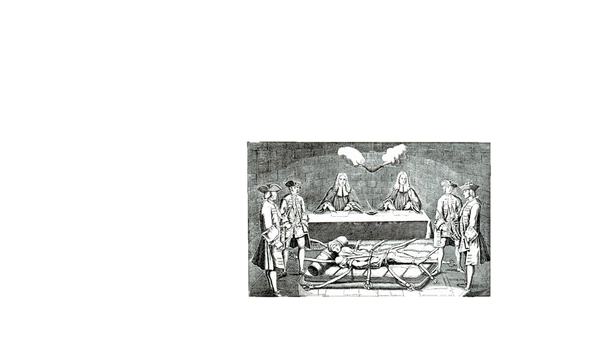

Figure And again Mr. Smith for the last time..what about that contradiction on page 100.