Unit 1
Site Design
COMP 266
Gaurav Khanna
Student # - 3391806

Theme and Purpose of the Website:
Website I am creating for this class is named TravelBlog. I will be including a few famous places to visit around the world with three different price range for people. The major purpose of the site will be helping people who are travel enthusiast but also operate with different budgets to plan a tour. I would be providing the information on ways of travelling, accommodation, food and places to visit. Also, sometimes website will give interesting facts (and videos) about the cities and particular places. The categories will be divided in three types of travellers: -

- Low Budget Travellers
- This category will be for the people usually operating on a very restricted budget. Usually saving money at almost all possible time.
- Regular Budget travellers
- This category for the people who usually travel once or maybe twice a year but have an allowance to go a bit more lavish than low budget travellers.
- Extravagant travellers
- This category will be for the people who want to experience the most off the place with no budget limitation, can almost take either a bus ride or an expensive taxi service depending on the occasion.

PERSONA #1
Name – Molly Hudson
Age – 21
Location – Calgary
Occupation – Student at University of Calgary and have a part time job at local retail store.

Molly is a first-year student at the University of Calgary, she is at her last semester of this year after which she is hoping to go for a vacation to get relaxed and enjoy sometime away from the daily routine. She is currently pursuing nursing right now at the university. So, after asking her friends she and her few friends have decided to go for a few trips to someplace nice after their last final exam. She will be using a laptop to do her search.

Scenario#1 – Molly and her friends decided to go for a European city but are tight on money so decided to go to TravelBlog and found Paris to be interesting destination for their tour of 5 nights and 6 days. After watching all the prices and places to visit Molly and friends decided to make it work.
Scenario#2 – Molly and her friends think what happens if they add another city or place, so they decided to go for Cannes for 2 days and 1 night and spending rest of the time in Paris.

PERSONA #2
Name – Elly Mason
Age – 27
Location – Toronto
Occupation – Software developer at a big corporate company.

Elly loves travelling since his college days. He has been thinking of going for a holiday for along time now, after working for a long year with no holidays he has a good number of holidays lined up and money saved to get him a nice vacation. So, this year at the end of this quarter Elly is planning to go for trip in Middle East. He will be using his iPhone to use the website.

Scenario#3 – Elly thought of going for a trip in Dubai, so he goes for the TravelBlog and searches for the things and places to visit in Dubai and adjacent area. He looks it up and finds a bunch of stuff to and thinks of making it a week’s trip to Dubai.
Scenario#4 – Elly is also an adventure sport enthusiast and loves amusement parks. When he does a little research, he finds there is also Abu Dhabi near Dubai. It has the worlds fastest roller coaster in Ferrari world which is located in Abu Dhabi. Now he thinks he should make it a trip of 8-9 days.

PERSONA #3
Name – Adam Dube
Age – 32
Location – Vancouver
Occupation – Owner of a chain of GYMs.

Adam started as a professional body builder and later when earned some money thought of owning a GYM. After a few years in the business he now owns a chain of GYMs around and in the city of Vancouver, making him a lavish person. Recently he has been thinking of taking a vacation to some place nice as he has been devoted to his business for too long. For his vacation he thought of going to Switzerland by the end of this year for New Year’s Eve. He would use a tablet mobile to do the search.

Scenario#5 – Adam starts by going to TravelBlog and saw couple of places and things to do in Switzerland. He sees it is one of the finest places to be at in order to be on New Years. It is sophisticated, and place loved by extravagant people. Adam after all the consideration thinks of going to Switzerland after celebrating Christmas with his family.
Scenario#6 – Although Adam likes to be the part of luxurious society he also likes to do some sports and shopping to, after looking through the TravelBlog that Switzerland serves his purpose and with money least of his worries he plans his vacations to all the places that serves his purpose.

FURTHER REQUIREMENTS
- Once everything gets started there might be some technical difficulties, or I might have to add more personas but for now the only challenge that is been seen is getting all the information required to get on the site. Also, with all this info comes a lot of credit to publishers.
SITE MAP

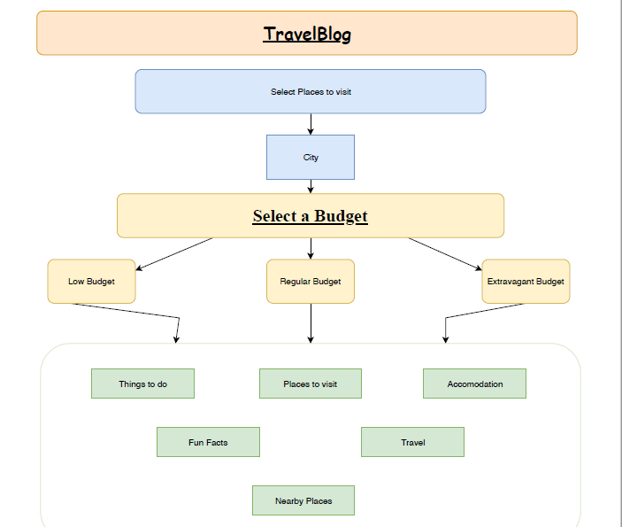

Mock Page: https://gomockingbird.com/projects/eg1xr6q

