Berry-Picking

What is it? This process is crucial for developing the confidence to gather information from various online sources before engaging in more complex sifting and sorting activities. With berry-picking, learners are encouraged to compose short posts that involve identifying, evaluating and selecting resources, and collecting ideas, links, and references.

How to evaluate learners? To demonstrate skills, learners showcase a series of mini blog posts that build up a list of annotated summary of useful online resources. This might take the form of either a collection of resources on a course wiki, a post on the class blog, or as a blog-roll.

Suggested Berry-Picking Activities
Learners can practice berry-picking by using their blogs to compose short posts of up to 50 words, or a few sentences. For practice, learners need to post at least once every couple days, for up to three to four different short mini-posts for this first week.

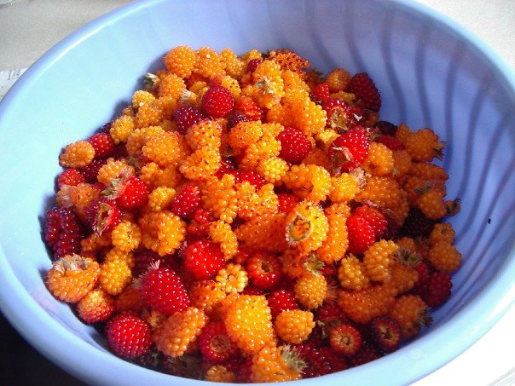
“The Ideas Sandbox” outlines, short drafts, questions, web sites, blog posts, videos, books, music, and photos.

“Inspirations for Writing” includes notes to self, scribbled notes, ideas to follow up, and interesting ideas.

“Link-log” is made up of a collection of links to useful resources and short comments about usefulness of the resources for their project.

“What I learned this week” is made up of a series of blog posts that describe sources of learning, such as events, people, sites, activities, and conversations.

Blogging Instructions for Learners

These instructions are intended as a guide for learners. You do not have to do all the activities as suggested; instead, you might want to try practicing different types of berry-picking posts and putting off other types, depending on your requirements as an individual learner. Try to practice different kinds of berry-picking activities, and anticipate what you might need to complete your project. These posts should be tagged under the tag berry-picking.

“The Ideas Sandbox”
Compose a series of three posts that collect your different thoughts for different projects you might be working on. For example, you might start off with sketches or outlines for your assignments,
Or upload voice memos, or scan and upload scanned written notes. In any case, berry-picking involves the uncensored collection process. You can compose short, fuzzy drafts, questions you are working on or have encountered, as well as brief descriptions of web sites, blog posts, videos, books, music, and/or photos. The ideas in the sandbox are typically a few sentences in length, unstructured, and should be tagged as berry-picking, ideas, sandbox.

“Inspirations for Writing”
Compose a series of blog posts that include eureka moments, often from a period of lucid dreaming. These short posts are often best attempted in the early morning. They can include notes to self, scribbled notes, ideas to follow up, and interesting ideas worthy of mention. They can also include inspiring videos, music, quotes, or things overheard that were personally significant for you in some way. These posts can be a few sentences up to several paragraphs in length, and might include several sections within a single post. These blog posts should be tagged berry-picking, inspirations, leads.

“Link-log”
Compose a series of blog posts that describe a collection of links to useful online resources and short comments about usefulness of these resources for one’s project. The entries are quite brief and there tends to be between three to five link summaries for each post. These blog posts should be tagged berry-picking, link-log.

“What I learned this week”
Compose a series of blog posts that describe your own sources of learning for this past week, such as significant events, things people have said or did, sites you visited, activities you participated in, and conversations you had. These posts tend to require between three to five paragraphs and should be tagged berry-picking, significant learning.

