Berry-Picking

What is it? This process is crucial for developing the confidence to gather information from various online sources before engaging in more complex sifting and sorting activities. With berry-picking, learners are encouraged to compose short posts that involve identifying, evaluating and selecting resources, and collecting ideas, links, and references.

Why Cultivating Online Berry-Picking Activity Is Important
Berry-picking in an online learning setting is often haphazard, and so it is important to develop methods to systematically organize one’s collected resources for future use. Because most bloggers post unconnected ideas “berries” at random, they seldom see the connections between their own posts and others, or rarely document these connections. Berry-Picking is a crucial skill novice bloggers need to develop to be able to compose blog posts that involve identifying, evaluating, selecting and collecting online resources such as experts, sites, references and content links. In the same fashion, blogging that documents these berry-picking activities and decisions made are valuable for both the individual, and for the group. Structured Berry-picking activities aid learners to connect the dots, primes them to be more aware of their information needs to meet goals such as projects, assignments, and presentations, and builds team-building skills.
The next section explores several suggested blogging activities that educators can use with their learners to cultivate online berry-picking skills, and that independent learners can engage in to develop their academic blogging skills.

Suggested Berry-Picking Activities
Learners can practice berry-picking by using their blogs to compose short posts of up to 50 words, or a few sentences. For practice, learners need to post at least once every couple days, for up to three to four different short mini-posts for the next few weeks.

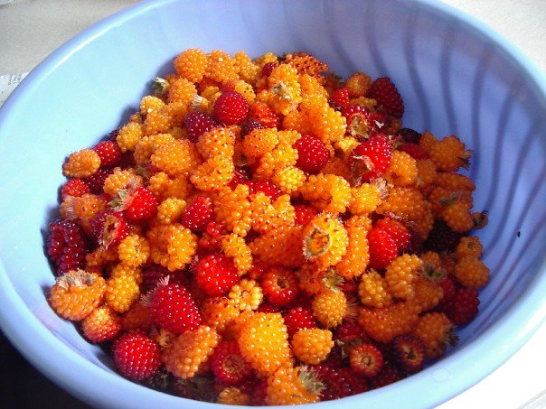
“The Ideas Sandbox” outlines, short drafts, questions, web sites, blog posts, videos, books, music, and photos.

“Inspirations for Writing” includes notes to self, scribbled notes, ideas to follow up, and interesting ideas.

“Link-log” is made up of a collection of links to useful resources and short comments about usefulness of the resources for their project.

“What I learned this week” is made up of a series of blog posts that describe sources of learning, such as events, people, sites, activities, and conversations.

Blogging Instructions for Learners

These instructions are intended as a guide for learners. You do not have to do all the activities as suggested; instead, you might want to try practicing different types of berry-picking posts and putting off other types, depending on your requirements as an individual learner. Try to practice different kinds of berry-picking activities, and anticipate what you might need to complete your project. These posts should be tagged under the tag berry-picking.

“The Ideas Sandbox”
Compose a series of three posts that collect your different thoughts for different projects you might be working on. For example, you might start off with sketches or outlines for your assignments, or upload voice memos, or scan and upload scanned written notes. In any case, berry-picking involves the uncensored collection process. You can compose short, fuzzy drafts, questions you are working on or have encountered, as well as brief descriptions of web sites, blog posts, videos, books, music, and/or photos. The posts in the sandbox are typically a few sentences in length, unstructured, and should be tagged as berry-picking, ideas, sandbox.

Another topic related to sandbox posts bloggers can do in their blogs is to identify some areas of interest they have been pursuing over the past few weeks. This type of serial reflection using the blogging tool serves to identify patterns and common themes for future assignments and projects. Oftentimes, when done in such a series, these kinds of posts tend to reveal a progression and development of ideas over time. These sandbox posts serve to explore and elaborate on ideas and encourage brainstorming of topics and themes. The ideas generated in such sandbox posts can be a great means for bloggers to find others with common interests and to engage in informal cooperative learning alongside formal instruction.

“Inspirations for Writing”
Compose a series of blog posts that include eureka moments, often from a period of lucid dreaming. These short posts are often best attempted in the early morning. They can include notes to self, scribbled notes, ideas to follow up, and interesting ideas worthy of mention. They can also include inspiring videos, music, quotes, or things overheard that were personally significant for you in some way. These posts can be a few sentences up to several paragraphs in length, and might include several sections within a single post. These blog posts should be tagged berry-picking, inspirations, leads.

“Link-log”
Compose a series of blog posts that describe a collection of links to useful online resources and short comments about usefulness of these resources for one’s project. The entries are quite brief and there tends to be between three to five link summaries for each post. These blog posts should be tagged berry-picking, link-log.

“What I learned this week”
Compose a series of blog posts that describe your own sources of learning for this past week, such as significant events, things people have said or did, sites you visited, activities you participated in, and conversations you had. These posts tend to require between three to five paragraphs and should be tagged berry-picking, significant learning.

Online Activity Journals
In these posts, individual bloggers recount their day-to-day experiences on their process of learning to navigate and find resources. Very frequently, these experiences tend to be hit-and-miss, and can include false trails, dead-ends, and back-tracking to re-trace one’s steps. For example, the journal entries might reflect on individuals’ attempts at evaluating if online resources about to be collected are in fact relevant and appropriate. There might be a case of needing to return later at a more opportune time, or it might be a case of mistakenly collecting the item only to have it filtered out later. The recording of the decisions made, the self-talk engaged in while collecting and evaluating resources, can provide a valuable learning archive for the individual blogger as well as others.
Significant Learning Notes
In these posts, completed at the end of a two-week period, bloggers review what they have posted on their blogs and posted to the Wire and Twitter, and also take a look at what was added as bookmarks in their web browser, or as bookmarks within the learning community or group blog. These reflective posts on blogging processes solidify some best practices one has observed and implemented, and adds more depth than general impressions. It provides an opportunity to consider ways to use the blog for meeting one’s learning goals and strategies, and promotes a review of personal successes and areas for future improvement.
Bloggers I Follow
This type of blog post requires us to explore the blog posts of others, and engage in a descriptive overview as well as an in-depth analysis of the expert bloggers’ main interests, issues, and topics. Of the many posts composed, why have certain posts been chosen over others? This post asks the blogger to engage in a search online for expert role models outside the formal instructional context to emulate and observe closely. How does this expert blogger use language? What is appealing or interesting about this expert blogger? What prompts “you” to keep returning to this blogger’s posts? How is this blogger’s voice unique? What have you learned from this expert blogger after watching from a distance?
Resource Summaries
In this activity, bloggers create resource summaries that include content metadata, as well as quotations, significant terms and phrases, questions derived from the content, and descriptions of how the reader might make use of the resource. In addition, bloggers include their own impressions of the content, how it is presented, and their own emotional responses (how much the content resonated with the reader, and for what reasons).
Team Resource Gathering
These posts are occurring within a group blog. A team of bloggers acting as berry-pickers seek to minimize time, not re-trace others’ steps, and collect the berries of content that will best serve their needs both in the short-term and possibly even long-term. Different pickers will have different versions of what is useful, and what might be useful, so the goals might differ. Such collaborative Teamwork using a group blog saves a great deal of time, and collects more resources sooner than any individual could on their own. Bloggers engage in the process of articulating their intentions and goals, determining a valuable set of guidelines, and sharing among the team a large number of resources.

