me2u: How to Create an E-Portfolio

Please read through all the instructions before you begin to build your portfolio.

Contents

- What is an e-portfolio?
- Log into me2u
- Get to know the me2u interface
- Upload your files
- Create your introductory page
- Create a page for a course
  - Add text
  - Add files
  - Add blog posts
- Create links between the introductory page and course pages
  - The plain view trick
- Give visitors access to your portfolio
  - Send URLs to users
  - Plain view
- Other tips and tricks (formatting)
- References & Additional Sources

1. What is an e-portfolio?
Electronic portfolios (e-portfolios) are a set of web based knowledge management and reflection tools. They are more than “simply electronic versions of physical portfolios” (Roberts, n.d.). You can use an e-portfolio for expressing ideas, information, arguments and documentation in graphic, text, audio and video formats. Within an e-portfolio, you can tag, search, archive, syndicate and display your documents and objects in multiple formats on a wide variety of presentation devices ranging from cell phones to lecture halls. E-portfolios are live—creating opportunities for you to interact with your peers, instructors or the general public. You can grant permissions to different audiences and view your portfolio in different formats.

An e-portfolio is a valuable reflective and learning tool. Abrami and Barrett (2005) note that e-portfolios “scaffold attempts at knowledge construction.” The Edutools website provides an interesting discussion about the reflection process:

Templates for reflection support conscious and careful consideration about one’s actions and about the thinking that accompanies actions. One intended pedagogical impact to the process of reflection is to enable the learner to generalize lessons learned beyond the context in which they were learned and be better able to cope with new situations (Edutools, 2007).

There is strong and growing evidence for the pedagogical usefulness of e-portfolios to enhance learning. Working with the e-portfolio provides you with a chance to experience and judge for yourself its usefulness and it possible utility in educational or training programs in which you work. For additional articles and references on e-portfolios please review the references at the conclusion of this document.

If you plan your e-portfolio well, you will be able to create a repository of your course assignments and other artefacts, share your reflections on the learning experience, document your learning strategies, keep track of your goals and progress, and build résumés for job applications.

The purpose of the CDE e-portfolio is twofold:
- To add a reflective component to your learning through selection, annotation and public display of course artefacts.
- To provide an alternative capstone project to the comprehensive examination at the end of the MDE program. This will consist of a selection of assignments, projects and other artefacts, your reflections on them, and any feedback from faculty and other students, collected in the e-portfolio during your program. You will write a culminating, integrative reflection your e-portfolio and program as a final component of your e-portfolio. This, as well as examination and discussion of the e-portfolio by an examining body of two faculty, will be the final capstone project in either the course-based route.
Building your e-Portfolio

This document is designed to introduce the me2u system (ELGG), and provide hands-on guidance for building an e-portfolio. Me2u is an instance of the ELGG open source social software suite. It provides a number of features including profiles, blogs, community and group workspaces, threaded discussion and extensive RSS notification, import and export services. Me2u is designed to support socialization and collaboration within the CDE that extends beyond the course. Any content you upload to me2u will remain accessible to yourself and those you choose for the foreseeable future. Each short section is accompanied by one or two screenshots to illustrate where to find links and how to fill in the text fields. It is highly recommended that you read through the entire document once, then return to the beginning and complete each step in order.

For general information about the ELGG system please visit: http://docs.elgg.org/wiki/Main_Page

Portfolio elements

There are five main elements of the e-portfolio in the me2u system:

- Profile 
- Files 
- Reflections 

- Blog postings
- Comments 
To use the system you must fill out your profile information. Then, to create a portfolio, you will have to upload files and add your thoughts and reflections.

Note: Keeping a blog is optional. This tool is available to you if you are interested in making use of it.

Note as well that it is possible for others within the me2u system to make comments about your blog or your portfolio depending on what access permissions you grant. Allowing other students and faculty to make comments on your portfolio is also optional and your choice. You may find this helpful if you choose to develop your e-portfolio on an ongoing basis throughout the MDE program.

Table 1
Mandatory | Optional

 | 


To see a very rough sample of an e-portfolio in the me2u system, please log in and visit: http://me2u.athabascau.ca/elgg/mkoole/presentations/2/clean

2. Log into me2u
To access the system, open your browser and go to this URL: http://me2u.athabascau.ca

Type in your student ID number and your password as prompted. (It is the same password that you use to access your courses in Moodle and/or myAU (student portal).

3. Get to know the me2u interface
Note: This document covers elements relevant to e-portfolio creation.
- The most important links in the me2u interface are located along the top of the page.
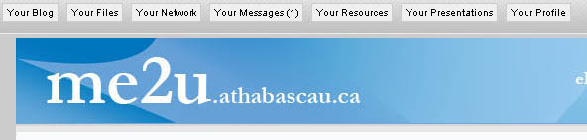
Figure 1: Main Menu

- This is the main menu bar (Figure 1: Main Menu). It contains the following links
  - Your Blog
  - Your Files
  - Your Network
  - Your Resources
  - Your Presentation
  - Your Profile

- First update “Your Profile” to add information about yourself. It is through this information that others in the system can locate you. For example, if you list eLearning as an interest, you will be linked to all other people who have listed eLearning as an interest.
  - Click on the “Your Profile” button located on the far right side of the main menu bar.
  - To edit your profile, click on the “Edit this profile” button just below the me2u logo (Figure 2: Edit this profile)
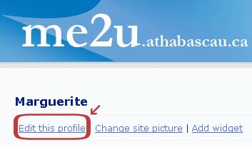
Figure 2: Edit this profile

  - You can add as much or as little information as you like, but you must supply required information. Required information is marked with an asterisk. (Note the “change site picture” link; this tool allows you to upload a picture or icon that will appear next to your name.)
  - Carefully consider the “Access Restriction” for each information field (Figure 3: Set access restrictions). You have at least 4 choices:
    - Public – Anyone visiting the site, regardless of community membership, can see your information.
    - Private – Only you can see your information.
    - Logged in users – Anyone logged into the system can see your information. Only currently registered staff and students enrolled at Athabasca University can log into this system.
    - Group – If you are a member of any groups or communities within the me2u system, you can specify that only a specific group will see your information. You may create a group consisting of any members of the me2u system and restrict access to that group.
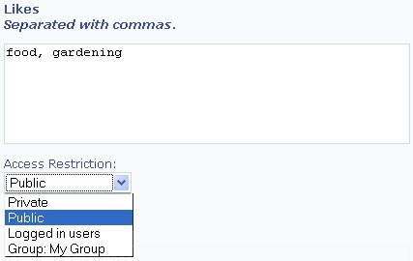
Figure 3: Set access restrictions

- Remember to save your profile by clicking the “Save your profile” button at the bottom of the page.
- Review your “extended profile” by clicking on the link entitled “Click here to view extended profile.” Take some time to scroll down and review your information. Some of the items in your interests, likes, dislikes, completed courses, and other sections will now be links. By clicking on these links, you should be able to see who shares your interests, likes, dislikes, etc. If you decide to make any edits, remember to save your profile again.

4. Upload your files

Once you are comfortable with the interface and you have set up your profile, you can concentrate on creating your e-portfolio. Because this is a repository of your course work, you will need to know how to add documents, pictures, and other media to the system.
- Click on “Your Files” in the main menu bar (Figure 4: Your files).
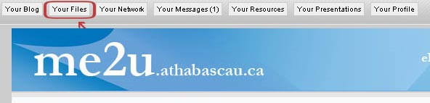
Figure 4: Your files

- Scroll down the page. You should see two main options:
  - Create a folder
  - Upload a file

Create file folders

To keep your files organized in a logical manner, it is best to create folders and place all your files within these folders.

- Create a new folder called “documents” (or presentations, publications etc.) (Figure 5: Create folder).
- It is easiest to use lowercase letters. (Try to be consistent with your file and folder names. Avoid punctuation marks. Use English alpha-numeric characters.)
- Choose “Default file folder” as the folder type.
- Choose an appropriate access restriction.
- If you want your files to be completely private while you are developing your portfolio, you might want to restrict the folder to private.
- Provide some keywords. The keywords will make it easier to search for your information—for you and others using the system.

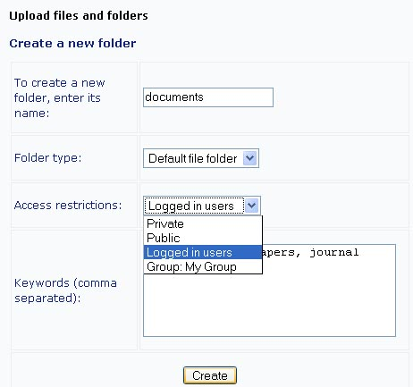
Figure 5: Create folder

Upload a document

- Navigate to the “documents” folder that you just created (Figure 6: Upload file).
(Hint: If you’re lost, click on the “Your Folders” link in the main menu—along the top of the page.)
  - Click on the “documents” folder to open it.
  - You should see the same options to
    - create a folder
    - upload a file
  - Scroll down to the “Upload a file” option.
  - Click on the “Browse” button to locate a document on your personal computer.
  - Type a logical name for your file in the title field. (Be careful not to put apostrophes or periods in the name. Use English alpha-numeric characters.)
  - Provide a description in the file description field.
  - Choose your preferred access restriction.
  - Provide keywords that describe your document. Use commas to separate the keywords.
  - If you have the “legal right to share this item,” click the checkbox just below the keywords field.
    - Note: When you tick this box, you are acknowledging that the item you are uploading belongs to you and that you have permission to share it. This is a serious copyright issue.
  - Remember to click the “Upload” button at the bottom of the page.
  - Upon upload, the system will show you the contents of the current folder.
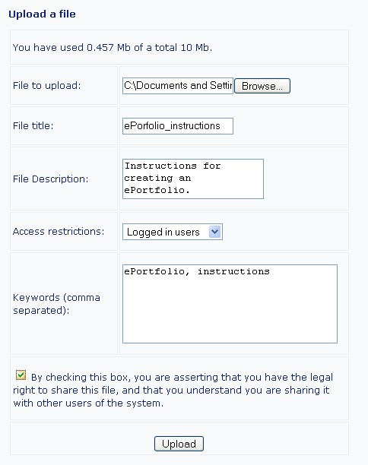
Figure 6: Upload file

At any time, you can navigate back to your “documents” folder to add additional files and documents. When you start building your e-portfolio, you will be able to link directly to all the files that you have uploaded into “Your Files.”

5. Create an introductory page

Once you have navigated through the system, edited your profile, and uploaded some files, you are ready to start building your portfolio. At this point, do not worry about doing anything fancy—later you can learn how to add images, change your fonts, and make other aesthetic changes. The most important part of this process is to link to your documents and provide insights about what you have learned through your studies.

The introductory page will serve as your “home page,” allowing you to introduce yourself, your course work, projects, and relevant professional activities. This page should be kept simple and should link to separate course pages. This method of developing your portfolio will help you keep your portfolio organized and will help you avoid creating unmanageably long pages—requiring your target audience to waste time scrolling up and down unnecessarily.

- Navigate to the presentations section of the me2u interface.
  - Click on the “Your Presentations” link at the top of the page (Figure 7: Your presentations).
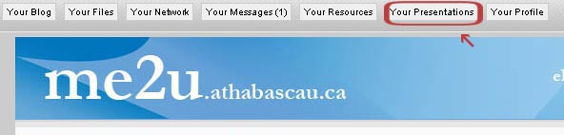
Figure 7: Your presentations
  - You will be at the “index” page (Figure 8: Index page) where you will see the options:
    - Index – This link always takes you to this main index page.
    - New – This link creates a new portfolio page.
  - On the index page, you will also see any portfolio pages that you may have already created.
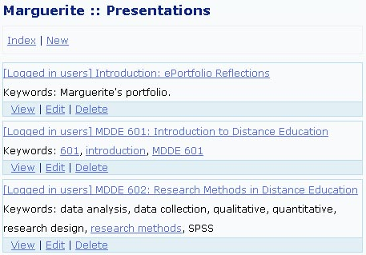
Figure 8: Index page

- Create the introductory portfolio page.
  - Click on “New” at the top (Figure 9: Create new page).
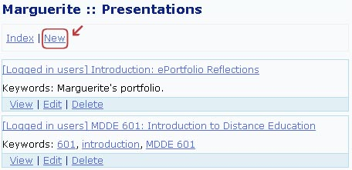
Figure 9: Create new page

  - After you click the “New” button, you will see a screen in which you can edit the name, keywords and access restrictions for your new page.
    - Type the title “Introduction to My e-portfolio” (or another title that you like).
    - Add any keywords that may help you and others to search for and locate your portfolio.
    - Set the access restriction – you may want to keep this private until you feel ready to share it. (Note that, in the image above, Marguerite has set her access restrictions so that only logged in users can see her pages.)
- Edit your introduction page.
  - From the index, locate your new page.
  - Click on the “Edit” link (Figure 10: Edit a page) below the name and keywords for your introductory page:
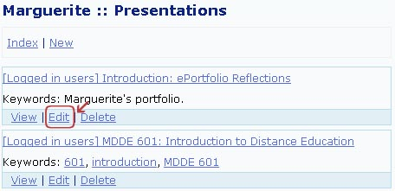
Figure 10: Edit a page

  - Scroll down the page to see what elements you can edit.
    - At the top, you can edit the “General details” including the title, keywords and access restrictions. (This is the same information as in the previous step; this ensures that you can change the page data any time you want.)
    - Further down the page, you can “Add a Section” that may include text, a blog post, or a file (Figure 11: Add a text section). You can try typing in some text right now—perhaps a brief introduction to your portfolio. Remember to save the text by clicking on the “Add section” button at the bottom.
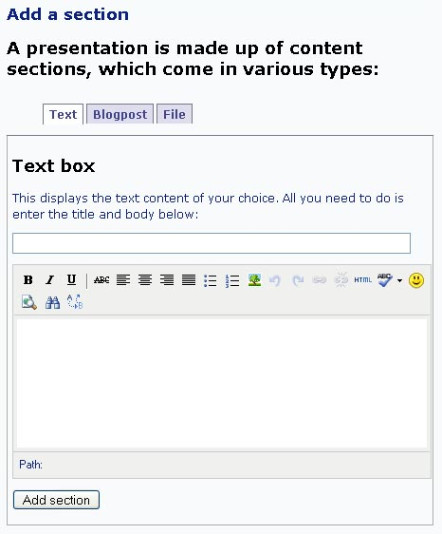
Figure 11: Add a text section

  - You are now ready to create individual artefact pages. Later, you will learn to link them to your introductory page.

6. Create a competency presentation page

We recommend that you create one “presentation” page for each competency that you include in your portfolio. At the top of each page, you can provide a brief summary of the specific artefact and how it impacted you professionally and personally.

Create a page for each artefact you wish to include
- Navigate to the presentations section of the me2u interface.
- Click on the “Your Presentations” link (Figure 12: Your presentations) at the top of the page. (It is the second last link to the right.)
Figure 12: Your presentations

- Create an artefact page.
  - Click on “New” (Figure 13: Create a new page)
Figure 13: Create a new page

- After you click the “New” button, you will see a screen in which you can edit the name, keywords and access restrictions for your new page.
    - Type an appropriate title, e.g., “MDDE 601: Introduction to . . .” (title of the artefact, website, multimedia object, paper, etc., that you are writing about).
    - Add any keywords that may help you and others to search for and locate your portfolio.
    - Set the access restriction—you may want to keep this private until you feel ready to share it.
    - Save.
- Edit your artefact page.
- From the index, locate your new page.
- Click on the “Edit” link below the name and keywords for your introductory page (Figure 14: Edit page).
Figure 14: Edit page

- After you have clicked the edit button, you will see a screen that allows you to modify the page. At the top, you can edit the “General details” including the title, keywords and access restrictions. If you scroll down, you will see that you can also add text, a blogpost, or a file.

Add a text section to your competency page (“Edit Presentation”)

- Scroll down to the “Add a section” area (Figure 15: Add a text section).
- The system will automatically present you with the text option.
Figure 15: Add a text section

- Type a short summary of the artefact.
  - You can introduce the artefact, describe how the it has affected your outlook, and add any other information that you think is relevant.
  - You can bold, highlight, and align your text. You can also switch to code view and use regular html code, if you like.
  - Click the “Add section” button.
- Click on the “Edit” link to see how to make changes to your summary (Figure 16: Edit page).
Figure 16: Edit page

- In the “edit” view of your course page, you should see some links below the content blurb that you’ve added. These links include:
  - Edit section – to update your text.
  - Delete section – to completely delete a section.
  - Move up – to reposition a section relative to other sections in a page.
  - Move down – to reposition a section relative to other sections in a page.
  - Top – to go to the top of the page (useful if your page is very long).
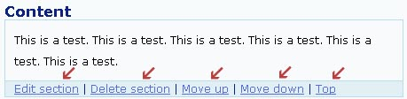
Figure 17: Edit content section

Add a file to your competency page (“Edit Presentation”)

The e-portfolio is a record of your progress and personal growth through your program of studies. Therefore, it is important that you upload your completed papers. You may or may not want to upload the papers with your final grades. This is something that you may want to discuss with your program advisor. Nevertheless, you will first need to upload your papers to “Your Files.” (Review section 4 “Upload your materials” above.)

To link to a file that you have uploaded to the system:

- Scroll down to the “Add a section” area.
- Click on the “File” tab (Figure 18: Add file).
- You will see the same text field when you add a text section. This field allows you to record your thoughts on the file that you are going to upload.
- Choose the file that you wish to upload from the drop down menu below the text box.
- To save, click the “Add section” button at the bottom.
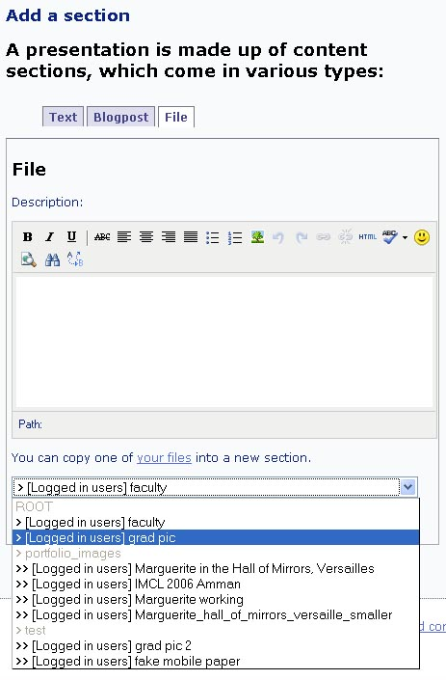
Figure 18: Add file

Note that any files that you have uploaded into “Your Files” will be available to you in the dropdown menu shown in the image above.

Add a blog posting to your competency page (“Edit Presentation”)

If you are keeping a blog while you study, you can display in your portfolio relevant blog postings and associated comments.

- Scroll down to the “Add a section” area.
- Click on the “Blogpost” tab (Figure 19: Add blog post).
- You will see the same text field when you add a text section. This field allows you to record your thoughts on the blogpost you are linking.
- Choose the posting that you wish to link from the drop down menu below the text box.
- If other members of the me2u community have commented on your blog, you can choose to import their comments by clicking in the checkbox below the dropdown menu (not visible in the screenshot below).
- To save, click the “Add section” button at the bottom.
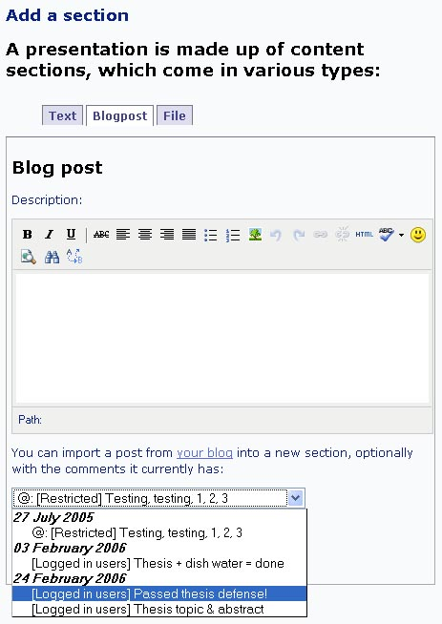
Figure 19: Add blog post
Note that any blogposts that you have made in the me2u system will be available to you in the dropdown menu shown in the image above.

7. Link your competency pages to your introduction

Currently, we do not have an easy way to automatically link different presentations to each other. So, in this section, we will teach you a few HTML skills! It is expected that future releases of ELGG will make this task easier.

First, you need to see the format that you will send to your committee, colleagues, friends, and/or family: the “Plain View.” To see the plain view, go to one of the portfolio pages that you created in the previous section and click on the “Plain View” link at the top:
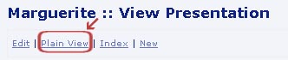
Figure 20: Plain view

You will want your visitors to see all your plain view pages, so you must make sure that you link to them—rather than to your working view. For an example, please see this Portfolio sample:
- Plain View: http://me2u.athabascau.ca/elgg/mkoole/presentations/2
- Working View: http://me2u.athabascau.ca/elgg/mkoole/presentations/2/clean

In this example, if you scroll down to the “Course Work” section and click on one of the course links, you will connect to a page in the plain view. Note: The plain view pages end with /clean.

Create your links

- Locate the link you want to add to your introduction page:
  - Navigate to the index page.
  - Click on the portfolio page, for example, MDDE 601.
  - Choose Plain View.
  - Copy the URL from the address bar in your browser. (To copy: Block highlight the URL. Then`, hold down the CTRL key and “v” at the same time.)
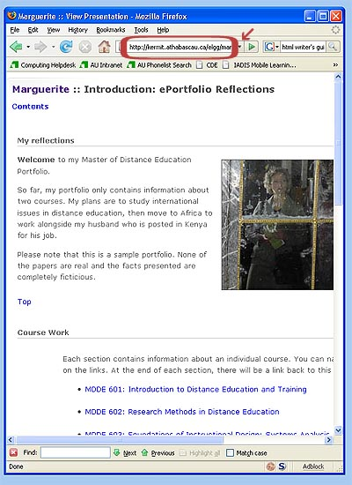
Figure 21: Page URL

- Return to your introduction page.
  - Click on “Edit” to edit your introduction page (Figure 22: Edit page).
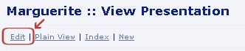
Figure 22: Edit page

  - Scroll down to the section in which you want to add your links. Click on “Edit section” to edit that section (Figure 23: Edit section of page).
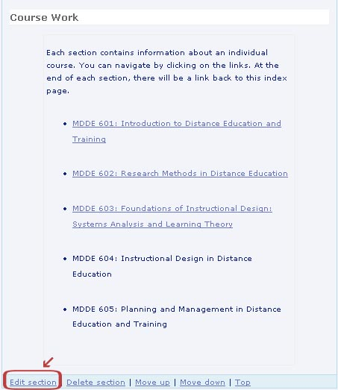
Figure 23: Edit section of page
  - Block-highlight the course title that you want to link. Then, click on the “Insert/edit link” tool () (Figure 24: Text editing - insert link button).
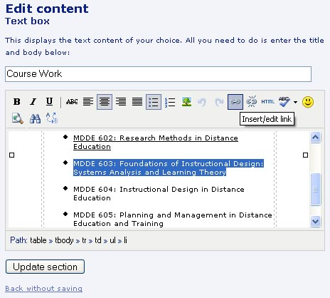
Figure 24: Text editing - insert link button

  - When you click on the link tool, a small box will appear (Figure 25: Insert link). Paste or type the URL into the first field. Decide if you want the page to open in the same window or a new window (from the drop down menu in the middle). And, provide a title (name) for the link.
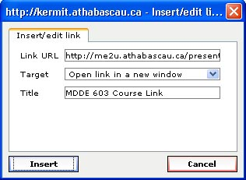
Figure 25: Insert link

  - After you click the “Insert” button, your link will appear to be underlined. Save this by clicking on the “Update Section” button. Then, you can test your new link.
  - Add links for all your portfolio sections.

8. Give visitors access to your portfolio

There are some things to consider before you give others access to your portfolio.
- Who will view your portfolio pages? Set the access permissions accordingly (Figure 26: Access permissions).
- Is this person a user within the me2u system—such as a classmate or instructor?
    - If so, then you can change your access restrictions to logged in users. Then, anyone logged into the me2u system can visit your portfolio pages.
- Is it a group or community within the me2u system?
    - If so, you can locate the group or community and set the access restrictions to permit that group. (First, you may need to become a member of that group or community.)
- Is it someone outside the me2u system or outside of Athabasca University?
    - If so, you will need to change your access restrictions to public. This will enable anyone in cyberspace to see your portfolio, provided you have given out the URL, or they find it via search engines such as Google.
Figure 26: Access permissions

When you have set all your permissions correctly, click to view the Plain View version (Figure 27: Plain view):
Figure 27: Plain view

Then, you can copy (block highlight, then press CTRL + v) and send the plain view URL to whomever you wish (Figure 28: Page URL).

Figure 28: Page URL

9. Other tips and tricks

- The me2u system will allow you to use HTML code. To do this, you would begin by editing a text section (see section 6a). Then, you can click the “Edit HTML source” button () in the text editor (Figure 29: Text editing - edit HTML button).
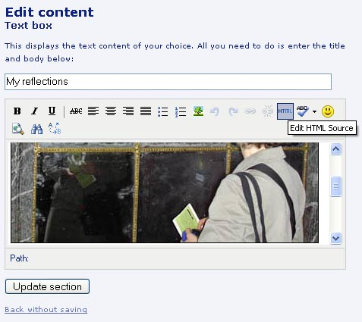
Figure 29: Text editing - edit HTML button

When you click on the “HTML” button, a small box will appear (Figure 30: HTML editing window).

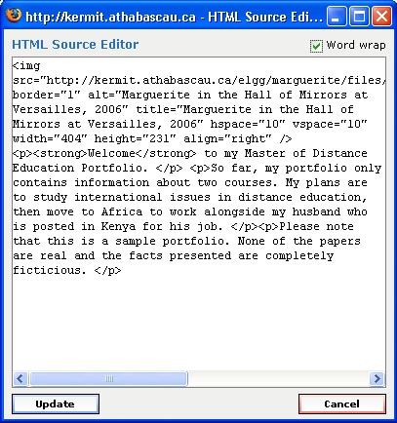
Figure 30: HTML editing window

You can type or paste HTML code directly into this window. When you are finished, make sure you click the “Update” button to save your work. This method would allow you to work with programs such as Dreamweaver or other HTML editors to create richly formatted pages.
To learn HTML, you can visit a number of sites:
- http://www.html.net/
- http://www.aaahtml.com/
- http://www.pagetutor.com/html_tutor/index.html
- http://www.hwg.org/

References and Additional Sources

Abrami, P., & Barrett, H. (2005). Directions for research and development on electronic portfolios. Canadian Journal of Learning and Technology, 31(3), 1-15. Retrieved January 29, 2007 from http://www.cjlt.ca/content/vol31.3/abrami.html

Challis, D. (2005). Towards the mature e-portfolio: Some implications for higher education. Canadian Journal of Learning and Technology, 31(3), 17-32. Retrieved January 29, 2007 from http://www.cjlt.ca/content/vol31.3/challis.html

Coppola, C. D. (n.d.). Rsmart OSP e-portfolio. Retrieved January 29, 2007 from http://www.sjsu.edu/cfd/docs/eportfolio_05_rsmart_vendor_questions.pdf
Cotterill, S. J., Horner, P., Hammond, G. R., McDonald, A. M., Drummond, P., Teasdale, D., et al. (2005). Implementing e-portfolios: Adapting technology to suit pedagogy and not vice versa! Retrieved February 5, 2007 from http://ww.eportfolios.ac.uk/FDTL4/fdtl4_docs/Cotterill_et_al_paper_for_eportfolios_2005.doc
EduTools. (2007). e-portfolio: EduTools e-portfolio Review. Retrieved July 31, 2007 from http://eportfolio.edutools.info/static.jsp?pj=16&page=HOME
Lind, V. (2007). E-portfolios in music teacher education. Innovate: Journal of Online Education, Volume 3(3), Retrieved February 2, 2007 from http://www.innovateonline.info/index.php?view=article&id=351

Roberts, G. p. m. (2006). Myworld: Wider opportunities for reflection, learning and development. Retrieved January 29, 2007 from http://www.jisc.ac.uk/whatwedo/programmes_edistributed/myworld.aspx

