MDDE 605: Planning and Management
in Distance Education and Training

Assignment 2: Structure and cost issues

Instructor: Dr. Ian Mugridge

Due Date: June 29th, 2008

ID number: 2548602
Student Name: Terumi Miyazoe

Note. Online course delivery on the side of ICU was added to the initial plan described in Assignment 1. Subsequently, the new student intake plan has been revised and can be found in Appendix 2 (EXCEL attachment, worksheet 2).
CONSORTIUM STRUCTURE

Legal structure

The ICU coordination unit will be located in the university as a part of the academic affairs’ office and its direct owner will be the University, which is a private institution. Therefore, its legal status is that of a school corporation (Private School Law, Act 2~4 in e-Gov., 2007).

Governance

Final decision-making authority will lie with the Dean of the University. The school law amendment of 2004 accorded much greater decision-making power to the Dean without the involvement of the school board members in order to ensure the school can respond swiftly to changes in the market, such as those expected from the declining birth-rate (as described in Assignment 1).

Organizational structure

Figure 1 outlines the organizational structure within the Unit. The coordination unit is a section in ICU that is specialized in coordinating the activities of various school units and consequently follows the existing hierarchical decision-making structure of the University. However, relations within the Unit are conceived as heterarchical so as to realize greater efficiency and smooth flow of work – anybody will do any task regardless of their title status in the Unit. Even so, final decision-making authority will lie with the unit Director.

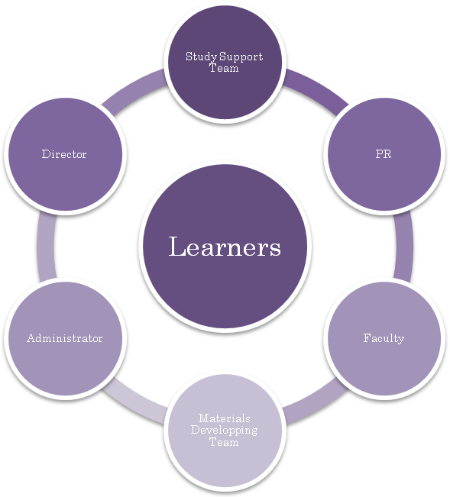
Figure 1. Organizational structure of the coordination unit

Management

In its initial stage, the coordination unit management will consist of two full-timers, Director and Administrator in order to minimize the start-up costs.

Title | Roles | Desirable qualifications
Director | Decision-making for the Unit, consultation with the faculty board of the University. | Experience of organizational management in higher education, preferably in Japanese and global contexts.
Administrator | Administration management and coordination of the members between ICU and the member institutions, consultation with the faculty and the Academic Degrees and University Evaluation (NIAD-UE) ¹⁾ | Experience of administration in higher education, preferably in Japanese and global contexts.
Table 1. Role assignments of the unit management

The Unit management staff will be sourced in-house to minimize the start-up costs (like many other institutions suffering from the decrease in enrollment, ICU has excess that have become fixed costs; however, it is very difficult to lay off personnel in Japan other than in cases of bankruptcy). Those who can cover a variety of ICT-related tasks will be particularly sought for so to share the relevant work without requiring the hiring of more people. Strong communication skills, both oral and written, in English and Japanese is required, along with a good sense of globalized education and the understanding of various academic cultures both in Japan and overseas. Ideally, they will have qualifications such as a Master or Doctor in Leadership or Administration in Global Education or similar but at present, it would be difficult to find someone who can satisfy all criteria.

Personnel
Under the two core members for direction and administration, additional personnel will be hired on a part-time basis depending on need. Only when the enterprise is established will further full-time staff be recruited. It is desirable to make the unit organization as simple and flexible as possible in order to allow for swift responses as needs arise. The role assignments are summarized in Table 2 below.

Title | Roles | Desirable qualifications
Study support team | Academic support (study skills and language) and mental support (cultural and emotional). | Preferably post-doc or doctoral students who hold DDE, DEd, DBA, or relevant but can be international students in ICU masters’ programs.
Materials development team | Based on the content provided by ICU faculty, making online course materials to be delivered from ICU to overseas. | Knowledge and skills regarding web design, Instructional design, web publication, plus preferably a basic understanding of web programming.
PR | Distribute information about the Unit, its functions, state, etc. through the unit website. | Ability of publication and website construction.
Faculty | Provide the course content and direct the materials developing process. If possible, tutors the course online also. However, this may be externally sourced. | PhD in the relevant field, plus understanding of DE, ideally trained in online teaching, preferably qualified with MDE or above or equivalent.
Learners | Learners are at the center of any decisions. Learners are responsible for taking initiative for their learning, planning, and making the best use of the learning opportunities provided via consultation to his/her personal academic advisor. | Enrolled in a master’s level program in a member institution in the consortium, plus enough ability/readiness to study by distance mode.
Table 2. Role assignments of the unit personnel

The online courses provided from ICU to overseas will not be made from scratch but will be drawn from a digital repository (please see http://olcs.icu.ac.jp/moodle/). These will be further developed for export by the expert instructional designer for online learning so as to minimize the start-up costs. Also, the materials will be enhanced by being combined with e-books, e-journals, etc. in both Japanese and English, which the University already provides subscriptions for its students (please refer to http://www-lib.icu.ac.jp/Databases/index.htm). A synchronous online meeting system such as Elluminate Live! (Elluminate.com, 2008) may be added to the course design depending on the composition of the course takers.

Business processes and procedures

Prior to beginning coordination, the enterprise should be fully introduced to the member institutions of the consortium.

Coordination will consist of:

- Reception of coordination requests by members of the consortium
- Evaluation of the request
- Matching from a pre-established course menu when viable
- Confirmation from the receiving institution
- Locate an alternative institution when the first choice is not viable
- Feedback the result to the member

Course delivery (related to Japanese subjects) will consist of:

- Digitizing the course content by materials developing team (in English)
- Course syllabus publication to recruit students overseas
- Registration and course fees arrangement by the coordination administrator
- Online course provision by faculty or the course content expert
- Course credit approval and communication by the coordination administrator
- Evaluation questionnaire executed by the Unit at both ends

Study support will consist of:

- Receiving support requests from students, if any
- Matching the supporter and student by the Unit
- Supporting students during a given course
- Re-coordination if any problems arise
- End of support by the end of a given term
- Evaluation questionnaire executed by the Unit at both ends

Infrastructure

Office
Office space sufficient to accommodate the Unit staff will be located on campus.

ICT equipment
A minimum of three reliable PCs are required, two for the managers and one for materials development that would also be shared by part-time personnel. Besides, there are hundreds of PCs with an Internet connection available for ICU staff and students on campus and personnel will be given liberty to work from any PC from any location. The courses provided on Japan side will be located on the existing school Moodle servers at the ILC (Integrated Learning Center) where many professional staffs are working, especially at the initial stage when few courses will be provided in order to keep the costs down.

Basic Internet infrastructure will rely on the existing school LAN that operates between all the sections of the school buildings. In addition, a dedicated internet line from an independent ISP shall be subscribed to in order to insure stable communication on and off campus: a mobile connection is necessary for the meetings outside the campus.

Marketing/advertising strategies

A common understanding of the enterprise shall first be presented to the relevant stakeholders; that is, the ICU faculty and students, and the representatives of each institution in the consortium.

PR personnel will be in charge of the unit website for the purpose of distributing the necessary information and advertising inside and outside Japan. However, the initial aim of the consortium is not to generate an enormous number of coordination requests. Consequently, the diffusion of information will preferentially target relevant and potentially interested parties.

Commonly used advertising strategies such as newspapers²⁾ and school pamphlets can be utilized to present the consortium’s special service within the annual routine recruitment process of each institute in the consortium. The cost of such advertising will be covered by each member institution. Also, since each institution in the consortium offers regular open campus days and open lectures when outside visitors can be informed of the special benefits of the enterprise.

The ICU Alumni club whose members are active in international organizations such as UNESCO and OECD³⁾ could also be a valuable channel for diffusing information about the enterprise.

In addition, ICU has a communication network among sister institutions that are tied together by the Christian faith both inside and outside of Japan.⁴⁾ This generally invisible channel could potentially be a highly effective and powerful ways of diffusing knowledge of the enterprise without the intervention of financial considerations.

All elements of marketing/advertising should be conducted in such a way as to not damage the brand image already established by ICU. The emphasis of providing better opportunities for learning without degrading quality is the key.

OPERATING COSTS

Start-up costs

The start-up costs will be minimized by relying, as far as is possible and practicable, on the existing resources currently held by ICU.

Direct costs
Consumable goods such as stationary goods, files, papers, pens, etc. should be bought at the beginning and continue to be supplied, independently from the ICU general budget. The majority of office facilities such as PCs will be rented as detailed in the financial plan section below. However a mono laser printer will be bought as renting costs were found to be greater than purchase.

Indirect costs
Office furniture such as desks, chairs, sofa for visitors, a counter desk, and filing cabinets will be sourced from the school depository. Utility costs such as power, heating and water will be also dependent on the school since the Unit is located in the school building.

Fixed costs
ICT facilities, such as office PCs (CPU 1.86GHz or above, Windows XP Pro/Vista Business, 19 inch TFT monitor, with MS office personal 2007), photocopier, etc. will be obtained on a rental basis to ensure that the system can be updated cost-effectively.²⁾ Initially, the LMS for the course offering from ICU will be located on one of the existing school servers; however, as demand increases, it will have to eventually establish its own server. To secure an external Internet connection, a 160mbps internet connection will be subscribed to, with VoIP and a portable phone (that covers 99% of Japan) also using the same line, which is independent from the school LAN.

Variable costs
Wages for personnel on part-time contracts will make up the largest of the variable costs for the Unit. These will be adjusted to the demands arising to keep the financial balance manageable. Costs such as transportation and advertising are also included in this category.

Based on the above, the cash that will be needed to start-up minimal operations at the very beginning of April of the first year is approximately 140,000 yen: 20,000 yen for the mono laser printer, and 120,000 yen for other office maintenance related fixed costs.

Funds for start-up

The coordination enterprise will be funded by the University as one of its annual experimental projects: the budget it provides depends on the size of the project and the minimum necessary for the start-up will rely on this project fund. Hypothetically, in this proposal, the cash amount of one million yen (about 9,090 CAD) should be provided for the start-up by the University.

Funds for annual operating

The basic policy is when necessity arises, the minimum fees will be charged to the stakeholders so that it makes its economy as small as possible.

In addition to the project fund provided by ICU, the members of the consortium will be asked to pay a membership fee for the minimum maintenance of the Unit: this is based on the idea of mutual support among the member institutions of the consortium, as is currently done for exchange programs and credit transfers in member institutions of the consortium.

For courses made up from the ICU curriculum, the course fees for overseas institutions will be paid by ICU. However, in the case students hope to take courses outside the pre-established menu of exchange, students will be asked to pay the fees directly.

Start-up balance sheet

Table 3 below shows the hypothetical start-up balance sheet of the coordination unit for the first fiscal year. The currency unit is hereafter presented in thousands of yen in order to avoid any misinterpretation resulting in fluctuations in the exchange rates of YEN-CAD; however, 1 CAD can be generally assumed to be equal to 110 YEN (x-rates.com, 2008).
(in thousands of yen)
Account Title | Amount | Account Title | Amount
ASSETS |  | LIABILITIES
Current Assets  Petty Cash  Bank Deposits  Accounts Receivable  Short-term Loans Receivable  Prepaid Expenses  Total Current Assets  Fixed Assets  Tangible Fixed Assets  Land  Office room  Office equipments  Intangible Fixed Assets  Amortization  Computer software  Total Fixed Assets | 500  500  4,960  0  0  5,960  13,250  6,625  100  1,000  200  21,175 | Current Liabilities  Accounts payable  Wages payable  Taxes payable  Total Current Liabilities  Fixed Liabilities  Accounts payable  Wages payable  Taxes payable  Total Fixed Liabilities  Long Term Liabilities  Long term loans  Mortgage  Total Long Term Liabilities | 22,603  3,500  132  26,235  0  0  0  0  0  0  0
 |  | TOTAL LIABILITIES | 26,235
 |  | EQUITY  Retained earnings  Current earnings  Total earnings | 0  140  140
 |  | TOTAL EQUITY | 140
TOTAL ASSETS | 26,375 | LIABILITY AND EQUITY | 26,375
Table 3. Start-up balance sheet – April 1, 2009 to March 31, 2010

The petty cash and bank deposits are the monies provided by ICU for the start-up. The land and office room values were calculated based on the actual land price published by the Ministry of Land (2008), which is 265,000 yen/m² of the area where ICU is located. The office was tentatively estimated as 50 m². Computer software are those necessary to create and maintain the unit websites and online course delivery and are installed in many PCs at ICU. As the nature of the coordination unit is in the category of benevolent cooperation, the only taxes levied are consumption taxes arising from the services and goods such as the rental services and office goods. The salaries for the Director and Administrator are normally included in the total current liabilities (“One Year Rule”) that amounts to 21,415 thousands yen (payable accounts minus current expenses). This, for the two qualified personnel, is within the salary range so the BS of the enterprise for the first year is sound.

Annual income statement

The finance of the proposed enterprise will be settled in cycles of one month, one term, and one year. The annual income statement (Table 4) shows the revenues/expenses relations in the second year (Assignment 1, p.12) when the enterprise is underway with a total of 30 domestic and 10 overseas students taking an online course from ICU to be coordinated.
(in thousands of yen per year)
Revenues | Amount |  | Expenses | Amount
 | Per month |  |  | Per month
Membership fees  Contingent fees  Students support fees  Course fees | 30 institutions@10  30 students@1  40 students@10  10 students@30 | 3,600  360  4,800  3,600 | Wages to personnel  Online course design  Course tutoring  Students support  Office utilities (rental)  PCs  PC monitors  Complex machine  Others Communication  Internet, mobile, IP phone package | 1 person@50  1 tutor@75  40 students@10  3 pieces@10  3 pieces@10  1 piece@10  30  1 line@10 | 600  900  4,800  360  360  120  360  120
Total | 12,360 |  | Total | 7,920
Table 4. Annual income statement

The membership fees from the institutions will be a combination of basic fees and the contingent fees that will be charged per student for an institution to be coordinated in a specific term period: the annual membership fees will be 120,000 yen, that is, 10,000 yen per month + a contingent fee of 4,000 yen per student per term will be demanded.

When providing a course from ICU, one course corresponds to 3 face-to-face credits, lasting 10 weeks. The course is currently offered for 105,000 yen (about 950 CAD) so the price of an online course is tentatively set for 120,000 yen (for convenience because the figure easily divides into 4 or 12 month periods).

Post-doctoral or doctoral students will be paid 2,000 yen per hour. The course tutoring wage per course is tentatively set as 300,000 yen per course, that is, 30,000 yen per week.

The online course design will be based on existing course content developed on Moodle; however, some re-design for online course delivery, clearing of copyright issues, etc. are necessary; once developed, the course design fees will become unnecessary for the same course until the time it needs further content remodeling, say, after three years.

A 10% of tax called consumption duty is levied on any services and goods; this is pre-included in all prices, and which is paid directly from the service providers to the government (taxes payable in the balance sheet). Therefore, all the prices of services and goods in the above below include this indirect tax.

Three PCs will be rented on a three year contract including maintenance services (Junction, 2008). The photocopier rental (monochrome, combined photocopier, fax, and printer) will be shared via a LAN within the office. Others include consumable goods such as pens, files, papers, etc.

An independent cable Internet line (160MB), IP phone, and mobile package will be subscribed to in order to secure communication: that costs about 10,000 yen (or 900 CAD) per month and advantageous (J-Com, 2008). ⁵⁾

Cash flow statement over three years

The cash flow statement (CS) regarding operating activities from April 2009 to March 2011 is presented (Appendix 1). The operating activities are defined as “principal revenue-producing activities and other activities that do not include investing or financing activities” (Hennie, 2004, p.32). The style of cash flow statements seems to vary slightly from country to country (Mulford, 2005, pp.73-74) and the CS in this paper follows a direct method itemization that includes the concrete cash flow items dealt by the coordination unit for its operation.

The hypothetical cash flow over three years period ends in the black; the 2010 year-end balance with 140 thousand yen, 2011 with 1,240, and 2012 with 5,040, as it depends on ICU’s existing resources and for a large part of its start-up costs. Profits will be re-invested in the Unit to improve the service or lower the membership fees. As the main role of the Unit is to be coordination services, the CF shows that the enterprise will get underway without requiring much investment in its initial stages.

Below is a graphical representation of the relations among variable revenues, fixed revenues, variable costs, fixed costs, the number of students, and the profit/loss balance, involved in the enterprise over its initial three years as determined from the CS (please see also Appendix 3). Since the large part of the start-up costs that would normally need to be funded is provided by ICU’s existing resources, the enterprise could make a small operating profit from the first year.

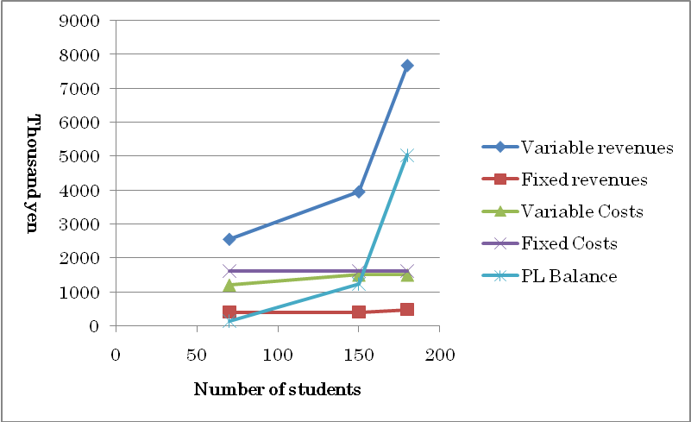
Figure 2. Revenues, costs, and student numbers

Appendix 3 shows that 1) as long as the Unit limits its scope to outsourcing necessary course components externally, the PL balance follows a quasi-zero economy and ICU neither gains or loses, 2) if successfully implemented, it is the online distance course delivery of Japan related subjects in English from ICU to overseas that will reap profits for the Unit, and 3) the number of students who will take online courses from ICU is positively related to the size of revenue expected. This means that in situations where overseas demand for online course delivery is low, the Unit will cease producing additional online courses and focus on coordination instead. In this way, it will be able to minimize any losses incurred in the long run. Since the intention is to start the enterprise keeping the start-up costs to the bare minimum, potential losses are further minimized.

Even if the enterprise itself does not prove profitable in the long term, it could intangible benefits to ICU such as higher enrollments in graduate programs, higher satisfaction of the students, more active academic exchange between Japan and the rest of the world, and greater awareness of ICU within the market. Also, by outsourcing a part of its graduate level courses, ICU will save on costs that had been paid for those courses; accordingly, the CS of the expenses of ICU should be better balanced as a whole.

ENDNOTES

- NIAD-UE (National Institute for Academic Degrees and University Evaluation) is a “credit bank” (Moran & Muggride, 1993, p.15): its primary role is to evaluate the academic equivalency of course credits and its capability to accord degrees by adding up course credits from more than one institution is still limited to a few fields of study in science.
- The two newspapers The Asahi Shimbun and Nihon Keizai Shimbun are usually considered to be appropriate for the kind of announcements that aim at higher end subscribers in our context. Japanese newspapers have a large circulation – ranking among top five circulations in the world (World Association of, 2004).
- ICU has placed the same number of graduates as officials in international organizations as Tokyo University. Given the difference in enrollment size between the two universities of 3000 vs. 15,000, the international contribution of ICU can be considered to be substantial.
- There are many missionary schools in Japan, which include recognized traditional universities such as Rikkyo University, Sophia University, Doshisha University, and ICU. This is because the Western style of education was brought to Japan along with Christianity and those universities share the same feature of emphasizing English education, that is, the viable interested party of the proposed enterprise. The particular relation of Christianity and higher education is a hidden socio-cultural code Japan often overlooked from foreign perspectives.
- Japan is said to offer the highest cost performance of the Internet provision with regard to its speed, and stability in the world at present (OECD, 2007 in BBC 2007).

REFERENCES

Bates, A. W. T. (2000). Managing Technological Change: Strategies for College and University Leaders. San Francisco: Jossey-Bass Inc., Publishers.
BBC. (2007). Global broadband prices revealed. Retrieved June 20, 2008, from http://news.bbc.co.uk/2/hi/technology/6900697.stm (original source: OECD Communications Outlook 2007).
e-Gov. (2007). Private School Law. Accessible at http://law.e-gov.go.jp/htmldata/S24/S24HO270.html
Elluminate.com. (2008). Accessible at http://www.elluminate.com/buy_now.jsp
Hennie, V.G. International Financial Reporting Standards : Practical Guide. Washington, DC, USA: World Bank Publications, 2004. p 32. Retrieved June 19, 2008, from http://site.ebrary.com/lib/athabasca/Doc?id=10069601&ppg=44 via AU Ebrary.
Kunisada, K. (2007). The trinity of balance sheet, income statement, and cash flow statement (Zaimu sanppyo ittai rikaiho). Tokyo. Asahi Shinsho.
ICU (International Christian University). (2005). Balance Sheet. Retrieved June 17, 2008, from http://www.icu.ac.jp/english/info/finance/pdf/2005/taishaku_e.pdf
J-Com. (2008). Package price. Retrieved June 20, 2008, from http://www.jcom.co.jp/pricing/tokyo/tokyo_pay_pack.html
Junction. (2008). Desktop PC rental. Retrieved June 18, 2008, from http://www.junc.net/syouhin/rental/rental-pc_desk.htm?gclid=CKOl2Izu_ZMCFRRnegodalYnWA
MEXT (Ministry of Education, Culture, Sports, Science and Technology). (0000). School Education Law. Retrieved May 26, 2008, from 0000
Ministry of Land, Infrastructure, Transportation and Tourism. (2008). Official announcement of land price: Mitaka-city, Retrieved June 20, 2008, from
http://www.land.mlit.go.jp/landPrice/SearchServlet?MOD=0&TDK=&SKC=13204&CHI=&YFR=2008&YTO=2008&YOU=&PFR=&PTO=&PG=1
Moran, L., & Mugridge, I. (Eds.). (1993). Collaboration in Distance Education: International Case Studies. New York: Routledge Taylor & Francis Group.
Mulford, C.W. (2005). International differences in the statement of cash flows. Creative Cash Flow Reporting : Uncovering Sustainable Financial Performance. Hoboken, NJ, USA: John Wiley & Sons, Incorporated. Retrieved June 19, 2008, from http://site.ebrary.com/lib/athabasca/Doc?id=10114162&ppg=91 via AU Ebrary.
NIAD-UE (National Institute for Academic Degrees and University Evaluation). (n.d.a). Awarding of Degrees. Retrieved April 18, 2007, from http://www.niad.ac.jp/n_gakui/ninteisisetsu/index.html
Phillips, R. A., & Wellman, J. V. (2001). Funding the "Infostructure": A guide to financing technology infrastructure in higher education [Electronic Version]. New Agenda Series, 3. Retrieved May 31, 2008, from http://www.luminafoundation.org/publications/newagenda.html
Powley, R. (2006). MDDE605 Study Guide, Alberta: Athabasca University
Rosenberg, M. J. (2001). E-Learning: Building Successful Online Learning in Your Organization. New York: McGraw-Hill.
World Association of Newspaper. (2004). World’s Largest Newspaper. Retrieved June 6, 2008, from http://www.wan-press.org/article2825.html
x-rates.com. (2008). Japanese Yens to 1 CAD. Retrieved June 17, 2008, from http://www.x-rates.com/d/JPY/CAD/graph120.html

