Unit 5 ideas :

- Add functionality for the tags present on the homepage so that the images displayed will only match that of the tags selected. This will let Leo and Misty marvel at the beasts of their choosing. Leo’s favourite animal is the Lion, and he can click on this tag and it will show him only lion images. As well, the user can enter a custom tag (less popular ones and see the images that show up that are affiliated with that tag)
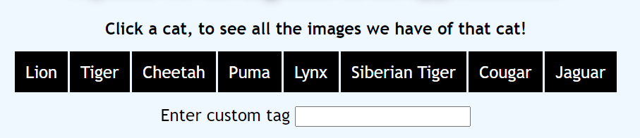

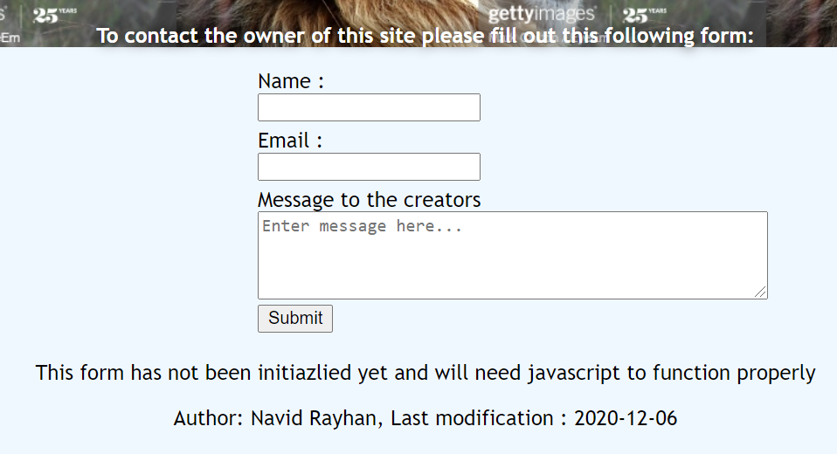
- Implement the email form in the Contact Section. This form being functional will allow Leo to submit images for the creators to upload with links to the images. It will also allow Racksina to give feedback on the images that she does not think are appropriate for this website and complain against the captivity of these cats.

- Add functionality to the About table to expand and collapse on user clicks to lead the user to different discussion boards on the internet , and to links to various charities. This will make the table much smoother and easier to use. It will be particularly useful to Misty Jones as she wants to learn more about these things and she can use the table to connect her to resources where she can do just that. It will also help Racksina as she will now have a place to easily find a curated list of approved charities that she can donate to. 